Machine Learning Engineer Nanodegree

Capstone Project

**CLASSIFICATION OF REVIEW RATINGS FOR AMAZON ALEXA**

Prabhakar Mudliyar  
July 20th, 2019

**I. Definition**

**Project Overview**

In the current market, companies are finding various ways to improve the product and increase the sale of their products. The main goal for a lot of companies is to study the customer feedback. Once the sale of product has started, it will all depend on the review of the end users. These review will help the company understand about the performance of the ongoing sale and future sales. Generally, people share their reviews online, mostly on the same website where the product was purchased. The main goal is collect all these reviews and find a way to automate the process of understanding the customer sentiments.

Amazon Alexa is one such product from Amazon for which the customers have shared many reviews and we will try to understand the customer sentiments using one of the Supervised Algorithms.

Why use Supervised Algorithms, as this will help to automate the process of reviewing the large datasets manually and also reduce human errors. And also in time how much we train our algorithm with data it will only increase performance.

**Problem Statement**

The main objective of this project will be understand the Amazon Alexa product reviews given by different type of people and different places. We will make use of one of Supervised Algorithm called Random Forest Classifier to understand the reviews which are in form of words.

Amazon has different type of products Alexa products and they want to know the feedback from the customers for the products. The objective is to perform the analysis of customer sentiments and derive insights into consumer reviews.

The Kaggle data consist of more than 3000 customer reviews, star ratings, review date, variant and feedback of Amazon Alexa products. The objective is to discover insights into consumer reviews and perform sentiment analysis on the data.

**Metrics**

The evaluation metric for this problem will the Confusion Matrix or also called as the Classification Accuracy.

The metrics are percentages of correct predictions. The classification report will also show the results of the precision, recall, f1score. Based on these scores we will be to evaluate the performance of the Algorithm.

**II. Analysis**

**Data Exploration**

For this problem we will make use of dataset[amazon_alexa.tsv] which can be downloaded from the below link.

* Dataset: [www.kaggle.com/sid321axn/amazon-alexa-reviews](http://www.kaggle.com/sid321axn/amazon-alexa-reviews)

The dataset contains 3150 reviews and 5 features which are explained below:

* Rating: Number ranging from 1 to 5 indicates likeness of the product by the customer.
* Date: On which date the review was recorded.
* Variation: Variants of Alexa Products ex Charcoal Fabric, Walnut Finish etc.
* Verified_reviews: The comment or the review given by the customer for the product.
* Feedback: This is the target variable which help to find the accuracy.

To understand the data, we will explore the datasets by loading the data (amazon_alexa.tsv) in the panda library and analyze the features of the dataset. The steps are given below.

1. Importing the data using the Panda library, we can see below that many other Python libraries are also imported. The below image shows first 5 reviews and also the features.

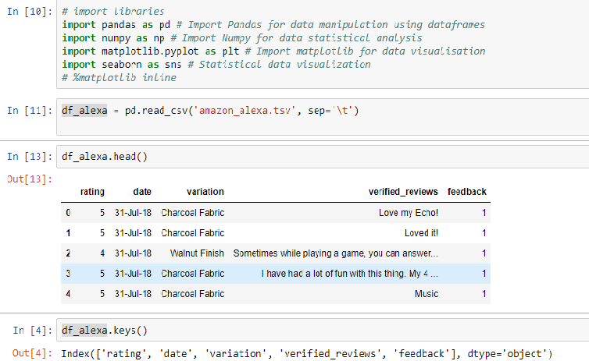

1. The below image shows all the reviews given by the customer, as you can see the reviews are not common and are in form of words.

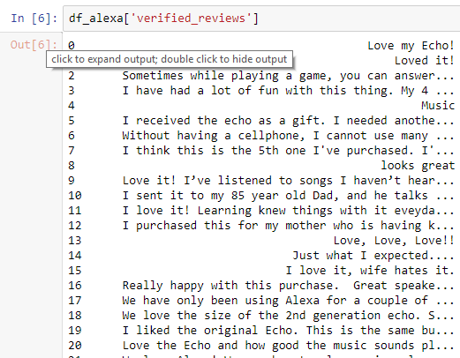

**Exploratory Visualization**

To explore and better understand the data we explore the same by visualization. The visualization will help us understand the statistics of the dataset better.

* The feedback feature from the dataset has only two values i.e 0 or 1. They can also be represented as positive or negative feedback based on the value. The following the image shows all the reviews for which the customer has given negative feedback.

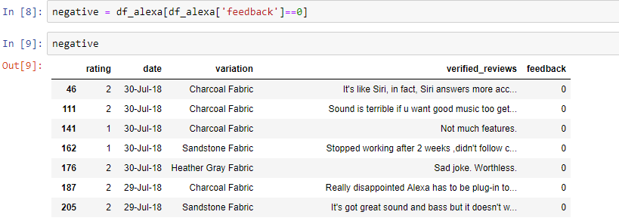

* The below image is the visual representation for the count of positive and negative feedbacks. The visualization clearly shows the Amazon Alexa has more positive feedbacks.

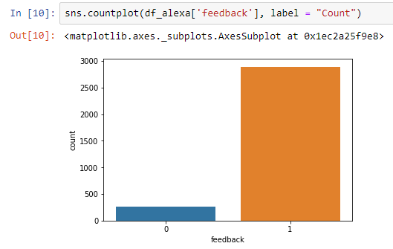

* The percentages for positive and negative feedback can be seen in the below image.

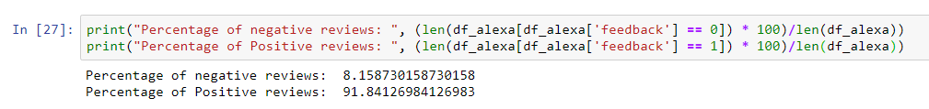

* The below visualization clearly shows that customer has given Alexa a 5 rating. As the count of rating 5 shows higher than the other ratings.

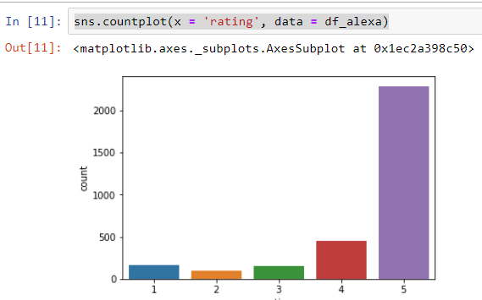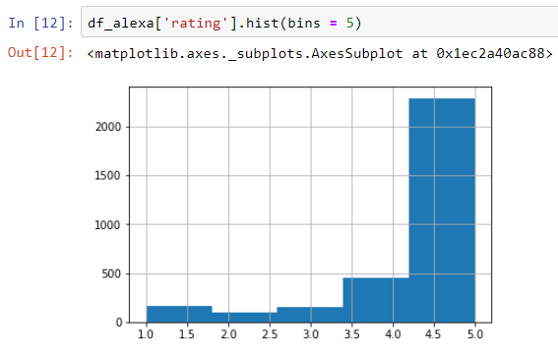

* The below visualization shows the average rating given to all the variants of Alexa. It clearly shows that Walnut Finish is the highest average variant than other variants.

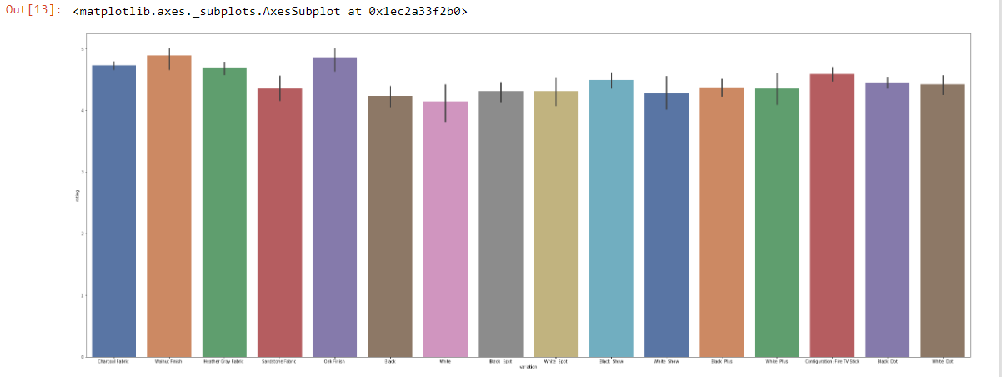

**Algorithms and Techniques**

To predict the sentiments analysis of the Amazon Alexa products, first will start the with loading and visualizing of different feature to understand our data. After that, we can remove the features which will not helpful in the algorithm to reduce the overhead.

To solve our problem in this project and to find out solution for our problem we will make use of the below Supervised algorithms.

**Decision Trees** are supervised algorithms where data is split according to a certain condition. DT consist of nodes and leaves where leaves are the decisions or the final outcome whereas the decision nodes is where the data is split based on a certain attribute.

**Random Forest Classifier** is a type of ensemble algorithms, it creates a set of DT tress from randomly selected subsets of training data and then it combines the votes from the different DT tree to decide final class of test object.

Decision Trees has a limitation that it tends to over fit the data, where the algorithm tries to memorize that data and then predict the target value. To overcome the problem of generalization we will use Random Forest Classifier, which creates of random sets of data to train the algorithm and then find the vote count for the sets and return the result as average.

Before implementing the data, we need to perform some feature extraction and feature encoding for some features. The features like rating and review_date are removed from the dataset as they are not useful.

For feature variant we perform feature encoding where we remove the dummy data which are duplicates and are concatenated to the dataframe with encoded values in the form of number.

The feature review which consist of lots of words need to feature encoded, which can be done using CountVectorizer. CountVectorizer creates a bag of unique words from the reviews and encodes a number to the words.

These bag of words are now concatenated with the features, for which each row will now contain the count of words occurring in the review.

After the step of feature engineering, we will train our model with the Random Forest Classifier. The feedback feature will be removed from the dataframe and will be used as label to predict the values.

After training of data, we test our model using the test data and evaluate our model using the confusion matrix.

Confusion matric consist of scores for Accuracy, Precision, Recall and F1-Score to evaluate the model.

**Benchmark**

As the Random Forest Classifier is one of the suitable algorithms we will first the train our model using Random Forest Classifier and find out the accuracy.

The accuracy will then be used as the benchmark to be crossed while improving the model in the later stages.

**III. Methodology**

**Data Preprocessing**

The dataset consists of 5 features which are rating, review_date, review, variant and the feedback. The review feature contains lot of vocabulary words used to describe customer sentiments towards different Alexa variants.

* Features such as rating and review_date cannot be used to predict the customer sentiments we remove them from the datasets.

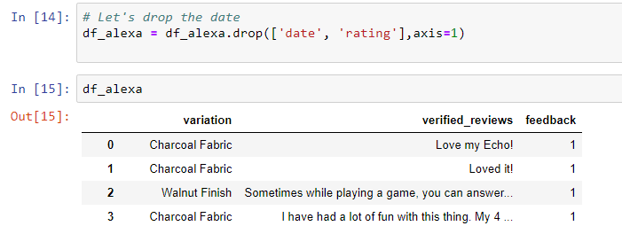

* Feature variant has lot of quality variables we need to quantify them. This can be achieved using Pandas get_dummies function which converts categorical variable into dummy/indicator variables (0 or 1) which makes them a lot easier to quantify and compare. We will use the axis = 1 parameter in the get_dummies function to concatenate the new variables as new features in our original dataframe.

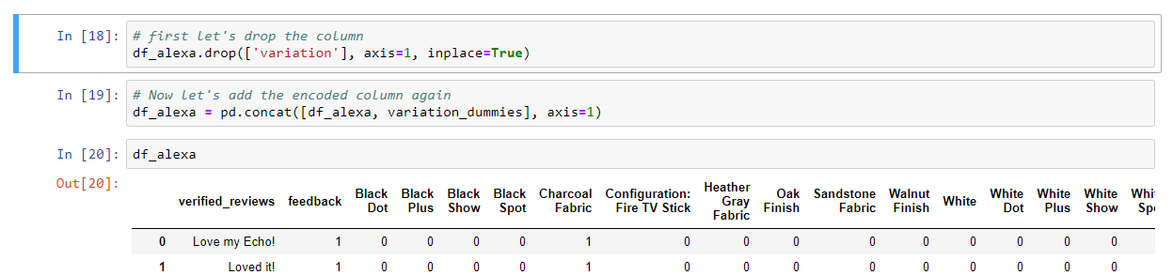

* Review Feature has lot of words which are quality variables but we need to encode them to make them quantifiable. For this we will use the Bag of Words model, which can be implemented using feature extraction function CountVectorizer. The CountVectorizer encodes each unique words in the review feature to a number which can then be easily quantifiable for analyzing the reviews. The steps performed to achieve these is given below.

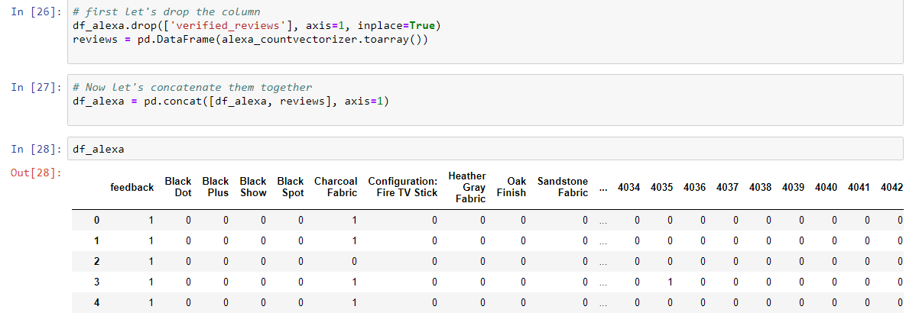

Now the data is completely processed to be trained.

**Implementation**

1. **Splitting Dataset**

* The previous step gave us a complete processed data which is quantifiable in nature which can be properly trained. To train our model with the dataset, we need to first split the data into training set and test set.
* The train_test_split function from the model_selection module from the sklearn library will be used to split the data. The function has parameters X(features ), y (feedback), test_size (this indicates the size of test data to split from the original data), random_state).
* The following image shows the steps of splitting the dataset.

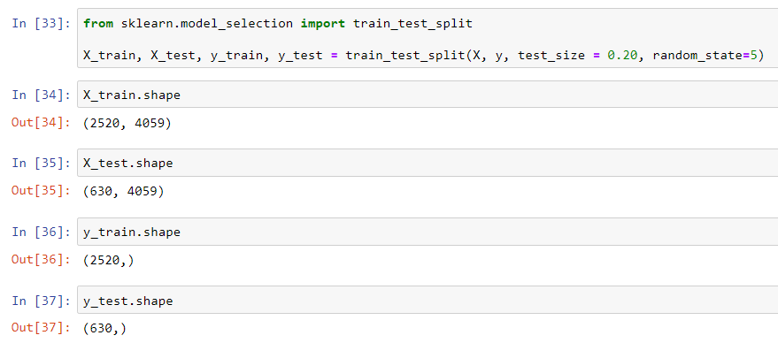

* The X_train consists of features that needs to be trained and y_train consist of feedback feature which will be used to predict the model. X_test consist of features that will be used as training set and y_test will be label to predict the values.

1. **Training the model**

We will use the training set to implement our model, for this we will be using the RandomForestClassifier Algorithm. The implementation steps are given below.

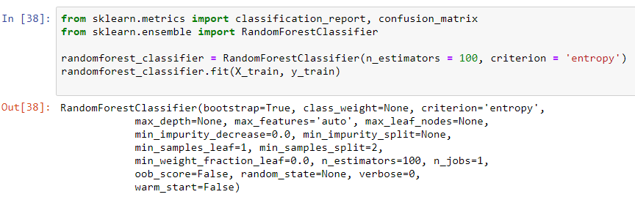

For RandomForestClassifier function we will pass the following parameters

n_estimators is defined as the number of trees and entropy criteria will be used to train our model

1. **Evaluating Model**

To evaluate the model, we will use the confusion matrix to find the accuracy of our model which trained with training dataset.

Confusion matrix is a table that is used to describe the performance of classifier model on a set of test data for which the truth values are known. Detailed explanation will be given in the Results section.

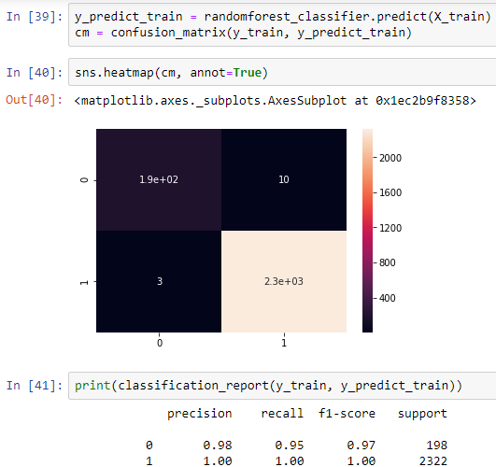

The randomforest_classifier.predict(X_train) function is used to predict the label for training set. Then the X_predict_train data is then passed to confustion_matrix function along with training label y_train. The image above clearly shows the model evaluates accuracy for the training model to 1.

Now the model is trained, it can be tested with our test dataset which can be seen in the below image:

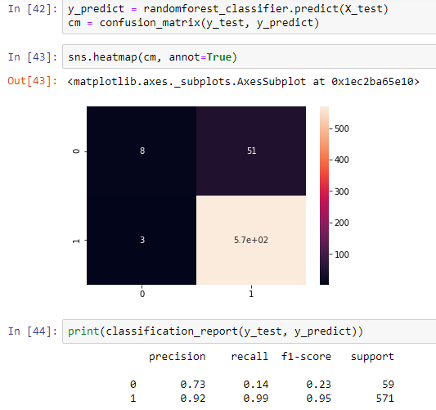

Now the randomforest_classifier.predict function is passed the test data and is predicted using feedback label. Classification report shows the accuracy for the test data set.

**Accuracy for the model = 0.92**

The above accuracy will now be considered as the benchmark. In the next step we will try to refine our model to achieve more accuracy than the benchmark.

**Refinement**

From the previous step, we trained our model to evaluate the accuracy, now in this will improve the model by following the below steps.

The length of the review feature from dataset can now be used as an additional feature to evaluate the sentiment analysis.

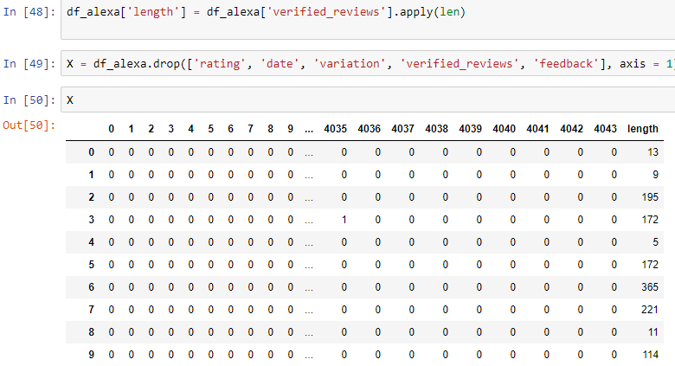

As shown above, an additional feature ‘length’ has been added to the dataset. Now we use the new dataset to train our model with the training set and then predict labels for it. Once the model is trained then we used this to predict labels for our test dataset. Once done we can evaluate the accuracy for the refined model using the confusion matrix. The steps performed are shown below.

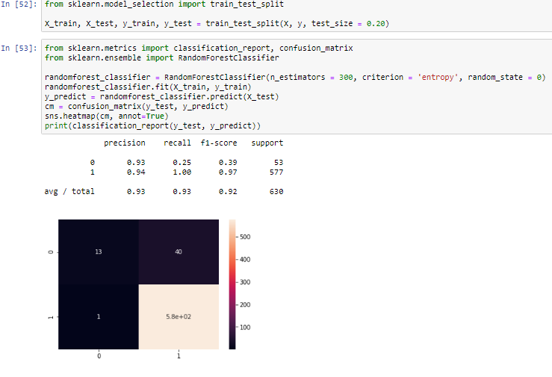

**Accuracy for the refined model = 0.93**

**IV. Results**

**Model Evaluation and Validation**

Model evaluation is done using the Confusion matrix.

“A confusion matrix is a table that is often used to **describe the performance of a classification model** (or "classifier") on a set of test data for which the true values are known.” [source from google.](https://www.dataschool.io/simple-guide-to-confusion-matrix-terminology/)

A confusion matrix for the model can be shown as below.

|  |  |  |
| --- | --- | --- |
| Feedback | **Predicted 0** | **Predicted 1** |
| **Actual 0** | True Negative | False Positive |
| **Actual 1** | False Negative | True Positive |

The matrix above shows the rows which are Actual 0 and Actual 1 i.e for data the feedback is either actually negative or positive respectively. And the column Predicted 0 and Predicted 1 are the predicted by the model.

Let’s now define our basic terms:

* True Negative: These are cases in which model predicted 0 (Negative feedback) and they are actual 0.
* True Positive: These are cases in which model predicted 1 (positive feedback) and they are actual 1.
* False Positive: These are cases in which model predicted 1 but they are actual 0
* False Negative: These are cased in which model predicted 0 but they are actual 1.

To find the accuracy of the model with respect to the above matrix, the following formula is used.

**Accuracy = (True Positive + True Negative) / Total**

Confusion matrix for our benchmark model and the refined model are given below

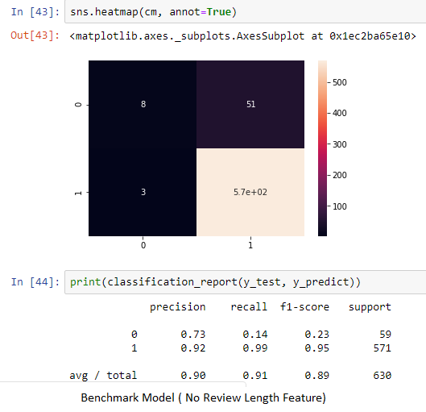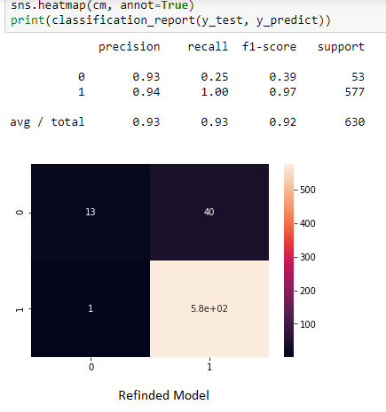

As shown in the above images the accuracy for the refined model ( right image) is greater than the benchmark model(left).

**Justification**

The benchmark model as show in the above left image has accuracy of 0.90 whereas our refined model has higher accuracy of 0.92. Hence we can say the refined model is correct model.

**V. Conclusion**

**Free-Form Visualization**

One aspect which I would like to note is the variation, the average rating for a variation depends on the count of variation.

Here is the count representation for the variations:

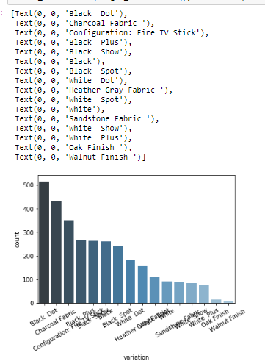

Now the Walnut Finish Variation has the least count but the average rating is higher for the Walnut Finish. So this may affect the accuracy of the overall model.

**Reflection**

The steps involved in this model can be stated as:

1. Load the model with dataset using pandas library.
2. Visualize the data and features to understand the data.
3. Preprocess data and perform feature encoding
4. Train the model with train data and predict labels for the training set
5. Test the model with the testing set and evaluate the accuracy using the confusion matrix.
6. Implement a refined model for the above model using addition feature and perform the same steps to get higher accuracy than the previous one.

To reflect back, the feature encoding steps was the hardest for me. But after some research I was able to perform it.

**Improvement**

In order to improve the model more, during the step of feature encoding we can remove the non-essential words from the bags of words for efficiency. The higher the no of words the time taken to implement will be higher.

**References**

[1[ Kaggle Amazon Alexa Reviews: <https://www.kaggle.com/sid321axn/amazon-alexa-reviews>

[2] Confusion Matrix: <https://www.dataschool.io/simple-guide-to-confusion-matrix-terminology/>