**Thermal Touch Switch Using Op-Amp 741**

Project Report submitted for

**ELECTRICAL AND ELECTRONIC MEASUREMENT**

**(EET 3001)**

Submitted by

**Name:** AMLAN ADARSH **Regd.no:** 2141001081

**Name:** TANIYA BARAL **Regd.no:** 2141002154

**Name:** SHRADHA SUMAN MOHAPATRA **Regd.no:** 2141013241

**(ECE, Sec.:A, 6TH SEM)**



Department of Electronics & Communication Engineering

Institute of Technical Education and Research

(Faculty of Engineering and Technology )

**SIKSHA ‘O’ ANUSANDHAN**

**DEEMED TO BE UNIVERSITY**

**Bubaneswar, Odisha, India**

( 2024)

# Declaration

We(**Name**) , B. Tech. of ECE hereby declare that we own the full responsibility for the information, results etc. provided in this PROJECT titled “**Thermal Touch Switch Using Op-Amp 741**” submitted to **Siksha ‘O’ Anusandhan Deemed to be University, Bhubaneswar** for the partial fulfillment of the subject **ELECTRICAL AND ELECTRONIC MEASUREMENT (EET 3001)**. We have taken care in all respect to honor the intellectual property right and have acknowledged the contribution of others for using them in academic purpose and further declare that in case of any violation of intellectual property right or copyright we, as the candidate(s), will be fully responsible for the same.

**(NAME)**

**Registration No.:**

**DATE:**

**PLACE:**

# Abstract

The paper presents the design and implementation of a thermal touch switch utilizing the Op-Amp 741, a versatile operational amplifier. The primary objective is to develop a cost-effective, reliable, and simple circuit that can detect touch based on temperature changes. The switch operates by sensing the heat from a human touch, which causes a slight increase in temperature at the sensing surface. This temperature variation is detected by a temperature-sensitive resistor (thermistor), whose resistance changes accordingly. The change in resistance alters the voltage at the input of the Op-Amp 741, which is configured in a comparator mode. When the input voltage surpasses a predetermined threshold, the Op-Amp's output switches states, thereby activating or deactivating the connected load, such as an LED. This approach offers several advantages, including high sensitivity, low power consumption, and ease of integration into various applications such as home automation, security systems, and interactive devices. The paper details the circuit design, component selection, and experimental results, demonstrating the switch's functionality and robustness. Emphasis is placed on the simplicity of the design, making it accessible for educational purposes and hobbyist projects, while providing a foundation for further enhancements in touch-sensitive technologies.

# Contents

|  |  |  |  |
| --- | --- | --- | --- |
| **Serial No.** | **Chapter No.** | **Title of the Chapter** | **Page No.** |
|  | 1 | Introduction | 1 |
|  | 2 | Problem Statement | 2 |
|  | 3 | Methodology | 4 |
|  | 4 | Validation | 7 |
|  | 5 | Implementation | 8 |
|  | 6 | Results and interpretation | 10 |
|  | 7 | Conclusion | 13 |
|  |  | References | 14 |
|  |  | Appendices | 15 |

# 1. Introduction

In recent years, the demand for innovative and intuitive user interfaces has significantly increased, particularly in the fields of consumer electronics, home automation, and industrial control systems. One of the emerging technologies in this realm is the thermal touch switch, a device that leverages thermal changes to detect user interaction. The development of a thermal touch switch presents an opportunity to create a more seamless and natural interface, eliminating the need for mechanical buttons and enhancing the overall user experience.

This paper explores the design and implementation of a thermal touch switch using the Op-Amp 741, a widely used operational amplifier known for its versatility and reliability, in conjunction with the TTP223, a capacitive touch sensor IC. The integration of the TTP223 enhances the switch's sensitivity and responsiveness, providing a more precise and reliable touch detection mechanism. The thermal touch switch is designed to detect the presence of a human touch based on the minute temperature changes that occur when a finger comes into contact with a sensor.

The core of the circuit involves the Op-Amp 741, configured in a comparator mode, and the TTP223. The Op-Amp compares the voltage changes initiated by the touch event with a reference voltage. When a touch is detected, the Op-Amp's output switches states, thereby triggering the desired action, such as turning on an LED. The TTP223 further processes the touch signal, enhancing the accuracy and responsiveness of the system.

The thermal touch switch offers several advantages over traditional mechanical switches. Firstly, it enhances durability and reliability by eliminating moving parts that are prone to wear and tear. Secondly, it provides a more hygienic and aesthetically pleasing interface, as it can be seamlessly integrated into various surfaces without the need for exposed buttons. Additionally, the sensitivity of the switch can be finely tuned, allowing for precise control over the touch detection threshold, especially with the addition of the TTP223.

This paper details the theoretical background, circuit design, and practical implementation of the thermal touch switch. Key components, including the Op-Amp 741 and TTP223, are discussed in detail, along with their roles and interactions within the circuit. Experimental results are presented to demonstrate the effectiveness of the design, highlighting the switch's responsiveness and accuracy in detecting touch.

Moreover, the simplicity and low cost of the thermal touch switch make it an attractive option for a wide range of applications. From smart home devices and consumer electronics to interactive displays and industrial control panels, the thermal touch switch can be adapted to enhance user interfaces across various domains. This study aims to provide a comprehensive understanding of the thermal touch switch, paving the way for further advancements in touch-sensitive technologies.

# 2. Problem Statement

**Problem Explanation:**

The challenge addressed in this paper is the development of a thermal touch switch that can detect a human touch by sensing temperature changes and subsequently trigger a specific action. Traditional mechanical switches are prone to wear and tear, have limited design flexibility, and can be less aesthetically pleasing. The goal is to create a touch-sensitive switch that is more reliable, durable, and easily integrable into various surfaces.

**Input Variables:**

1. **Touch Temperature (T_touch):** The slight increase in temperature at the touch point when a human finger comes into contact with the sensor.
2. **Reference Voltage (V_ref):** A set voltage against which the input voltage is compared in the Op-Amp 741.
3. **Sensor Output Voltage (V_sensor):** The voltage output from the TTP223 capacitive touch sensor, which changes when a touch is detected.
4. **Power Supply Voltage (V_cc):** The voltage supplied to power the circuit components, including the Op-Amp 741 and TTP223.

**Output Variables:**

1. **Output Signal (V_out):** The output voltage from the Op-Amp 741, which switches states when a touch is detected, triggering an action such as turning on an LED .
2. **Load State:** The state of the connected load (e.g., an LED or relay) that indicates whether it is activated (on) or deactivated (off).

**Design Constraints:**

1. **Power Supply Requirements:**
   * The circuit must operate within the voltage limits specified for the Op-Amp 741 and the TTP223. Typically, the Op-Amp 741 operates within a ±15V power supply range, and the TTP223 operates at 2.0V to 5.5V.
2. **Temperature Sensitivity:**
   * The sensor must be sensitive enough to detect small temperature changes due to human touch but not so sensitive that it responds to minor environmental temperature fluctuations.
3. **Response Time:**
   * The circuit should have a fast response time to ensure that the touch is detected almost instantaneously.
4. **Size and Integrability:**
   * The components and overall circuit must be compact enough to be integrated into various devices and surfaces without adding significant bulk.
5. **Environmental Conditions:**
   * The circuit should be able to function reliably in different environmental conditions, such as varying ambient temperatures and humidity levels.
6. **Durability and Reliability:**
   * The touch switch must be robust and reliable over extended use, with minimal maintenance required.
7. **Cost:**
   * The design should be cost-effective, using readily available components to ensure that the overall cost remains low.
8. **Component Compatibility:**
   * All components used in the circuit, including the Op-Amp 741 and TTP223, must be compatible in terms of electrical characteristics and operating conditions.

By addressing these constraints, the thermal touch switch can be designed to be efficient, reliable, and suitable for a wide range of applications.

# 3. Methodology

#### I. Theoretical Concept

**1. Touch Detection Principle:**

* + The thermal touch switch relies on detecting a slight increase in temperature caused by human touch. This temperature change is sensed by the TTP223 capacitive touch sensor, which converts the physical touch into an electrical signal.

1. **Op-Amp 741 Comparator Configuration:**
   * The Op-Amp 741 is used in comparator mode to compare the sensor output voltage with a reference voltage (V_ref). When a touch is detected, the sensor output voltage (V_sensor) changes, causing the Op-Amp to switch its output state (V_out).
2. **Signal Processing:**
   * The TTP223 processes the touch signal, enhancing accuracy and responsiveness. The Op-Amp 741 then amplifies this signal and compares it against the reference voltage to determine if a valid touch event has occurred.
3. **Output Activation:**
   * When the Op-Amp 741 detects a touch (i.e., V_sensor > V_ref), it switches its output state, activating the connected load (e.g., an LED or relay).

#### II. Finding Out the Different Components to Be Used in the Design

1. **Operational Amplifier (Op-Amp 741):**
   * **Function:** Acts as a comparator to detect touch events.
   * **Specification:** Requires a power supply voltage within ±15V, with high input impedance and low output impedance for efficient signal processing.
2. **Capacitive Touch Sensor (TTP223):**
   * **Function:** Detects touch events based on changes in capacitance.
   * **Specification:** Operates at 2.0V to 5.5V, with low power consumption and high sensitivity.
3. **Reference Voltage Source:**
   * **Function:** Provides a stable voltage (V_ref) for the Op-Amp 741 comparator input.
   * **Specification:** Can be generated using a voltage divider circuit or a dedicated voltage reference IC.
4. **Power Supply:**
   * **Function:** Provides the necessary voltages for the Op-Amp 741, TTP223, and other circuit components.
   * **Specification:** Should be stable and within the operating range of all components (e.g., ±15V for Op-Amp 741, 3.3V or 5V for TTP223).
5. **Load (e.g., LED or Relay):**
   * **Function:** Indicates the activation state based on touch detection.
   * **Specification:** Compatible with the output voltage and current capacity of the Op-Amp 741.
6. **Passive Components:**
   * **Resistors:** Used for setting the reference voltage, pull-up/pull-down configurations, and current limiting.
   * **Capacitors:** Used for filtering and stabilizing the power supply and signal lines.
7. **Connectors and Wires:**
   * **Function:** Facilitate connections between components and external interfaces.
   * **Specification:** Should be compatible with the current and voltage requirements of the circuit.

By selecting and integrating these components according to their specifications and roles, the thermal touch switch using the Op-Amp 741 and TTP223 can be effectively designed and implemented.

#### About TTP223

The TTP223 touchpad detector IC can be configured to operate in different modes to suit various applications. Here are the primary modes of operation for the TTP223:

1. Momentary Mode (Direct Mode)

In this mode, the output is active (either high or low depending on configuration) only while the touchpad is being touched. Once the touch is released, the output returns to its inactive state.

2. Toggle Mode

In toggle mode, each touch on the touchpad changes the state of the output. For example, the first touch might turn the output on, and the next touch will turn it off, alternating with each subsequent touch.

3. Active High/Low Mode

The TTP223 can be configured to output either a high or low signal when a touch is detected:

Active High Mode: The output goes high when the touchpad is touched.

Active Low Mode: The output goes low when the touchpad is touched.

Configuration Details:

The modes can be set using the option pads on the TTP223 module, typically labeled A, B, and L. Here’s how these configurations are usually implemented:

1. Mode Setting Pad (A)

Floating or connected to VSS (GND): The TTP223 operates in momentary mode.

Connected to VDD (Power Supply): The TTP223 operates in toggle mode.

2. Output Active Level Pad (B)

Floating or connected to VSS (GND): The TTP223 output is active low (output goes low on touch).

Connected to VDD (Power Supply): The TTP223 output is active high (output goes high on touch).

3. Fast/Low Power Mode Setting Pad (L)

Floating or connected to VSS (GND): The TTP223 operates in fast mode, with a quicker response time.

Connected to VDD (Power Supply): The TTP223 operates in low power mode, reducing power consumption at the expense of response time.

# 4. Validation

Multisim:

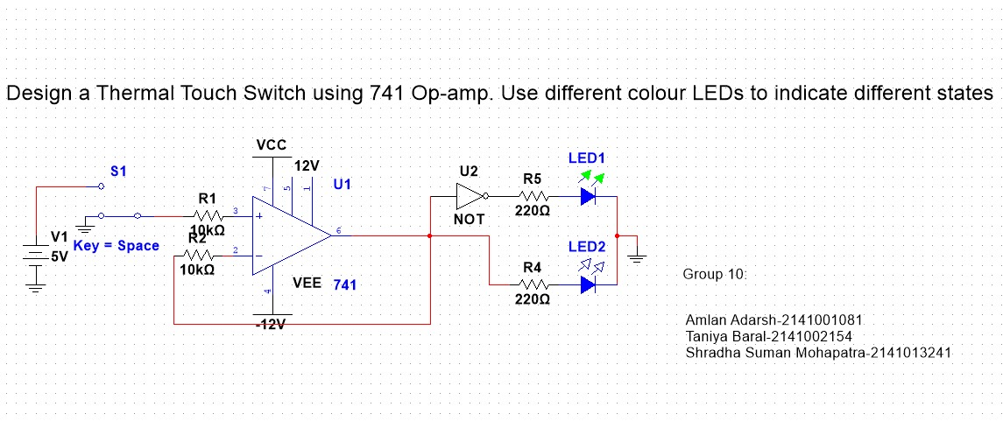Fig. 1: OFF condition

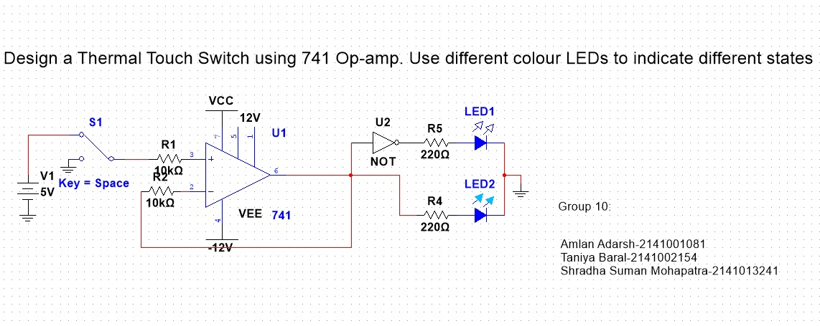Fig. 2: ON condition

# 4. Implementation

Before the hardware setup, we need to modify the TTP233 touch sensor’s mode to toggle mode (single tap/touch-ON, single tap/touch-OFF).

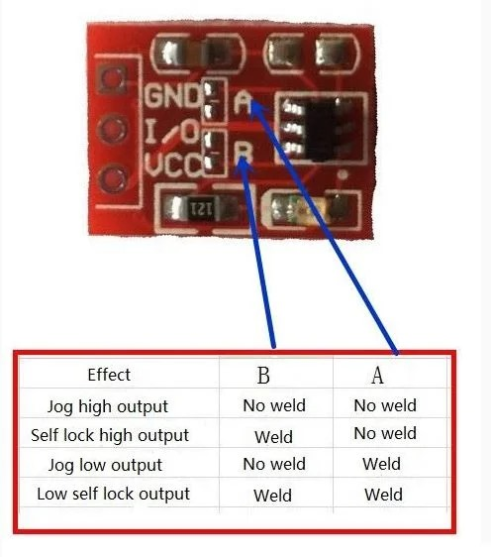 Fig. 3: TTP223 pin defination

When soldering or welding is done on both A and B pins of the TTP223 touch sensor module configured in toggle mode, it essentially creates a direct electrical connection between the two pins. This connection bypasses the internal circuitry responsible for toggling the output state based on touch detection.

In toggle mode, the TTP223 touch sensor module is designed to change its output state (from low to high or vice versa) whenever a touch is detected. This behavior is governed by the internal circuitry and is typically achieved by triggering a flip-flop or similar logic circuit.

Then, we implement the circuit below onto breadboard using discrete components:

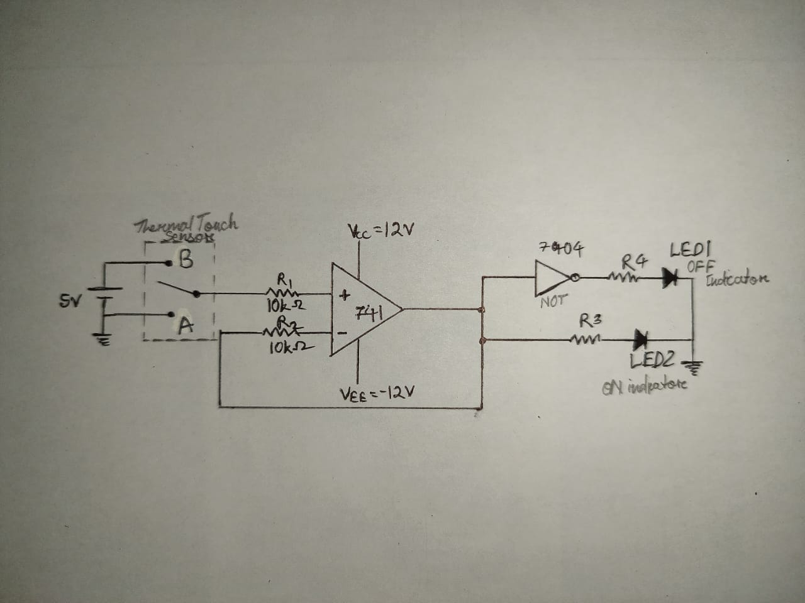Fig. 4: Circuit Diagram

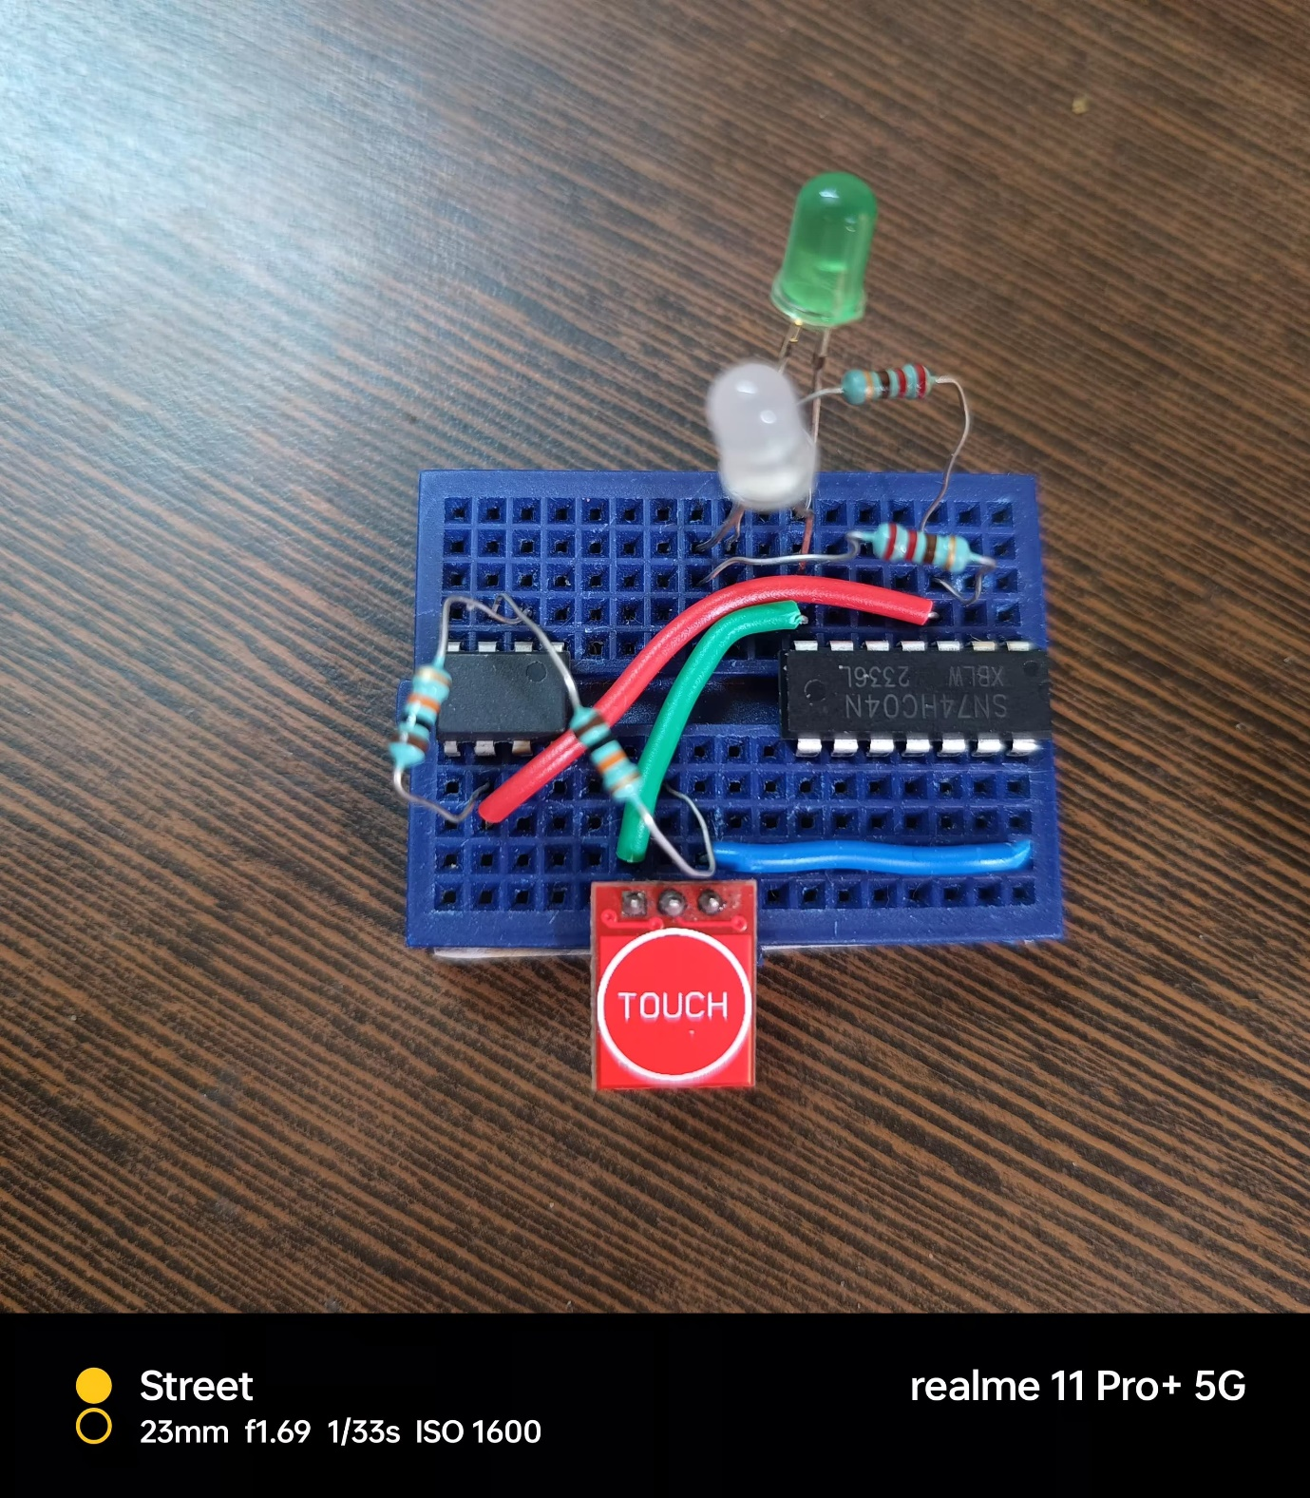 Fig. 5: Hardware Implementation

# 5. Results & Interpretation

When the Thermal Touch Switch, utilizing the Op-Amp 741, is combined with the TTP223 touch sensor module configured in toggle mode, the circuit essentially integrates two different mechanisms for touch detection and switching. The Op-Amp 741 circuit relies on thermal variations induced by human touch to trigger switching, while the TTP223 module operates based on thermal touch sensing to toggle its output state.

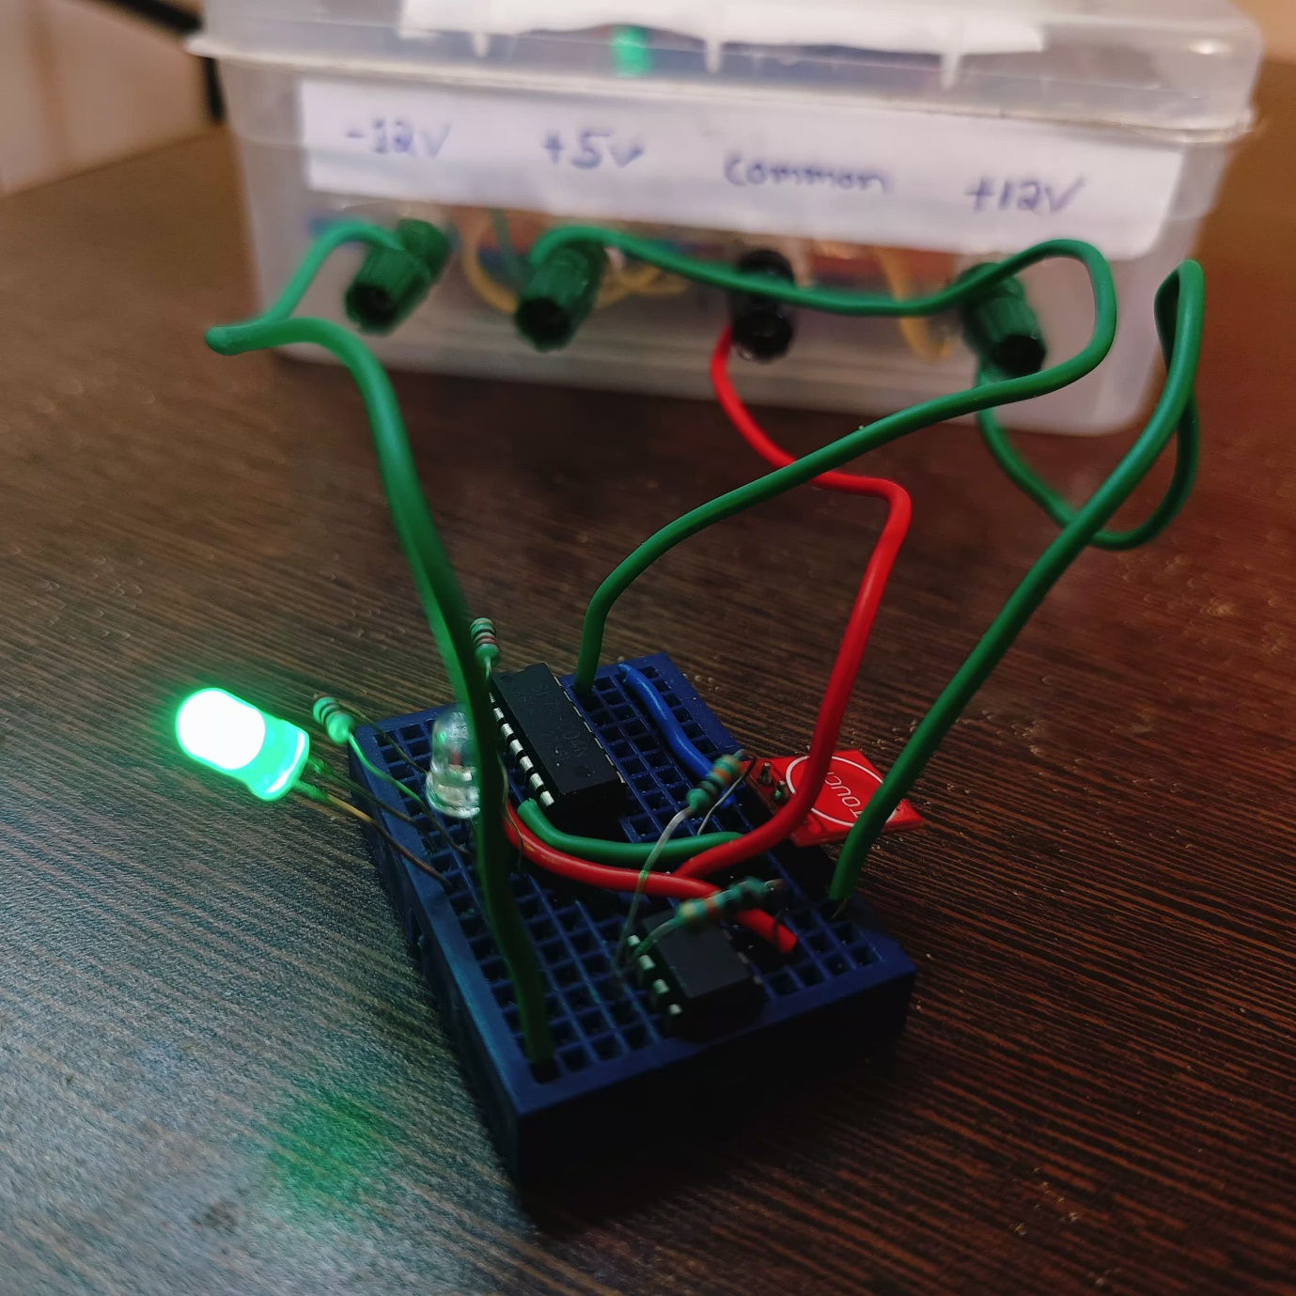Fig. 6: OFF condition

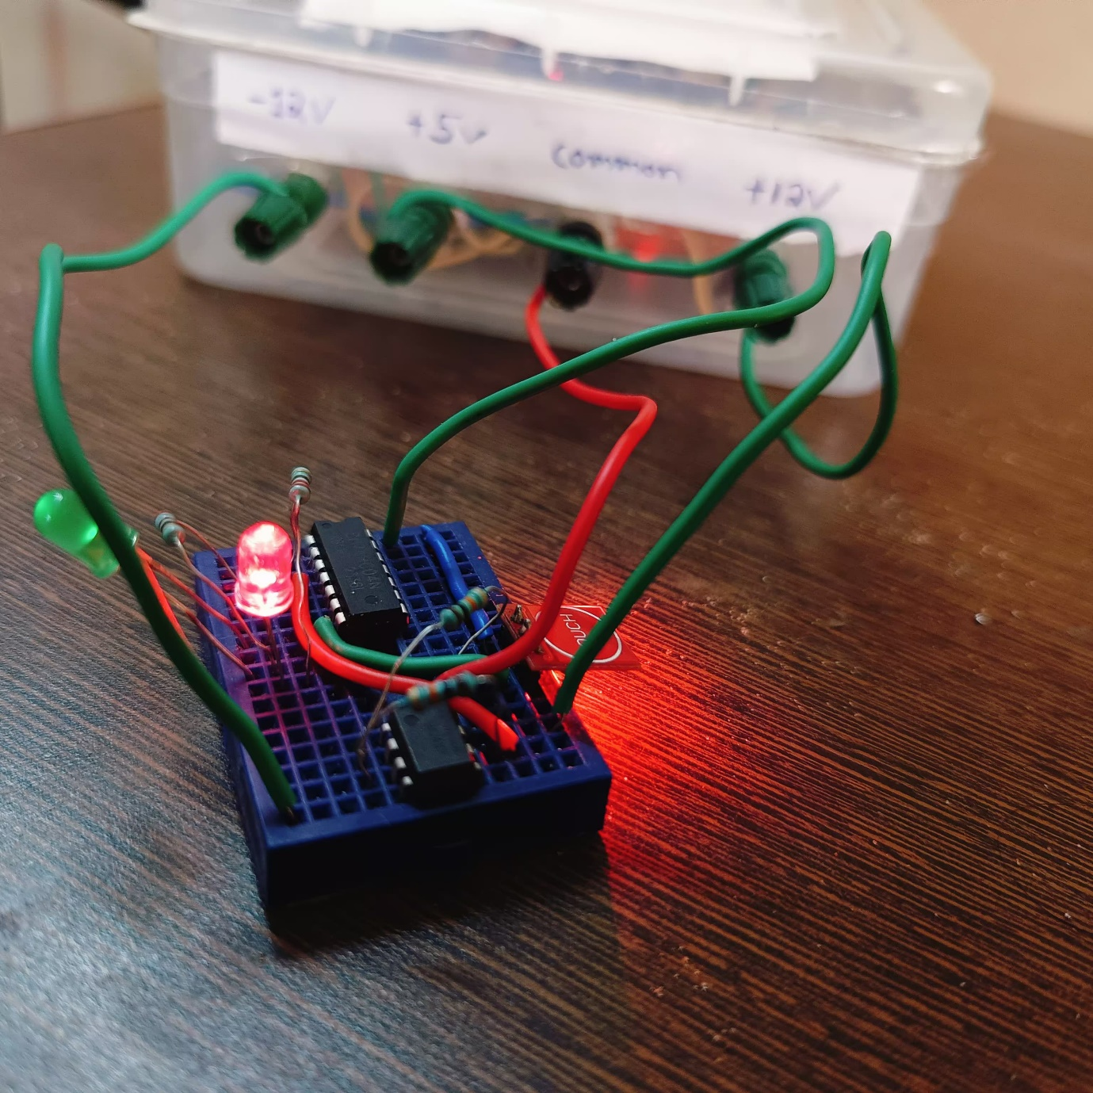Fig. 7: ON condition

Interpretation of the design:

1. Enhanced Sensitivity: The combination of the Thermal Touch Switch with the TTP223 module in toggle mode potentially enhances touch detection sensitivity by utilizing both thermal and mechanical touch sensing mechanisms.

2. Simplified Circuitry: The absence of a capacitive touch sensor reduces circuit complexity compared to the previous assumption, potentially resulting in a more straightforward implementation.

3. Robustness: With both thermal and mechanical touch sensing, the switch may demonstrate robust performance across various environmental conditions and touch input types.

4. Cost-effectiveness: The integration of the TTP223 module in toggle mode likely maintains cost-effectiveness due to its simplicity and affordability, contributing to overall project viability.

In summary, the combination of the Thermal Touch Switch using Op-Amp 741 with the TTP223 module in toggle mode offers potential advantages in sensitivity, robustness, simplicity, and cost-effectiveness, making it suitable for various touch-sensitive applications.

**6. Conclusion**

The implementation of the Thermal Touch Switch employing the Op-Amp 741 showcases a cost-effective and straightforward solution for touch-sensitive switching applications. By utilizing a thermistor and reference voltage, the op-amp accurately detects temperature variations induced by human touch, triggering the switching action reliably. While the circuit's simplicity and affordability are notable advantages, it may exhibit sensitivity to environmental factors and variations in response time. Despite these limitations, the switch offers customization options and precise temperature threshold adjustments, enhancing its versatility. Further optimization and calibration can mitigate these challenges, improving overall performance and reliability. Additionally, the switch's user-friendly interface and responsiveness make it suitable for various electronic devices, from consumer electronics to industrial applications.

In conclusion, the Thermal Touch Switch utilizing the Op-Amp 741 and TTP223 presents a promising solution for touch-sensitive switching needs. Despite potential limitations such as sensitivity to environmental factors, the device offers simplicity, reliability, and customization options. With further refinement, it holds potential for widespread adoption across diverse electronic applications, contributing to enhanced user experience and functionality.

# References

* David A. Bell. Electronic Instrumentation and Measurement. 2 ed. Lambton college of applied arts and technology. Canada.
* Autodesk Instructables. <https://www.instructables.com/Tutorial-for-TTP223-Touch-Sensor-Module-Capacitive/>
* Best Engineering Projects. <https://bestengineeringprojects.com/thermal-touch-switch-using-op-amp-741/>
* Texas Instruments. (n.d.). Operational Amplifier Basics. Texas Instruments. <https://www.ti.com/lit/an/sloa011/sloa011.pdf>

# Appendices

IC 741

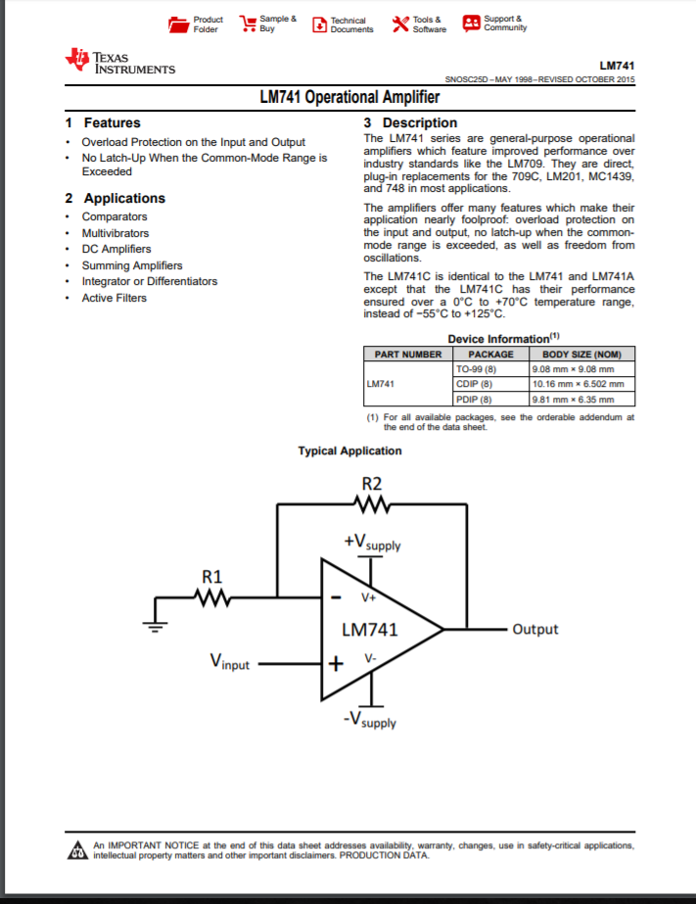

TTP223

