|  |  |  |
| --- | --- | --- |
| **Name: Mert**  **Surname: Sancar**  **Student Number: 20192905004**  **Section: 7** |  | **02.06.2020**  **(18:00 – 20:00)** |

**ACM 114 – Introduction to Computer Science and Programming**

**Final Exam (Answer Sheet)**

**Solution to Question 1:**

küçük_harf = 'abcdefghijklmnopqrstuvwxyz'

basamak = '0123456789'

#userid=aa49

user_id=""

all_user_id=[]

for i in küçük_harf:

user_id=user_id+i

for t in küçük_harf:

user_id=user_id+t

break

for x in basamak:

user_id=user_id+x

break

all_user_id.append(user_id)

user_id=""

print(all_user_id)

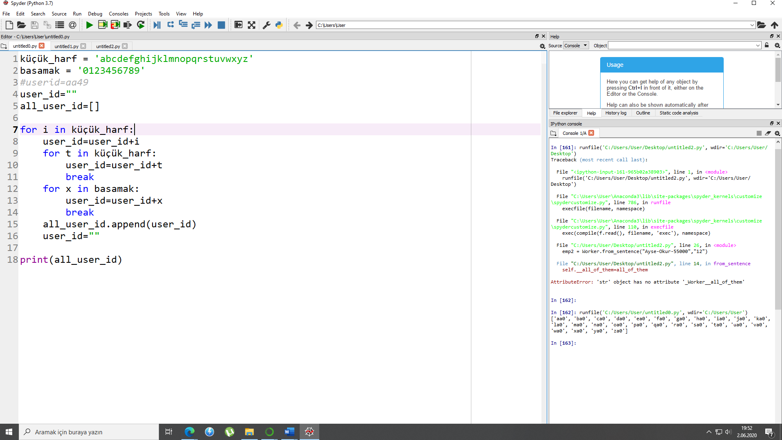

**Solution to Question 2:**

def enc_alphabet(txt):

d= {"A":".-","B":"-...","C":"-.-.","D":"-..","E":".","F":"..-.","G":"--.","H":"....","I":"..","J":".---","K":"-.-","L":".-..","M":"--","N":"-.","O":"---","P":".--.","Q":"--.-","R":".-.","S":"...","T":"-","U":"..-","V":"...-","W":".--","X":"-..-","Y":"-.--","Z":"--.."," ":"....."}

txt=list(txt)

new_text=[]

for i in d.keys():

for k in txt:

if k==i:

new_text.append(d.get(k))

print(new_text)

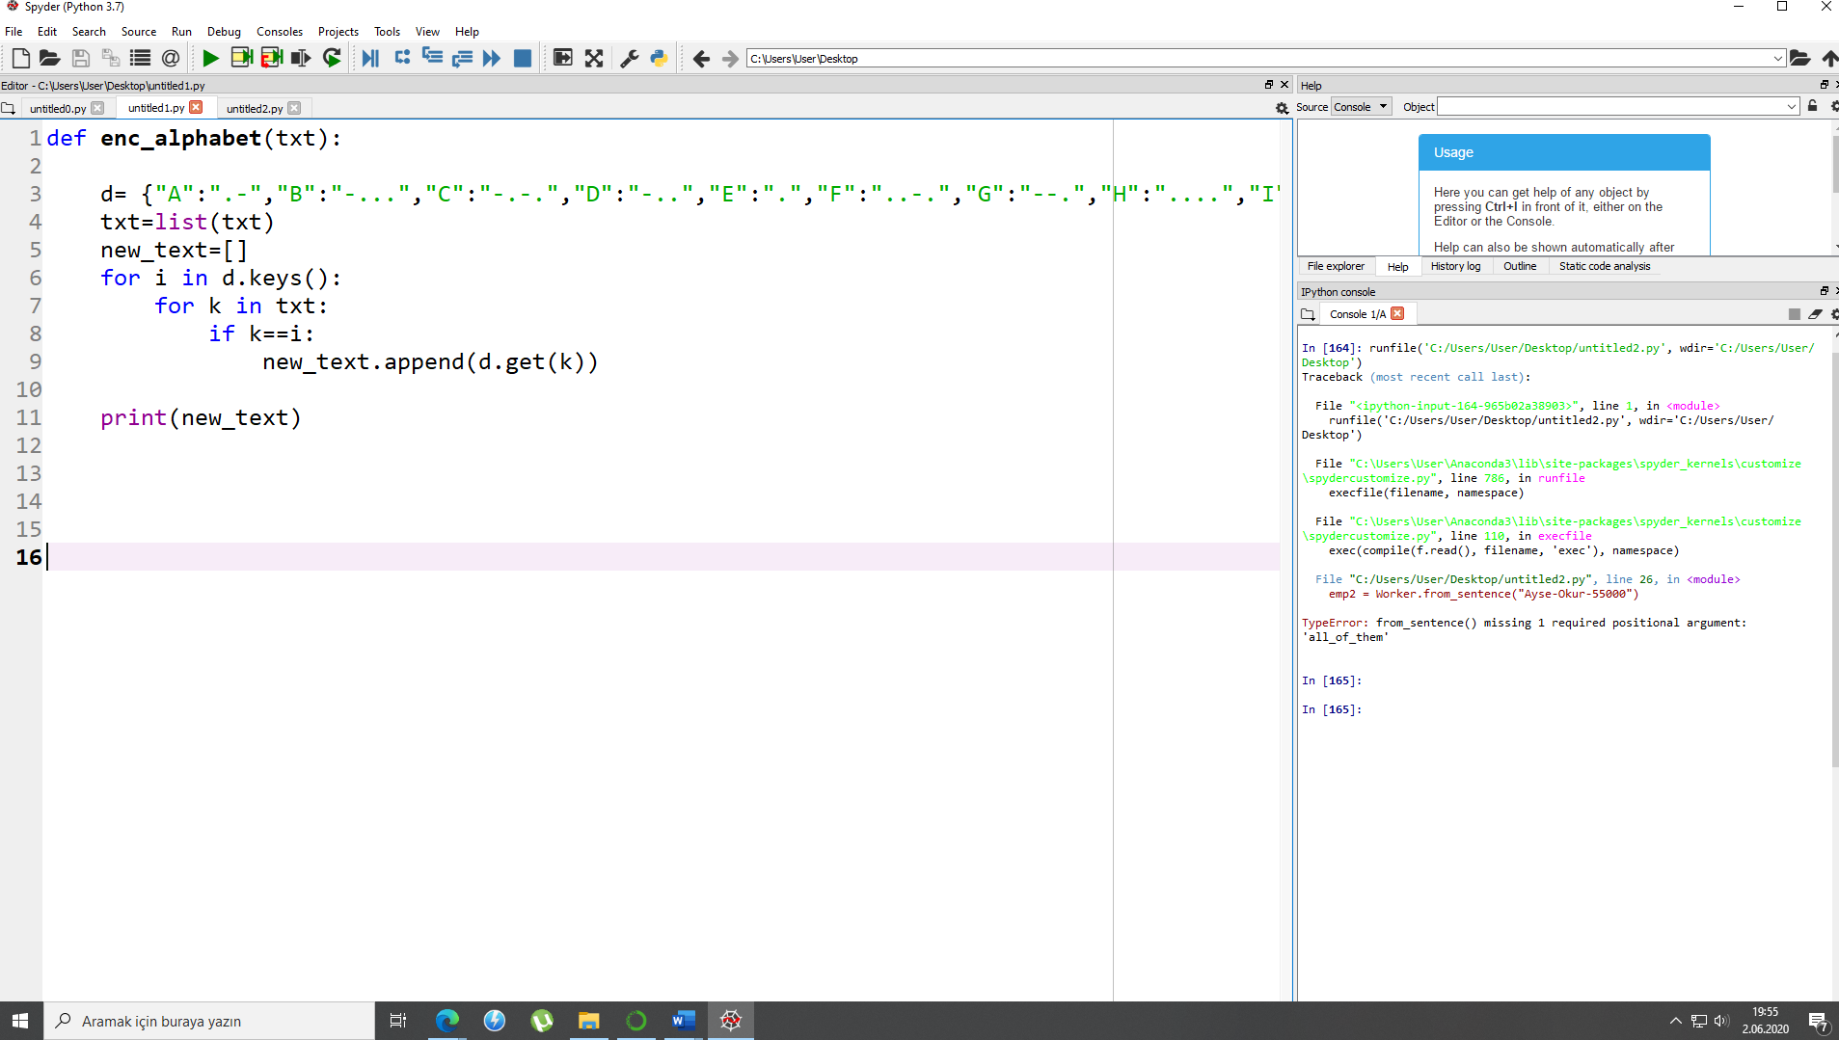

**Solution to Question 3:**

class Worker:

__f_name=None

__l_name=None

__salary=None

__all_of_them=None

def __init__(self,f_name,l_name,salary):

self.__f_name=f_name

self.__l_name=l_name

self.__salary=salary

def from_sentence(self,all_of_them):

self.__all_of_them=all_of_them

all_list=all_of_them.split("-")

self.__f_name=all_list[0]

self.__l_name=all_list[1]

self.__salary=all_list[2]

emp1 = Worker("Ahmet", "Yazar", "60000")

emp2 = Worker.from_sentence("Ayse-Okur-55000")

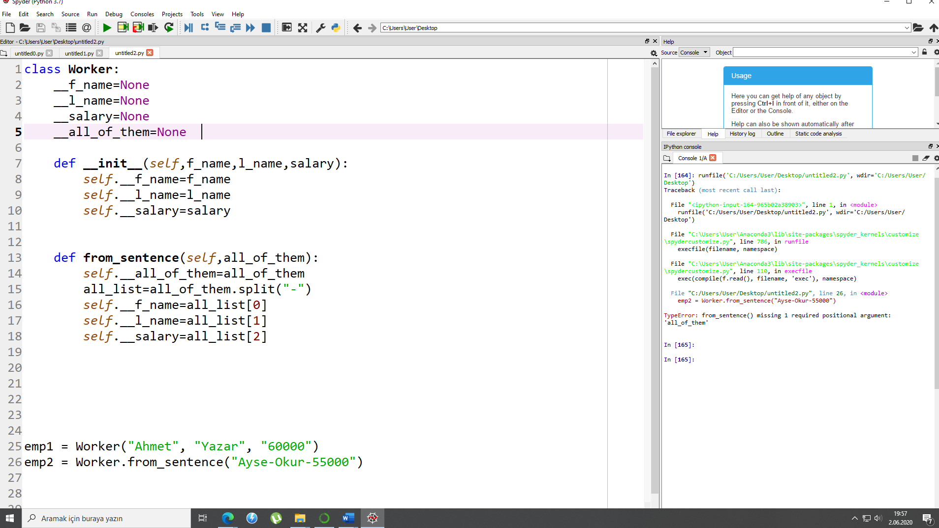

**Solution to Question 4:**

perfects=[]

for i in range(1,10000):

sum=0

bolen=1

while bolen < i:

if not i % bolen:

sum=sum+bolen

bolen = bolen + 1

if sum==i:

perfects.append(i)

print(perfects)

