**The World of Anthis**

**Notes**

This document is an outline describing the spiritual successor to Runebearer RPG. What follows is the barest amount of information necessary to start an Anthis campaign. Where no rules exist here, assume that Runebearer’s rules apply – basic skill resolution is a good example of this, since the opposed d12 mechanic is unchanged.

**Character Creation**

Typically, your character in Anthis is a new adventuring hero. They may have had some training from a master, or from a previous profession, but they are just beginning their heroic saga.

To create your Anthean Hero, follow these steps:

* Generate your starting Primary Stats
* Choose your Race
  + Apply stat modifiers
  + Record racial Boons & Banes
* Choose your Background
  + Record background skills & perks
* Choose your Focus
  + Record focus skills & perks
* Calculate your Figured Stats
* Choose your Tag Skills
* Record your Starting Equipment

**Primary Stats**

Characters in Anthis have seven primary stats:

* Muscle (M) – Physical strength and the ability to leverage it
* Skill (S) – Agility, dexterity and hand-eye coordination
* Reflex (R) – Reaction time, raw speed, OODA and perception
* Toughness (T) – Ability to withstand hardship and damage
* Wit (W) – Intelligence and perception
* Power (P) – Force of will, luck, and magical aptitude
* Charisma (C) – Personality, looks, luck, and connection to the divine

Generate your starting stats by rolling **2d4+6** seven times. This will generate scores between 8 and 14. You can assign the scores to any of your primary stats.

**Bonus**

Each stat has a bonus associated with it. This value is used to calculate figured stats, as well as add to skill checks. The bonus for a stat is calculated as follows:

***Bonus = (stat – 10) / 2 (keep the fraction)***

So, a stat of 12 has gives bonus of +1 to relevant skill checks, and a stat of 8 gives a “bonus” of –1.

You do keep and record any fractions. So having a stat of 11 produces a bonus of ½. Since skills and figured stats are generated using two primary stats, two fractional bonuses can add up.

**Effect Dice**

Each stat also has an effect die based on your character’s score for that stat. When the result of an action isn’t simply pass or fail, you may be asked to roll one or more effect dice based on the stats involved in the task. The most common example of this is combat – when you hit your opponent, one of your damage dice is your muscle effect die.

|  |  |
| --- | --- |
| **Stat Value** | **Effect Die** |
| 0-3 | 1d3-1 |
| 4-5 | 1d3 |
| 6-8 | 1d4 |
| 9-12 | 1d6 |
| 13-15 | 1d8 |
| 16-18 | 1d10 |
| 19-20 | 1d12 |
| 21-22 | 1d12+1 |
| 23-24 | 1d12+2 |

**Figured Stats**

There are four figured stats in Anthis:

* ***Hit Points =*** Toughness + ½ Muscle + ½ Power (fractions round up)
* ***Initiative =*** Reflex Bonus + Wit Bonus
* ***Base Move =*** 6 hexes/combat round (race, background might change this)
* ***Base Defense =*** 6 (backgrounds, talents might change this)

**The Races of Anthis**

Anthis is home to over a dozen (?) races and cultures.

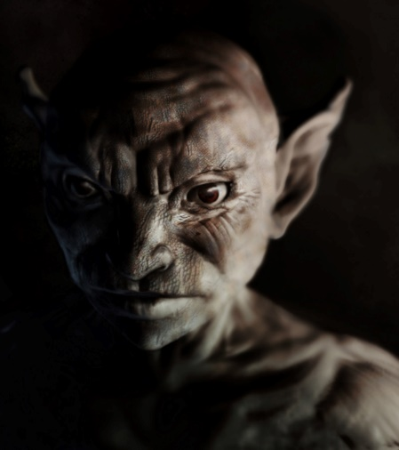**Ashen** – The Ashen are the descendants of the slaves of Shadow. Centuries of exposure to horrible magic have shortened their stature, twisted their limbs, and bleached their skin. Once proud dwarves, elves, and men, the depredations of Shadow have mutated them beyond recognition.

Today, the Ashen are an independent race, living in small, isolated villages. Though they share blood, the other races shun their misshapen brethren for fear they are tainted by the darkness.

|  |  |  |
| --- | --- | --- |
| **Ashen Racial Modifiers** | | |
| Stats:   * +1 Skill * +1 Reflex * +1 Wit * -1 Muscle * -1 Toughness * -1 Charisma | Traits:   * Fallen * Patron God (Castor and Corax) * Shade Touched * Shadow Sight * Short Legs * Tricky | Boons (choose one):   * Amateur Trickster * Child of Darkness * Divine Favor (Castor and Corax) * Resist Shadow |

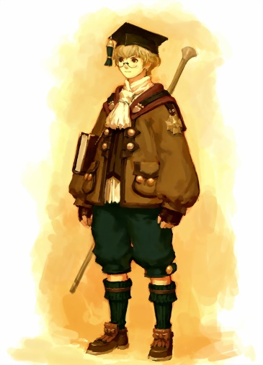**Caldruine** – Caldrune is a human city situated high in the Savos Peaks. When The Darkness was lifted, a small group of sorcerers devoted their lives to gathering knowledge that survived the ruin and they founded Caldrune as a place to store and protect their discoveries.

Today, Caldrune is a small, but vital city of scholars and libraries. Its remote location, and unique mission, isolate it from the rest of Anthis. Aside from the travelers charged with collecting lore, many Caldruine have never left the safety of their city’s walls. Indeed, many Caldruine see the world as a barbaric and dangerous place and those that travel are regarded with a mix of awe and suspicion.

|  |  |  |
| --- | --- | --- |
| **Caldruine Racial Modifiers** | | |
| Stats:   * +1 Wit * +1 Charisma * -1 Muscle * -1 Toughness | Traits:   * Book Smart * Lore Gatherers * Patron God (Libra) | Boons (choose one):   * Amateur Alchemist * Creation Lore * Divine Favor (Libra) * Quick Learner * Sanctioned Traveler |

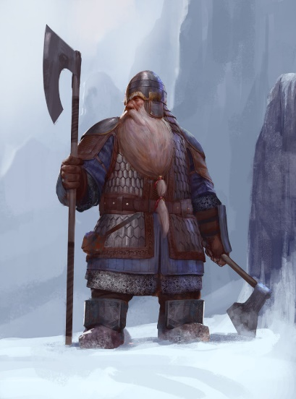**Dwarves** – Before darkness fell, the dwarves were the masters of a sprawling civilization beneath the surface of Anthis. Unfortunately, when Shadow came, the huge, black tunnels provided the perfect spawning grounds and the once proud dwarf holds were overrun by millions of horrors.

The dwarves fought a desperate war against the Shadow, but ultimately lost six of the original nine holds. The three that survived did so by collapsing or sealing huge sections of the tunnels, consigning thousands of their brethren to death, or enslavement.

Modern dwarves call themselves Monhemnir (“Those That Remain”) and live in the remaining three holds. They are skilled tradesmen and metal workers. Many are great warriors who long for the day when they can open the ruined holds, defeat the monsters within, and reclaim their ancestral tunnels.

|  |  |  |
| --- | --- | --- |
| **Dwarven Racial Modifiers** | | |
| Stats:   * +1 Muscle * +1 Toughness * +1 Wit * -1 Reflex * -1 Power * -1 Charisma | Traits:   * Patron God (Mordain) * Shadow Sight * Short Legs * Tunnel Sense * Underworld Guardians | Boons (choose one):   * Creation Lore * Heirloom Item * Legendary Greed * Resist Shadow * Tough(4) |

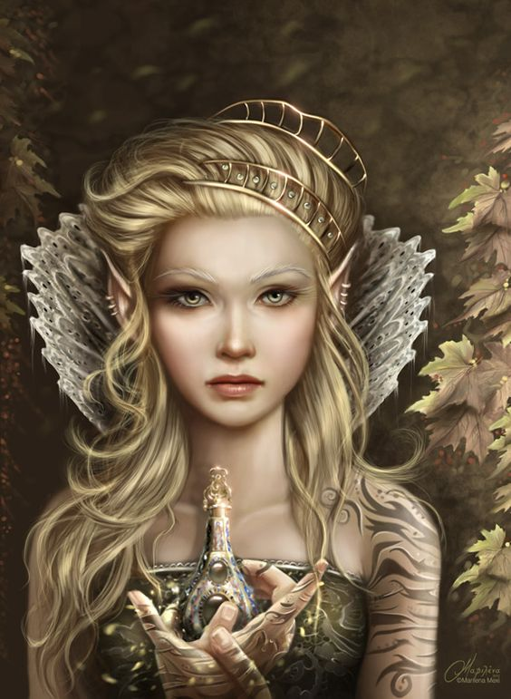**Elves** – A long time ago, elves were the beloved firstborn children of the gods. They were granted mastery of magic and technology, and given the gift of eternal life. These gifts allowed them to rule over the other races and forge a powerful empire.

Unfortunately, even though the elves were benevolent rulers, the lesser races grew restless and started to rebel against their masters. To save the empire from splintering, the elves sought ways of better controlling their subjects. To this end, they created a spell that would shape darkness into chains that would bind the will of the mortal races forever.

That spell backfired, destroying civilization and plunging Anthis into Shadow for hundreds of years.

Today, the elves are a fallen race, mistrusted by the races they once ruled, and shunned by the gods who once favored them. (more here?)

|  |  |  |
| --- | --- | --- |
| **Elven Racial Modifiers** | | |
| Stats:   * +1 Skill * +1 Reflex * +1 Wit * +1 Power * +1 Charisma | Traits:   * Fallen * Forbidden Knowledge * Immortal * Shunned * Steadfast | Boons (choose one):   * Amateur Chanter * Animal Companion * Creation Lore * Heirloom Item * Swift(1) |

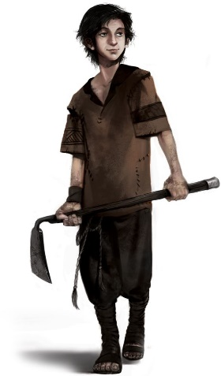**Heiraxan** – The Grand King Heirax once ruled over all of the lands of the Eleon Valley. When the king was killed by assassins, his three children fought over the kingdom, sparking a bitter civil war. To this day, the land remains split into the realms of Heirot, Lycopolis, and Sadia, between which there remains an uneasy peace.

By their nature, Heiraxans are simple farmers and herders that do not share the ambitions of their leaders. They resent the foreign sell swords that live among them, and the seemingly endless battles and schemes that have cost them so much.

|  |  |  |
| --- | --- | --- |
| **Heiraxan Racial Modifiers** | | |
| Stats:   * +1 Muscle * +1 Charisma * -1 Reflex * -1 Power | Traits:   * One With The Land * Patron God (Aquae or Hegre) | Boons (choose one):   * Divine Favor (Aquae or Hegre) * Swift(1) * War Weary |

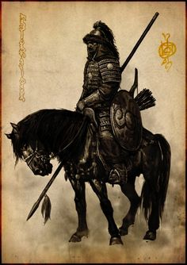

**Sarkan** – The Sarkan are men who originated from the arid lands to the southeast, across the Sheerost (mountains). They were tribal nomads who followed the rains to carve out a life in an inhospitable land. Tribal infighting caused several Sarkan tribes to cross the Sheerost and settle Anthis.

Sarkan live by raiding their neighbors, taking livestock, crops and slaves. Over the years, they have gained a reputation as master horsemen, vicious warriors, and relentless hunters of men. They are feared by men of peace, but often sought after as mercenaries by men of war.

|  |  |  |
| --- | --- | --- |
| **Sarkan Racial Modifiers** | | |
| Stats:   * +1 Toughness * +1 Wit * -1 Reflex * -1 Power | Traits:   * Desert Sense * Man Hunter * Trapper | Boons (choose one):   * Born in the Saddle * Fight With Wild Abandon * Slaver * Tough(3) |

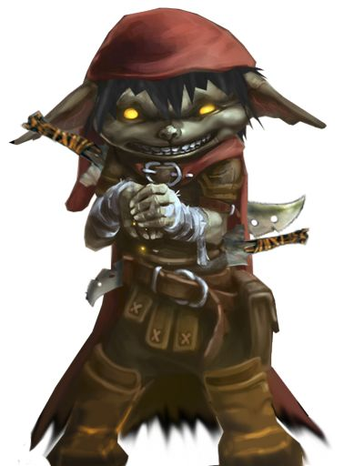**Theydan** – Theydan lore indicates that their race once ruled an extensive underwater kingdom, but that some sunken horror caused them to abandon their home. Ulder took pity on them and allowed them to ascend to the surface and settle on the island of Theyd.

Theydan are small, impish creatures with webbed hands and feet that hint at their aquatic origins. They have a unique physiology that allow them to hold their breath for extended periods, and their hands are clawed, allowing them to climb quickly. These traits, along with their love of the sea, make them expert sailors.

|  |  |  |
| --- | --- | --- |
| **Theydan Racial Modifiers** | | |
| Stats:   * +1 Skill * +1 Reflex * -1 Wit * -1 Power | Traits:   * Breath Control * Claws * Patron God (Ulder or Tathe) * Natural Swimmers | Boons (choose one):   * Boatman * Divine Favor (Ulder or Tathe) * Mutineer * Treasure Map * Weather Eye |

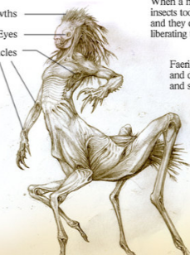**Tirkid** – Tirkid are large (2.5m tall), alien creatures that resemble a cross between a mantis and a centaur.

The origins of the Tirkid are unknown, even to them. Soon after the defeat of Shadow, their mysterious sailing ship crashed on the rocky Anthean coast. The tirkid survivors stumbled out of the wreck, unable to remember anything about their journey or their previous home.

|  |  |  |
| --- | --- | --- |
| **Tirkid Racial Modifiers** | | |
| Stats:   * +1 Muscle * +1 Wit * -1 Skill * -1 Charisma | Traits:   * Alien * Large Frame * Multiple Legs * Natural Sprinters | Boons (choose one):   * Tough(3) |

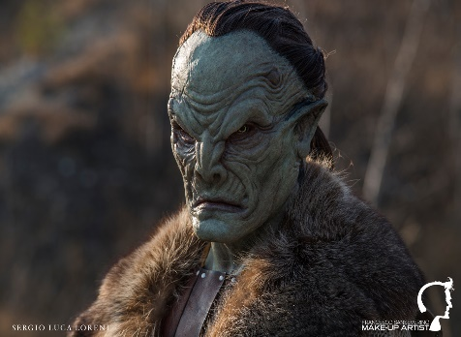 **Vask** – The Vask were the shock troops of the old empire, enforcing the will of their elven masters, and keeping the peace. When the empire fell, the Vaskan legions threw themselves against waves of shadow beasts. Though the fighting nearly drove them to extinction, the Vask never succumbed to Shadow.

Today, the Vask are known as powerful mercenaries. Their society is organized around the military orders they maintained before the cataclysm. Most Vask belong to these mercenary legions and spend their lives traveling from contract to contract, only returning home once or twice a year.

|  |  |  |
| --- | --- | --- |
| **Vask Racial Modifiers** | | |
| Stats:   * +1 Muscle * +1 Toughness * -1 Wit * -1 Charisma | Traits:   * Patron God (Brul) * Resolute | Boons (choose one):   * Divine Favor (Brul) * Swift(1) * Tough(4) |

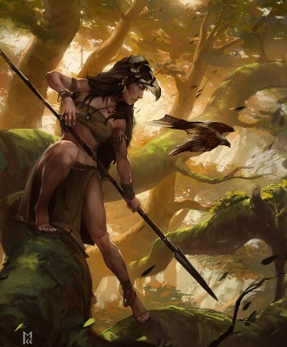**Vnaar** – The Vnaar are a tribal society that live in the dense, tropical forests that dominate southwest Anthis. Because of the many dangerous predators in their homeland, they have learned to live closely with nature and blend in with their surroundings.

|  |  |  |
| --- | --- | --- |
| **Vnaar Racial Modifiers** | | |
| Stats:   * +1 Skill * +1 Toughness * -1 Wit * -1 Power | Traits:   * Blend with Nature * Natural Climbers * Patron God (Hegre) * Swift(1) | Boons (choose one):   * Animal Companion * Divine Favor (Hegre) * Tough(3) |

**Backgrounds**

Once you have chosen a race, you must choose a background for your character. Each background represents the circumstances where your character spent his formative years. It could be where he grew up, where he received his most important training, or his most recent profession before becoming a hero.

Each background gives your character 4 skills (with a +1 background bonus) and 2 perks.