# OPENCBS 15.12 Installation Guide

## Intro

OPENCBS depends on the following software to function properly: Microsoft .NET 4.0, Microsoft SQL Server 2014 Express, SAP Crystal Reports.

If you have all the required dependencies installed you can safely jump to the First Launch section. Otherwise, follow the steps outlined in each section to make sure everything is in place.

## Installing Microsoft .NET 4.0

*Note: if you are running Microsoft Windows 8.0 or higher you can safely skip this section.*

Microsoft .NET is a library of reusable components that are used to build modern software. OPENCBS requires version 4.0. Here is how you can check if you have the proper version installed.

* Navigate to this URL: <http://smallestdotnet.com/>
* Click the **.NET Checker** button
* The browser will prompt you to save a small utility program
* Click **Save**
* When the download is finished, run the utility
* The utility will open a browser and display a web page with a message similar to this *"The .Net Checker application determined that you have 4.0 on your machine."*

If it states that the version of .NET installed on your machine is 4.0 or higher (4.5, 4.5.1, or 4.6) then you can safely skip the rest of this section.

Otherwise, follow the steps below to download and install the latest version of Microsoft .NET.

* Navigate to this URL: <https://www.microsoft.com/en-us/download/details.aspx?id=48130>
* Click the **Download** button
* The browser will prompt you to save the web installer
* Click **Save**
* When the download is finished, launch the installer
* Make sure **the I have read and accept the license terms** checkbox is checked
* Click **Install**
* Let the installer download the necessary files from the internet and install them on your computer
* When the installation is complete, you will be prompted to reboot the computer; please proceed

## Installing Microsoft SQL Server 2014 Express

MS SQL Server is one of the best enterprise-level database engines and OPENCBS uses it store all its data.

Follow the steps below to install a standalone version of Microsoft SQL Server 2014 Express database server on your machine.

Navigate to this URL: <https://www.microsoft.com/en-us/download/details.aspx?id=42299>

If you are running a 32-bit system, please check **ExpressAndTools 32BIT\SQLEXPRWT_x86_ENU.exe**

If you are running a 64-bit system, please check **ExpressAndTools 64BIT\SQLEXPRWT_x64_ENU.exe**

Click **Next**.

You will be prompted to save the file. Click **Save** and wait untill the download is complete. When it's done, please launch the file.

The installation wizard will greet you with this initial screen:

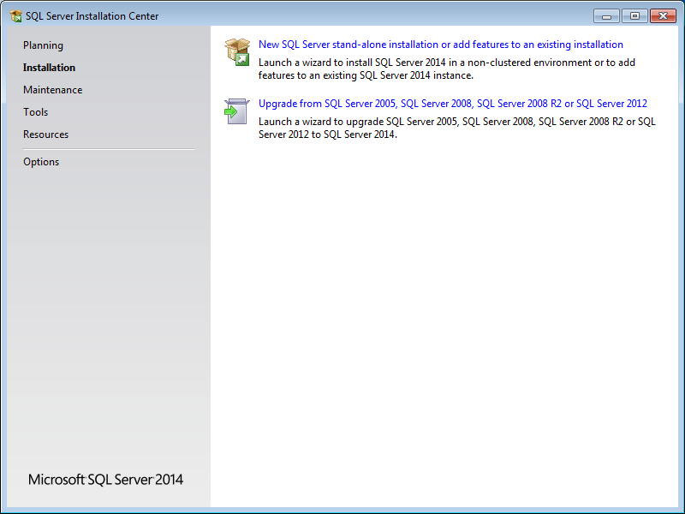

Click the **New SQL Server stand-alone installation or add features to an existing installation** link.

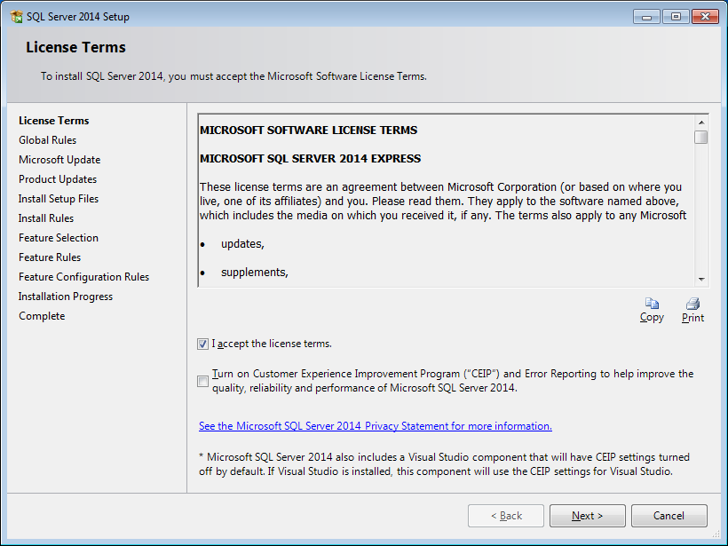

Check **I accept the license terms** and click **Next**.

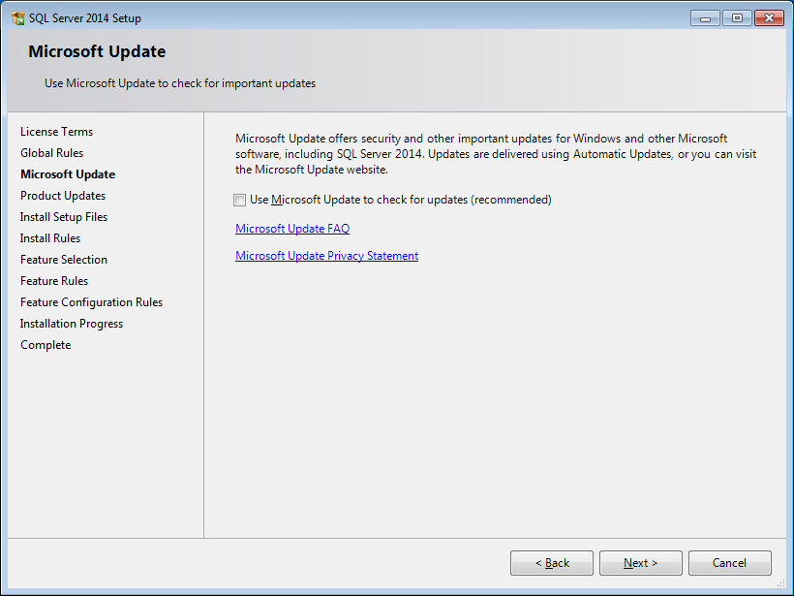

Skip this screen by clicking **Next**.

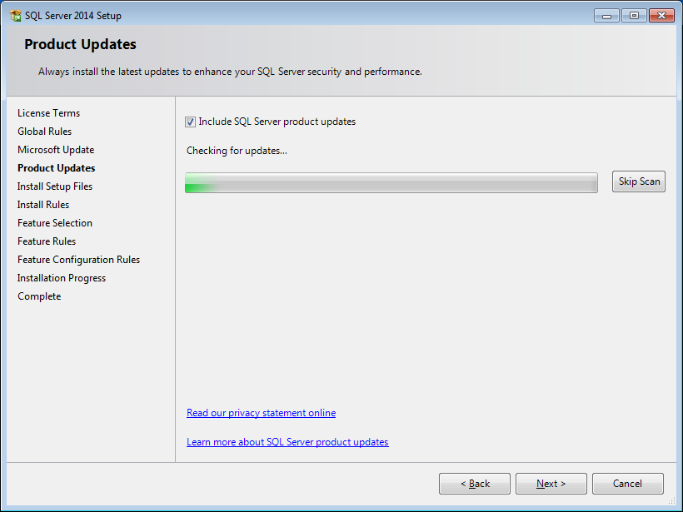

Click **Next**.

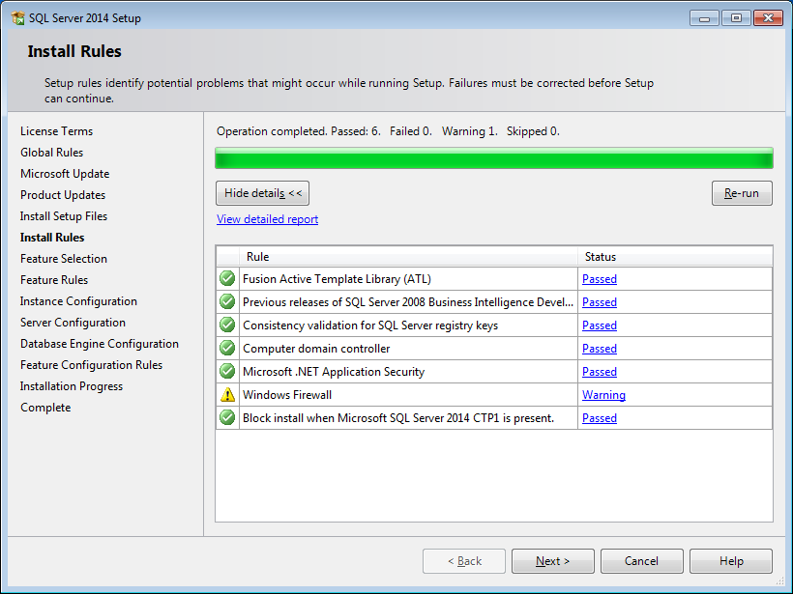

Click **Next**.

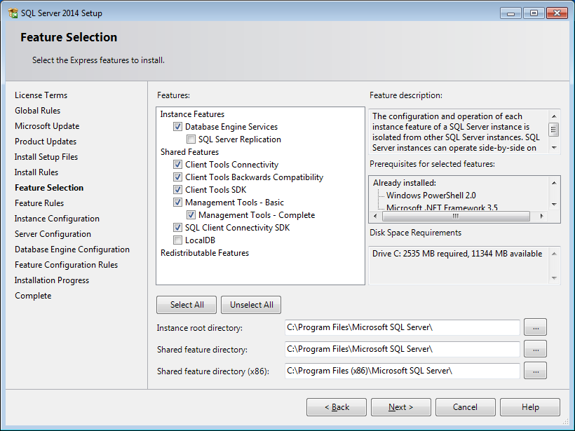

Select the features by checking/unchecking the checkboxes as shown on the screenshot. Leave other settings intact and click **Next**.

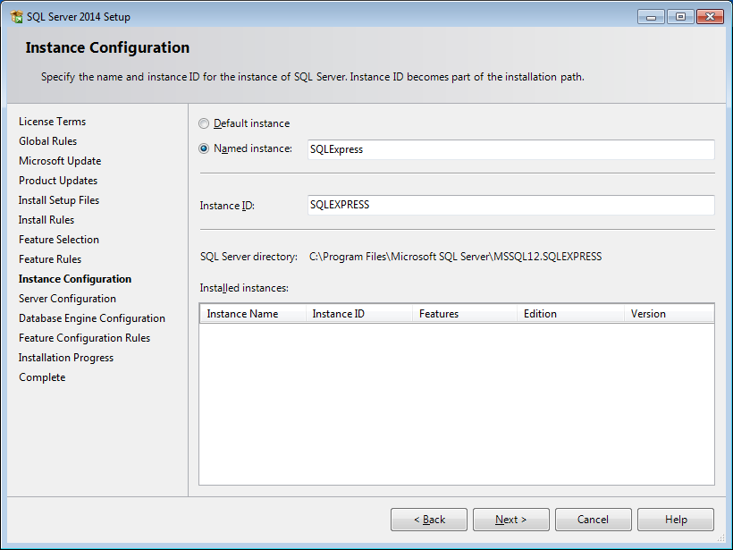

Type in the instance name. Please remember what you have entered because this name will later be used in the First Launch section.

Click **Next**.

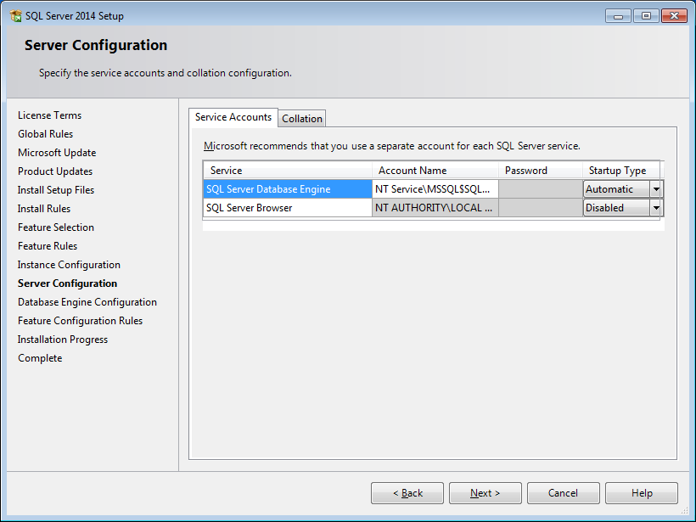

Leave the default settings and click **Next**.

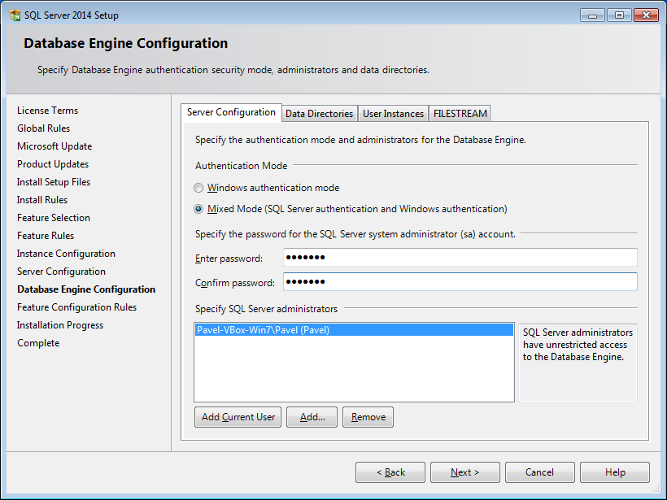

This screen is important.

Please choose **Mixed Mode**. Then type in the password for the system administrator. Re-type the password in the second text field. Please remember this password as it will be used in the First Launch section.

Click the **Add Current User** button.

Click **Next**.

Now let the wizard install the necessary files on your machine.

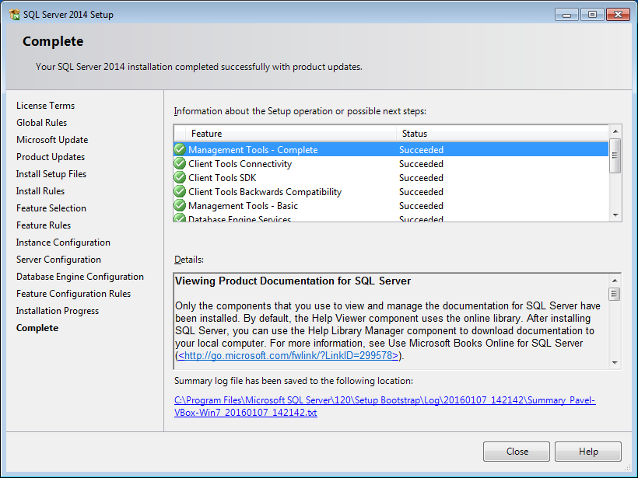

The installation of Microsoft SQL Server 2014 Express is done. Click **Close**.

## Installing SAP Crystal Reports

Crystal Reports is a report generation engine and OPENCBS uses it to print out reports and internal forms.

If you are running a 32-bit system, please navigate to this URL: <http://downloads.businessobjects.com/akdlm/cr4vs2010/CRforVS_redist_install_32bit_13_0_15.zip>

If you are running a 64-bit system, please navigate to this URL: <http://downloads.businessobjects.com/akdlm/cr4vs2010/CRforVS_redist_install_64bit_13_0_15.zip>

Unpack the file, go to the folder inside and launch the installation file.

The installation process is pretty straightforward – just let it install all the files on your machine.

## First Launch

When all the dependencies are in place you are ready to launch OPENCBS for the first time.

During the first launch OPENCBS will bring up this screen:

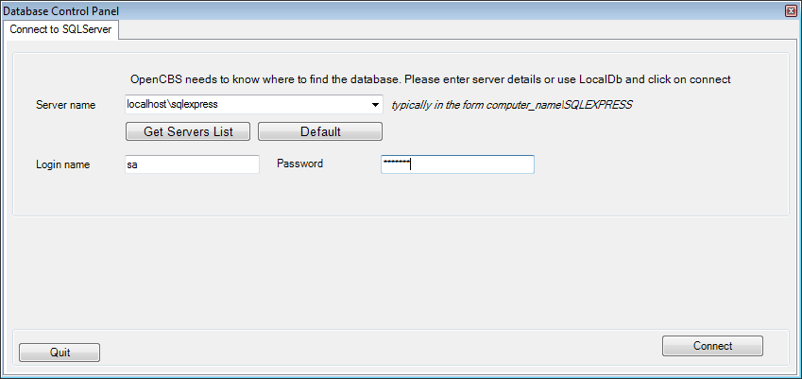

Here you have to configure the database connection.

The database server name is usually formed like PC_NAME\INSTANCE_NAME. In the example, it is localhost\sqlexpress. Remember the instance name from the MS SQL Server installation section a couple of pages above? If you changed it from sqlexpress to something else, please replace it after the backslash.

Type in the super administrator password. This is the same password that you entered while configuring database settings in the MS SQL Server installation wizard.

Click **Connect**. If you see an error, then something went wrong. Usually either the server name or the password is incorrect. Please fix them and try again.

Otherwise you will be taken to the next screen:

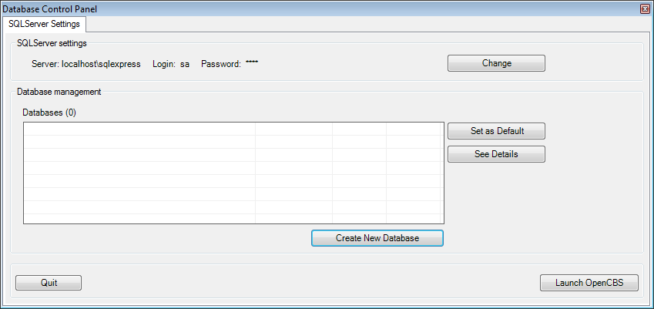

Click **Create New Database** and type in the database name. Click OK. Now it looks like this:

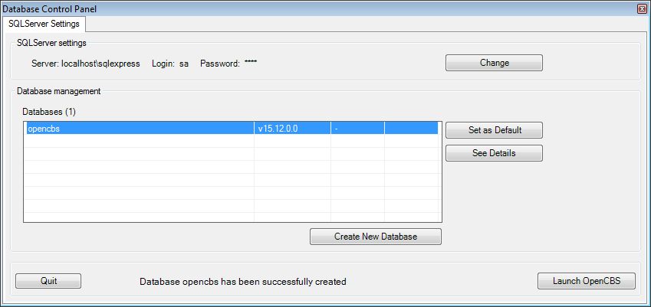

Click **Launch OPENCBS**.

Congratulations! You have successfully launched OPENCBS for the first time.