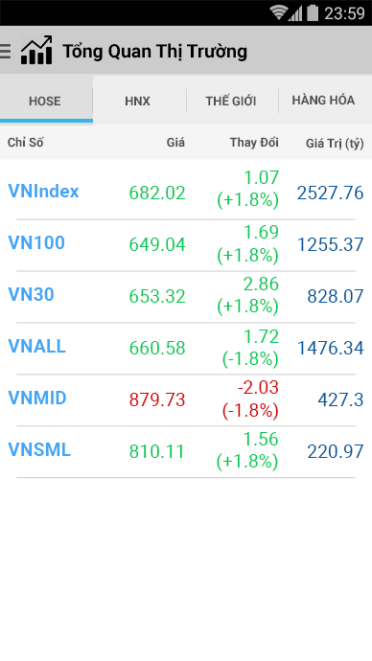

12

14

16

8

12

12

56

36

52

52

96

8

8

8

8

All in [Roboto](https://fonts.google.com/specimen/Roboto) font.

|  |  |
| --- | --- |
|  | Icon Stock: 32dp  File name: ic_stock_32dp.png |
| Text Size: 20sp  Text Style: Bold  Text Color: #000000  Background Color: #CCCCCC |
|  | All in Capslock  Text Size: 14sp  Text Color: #505050 |
| Background Color: #EEEEEE  Background Pressed Color: #DFDFDF |
| Line Selected: 4dp  Line Selected Color: #33B5E5 |
| Line Devider: 1dp  Line Devider Color: #D6D6D6 |
|  | Text Size: 14sp  Text Color: #505050  Align: center_vertical | left  Background Color: #F5F5F5 |
|  | Text Size: 14sp  Text Color: #505050  Align: center_vertical | right  Background Color: #F5F5F5 |
|  | Text Size: 18sp  Text Style: Bold  Text Color: #42A5F5  Align: center_vertical | left |
|  | Text Size: 18sp  Text Color:   * Up: #00C853 * Down: #CC0000 * Unchange: #FFD600   Align: center_vertical | right |
|  | Text Size: 18sp  Text Color: #01579B  Align: center_vertical | right |
|  | Divider Height: 1dp  Divider Line Color: #CCCCCC |