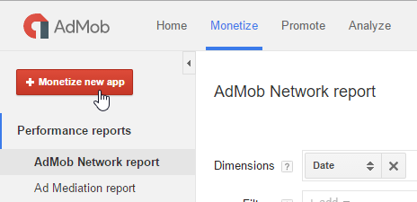
1) First of all you need to add new app in AdMob console.

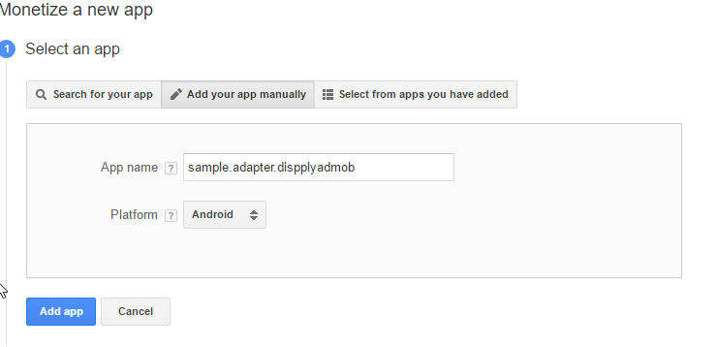
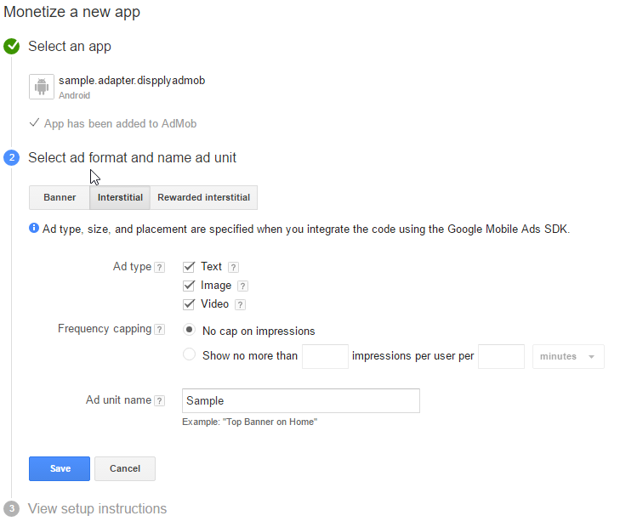
You will get UnitId string like 'ca-app-pub-*************/*************'.

For the next few hours you may get the AdMob errors with codes 0 or 2. Just be patient.

2) Then you need to add new mediation source.

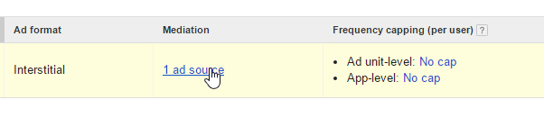
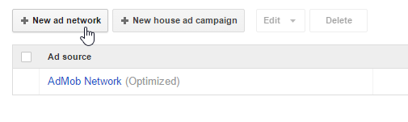

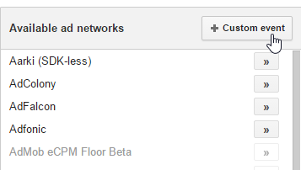

Fill 'Class Name ' field with a 'com.dispply.admobadapter.DispplyInterstitialEvent' string. And a Parameter with your Dispply statement string.

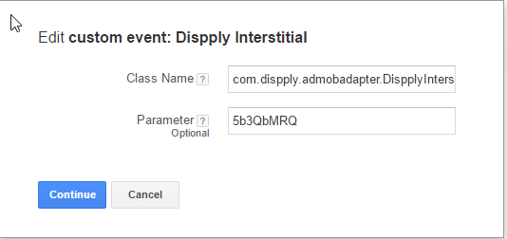
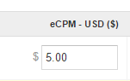

Setup eCPM for new network

3) Now you can setting up your android project.
Put Dispply-SDK and AdMob-adapter in 'libs' folder.

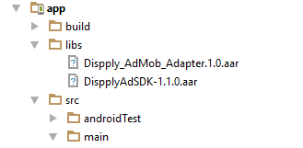

4) Add those lines in your build.gradle file:

allprojects {
repositories {
jcenter()
flatDir {
dirs 'libs'
}
}
}
dependencies {

compile(name: 'DispplyAdSDK-1.1.0', ext: 'aar')
compile(name: 'Dispply_AdMob_Adapter.1.0', ext: 'aar')
compile 'com.google.android.gms:play-services-ads:8.4.0'
compile 'com.google.android.gms:play-services-base:8.4.0'
}
5) Just create AdMob interstitial Ad as usually:

public class MainActivity extends AppCompatActivity {
private com.google.android.gms.ads.InterstitialAd mAdapterInterstitial;
@Override
protected void onCreate(Bundle savedInstanceState) {
super.onCreate(savedInstanceState);
setContentView(R.layout.activity_main);
loadInterstitialAd();
}
private void loadInterstitialAd() {
mAdapterInterstitial = new com.google.android.gms.ads.InterstitialAd(this);
mAdapterInterstitial.setAdUnitId(
"ca-app-pub-6172762133617463/1894001031"
);
mAdapterInterstitial.setAdListener(new com.google.android.gms.ads.AdListener() {
@Override
public void onAdFailedToLoad(int errorCode) {
Toast.makeText(MainActivity.this,
"Error loading adapter interstitial, code " + errorCode,
Toast.LENGTH_SHORT).show();
}
@Override
public void onAdLoaded() {
Toast.makeText(MainActivity.this,
"onAdLoaded()",
Toast.LENGTH_SHORT).show();
}
@Override
public void onAdOpened() {
}
@Override
public void onAdClosed() {
mAdapterInterstitial.loadAd(new AdRequest.Builder().build());
}
});
mAdapterInterstitial.loadAd(new AdRequest.Builder().build());
}
public void showInterstitial(View view) {
if (mAdapterInterstitial.isLoaded())
mAdapterInterstitial.show();
else
Toast.makeText(this, "The Interstitial AD not ready yet. Try again!", Toast.LENGTH_LONG).show();
}

