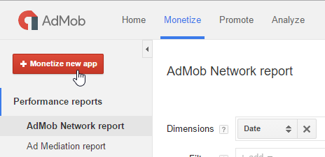
1) First of all you need to add new app in AdMob console.

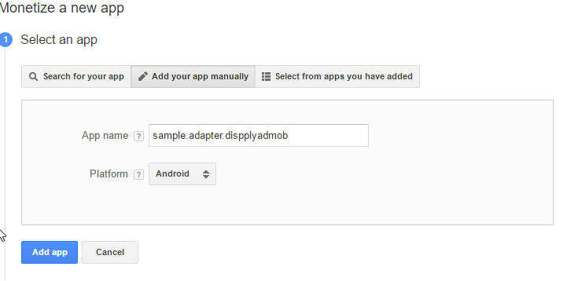
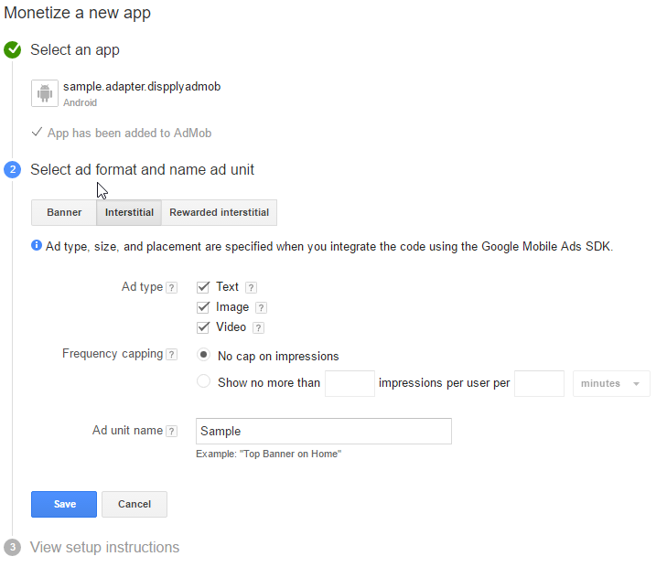
You will get UnitId string like 'ca-app-pub-*************/*************'.

For the next few hours you may get the AdMob errors with codes 0 or 2. Just be patient.

2) Then you need to add new mediation source.

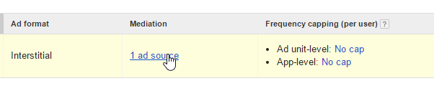
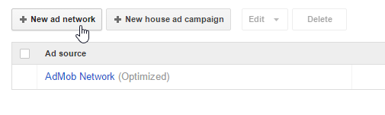

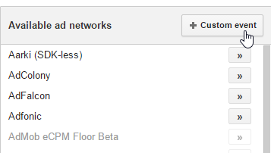

Fill 'Class Name ' field with a 'com.hyperadx.admob.HADInterstitialEvent' string. And a Parameter with your Dispply statement string.

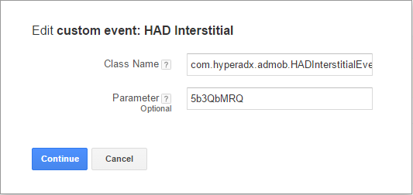
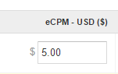

Setup eCPM for new network

3) Now you can setting up your android project.
Put Dispply-SDK and AdMob-adapter in 'libs' folder.

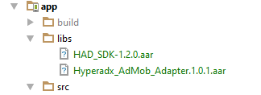

4) Add those lines in your build.gradle file:

allprojects {
repositories {
jcenter()
flatDir {
dirs 'libs'
}
}
}
dependencies {
compile fileTree(dir: 'libs', include: ['*.jar'])
testCompile 'junit:junit:4.12'
compile 'com.android.support:appcompat-v7:23.4.0'
compile(name: 'HAD_SDK-1.2.0', ext: 'aar')
compile(name: 'Hyperadx_AdMob_Adapter.1.0.1', ext: 'aar')
compile 'com.google.android.gms:play-services-ads:9.0.0'
compile 'com.google.android.gms:play-services-base:9.0.0'
}

5) Just create AdMob interstitial Ad as usually:

package com.hyperadx.admob_sample;
import android.os.Bundle;
import android.support.v7.app.AppCompatActivity;
import android.view.View;
import android.widget.Toast;
import com.google.android.gms.ads.AdRequest;
public class MainActivity extends AppCompatActivity {
private com.google.android.gms.ads.InterstitialAd mAdapterInterstitial;
@Override
protected void onCreate(Bundle savedInstanceState) {
super.onCreate(savedInstanceState);
setContentView(R.layout.activity_main);
loadInterstitialAd();
}
private void loadInterstitialAd() {
mAdapterInterstitial = new com.google.android.gms.ads.InterstitialAd(this);
mAdapterInterstitial.setAdUnitId(
"ca-app-pub-6172762133617463/5529648238"
);
mAdapterInterstitial.setAdListener(new com.google.android.gms.ads.AdListener() {
@Override
public void onAdFailedToLoad(int errorCode) {
Toast.makeText(MainActivity.this,
"Error loading adapter interstitial, code " + errorCode,
Toast.LENGTH_SHORT).show();
}
@Override
public void onAdLoaded() {
Toast.makeText(MainActivity.this,
"onAdLoaded()",
Toast.LENGTH_SHORT).show();
}
@Override
public void onAdOpened() {
}
@Override
public void onAdClosed() {
mAdapterInterstitial.loadAd(new AdRequest.Builder().build());
}
});
mAdapterInterstitial.loadAd(new AdRequest.Builder().build());
}
public void showInterstitial(View view) {
if (mAdapterInterstitial.isLoaded())
mAdapterInterstitial.show();
else
Toast.makeText(this, "The Interstitial AD not ready yet. Try again!", Toast.LENGTH_LONG).show();
}
}

