Mopub
You can use Hyperadx as a Network in Mopub's Mediation platform.

1. Setup SDKs
- Integrate with Mopub SDK (https://github.com/mopub/mopub-android-sdk/wiki/Getting-Started)
- Install Hyperadx SDK
More info how to install Hyperadx SDK on Integration and API documentation

2. Setup Mopub Dashboard
Create an "Hyperadx" Network in Mopub's dashboard and connect it to your Ad Units.
- In Mopub's dashboard select Networks > Add New network
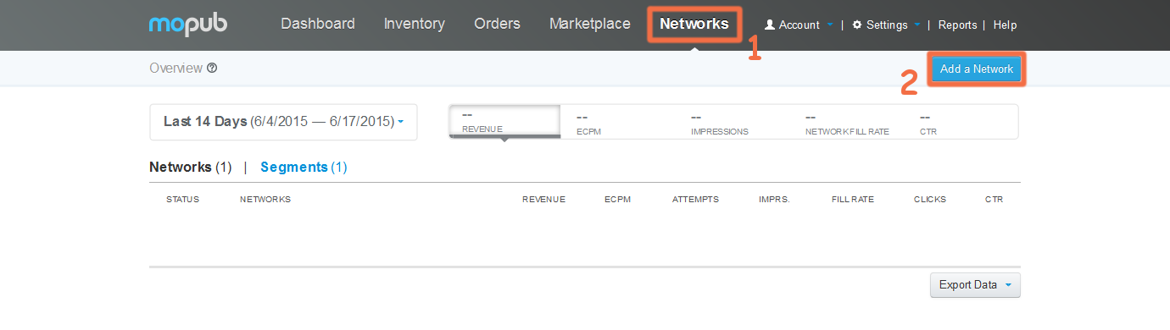
- Then select Custom Native Network
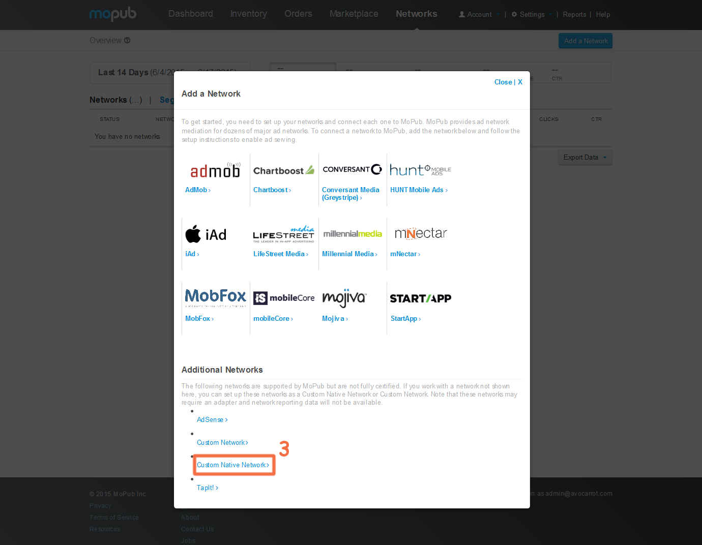
- Complete the fields accordingly to the Ad Unit that you want to use
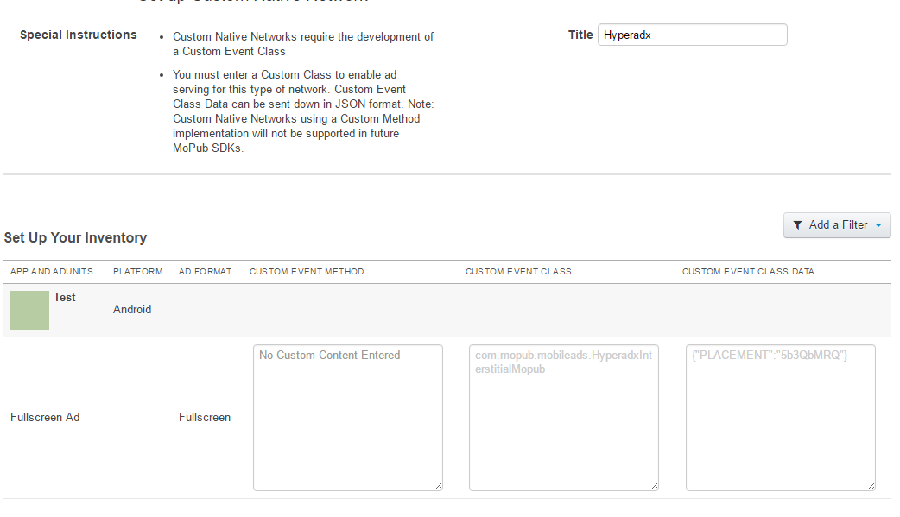
Custom Event Class
com.mopub.mobileads.HyperadxInterstitialMopub
Custom Event Class Data
{"PLACEMENT":"<YOUR PLACEMENT>"}
You can use the test placement "5b3QbMRQ"

2. Add adapter in your project

Create package "com.mopub.mobileads" in your project and put this class in there:
HyperadxInterstitialMopub.java
package com.mopub.mobileads;
import android.content.Context;
import android.util.Log;
import com.hyperadx.lib.sdk.interstitialads.HADInterstitialAd;
import com.hyperadx.lib.sdk.interstitialads.InterstitialAdListener;
import java.util.Map;
public class HyperadxInterstitialMopub extends CustomEventInterstitial {
private static final String PLACEMENT_KEY = "PLACEMENT";
private HADInterstitialAd interstitialAd;
private com.hyperadx.lib.sdk.interstitialads.Ad iAd = null;
CustomEventInterstitialListener customEventInterstitialListener;
@Override
protected void loadInterstitial(final Context context, final CustomEventInterstitialListener customEventInterstitialListener, Map<String, Object> localExtras, Map<String, String> serverExtras) {
final String placement;
final String appId;
if (serverExtras != null && serverExtras.containsKey(PLACEMENT_KEY)) {
placement = serverExtras.get(PLACEMENT_KEY);
} else {
customEventInterstitialListener.onInterstitialFailed(MoPubErrorCode.ADAPTER_CONFIGURATION_ERROR);
return;
}
interstitialAd = new HADInterstitialAd(context, placement); //Interstitial AD constructor
interstitialAd.setAdListener(new InterstitialAdListener() { // Set Listener
@Override
public void onAdLoaded(com.hyperadx.lib.sdk.interstitialads.Ad ad) { // Called when AD is Loaded
iAd = ad;
// Toast.makeText(context, "Interstitial Ad loaded", Toast.LENGTH_SHORT).show();
customEventInterstitialListener.onInterstitialLoaded();
}
@Override
public void onError(com.hyperadx.lib.sdk.interstitialads.Ad Ad, String error) { // Called when load is fail
// Toast.makeText(context, "Interstitial Ad failed to load with error: " + error, Toast.LENGTH_SHORT).show();
customEventInterstitialListener.onInterstitialFailed(MoPubErrorCode.UNSPECIFIED);
}
@Override
public void onInterstitialDisplayed() { // Called when Ad was impressed
// Toast.makeText(context, "Tracked Interstitial Ad impression", Toast.LENGTH_SHORT).show();
customEventInterstitialListener.onInterstitialShown();
}
@Override
public void onInterstitialDismissed(com.hyperadx.lib.sdk.interstitialads.Ad ad) { // Called when Ad was dissnissed by user
// Toast.makeText(context, "Interstitial Ad Dismissed", Toast.LENGTH_SHORT).show();
customEventInterstitialListener.onInterstitialDismissed();
}
@Override
public void onAdClicked() { // Called when user click on AD
// Toast.makeText(context, "Tracked Interstitial Ad click", Toast.LENGTH_SHORT).show();
customEventInterstitialListener.onInterstitialClicked();
}
});
this.customEventInterstitialListener = customEventInterstitialListener;
interstitialAd.loadAd(); // Call to load AD
}
@Override
protected void showInterstitial() {
if (iAd != null)
HADInterstitialAd.show(iAd); // Call to show AD
else
Log.e("HADInterstitialMopub", "The Interstitial AD not ready yet. Try again!");
}
@Override
protected void onInvalidate() {
}
}
This is your adapter. Now you can use Mopub as usual.

