Mopub
You can use Hyperadx as a Network in Mopub's Mediation platform.

1. Setup SDKs
- Integrate with Mopub SDK (https://github.com/mopub/mopub-android-sdk/wiki/Getting-Started)
- Install Hyperadx SDK
More info how to install Hyperadx SDK on Integration and API documentation

2. Setup Mopub Dashboard
Create an "Hyperadx" Network in Mopub's dashboard and connect it to your Ad Units.
- In Mopub's dashboard select Networks > Add New network
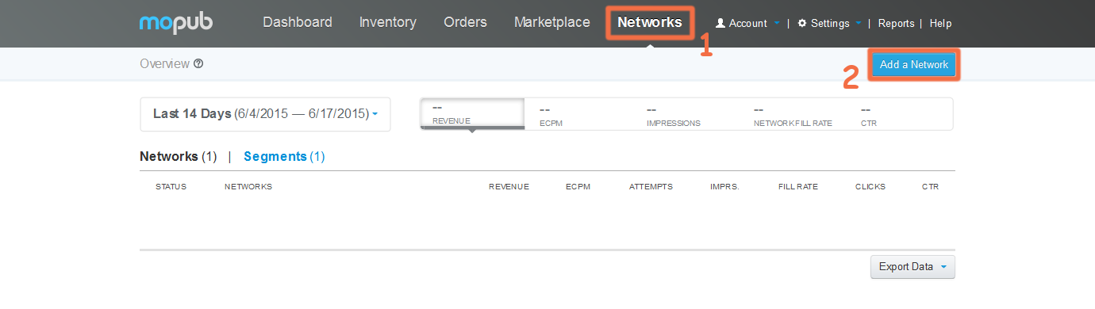
- Then select Custom Native Network
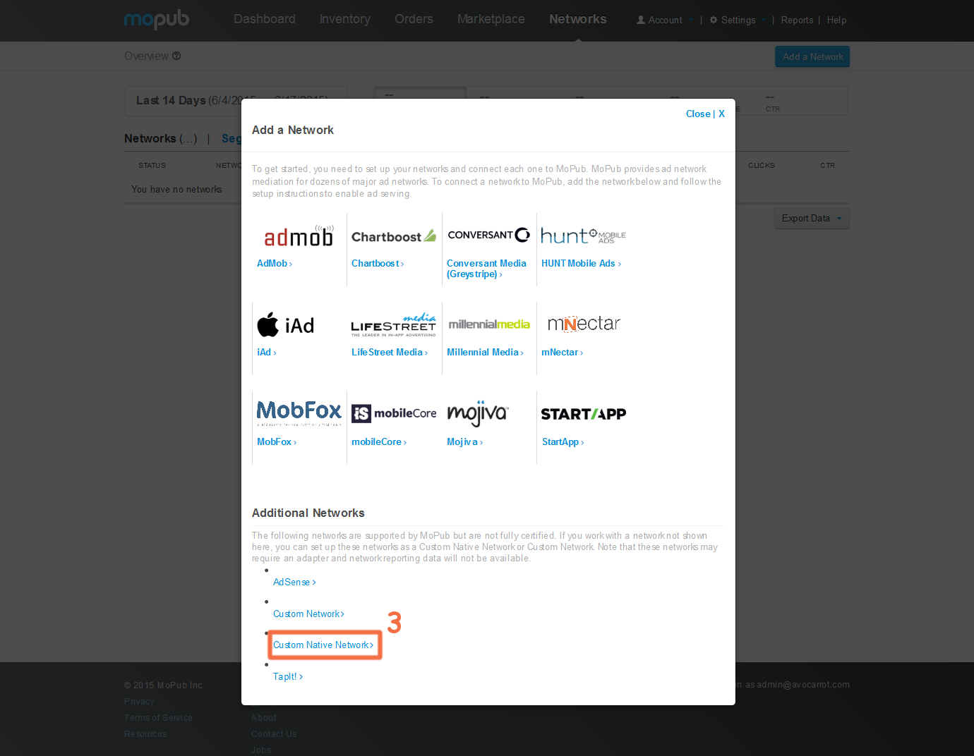
- Complete the fields accordingly to the Ad Unit that you want to use
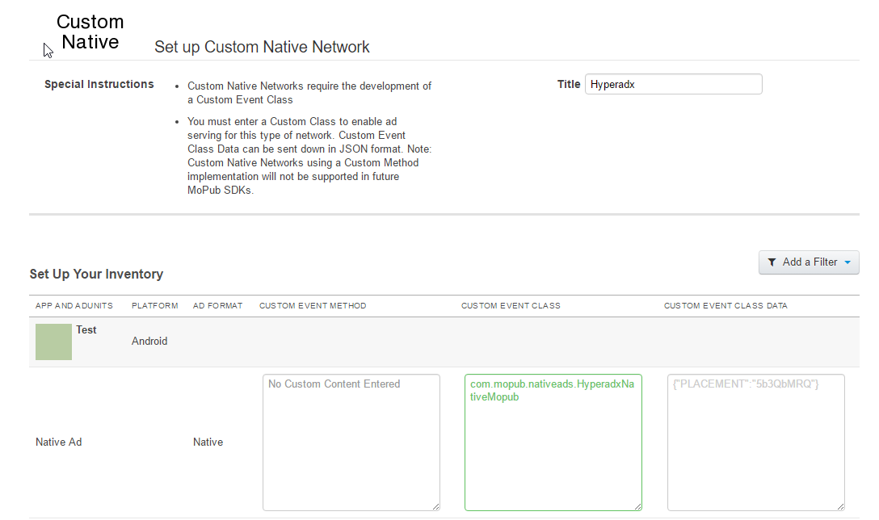
Custom Event Class
com.mopub.nativeads.HyperadxNativeMopub
Custom Event Class Data
{"PLACEMENT":"<YOUR PLACEMENT>"}
You can use the test placement "5b3QbMRQ"

2. Add adapter in your project

Create package "com.mopub.nativeads" in your project and put this class in there:
HyperadxNativeMopub.java
package com.mopub.nativeads;
import android.app.Activity;
import android.os.AsyncTask;
import android.support.annotation.NonNull;
import android.util.Log;
import android.view.View;
import com.hyperadx.lib.sdk.nativeads.Ad;
import com.hyperadx.lib.sdk.nativeads.AdListener;
import com.hyperadx.lib.sdk.nativeads.HADNativeAd;
import java.io.IOException;
import java.net.HttpURLConnection;
import java.net.MalformedURLException;
import java.net.URL;
import java.util.HashSet;
import java.util.Map;
import java.util.Set;
public class HyperadxNativeMopub extends CustomEventNative {
private static final String PLACEMENT_KEY = "PLACEMENT";
com.hyperadx.lib.sdk.nativeads.HADNativeAd nativeAd;
@Override
protected void loadNativeAd(final @NonNull Activity activity, final @NonNull CustomEventNativeListener customEventNativeListener, @NonNull Map<String, Object> localExtras, @NonNull Map<String, String> serverExtras) {
final String placement;
if ((serverExtras != null) && serverExtras.containsKey(PLACEMENT_KEY)) {
placement = serverExtras.get(PLACEMENT_KEY);
} else {
customEventNativeListener.onNativeAdFailed(NativeErrorCode.NATIVE_ADAPTER_CONFIGURATION_ERROR);
return;
}
nativeAd = new com.hyperadx.lib.sdk.nativeads.HADNativeAd(activity, placement); //Native AD constructor
nativeAd.setContent("title,icon,description");
nativeAd.setAdListener(new AdListener() { // Add Listeners
@Override
public void onAdLoaded(Ad ad) {
customEventNativeListener.onNativeAdLoaded(new HyperadxNativeAd(ad, nativeAd, activity));
}
@Override
public void onError(Ad nativeAd, String error) { // Called when load is fail
customEventNativeListener.onNativeAdFailed(NativeErrorCode.EMPTY_AD_RESPONSE);
}
@Override
public void onAdClicked() { // Called when user click on AD
Log.wtf("TAG", "AD Clicked");
}
});
nativeAd.loadAd();
}
class HyperadxNativeAd extends StaticNativeAd {
final Ad hadModel;
final com.hyperadx.lib.sdk.nativeads.HADNativeAd nativeAd;
final ImpressionTracker impressionTracker;
final NativeClickHandler nativeClickHandler;
final Activity activity;
public HyperadxNativeAd(@NonNull Ad customModel, HADNativeAd nativeAd, Activity activity) {
hadModel = customModel;
this.nativeAd = nativeAd;
this.activity = activity;
impressionTracker = new ImpressionTracker(activity);
nativeClickHandler = new NativeClickHandler(activity);
setIconImageUrl(hadModel.getIcon_url());
setMainImageUrl(hadModel.getImage_url());
setTitle(hadModel.getTitle());
setText(hadModel.getDescription());
setClickDestinationUrl(hadModel.getClickUrl());
for (Ad.Tracker tracker : hadModel.getTrackers())
if (tracker.getType().equals("impression")) {
addImpressionTracker(tracker.getUrl());
}
}
@Override
public void prepare(final View view) {
impressionTracker.addView(view, this);
nativeClickHandler.setOnClickListener(view, this);
}
@Override
public void recordImpression(final View view) {
notifyAdImpressed();
for (Ad.Tracker tracker : hadModel.getTrackers())
if (tracker.getType().equals("impression")) {
new LoadUrlTask().execute(tracker.getUrl());
}
}
@Override
public void handleClick(final View view) {
notifyAdClicked();
nativeClickHandler.openClickDestinationUrl(getClickDestinationUrl(), view);
if (hadModel.getClickUrl() != null)
new LoadUrlTask().execute(hadModel.getClickUrl());
}
private class LoadUrlTask extends AsyncTask<String, Void, String> {
String userAgent;
public LoadUrlTask() {
userAgent = com.hyperadx.lib.sdk.Util.getDefaultUserAgentString(activity);
}
@Override
protected String doInBackground(String... urls) {
String loadingUrl = urls[0];
URL url = null;
try {
url = new URL(loadingUrl);
} catch (MalformedURLException e) {
return (loadingUrl != null) ? loadingUrl : "";
}
com.hyperadx.lib.sdk.HADLog.d("Checking URL redirect:" + loadingUrl);
int statusCode = -1;
HttpURLConnection connection = null;
String nextLocation = url.toString();
Set<String> redirectLocations = new HashSet<String>();
redirectLocations.add(nextLocation);
try {
do {
connection = (HttpURLConnection) url.openConnection();
connection.setRequestProperty("User-Agent",
userAgent);
connection.setInstanceFollowRedirects(false);
statusCode = connection.getResponseCode();
if (statusCode == HttpURLConnection.HTTP_OK) {
connection.disconnect();
break;
} else {
nextLocation = connection.getHeaderField("location");
connection.disconnect();
if (!redirectLocations.add(nextLocation)) {
com.hyperadx.lib.sdk.HADLog.d("URL redirect cycle detected");
return "";
}
url = new URL(nextLocation);
}
}
while (statusCode == HttpURLConnection.HTTP_MOVED_TEMP || statusCode == HttpURLConnection.HTTP_MOVED_PERM
|| statusCode == HttpURLConnection.HTTP_UNAVAILABLE
|| statusCode == HttpURLConnection.HTTP_SEE_OTHER);
} catch (IOException e) {
return (nextLocation != null) ? nextLocation : "";
} finally {
if (connection != null)
connection.disconnect();
}
return nextLocation;
}
@Override
protected void onPostExecute(String url) {
}
}
}
}

This is your adapter. Now you can use Mopub as usual.

