# Uniform and Packaging Math Assessment

Include the correct answer and explanation.

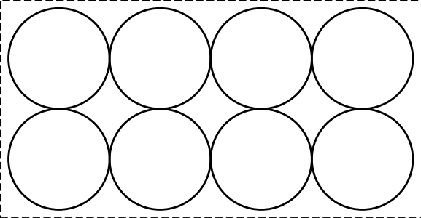

Diagram: Top view of 8 tightly packed spheres.