Algorithm Design — Lab Assignment 4
Convex Hull: Monotone Chain vs. Divide and Conquer
Student ID: 411321344
Name: Wilkend AUGUSTE
Course: Lab of Algorithm
Date: Wednesday 1, 2026

National Dong Hwa University
Department of Computer Science and Information Engineering

1. Problem Definition

The convex hull of a set of points is the smallest convex polygon that contains all of them. I like the rubber band analogy from the assignment sheet — if you put nails at all the point positions on a board and stretch a rubber band around the outside, the shape the band makes when released is the convex hull.

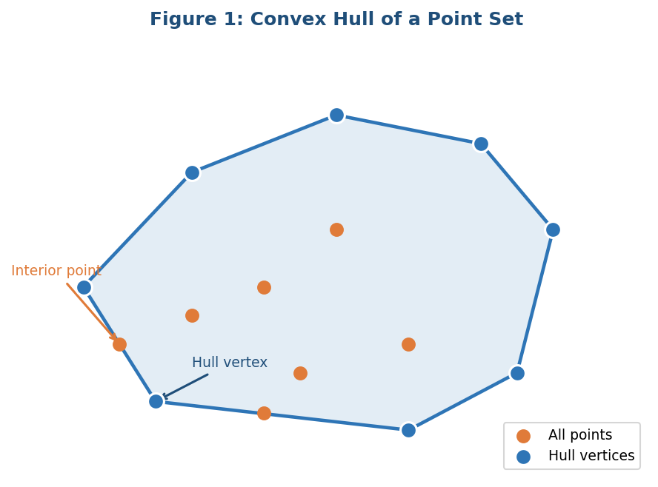
Figure 1: A set of 15 points. Orange dots are interior points, blue dots on the boundary are hull vertices.
Formally, a point p is on the convex hull if there is no way to write it as a combination of other points in the set. The hull vertices are the "extreme" points that define the outer boundary.
Convex hulls show up in a lot of places. In robotics and game development, collision detection uses them to check if two objects overlap. In GIS software, they help define the boundary of a geographic region. In computer vision, they are used for shape analysis. Understanding how to compute them efficiently is a useful skill.
The two algorithms I am comparing in this report are Monotone Chain and Divide-and-Conquer. Both give the correct answer, but they use pretty different approaches to get there.

2. Monotone Chain

2.1 Core Idea
Monotone Chain works by first sorting all the points by x-coordinate (ties broken by y), and then doing two passes through the sorted list — one forward to build the lower hull, one backward to build the upper hull. Combining both halves gives the full convex hull.
The reason we sort first is that it lets us process points in a predictable left-to-right order. Once they are sorted, we can build the hull with a simple stack-based scan — we just keep track of the last few points we added and check if each new point makes a left turn. If it does not, we remove the previous point and try again.

2.2 The Cross Product Turn Test
The key check in Monotone Chain is: given three consecutive points O, A, B, does the path O→A→B make a left turn, a right turn, or go straight?
This is computed using the 2D cross product:
cross(O, A, B) = (A.x − O.x)(B.y − O.y) − (A.y − O.y)(B.x − O.x)

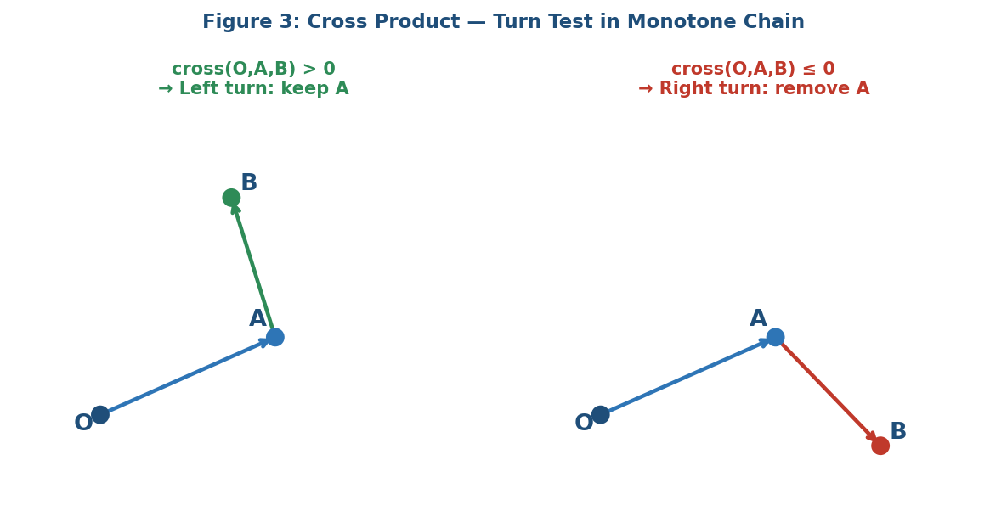
Figure 3: Left turn (cross > 0) means A is a valid hull point. Right/straight (cross ≤ 0) means A should be removed.
If cross > 0, the turn is left and we keep A. If cross ≤ 0, the path is going right or straight, which means A cannot be on the convex hull boundary for this direction, so we remove it from our stack and check the point before it.

2.3 Step-by-Step Process
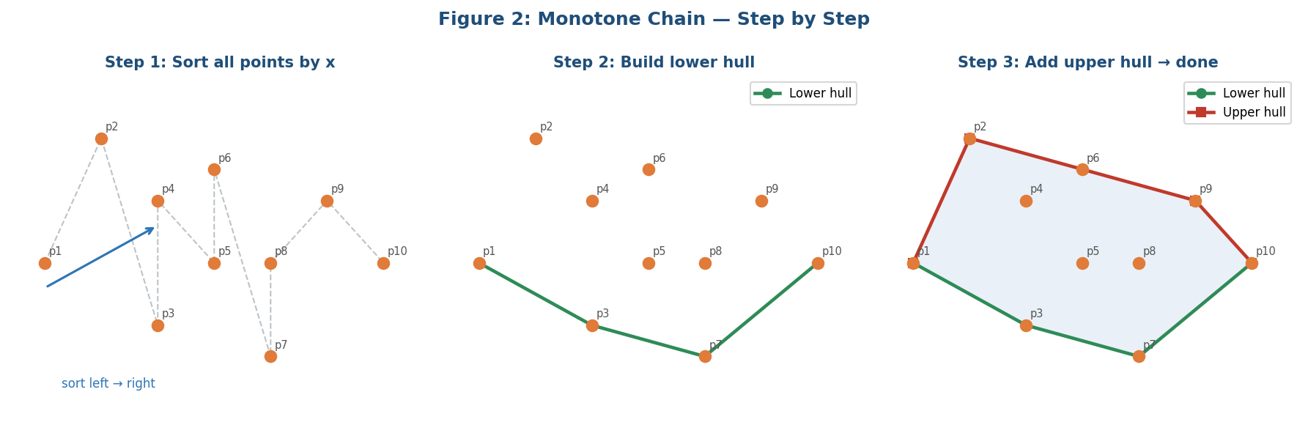
Figure 2: Monotone Chain builds a lower hull (left to right) then an upper hull (right to left), combining them at the end.

2.4 Pseudocode
Lower hull construction:
function monotone_chain(points):
sort points by (x, y)
lower = []
for p in points:
while len(lower) >= 2 and cross(lower[-2], lower[-1], p) <= 0:
lower.pop()
lower.append(p)
upper = []
for p in reversed(points):
while len(upper) >= 2 and cross(upper[-2], upper[-1], p) <= 0:
upper.pop()
upper.append(p)
return lower[:-1] + upper[:-1] // remove duplicate endpoints

The lower hull loop goes left to right and keeps only left-turning points. The upper hull loop goes right to left and does the same thing in the opposite direction. At the end, the two lists are concatenated (dropping the shared endpoints at each extreme) to form the complete hull boundary.
One thing I found a bit tricky at first is why we remove the last element before concatenating. The reason is that the leftmost and rightmost points appear in both halves, so we would get duplicates if we did not trim them.

3. Divide-and-Conquer Convex Hull

3.1 Core Idea
The Divide-and-Conquer approach breaks the problem into smaller subproblems recursively. It splits the point set into two halves, computes the convex hull of each half independently, and then merges the two smaller hulls into one final hull.
This structure directly follows the divide-and-conquer pattern we have been studying: split the problem, recurse on each part, then combine the results. The tricky part is the merge step, which requires finding the "bridge" lines (tangents) that connect the two hulls.

3.2 Split and Recurse
The point set is sorted by x-coordinate, then split at the median. The left half goes to one recursive call and the right half to another. The base case is when there are 3 or fewer points, where the hull can be computed directly by checking orientation.

3.3 The Merge Step
Merging is the most complex part. Given two convex hulls that do not overlap (because we split by x), we need to find:
- The upper tangent: the line that touches the top of both hulls without any hull points above it
- The lower tangent: the line that touches the bottom of both hulls without any hull points below it
Finding a tangent works by walking along the hull vertices. For the upper tangent, we start with the rightmost point of the left hull and the leftmost point of the right hull, then adjust each endpoint up until the line is tangent to both hulls. This takes O(n) time in the worst case.
Once we have both tangents, the merged hull consists of: the upper part of the left hull (from upper tangent to lower tangent, going counterclockwise) + the lower part of the right hull.

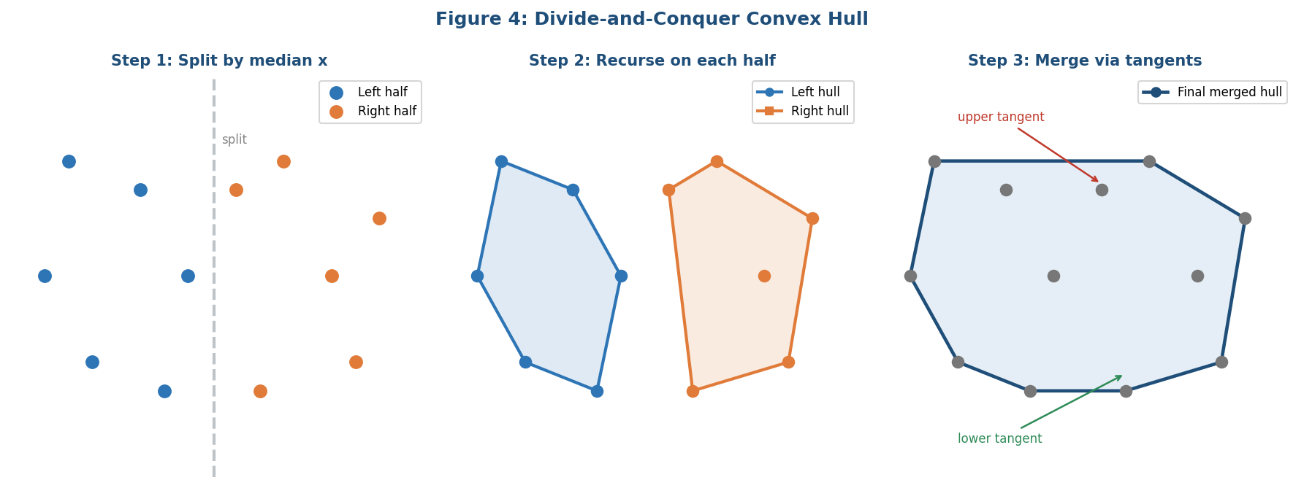
Figure 4: D&C splits the points into left/right halves, solves each recursively, then finds the upper and lower tangent lines to merge the two hulls.

3.4 Pseudocode
function dc_hull(points):
sort points by x
return _dc_recursive(points)

function _dc_recursive(points):
if len(points) <= 3:
return base_case_hull(points) // direct solution
mid = len(points) / 2
left_hull = _dc_recursive(points[0..mid])
right_hull = _dc_recursive(points[mid..n])
return merge(left_hull, right_hull)

function merge(L, R):
upper_tan = find_upper_tangent(L, R)
lower_tan = find_lower_tangent(L, R)
return combine using upper_tan and lower_tan

The merge function is where the actual geometric work happens. Finding each tangent line requires iterating along the hulls, which in the worst case touches each point once per merge level. Since there are O(log n) levels of recursion, the total merge cost is O(n log n).

4. Comparative Analysis

Aspect | Monotone Chain | Divide and Conquer
Design paradigm | Sorting + linear scan | Classic divide and conquer
Sorting required | Yes, at the start | Yes, at the start
Recursion | No | Yes (log n levels)
Main operation | Stack-based scan with cross product check | Tangent finding during merge
Merge complexity | Not needed (just concatenate) | O(n) per level
Implementation | Relatively straightforward | More complex, especially merge
Conceptual difficulty | Moderate (turn test logic) | Higher (tangent finding)
Output order | Counterclockwise from bottom-left | Depends on implementation
Total complexity | O(n log n) | O(n log n)

Both algorithms have the same asymptotic time complexity of O(n log n), which is dominated by the initial sort. In practice though, Monotone Chain tends to be simpler to implement correctly. The scan phase is just two linear passes with a stack, and the cross product check is a single formula.
Divide and Conquer is more structurally interesting from an algorithm design perspective because it clearly shows how D&C can be applied to geometry problems. However, the merge step is genuinely tricky — finding the upper and lower tangents requires careful handling of the hull traversal direction and edge cases with collinear points.
One important difference is that Monotone Chain does not use recursion, so it has no risk of stack overflow on very large inputs. D&C goes log n levels deep, which is fine in practice but is something to be aware of.
In terms of whether they are both "real" divide-and-conquer: D&C obviously is. Monotone Chain is not, strictly speaking — it does not split the problem recursively. It solves it in a single sweeping pass after sorting. Some people classify it more as a "sweep line" algorithm.

5. Time Complexity Analysis

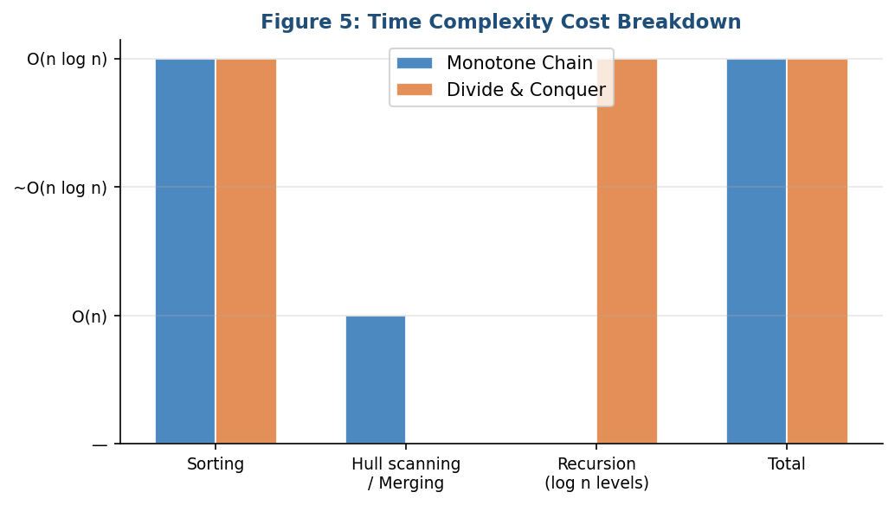
Figure 5: Comparison of time cost contributors for each algorithm. Both algorithms are O(n log n) overall.

5.1 Monotone Chain
Sorting all n points takes O(n log n). After that, the lower hull and upper hull passes each take O(n) amortized time — each point is pushed and popped from the stack at most once. So the total time is:
T(n) = O(n log n) + O(n) + O(n) = O(n log n)
The O(n log n) sort dominates. The rest is linear.

5.2 Divide and Conquer
The recursion splits the problem in half at each level, giving log n levels. At each level, the merge step (finding tangents and assembling the combined hull) takes O(n) total across all subproblems at that level. The initial sort also takes O(n log n). So we get:
T(n) = O(n log n) sort + O(n log n) merge = O(n log n)
The recurrence is T(n) = 2T(n/2) + O(n), which by the Master Theorem gives O(n log n). This is the same asymptotic result as Monotone Chain, but with a larger constant because of the tangent-finding overhead.

 | Monotone Chain | Divide and Conquer
Sorting | O(n log n) | O(n log n)
Main pass / Merge | O(n) | O(n log n)
Space | O(n) | O(n log n) due to recursion stack
Total | O(n log n) | O(n log n)

6. Conclusion and Personal Reflection

After working through both algorithms, I find Monotone Chain easier to understand and implement. The logic is fairly linear — sort, scan left to right, check turns with the cross product, scan right to left, combine. Each step makes intuitive sense once you understand what the lower and upper hull represent.
Divide and Conquer is more interesting structurally. It shows that D&C applies not just to sorting and searching but also to geometric problems. But the merge step is genuinely hard to get right. Figuring out how to walk along two hulls to find the tangent line without missing any edge cases is not trivial. I think for a practical implementation, Monotone Chain is the better choice.
That said, if the goal is to demonstrate divide-and-conquer thinking, then the D&C hull is the better example. The split-recurse-merge structure is clean and mirrors how we think about problems like merge sort.
One thing that surprised me while studying this was how both algorithms end up at the same O(n log n) complexity, but for completely different reasons. In Monotone Chain, the bottleneck is the sort. In D&C, the bottleneck is the O(n) merge at each of the O(log n) recursion levels. It is a nice example of how different designs can reach the same performance for different structural reasons.

