Lab Experiment 9: Documentation Generation -Automatic
documentation and code comments
Name :T.Anjali
Roll no: 2503A52410
Batch no: 14

Problem 1:
Consider the following Python function:
def find_max(numbers):
return max(numbers)
Prompt:
• Write documentation for the function in all three formats:
(a) Docstring
(b) Inline comments
(c) Google-style documentation

• Critically compare the three approaches. Discuss the
advantages, disadvantages, and suitable use cases of each
style.
• Recommend which documentation style is most effective
for a mathematical utilities library and justify your
answer.

Input:
# Calculate average score of a student
def calc_average(marks):
total = 0

for m in marks:
total += m

average = total / len(marks)
return average

marks = [85, 90, 78, 92]
print("Average Score is", calc_average(marks))

Explanation:
Indentation error: Proper indentation was added inside the function, loop, and other blocks. Typographical error: average was corrected to average. Syntax error: The missing closing parenthesis in the print() statement was added.
Output:
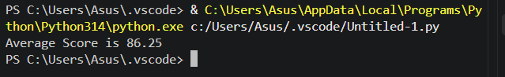

Problem 2: Consider the following Python function:
def login(user, password, credentials):
return credentials.get(user) == password
Prompt:
1. Write documentation in all three formats.
2. Critically compare the approaches.
3. Recommend which style would be most helpful for new
developers onboarding a project, and justify your choice.

Input:
# Problem 2: Documentation of Python Functions

# (a) Docstring Documentation
def login_docstring(user, password, credentials):
"""Check whether the provided password matches the stored password."""
return credentials.get(user) == password

# (b) Inline Comments
def login_comments(user, password, credentials):
# Get the stored password for the given username
stored_password = credentials.get(user)

# Compare the stored password with the provided password
return stored_password == password

# (c) Google-Style Documentation
def login_google(user, password, credentials):
"""Check whether the provided password matches the stored password.

Args:
user (str): The username to check.
password (str): The password provided by the user.
credentials (dict): A dictionary mapping usernames to passwords.

Returns:
bool: True if the passwords match; otherwise, False.
"""
return credentials.get(user) == password

# Sample credentials
credentials = {
"Anjali": "abc123",
"Rahul": "xyz789"
}

# Test all three functions
print("Docstring Output:", login_docstring("Anjali", "abc123", credentials))
print("Inline Comments Output:", login_comments("Anjali", "abc123", credentials))
print("Google-Style Output:", login_google("Anjali", "abc123", credentials))

# Test invalid login
print("Invalid Login:", login_google("Anjali", "wrong", credentials))

# Display function documentation
print("\nGoogle-Style Documentation:")
help(login_google)
Explanation:
Easy understanding: Developers can quickly understand the purpose of the function. Parameter clarity: Each input is explained separately. Return-value clarity: Developers know what result to expect.
Output:

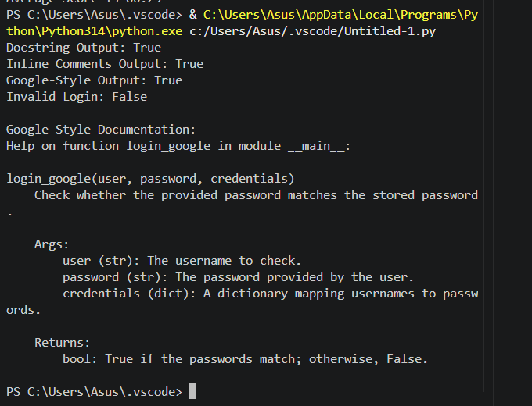
Problem 3: Calculator (Automatic Documentation Generation)
Prompt: Design a Python module named calculator.py and
demonstrate automatic documentation generation.
Instructions:
1. Create a Python module calculator.py that includes the
following functions, each written with appropriate docstrings:
o add(a, b) – returns the sum of two numbers
o subtract(a, b) – returns the difference of two numbers
o multiply(a, b) – returns the product of two numbers
o divide(a, b) – returns the quotient of two numbers
2. Display the module documentation in the terminal using
Python’s documentation tools.
3. Generate and export the module documentation in HTML

format using the pydoc utility, and open the generated HTML
file in a web browser to verify the output.
Input:

"""
Calculator Module
Provides basic arithmetic operations:
addition, subtraction, multiplication, and division.
"""

def add(a, b):
"""Return the sum of two numbers.

Args:
a (int or float): First number.
b (int or float): Second number.

Returns:
int or float: Sum of a and b.
"""
return a + b

def subtract(a, b):
"""Return the difference between two numbers.

Args:
a (int or float): First number.
b (int or float): Second number.

Returns:
int or float: Difference between a and b.
"""
return a - b

def multiply(a, b):
"""Return the product of two numbers.

Args:
a (int or float): First number.
b (int or float): Second number.

Returns:
int or float: Product of a and b.
"""
return a * b

def divide(a, b):
"""Return the quotient of two numbers.

Args:
a (int or float): Numerator.
b (int or float): Denominator.

Returns:
float: Quotient of a and b.

Raises:
ZeroDivisionError: If the denominator is zero.
"""
if b == 0:
raise ZeroDivisionError("Cannot divide by zero.")
return a / b

if __name__ == "__main__":
print("Addition:", add(10, 5))
print("Subtraction:", subtract(10, 5))
print("Multiplication:", multiply(10, 5))
print("Division:", divide(10, 5))

Explanation:
The calculator.py module contains four functions: addition, subtraction, multiplication, and division, each with docstrings. The pydoc tool displays the module documentation in the terminal and generates an HTML file using python -m pydoc -w calculator. The generated calculator.html file can be opened in a web browser to verify the documentation.

Output:
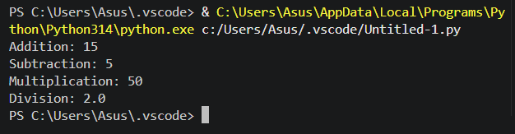

Problem 4: Conversion Utilities Module
Prompt:
1. Write a module named conversion.py with functions:
o decimal_to_binary(n)
o binary_to_decimal(b)
o decimal_to_hexadecimal(n)
2. Use Copilot for auto-generating docstrings.
3. Generate documentation in the terminal.
4. Export the documentation in HTML format and open it in a
browser.
Input:

"""
Conversion Utilities Module
Provides functions to convert decimal numbers to binary,
binary numbers to decimal, and decimal numbers to hexadecimal.
"""

def decimal_to_binary(n):
"""Convert a decimal integer to a binary string.

Args:
n (int): The decimal integer to convert.

Returns:
str: The binary representation of the integer.
"""
return bin(n)[2:] if n >= 0 else "-" + bin(-n)[2:]

def binary_to_decimal(b):
"""Convert a binary string to a decimal integer.

Args:
b (str): A string containing a binary number.

Returns:
int: The decimal representation of the binary number.

Raises:
ValueError: If the input is not a valid binary number.
"""
return int(b, 2)

def decimal_to_hexadecimal(n):
"""Convert a decimal integer to a hexadecimal string.

Args:
n (int): The decimal integer to convert.

Returns:
str: The hexadecimal representation of the integer.
"""
return hex(n)[2:] if n >= 0 else "-" + hex(-n)[2:]

if __name__ == "__main__":
print("Decimal to Binary:", decimal_to_binary(10))
print("Binary to Decimal:", binary_to_decimal("1010"))
print("Decimal to Hexadecimal:", decimal_to_hexadecimal(255))
The conversion.py module contains three functions to convert decimal numbers to binary, binary numbers to decimal, and decimal numbers to hexadecimal.GitHub Copilot helps generate docstrings that describe each function's purpose, parameters, and return values. The pydoc tool displays documentation in the terminal and generates conversion.html, which can be opened in a web browser.
Output:
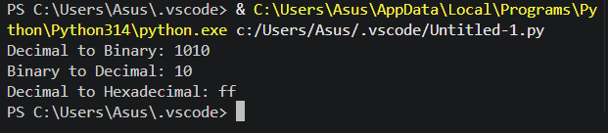
Problem 5 – Course Management Module
Prompt:
1. Create a module course.py with functions:
o add_course(course_id, name, credits)
o remove_course(course_id)
o get_course(course_id)
2. Add docstrings with Copilot.
3. Generate documentation in the terminal.
4. Export the documentation in HTML format and open it in a
browser.
Input:

"""
Course Management Module
Provides functions to add, remove, and retrieve courses.
"""

# Store course details
courses = {}

def add_course(course_id, name, credits):
"""Add a new course to the course management system.

Args:
course_id (int): Unique ID of the course.
name (str): Name of the course.
credits (int): Number of course credits.

Returns:
str: Confirmation message.
"""
if course_id in courses:
return "Course already exists."

courses[course_id] = {
"name": name,
"credits": credits
}
return "Course added successfully."

def remove_course(course_id):
"""Remove a course using its course ID.

Args:
course_id (int): ID of the course to remove.

Returns:
str: Result message.
"""
if course_id in courses:
del courses[course_id]
return "Course removed successfully."

return "Course not found."

def get_course(course_id):
"""Retrieve course details using the course ID.

Args:
course_id (int): ID of the course to retrieve.

Returns:
dict or None: Course details if found, otherwise None.
"""
return courses.get(course_id)

if __name__ == "__main__":
print(add_course(101, "Python Programming", 4))
print(add_course(102, "Database Management", 3))

print("Course Details:", get_course(101))

print(remove_course(102))
print("Remaining Courses:", courses)

Explanation:
Create a Python module named course.py with functions to add a course, remove a course, and retrieve course details using the course ID. Use GitHub Copilot to generate docstrings describing each function's purpose, parameters, and return values.Run python -m pydoc course to display documentation in the terminal, then use python -m pydoc -w course to generate course.html and open it in a browser using start course.html.

Output:
