Data Base Management System
COM1302

Project

Name :H.B.T.D.Sanjitha
Reg.no :ASP/17/18/059
Index no:4085

Milestone 01;

- Aim

This Database is for ABC tyre company store room which used to easily calculate the quantity which is stored, to manage customer stores data, and for fast delivering island wide when an order is placed.

Advantages:
- Can get some statistical data and it will help for production purposes.
- To maintain customer data easily.
- Can get an overall idea about earnings and expenses. (It will help to calculate profits easily).

- Description

In this store room there are four main departments as managing department, store keeping department, production sector, and cashiering. Managing department have access to the all data inside this store room. They are the one who handle this store rooms. Store keepers are the one who looks for items and stocks. They are responsible for stocks and goods. If any tyre sizes are going to be unavailable, they will ask the production to make them for the stock. Cashier is the place where all the sells are happening. Where large scale buyers are getting the products which they need for their shops.
- Use case diagram
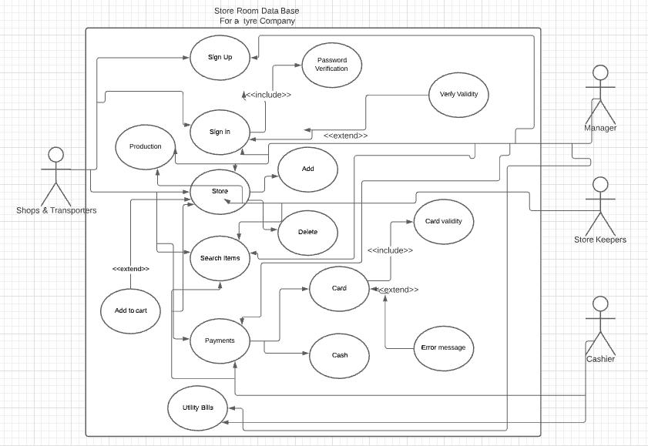

- Use case explanation.

Use Case | Actor | Description
Sign Up | Customer , Manager | - New customer provide details and confirm them it
Sign In | Customer, Manager | - Existing customers log in to the system  - Can access the customer list by the manager
Store | Customer, Manager, Store Keeper | - Customers make order by giving the tyre number.  - Store keeper must maintain the stocks.  - Checking for the validity of things.
Search Items | Customer, Manager, Store Keeper, Cashier | - Can searc for items in the data base.
Payments | Customer, Manager, Cashier | - Customers pay for the order.  - Cashier check the prices and make the bill.  - Manager check for payment validity.
Utility Bills | Manager, Cashier | - Search for the bills in the store and order the cashier to pay the bills.
Production Sector | Manger, Store Keeper | - Store keepers are call the production sector after reporting the management when goods in the store are going to be out of stock.  - Managers are going to be call store keepers if they seems that store is going to be out of stock or if they realize that more good might sell in a certain time period.

