上传下载文件并显示进度条（基于Ajax）

1. 关于项目

采用 node 作为服务器环境，express 框架、ejs模板。

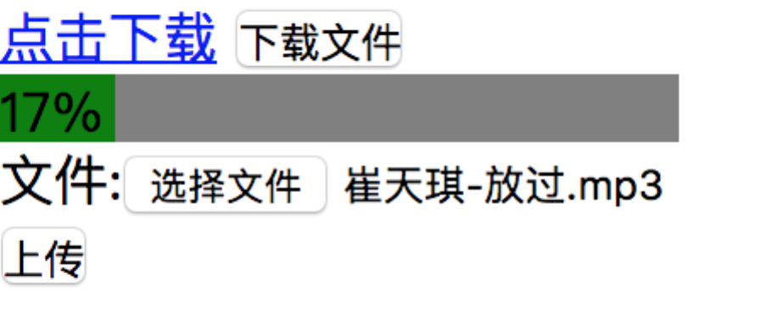

1. node服务器配置
2. 关于上传文件的配置

node 接收文件需要安装 multer 模块进行处理

var objmulter=multer({dest:'./www/upload'}); // 上传保存路径

server.use(objmulter.any());

server.post('/upload',(req,res)=>{

console.log(req.files); // 读取上传文件

// 获取原始扩展名

// var newName=req.files[0].path+pathlib.parse(req.files[0].originalname).ext;

var newName=req.files[0].destination+'/'+req.files[0].originalname;

fs.rename(req.files[0].path,newName,(err)=>{

if(err){

res.send('上传失败')

}else{

res.send('上传成功')

}

})

})

1. 文件下载

server.get('/1.txt',(req,res)=>{

res.setHeader('Content-Disposition','attachment;filename=1.txt');

res.sendFile('/Users/dongdongwang/demo/nodep/download/www/download/崔天琪 - 放过.mp3')

})

1. 前端ajax监听事件
2. 下载
3. $('#download').click(function () {
4. var that = this;
5. var page_url = 'http://localhost:8080/1.txt';
6. var req = new XMLHttpRequest();
7. req.open("get", page_url, true);
8. req.onprogress = function(evt){ // 进度事件
9. if (evt.lengthComputable) {
10. var percentComplete = evt.loaded / evt.total;
11. $("#progressing").width((Math.floor(percentComplete * 100)) + "%");
12. $("#progressing").html((Math.floor(percentComplete * 100)) + "%");
13. }
14. };
15. req.responseType = "blob";
16. req.onreadystatechange = function () {
17. if (req.readyState === 4 && req.status === 200) {
18. var filename = $(that).data('filename');
19. if (typeof window.chrome !== 'undefined') {
20. // Chrome version
21. var link = document.createElement('a');
22. link.href = window.URL.createObjectURL(req.response);
23. link.download = filename;
24. link.click();
25. } else if (typeof window.navigator.msSaveBlob !== 'undefined') {
26. // IE version
27. var blob = new Blob([req.response], { type: 'application/force-download' });
28. window.navigator.msSaveBlob(blob, filename);
29. } else {
30. // Firefox version
31. var file = new File([req.response], filename, { type: 'application/force-download' });
32. window.open(URL.createObjectURL(file));
33. }
34. }
35. };
36. req.send();
37. });
38. 上传
39. let files = Array.from(document.getElementsByName('file1'));
40. let page_url = 'http://localhost:8080/upload';
41. var req = new XMLHttpRequest();
42. req.upload.onerror=()=>{
43. alert('上传出错')
44. }
45. req.upload.onprogress=(evt)=>{
46. var percentComplete1 = evt.loaded / evt.total;
47. $("#progressing").width((Math.floor(percentComplete1 * 100)) + "%");
48. $("#progressing").html((Math.floor(percentComplete1 * 100)) + "%");
49. }
50. req.open("post", page_url, true);
51. //监听进度事件
52. let formData = new FormData();
53. files.forEach(oFile=>{
54. Array.from(oFile.files).forEach(item=>{
55. formData.append('file1',item);
56. })
57. })
58. req.send(formData);
59. req.onreadystatechange=()=>{
60. if(req.readyState === 4){
61. alert(req.status);
62. }
63. }