A PROJECT ON

“ FORECASTING OF BITCOIN PRICES”
SUBMITTED IN
PARTIAL FULFILLMENT OF THE REQUIREMENT FOR THE COURSE OF
DIPLOMA IN BIG DATA ANALYSIS



SUNBEAM INSTITUTE OF INFORMATION TECHNOLOGY, PUNE
Submitted By:

Rohini Alone (80614)

John Mathews (80543)

Mr.Nitin Kudale Mrs.Manisha Hingne Center Coordinator Course Coordinator



CERTIFICATE

This is to certify that the project work under the title ‘Forecasting of Bitcoin Prices’ is done by Rohini Alone & John Mathews in partial fulfillment of the requirement for award of Diploma in Big Data Analysis Course.

Mr. Aniket P Mrs. Manisha Hingne
Project Guide Course Coordinator

Date:

ACKNOWLEDGEMENT

A project usually falls short of its expectation unless aided and guided by the right persons at the right time. We avail this opportunity to express our deep sense of gratitude towards Mr. Nitin Kudale (Center Coordinator, SIIT, Pune) and Mrs. Manisha Hingne (Course Coordinator, SIIT ,Pune) and Project Guide Mr. Aniket P.
We are deeply indebted and grateful to them for their guidance, encouragement and deep concern for our project. Without their critical evaluation and suggestions at every stage of the project, this project could never have reached its present form.
Last but not the least we thank the entire faculty and the staff members of Sunbeam Institute of Information Technology, Pune for their support.

Rohini Alone
PGDBDA Sept 2023 Batch, SIIT Pune

John Mathews
PGDBDA Sept 2023 Batch, SIIT Pune

.
TABLE OF CONTENTS

- Introduction
  - Introduction And Objectives
  - Why this problem needs To be Solved?
  - Dataset Information

Problem Definition and Algorithm
  - Problem Definition
  - Algorithm Definition

Experimental Evaluation
  - Methodology/Model
  - Exploratory Data Analysis

Results And Discussion

- GUI

- GitHub link

- Challenges and Limitations

8.Future Work And Conclusion
8.1 Future Work
8.2 Conclusion
    - Introduction

      - Introduction And Objectives:
Bitcoin is the first decentralized cryptocurrency. Nodes in the peer-to-peer bitcoin network verify transactions through cryptography and record them in a public distributed ledger, called a blockchain, without central oversight. Consesus between nodes is achieved using a computationally intensive process based on proof-of-work, called mining, that requires increasing quantities of electricity and guarantees the security of the bitcoin blockchain.[1]
The objective of a project focused on predicting Bitcoin cryptocurrency prices up to 60 days using machine learning .The project involves analyzing historical price data to predict future prices, making it a time series prediction task. This entails handling sequential data, understanding trends, and capturing patterns over time. Time series prediction is a crucial skill in financial forecasting, and it showcases ability to model and predict values based on historical trends in a dynamic market like cryptocurrencies.

Why this problem needs To be Solved?

Cryptocurrency markets, particularly Bitcoin, are known for their high volatility and dynamic nature. This makes it an interesting and challenging domain for machine learning projects. The ability to predict price movements in such a volatile market showcases the skills in handling complex and real-time data, as well as the potential for creating valuable insights for investors and traders.

The project has practical applications in the financial sector. Successful prediction models can be utilized by investors, traders, and financial institutions to make informed decisions about buying or selling cryptocurrencies. Being able to contribute to a field with real-world impact adds significance to the project and demonstrates your ability to create solutions that can be applied in the industry.

      - Dataset Information:

The dataset used in this project comprises historical stock price data along with relevant features such as trading volume, market indices, economic indicators, and sentiment analysis scores. The dataset is obtained from reputable financial sources and undergoes pre-processing steps, including cleaning, normalization, and feature engineering, to ensure its suitability for training machine learning models.

For web scraping :
bitcoin.html
This file contains the data in HTML format from the years 2010 to 2023, obtained through web scraping from the website https://in.investing.com

cleaned_data.csv
4858 x 7 : rows x columns

Also The dataset for the project is taken from imported yfinance module . It consists of 7 columns namely Date, Open, High, Low, Close, Adj Close and Volume. Out of which the Date and Close column are studied.

Columns:

Date: This column represents the date for which the Bitcoin data is recorded. Each row corresponds to a specific date, usually in a standardized format such as yyyy-mm-dd.
Price: The "Price" column typically refers to the closing price of the Bitcoin on the given date. This is the last price at which the Bitcoin traded during the trading day.
Open: The "Open" column represents the opening price of the Bitcoin on the given date. This is the price at which the Bitcoin starts trading when the market opens for the day.
High: The "High" column indicates the highest price at which the Bitcoin traded during the trading day. It represents the peak price reached by the stock on that particular date.
Volume: The "Volume" column shows the total number of shares traded for the Bitcoin on the given date. It reflects the level of activity or liquidity in the Bitcoin market for that particular Bitcoin on that day.
Change%: This column typically shows the percentage change in the Bitcoin price from the previous day's closing price to the current day's closing price. It indicates the relative price movement of the Bitcoin on a percentage basis.

Problem Definition and Algorithm:
      - Problem Definition
The problem is quite straightforward. Data from yfinance is given and we have to forecast their next 60 days prices. The data we have to split into a training and a testing set, and we want to analyze the trends, patterns and seasonality of the data, also to fit a model to the training data that is able to forecast those future prices as accurately as possible. In fact, our metric of interest will be the Mean Absolute Error and Mean Absolute Percentage Error . The metric is not very complicated. The further away from the actual outcome our forecast is, the harder it will be punished. Optimally, we exactly predict the future prices. This of course is highly unlikely, but we must try to get as close as possible.
We will evaluate the model's performance using key metrics such as Root Mean Squared Error (RMSE), Mean Absolute Percentage Error (MAPE), Mean Error (ME), and Mean Absolute Error (MAE). These metrics provide insights into the accuracy and precision of our predictions by quantifying the discrepancies between our predicted Bitcoin prices and the actual observed prices.

Algorithm Definition

Linear regression: is one of the very basic forms of machine learning where we train a model to predict the behaviour of your data based on some variables. In the case of linear regression as you can see the name suggests linear that means the two variables which are on the x-axis and y-axis should be linearly correlated.

Augmented Dickey-Fuller Test (ADF Test):
The Augmented Dickey-Fuller Test is a statistical test used to determine whether a given time series is stationary or non-stationary. Stationarity is a desirable property in time series analysis, where the statistical properties of the series remain constant over time. The ADF test assesses the null hypothesis that a unit root is present in a time series, indicating non-stationarity. If the p-value obtained from the test is below a predefined significance level (typically 0.05), the null hypothesis is rejected, indicating that the time series is stationary. Otherwise, if the p-value is above the significance level, the null hypothesis cannot be rejected, suggesting that the time series is non-stationary.

ARIMA Models (AutoRegressive Integrated Moving Average):
ARIMA models are a class of time series models that combine autoregressive (AR), differencing (I), and moving average (MA) components to capture the underlying patterns and dynamics in a time series. ARIMA models are specified by three parameters: p, d, and q, representing the order of autoregression, differencing, and moving average, respectively. The autoregressive component (AR) captures the linear relationship between the current observation and its lagged values, while the moving average component (MA) captures the relationship between the current observation and the residual errors from previous predictions. The differencing component (I) is used to transform non-stationary time series into stationary ones by taking differences between consecutive observations.

Simple Exponential Smoothing:
Simple Exponential Smoothing is a basic method for forecasting time series data that assigns exponentially decreasing weights to past observations. In simple exponential smoothing, each observation in the time series is given a weight that decreases exponentially as observations become older. The forecast for the next time period is calculated as a weighted average of past observations, where more recent observations are given higher weights. The smoothing parameter (alpha) determines the rate at which weights decrease, with smaller values of alpha giving more weight to recent observations and larger values giving more weight to older observations.

Holt's Exponential Smoothing:
Holt's Exponential Smoothing, also known as double exponential smoothing, extends simple exponential smoothing to incorporate trend information in the time series data. In addition to exponentially weighted averages of past observations, Holt's method introduces a trend component that captures the overall direction and magnitude of change in the time series. The trend component is updated at each time period using a separate smoothing parameter (beta), allowing the model to adapt to changing trends over time.

Exponential Smoothing:
Exponential Smoothing is a flexible time series forecasting method that encompasses various techniques, including simple exponential smoothing, Holt's exponential smoothing, and Holt-Winters exponential smoothing. It is based on the principle of exponentially weighted averages, where past observations are weighted exponentially, with the weights decreasing as observations become older. Exponential smoothing methods are widely used for forecasting time series data in a variety of domains due to their simplicity and effectiveness in capturing underlying patterns and trends.

Experimental Evaluation:

      - Methodology:

The objective of this project is to predict the future prices of bitcoin up to next 60 days. The data set is from yfinance and has 1 csv file namely Bitcoin.csv .Basically date vs close column has been chosen for predictions .Then the data preprocessing is carried out.

Loading in raw data
import yfinance as yf
df = yf.download('BTC-USD')
df.head()

Exploratory Data Analysis:
Prior to model training, we conduct exploratory data analysis (EDA) to gain insights into the dataset's characteristics and identify potential patterns or correlations. EDA involves visualizing the data using techniques such as time series plots, scatter plots, and correlation matrices, allowing us to understand the relationships between different variables and make informed decisions during model development.
df.info()
df.describe()
df.corr()

Preprocessing:
Firstly the data is checked for null values if any:
df.isnull().sum()

Then the columns are renamed as:
df.rename(columns = {
"Vol." : "Volume",
"Change %" : "Change"
},inplace = True)

Removed the commas from price , Open , High , Low:
df["Price"] = df["Price"].str.replace(',', '').astype(float)
df["Open"] = df["Open"].str.replace(',', '').astype(float)
df["High"] = df["High"].str.replace(',', '').astype(float)
df["Low"] = df["Low"].str.replace(',', '').astype(float)

Converted the date object into DateTime Format since we were dealing with timeseries data
df['Date'] = pd.to_datetime(df['Date'])

Converted the "K" , "M" and "B" string values into numerical in df["Volume"]
df.dropna(inplace = True)

df["Volume"] = df["Volume"].replace({ "K" : "*1e3" , "M" : "*1e6" , "B" : "*1e9" } , regex = True ).map(pd.eval).astype(float)

Thus the obtained cleaned data is saved as Cleaned_Bitcoin.csv.

Flow Diagram :
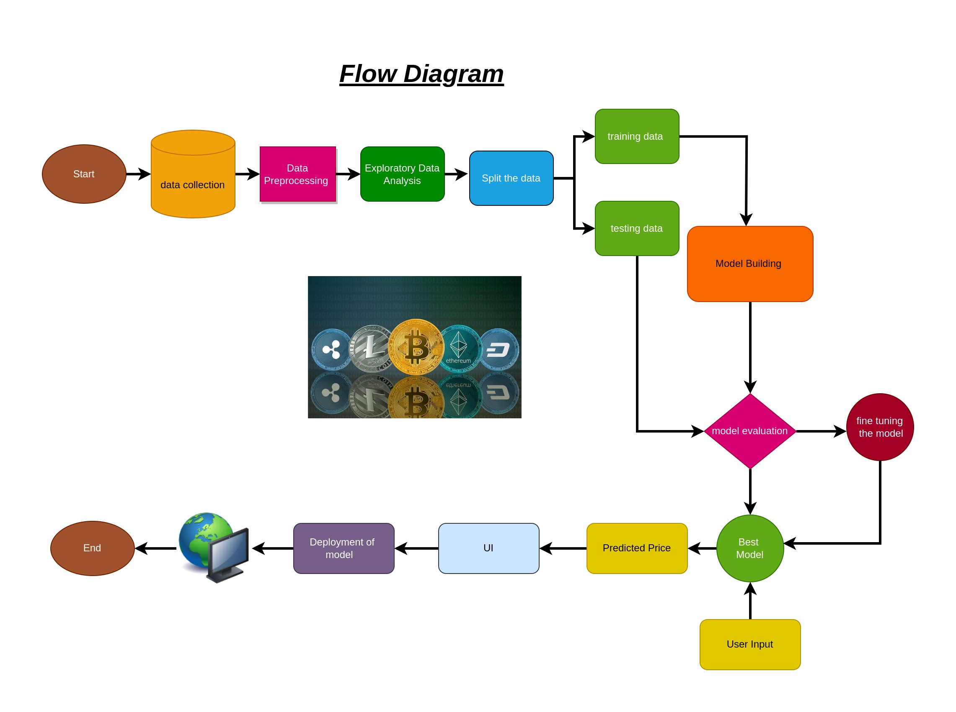
Fig 1.Flow Diagram
      - Exploratory Data Analysis:
Bitcoin Closing Price: This line graph visualizes the closing prices of Bitcoin over time, typically spanning multiple years. The x-axis represents the years, while the y-axis represents the closing prices of the Bitcoin. Each data point on the graph corresponds to the closing price of Bitcoin on a specific date. This visualization helps in understanding the trend and fluctuations in the Bitcoin prices of over the years, providing insights into its historical performance.

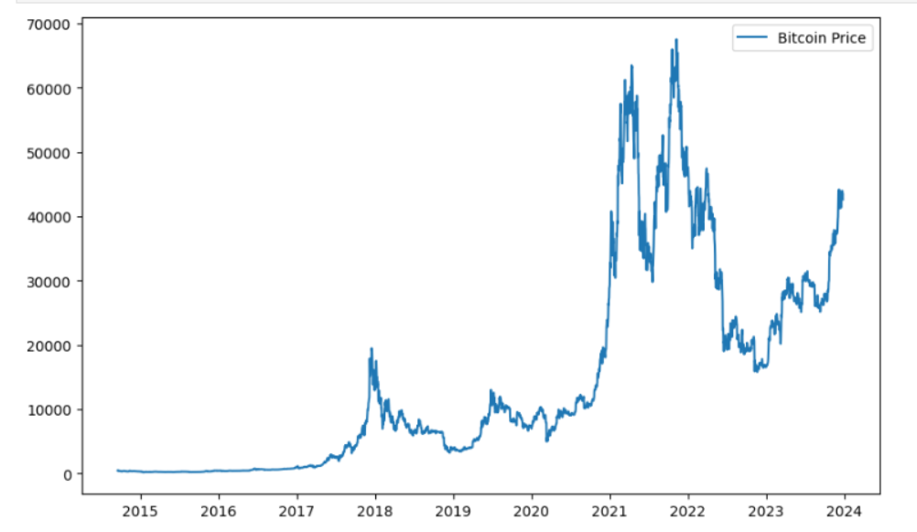
Fig 2.Closing Price of Bitcoin over the time
Distribution of Dataset : This line graph illustrates the distribution of the dataset using the density parameter, which indicates the probability density function (PDF) of the data. The x-axis represents the values of the dataset, while the y-axis represents the probability density or frequency of occurrence of those values. Unlike a histogram, which represents data in discrete bins, the density plot provides a smooth curve that shows the overall shape and spread of the data distribution. This visualization is useful for understanding the overall distributional characteristics of the dataset, including its central tendency, spread, and presence of any outliers or skewness.

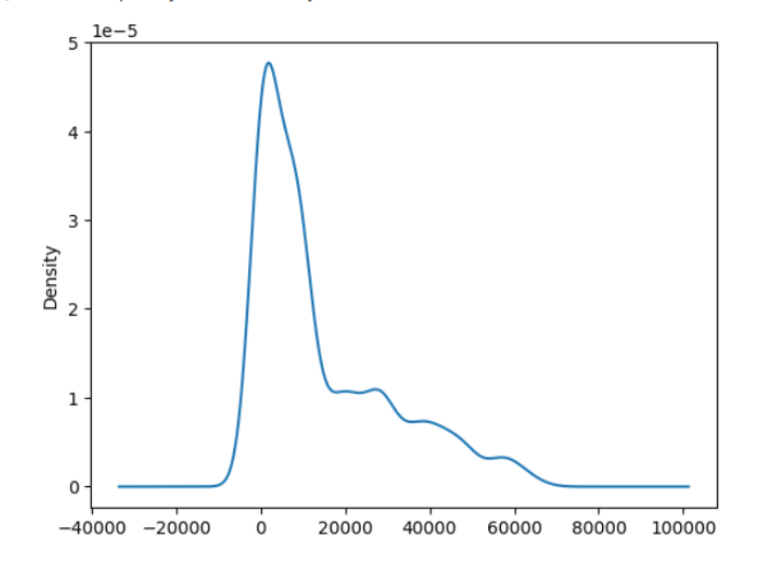
Fig 3: Distribution of data set
Seasonal Decompose: Seasonal decomposition is a technique used to decompose a time series into its underlying components, including trend, seasonal, and residual (or error) components. The seasonal decompose chart typically consists of multiple subplots, each displaying one of the decomposed components along with the original time series. These components help in understanding the various patterns and trends present in the time series data. The trend component represents the long-term direction or trend in the data, the seasonal component captures recurring patterns or seasonality, and the residual component reflects random fluctuations or noise in the data. By decomposing the time series, analysts can better understand the underlying structure of the data and identify important patterns or anomalies.

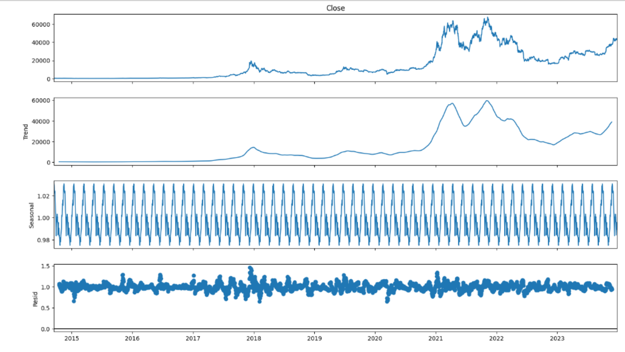
Fig 4: Seasonal Decompose

Results and discussion:

After buidling 2 Arima models in different (p,d,q) combinationS and
3 models based on Simple exponential smoothing , Holt-Winter Method , Holt Method. We decided to go with Arima model with order of (4,1,4)
because it was producing the least MAPE (Mean Absolute Percentage Error).

Error of Arima(4,1,4) model

Root Mean Sqaured Error (RMSE) : 7495.392
Mean Absolute Percentage Error (MAPE) : 0.215
Mean Error (ME) : -6530.812
Mean Absolute Error (MAE) : 6530.925

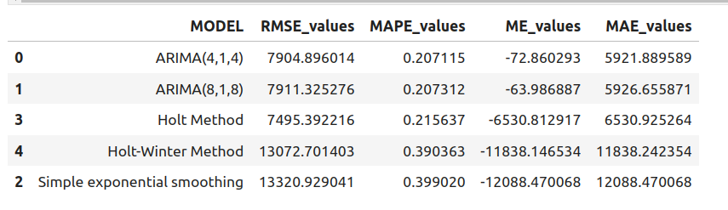

Hence after evaluating all the models we decided to build final model on entire dataset using algorithm based on Arima with order of (4,1,4).

Graphical User Interface :

In the development of our graphical user interface (GUI), Flask has been employed as the framework for creating a responsive web application. Flask, characterized as a microframework and coded in Python, is chosen due to its minimalist approach, not imposing specific tools or libraries. Unlike comprehensive frameworks, Flask lacks built-in components like a database abstraction layer or form validation, offering flexibility. Instead, it leverages third-party extensions to integrate features such as object-relational mappers, form validation, and various authentication technologies seamlessly into the application. This modular design enhances adaptability and aligns with our project's goal of creating a tailored web interface using Flask's lightweight and versatile architecture.

6. GitHubLink:

https://github.com/80543-B1/Bitcoin-Prediction-Model

Deployment on AWS cloud :
http://13.126.40.59:4000/

Tableau Visualization :
https://public.tableau.com/app/profile/rohini.alone/viz/BitcoinDataVisualization/Dashboard1?publish=yes

7.Challenges and limitations :
7.1 Challenges faced during project:

High Volatility:
Cryptocurrency markets are known for their extreme volatility. Sudden and unpredictable price movements can make it challenging to accurately model and predict future prices.

Lack of Historical Data:
Availability of historical data is essential for training and testing machine learning models. However, cryptocurrency markets, might have limited historical data, which can impact the robustness of the model.

Data Quality and Cleaning:
Cryptocurrency data can be noisy and prone to errors. Cleaning and preprocessing the data effectively is crucial for building reliable models. Handling missing values, outliers, and ensuring data consistency are common challenges.

Feature Engineering:
Selecting and engineering relevant features is crucial for the performance of the model. Understanding the factors that influence cryptocurrency prices and translating them into meaningful features can be a non-trivial task.

7.2 Limitations :

Risk Management Considerations:
While the focus is often on predicting price movements, risk management is equally crucial. Predictive models may not inherently provide guidance on managing risks associated with cryptocurrency investments.

Cryptocurrency Market Manipulation:
Cryptocurrency markets are susceptible to manipulation, including pump-and-dump schemes and market manipulation by large players. Such activities can distort typical market patterns, challenging the accuracy of predictive models.

Black Swan Events:
Unpredictable, rare, and extreme events, often referred to as "black swan" events, can significantly impact cryptocurrency prices. These events are, by nature, difficult to anticipate and incorporate into a predictive model.

8.Future work And Conclusion 8.1Future Work:
In advancing Bitcoin price prediction entails integrating macro-economic indicators, high-frequency trading data, and cross-asset correlations to optimize model comprehensiveness. Dynamic feature selection, integrating real-time market sentiment and ESG factors, coupled with sector-specific analysis, is crucial for adapting to evolving market dynamics. Developing real-time anomaly detection algorithms and leveraging behavioral analysis of market participants, including retail traders, enhances model robustness. Exploring customer sentiment analysis on financial platforms introduces innovative dimensions for obtaining nuanced predictive insights aligned with evolving market sentiments.

8.2 Conclusion:

In conclusion, our project focused on developing a Bitcoin price prediction machine learning model has been a significant endeavor in the realm of cryptocurrency analytics. Through extensive data analysis, feature engineering, and the implementation of machine learning algorithms, we aimed to forecast Bitcoin prices with accuracy and reliability.

Throughout the project, we encountered various challenges, including data preprocessing complexities, model selection dilemmas, and the inherent volatility of cryptocurrency markets. Despite these challenges, our team persevered, leveraging cutting-edge techniques and methodologies to construct a robust predictive model.

Our efforts yielded promising results, showcasing the potential of machine learning in forecasting Bitcoin prices. By leveraging historical price data, market sentiment indicators, and technical features, our model demonstrated the ability to capture underlying trends and patterns within the Bitcoin market.

8.3 References :
1.https://en.wikipedia.org/wiki/Bitcoin

