**Practical -1**

Q:- Create web app in Azure and publish using file explorer.

Step 1:-Enter the [www.portal.azure.com](http://www.portal.azure.com) in browser and sign in .

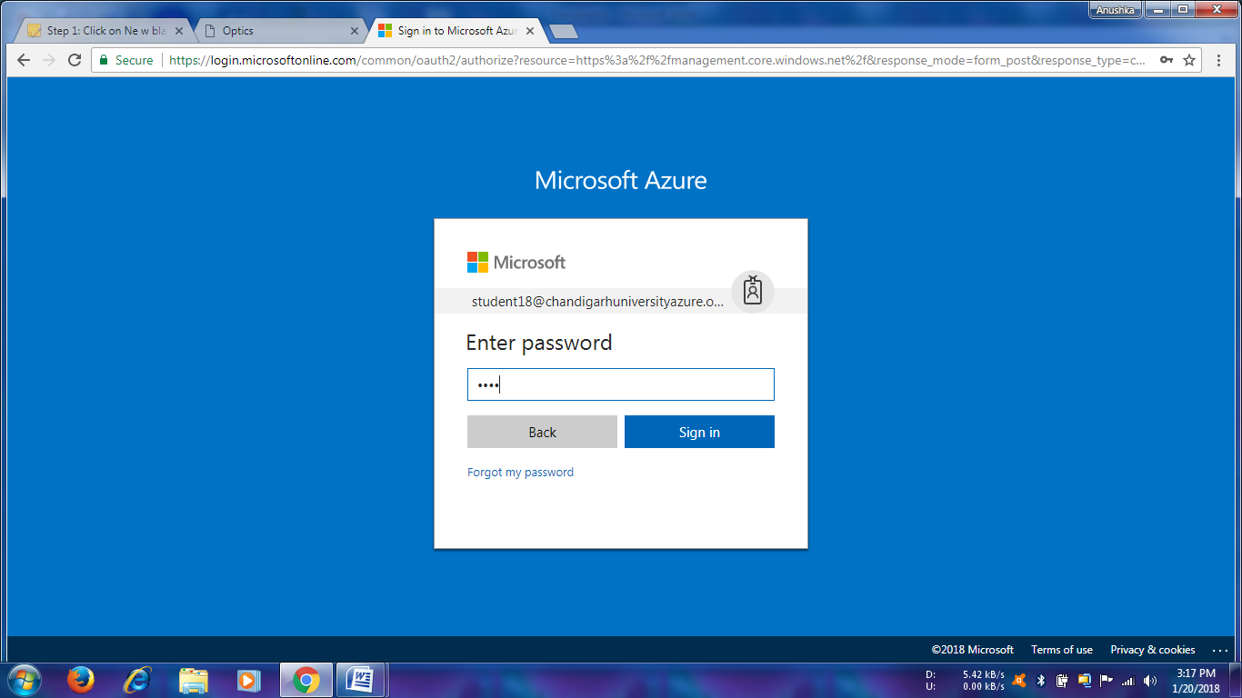

Step 2:-Now click to the New>Web App.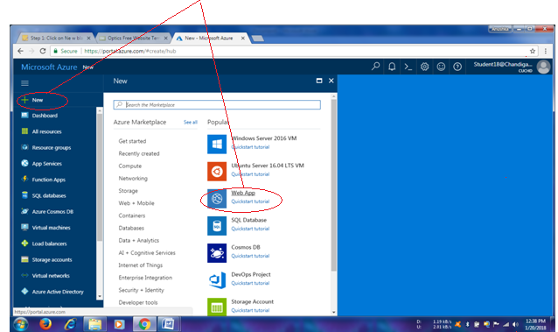

Step 3:-Enter a name for your WebApp that is available and select Subscription, Resource Group ,O.S, and Service plan.Check the pin to dashboard and click on create button .

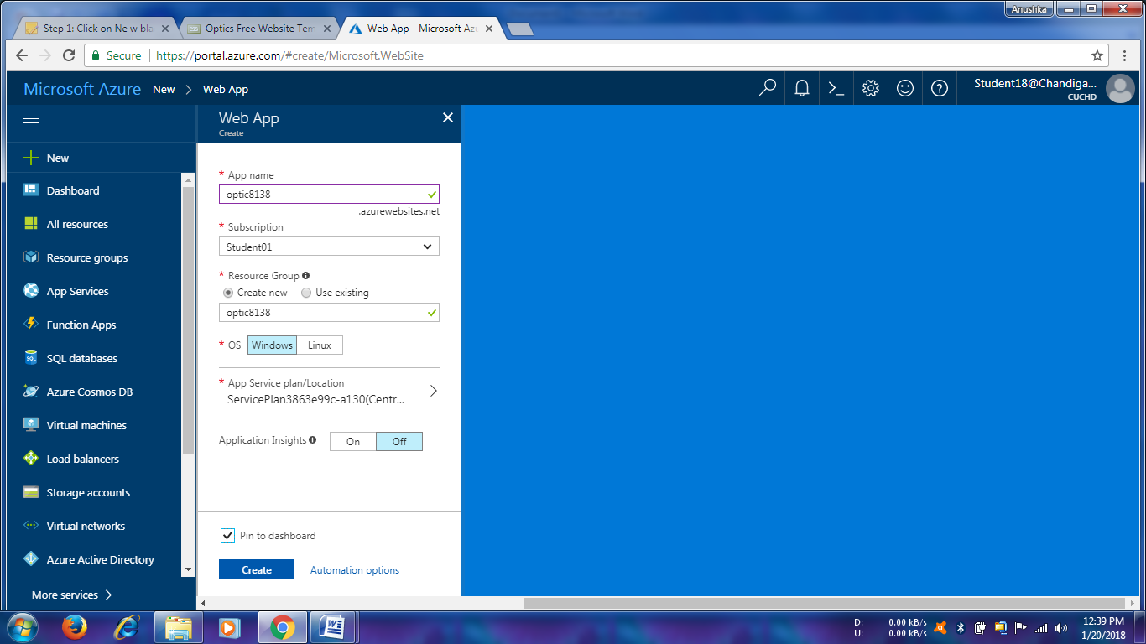

Wait for deployment-

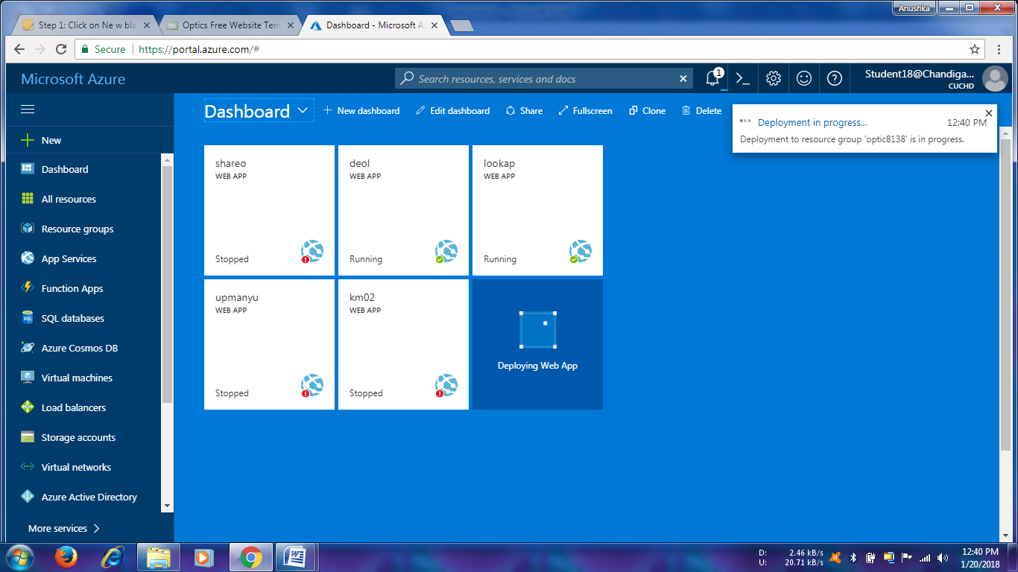

Step 4:- Download the Publish profile by clicking.

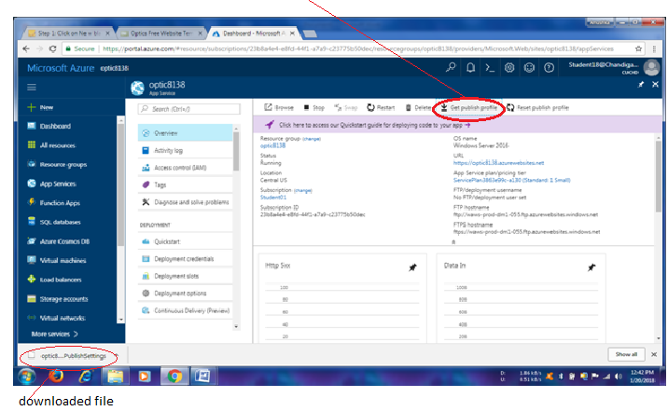

Step 5:-Copy the FTP URL and paste it in file explorer and press enter. Now you have to enter UserName and Password. you find both in that downloaded file entered them and click LogOn .

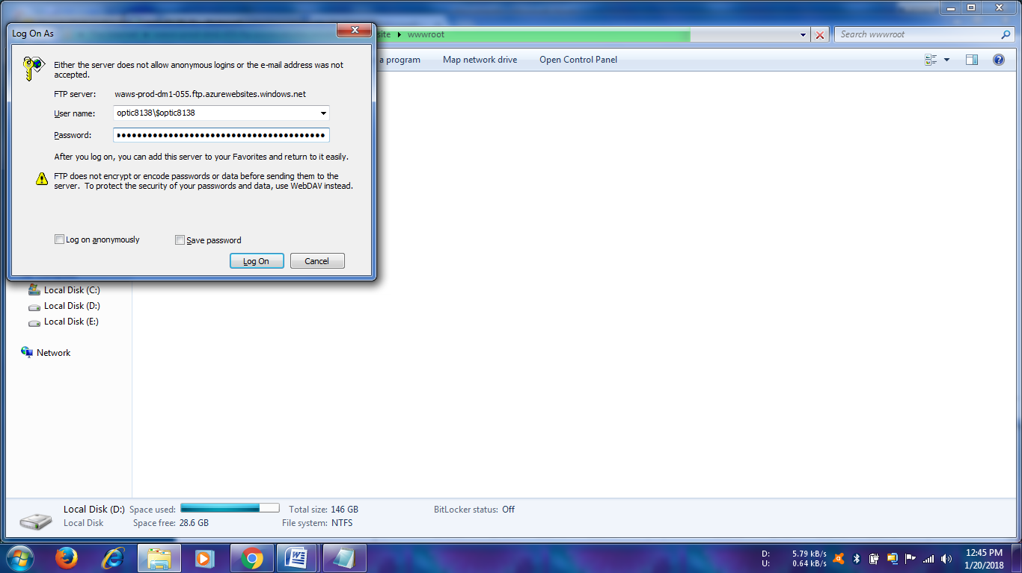

Step 6:-Yor are now in the”wwwroot” directory Paste your website here, wait until the files get copied.

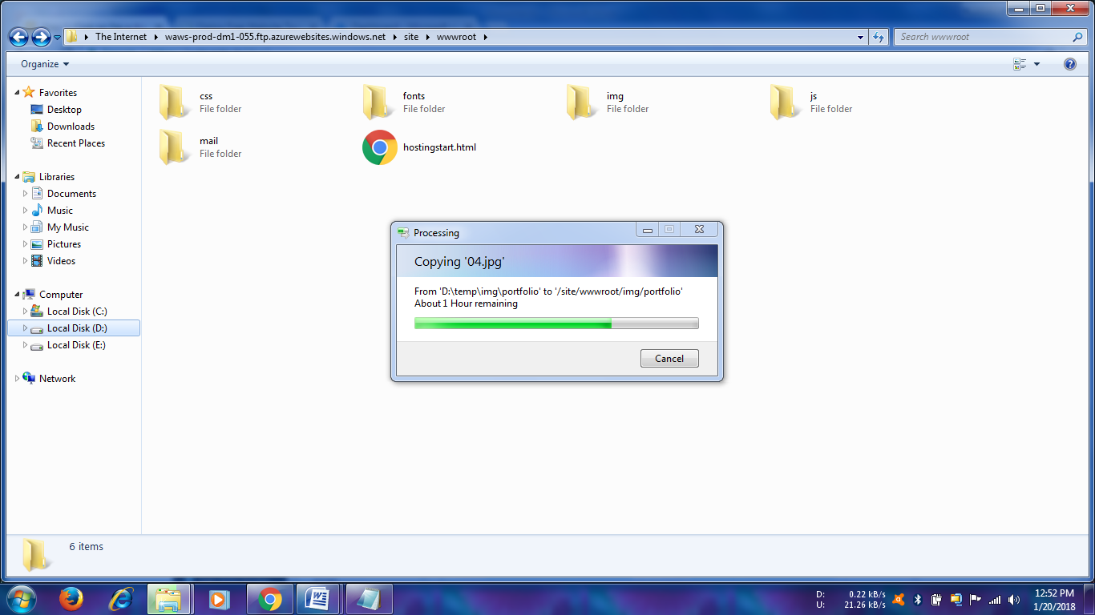

Step 7:-Now from dashboard >WebApp Overview click on the URL to open the website.

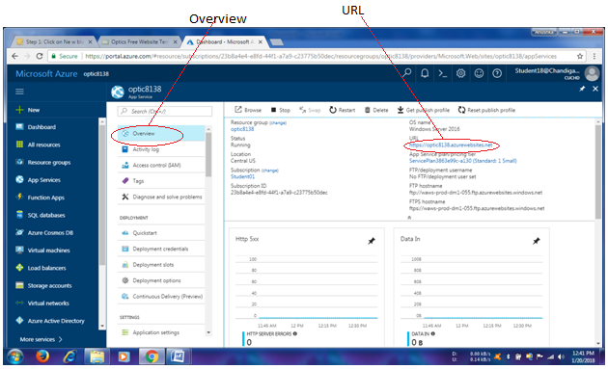

**OUTPUT:-**

