# MySQL环境搭建

## MySQL单机搭建

1. **下载**

下载地址：<https://dev.mysql.com/downloads/mysql/#downloads>

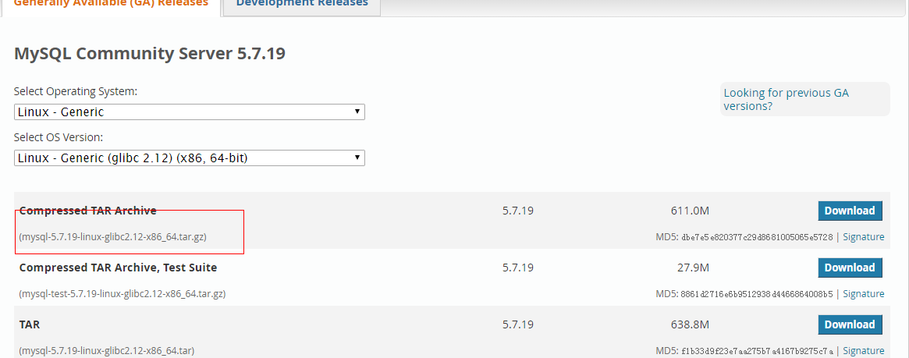

1. **解压**

**tar xvf mysql-5.7.19-linux-glibc2.12-x86_64.tar**

**mv mysql-5.7.19-linux-glibc2.12-x86_64 mysql**

1. **修改MySQL配置文件（support-files/ my-default.cnf）**

**basedir=/home/mysql**

**datadir=/home/mysql/data**

**port=3306**

**character-set-server=utf8**

**collation-server=utf8_general_ci**

**default-storage-engine=INNODB**

**max_connections=1000**

1. **修改MySQL服务配置（support-files/ mysql.server）**

**basedir=/home/mysql**

**datadir=/home/mysql/data**

1. **添加系统mysql组和mysql用户**

**groupadd mysql  
useradd -r -g mysql -s /bin/false mysql**

1. **进入安装目录且修改拥有者**

**chown -R mysql:mysql ./**

1. **安装**

**./scripts/mysql_install_db --user=mysql --basedir=/home/mysql --datadir=/home/mysql/data**



以上错误解决办法: yum install -y perl-Data-Dumper

1. **安装目录授权**

**chown -R root:root ./**

**chown -R mysql:mysql data**

1. **启动服务配置及授权**

**cp support-files/mysql.server /etc/init.d/mysql**

**chmod +x /etc/init.d/mysql**

1. **启动/停止服务**

**/etc/init.d/mysql start**

**/etc/init.d/mysql stop**

1. **MySQL用户root授权**

**Cd /home/mysql/bin**

**./mysql –uroot –p**

**mysql> use mysql;**

**mysql> GRANT ALL PRIVILEGES ON *.* TO 'root'@'%' ;**

**mysql> FLUSH PRIVILEGES;**

注：root默认密码为空

1. **辅助配置**

# 添加服务

**chkconfig --add mysql**

#启动mysql

**service mysql start**

#关闭mysql

**service mysql stop**

#查看运行状态

**service mysql status**

*#加入环境变量，编辑 /etc/profile，这样可以在任何地方用mysql命令了*

***export PATH=$PATH:/usr/local/mysql//bin***

***source /etc/profile***

## MySQL集群搭建

1. **官网下载MySQL-Cluster**

<https://dev.mysql.com/downloads/cluster/>

对应版本MySQL-Cluster v7.3.X —> MySQL 5.5.X,MySQL-Cluster v7.4.X —> MySQL 5.6.X,

MySQL-Cluster v7.5.X —> MySQL 5.7.X,

以MySQL Cluster 7.4.16(对应MySQL 5.6.37)为例

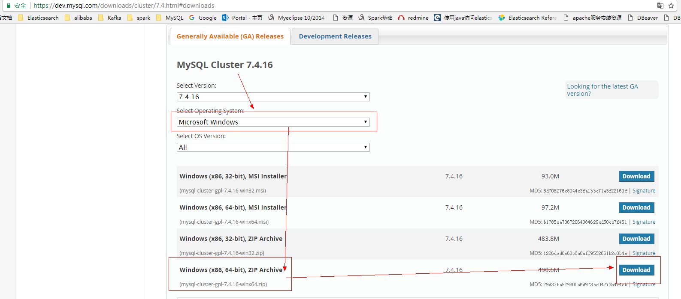

1. **解压文件**

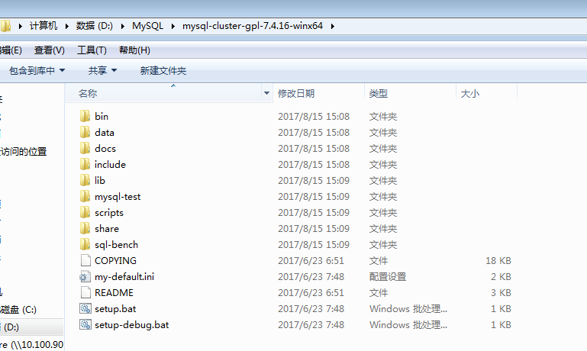

1. **配置管理点**

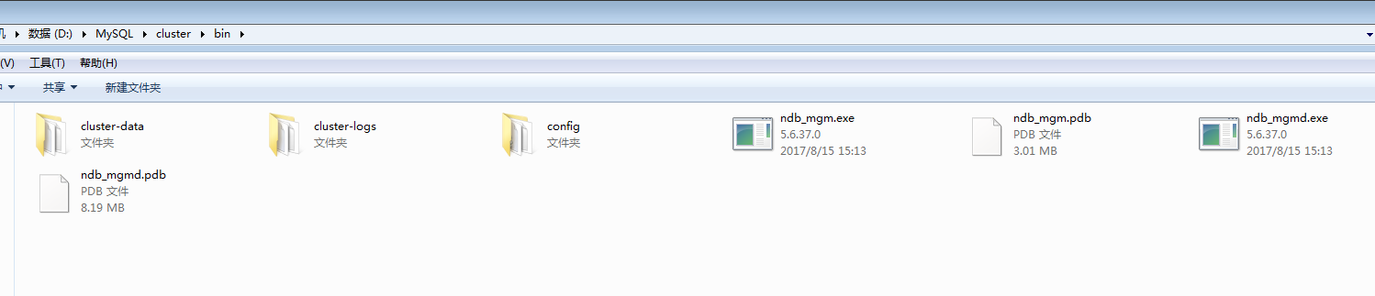

建立集群管理点，创建bin目标并在其下建立config、cluster-data、cluster-logs目录

将ndb_mgm.exe、ndb_mgmd.exe移至bin目录，并在config建立配置文件config.ini/my.ini

1. **config.ini**

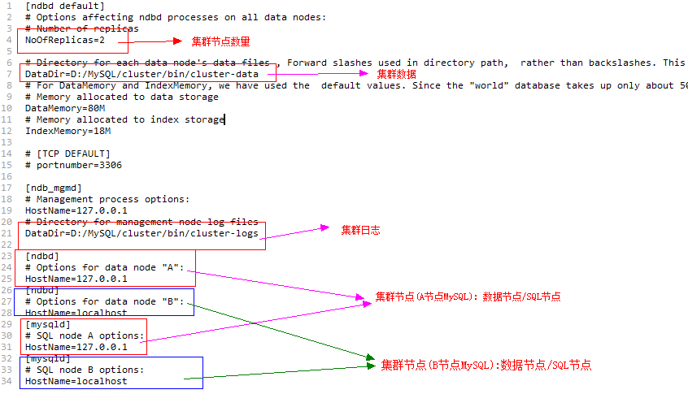

|  |
| --- |
| [ndbd default]  # Options affecting ndbd processes on all data nodes:  # Number of replicas  NoOfReplicas=2  # Directory for each data node's data files , Forward slashes used in directory path, rather than backslashes. This is correct; see Important note in text  DataDir=D:/MySQL/cluster/bin/cluster-data  # For DataMemory and IndexMemory, we have used the default values. Since the "world" database takes up only about 500KB, this should be more than enough for this example Cluster setup.  # Memory allocated to data storage  DataMemory=80M  # Memory allocated to index storage  IndexMemory=18M  # [TCP DEFAULT]  # portnumber=3306  [ndb_mgmd]  # Management process options:  HostName=127.0.0.1  # Directory for management node log files  DataDir=D:/MySQL/cluster/bin/cluster-logs  [ndbd]  # Options for data node "A":  HostName=127.0.0.1  [ndbd]  # Options for data node "B":  HostName=localhost  [mysqld]  # SQL node A options:  HostName=127.0.0.1  [mysqld]  # SQL node B options:  HostName=localhost |

1. **my.ini**

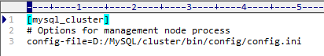

|  |
| --- |
| [mysql_cluster]  # Options for management node process  config-file=D:/MySQL/cluster/bin/config/config.ini |

1. **配置数据点**

MySQL的A/B节点可以单独安装部署也可以使用解压包中的MySQL相关文件：

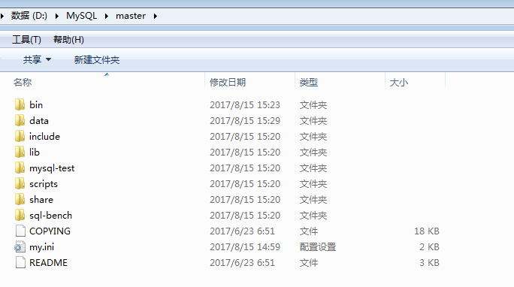

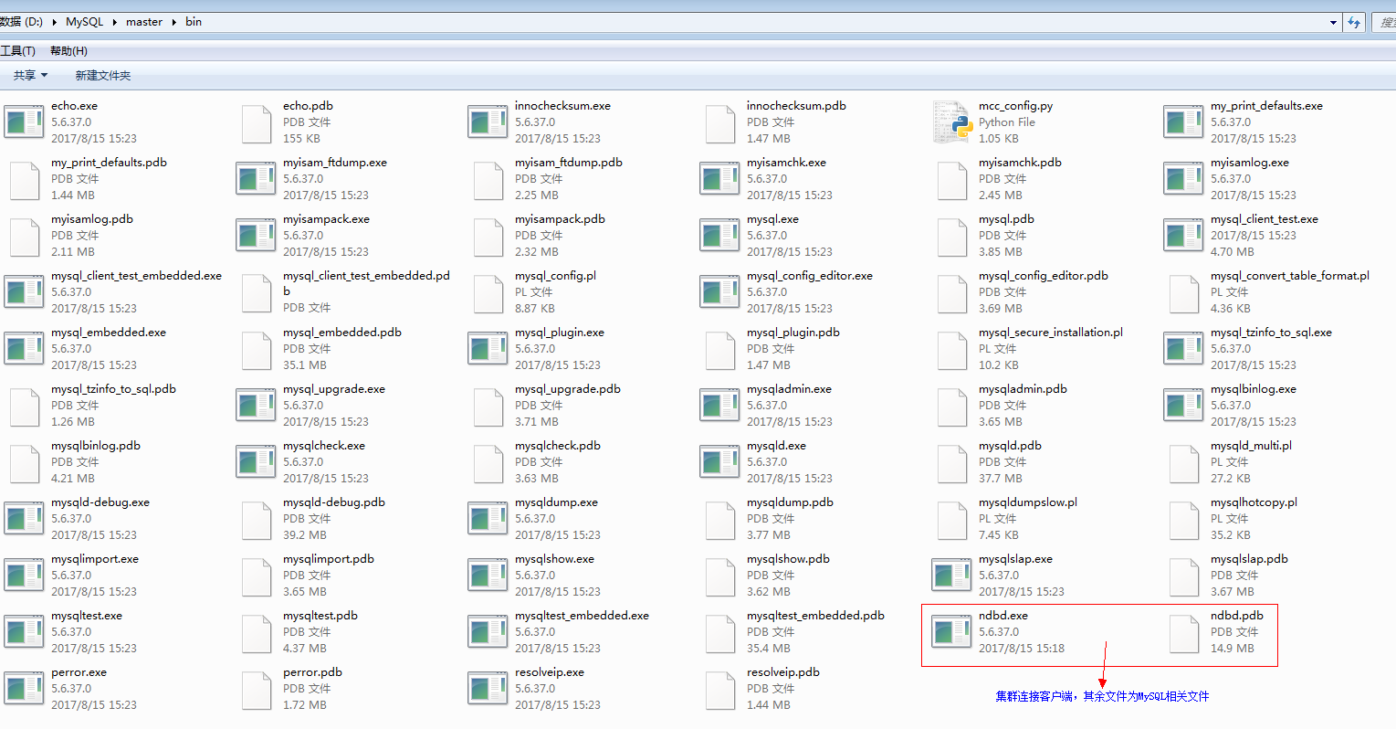

1. 复制解压包中的ndbd.exe集群客户端至MySQL安装目录bin下以便数据节点连接
2. 配置MySQL的my.ini文件(分别配置A/B节点)

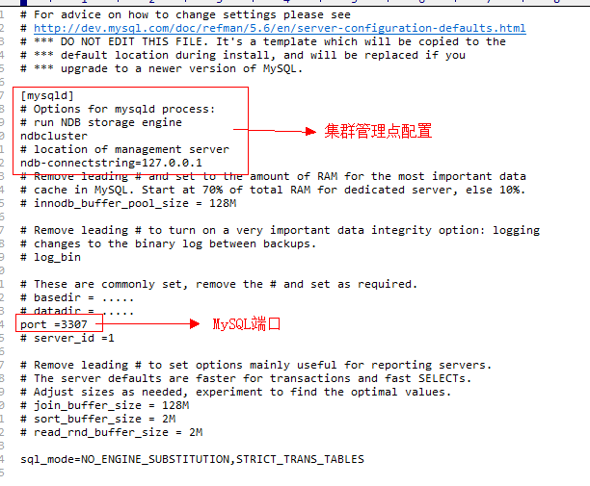

|  |
| --- |
| [mysqld]  # Options for mysqld process:  # run NDB storage engine  ndbcluster  # location of management server  ndb-connectstring=127.0.0.1 |

1. **启动集群**
2. **启动管理点**

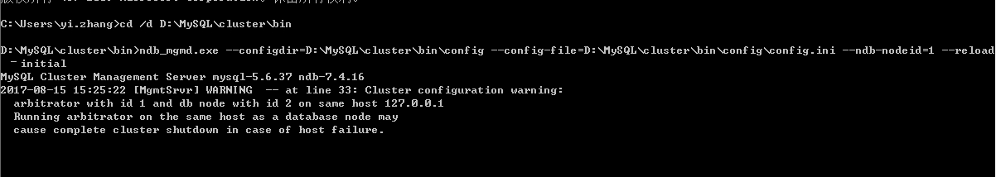

|  |
| --- |
| cd /d D:\MySQL\cluster\bin  ndb_mgmd.exe --configdir=D:\MySQL\cluster\bin\config --config-file=D:\MySQL\cluster\bin\config\config.ini --ndb-nodeid=1 --reload –initial |

1. **启动A/B数据节点**(IP地址为管理点地址)

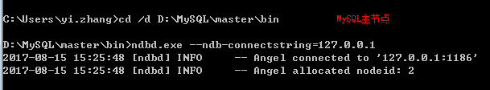

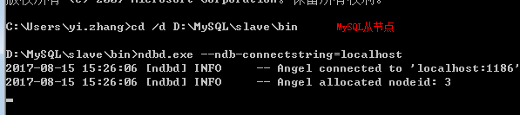

|  |
| --- |
| 主节点：  cd /d D:\MySQL\master\bin  ndbd.exe --ndb-connectstring=127.0.0.1  从节点：  cd /d D:\MySQL\slave\bin  ndbd.exe --ndb-connectstring=127.0.0.1 |

1. **启动A/B SQL节点**

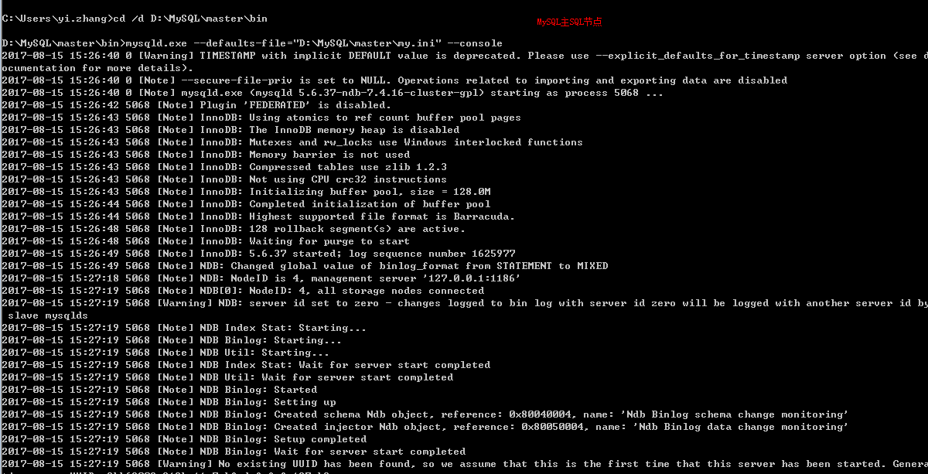

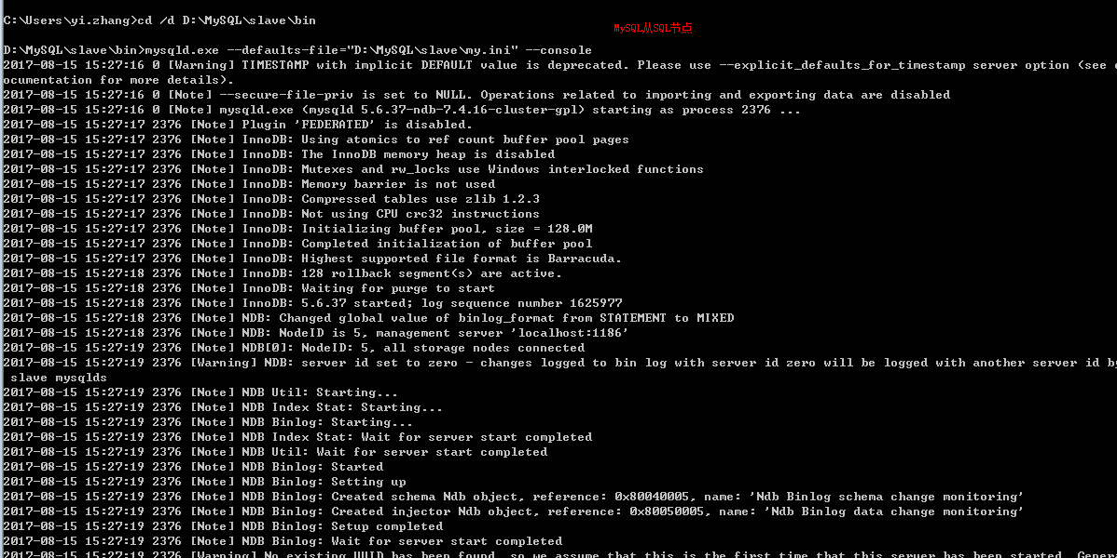

|  |
| --- |
| 主节点：  mysqld.exe --defaults-file="D:\MySQL\master\my.ini" –console  从节点：  mysqld.exe --defaults-file="D:\MySQL\slave\my.ini" --console |

1. **客户端连接操作**
2. 修改root密码(默认密码为空)

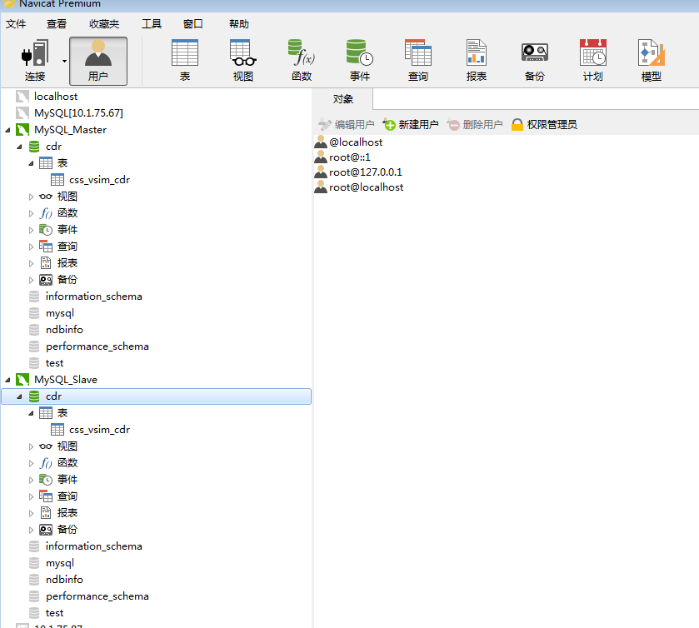

1. 创建数据库
2. 创建数据表(表引擎必须为: engine=ndbcluster)

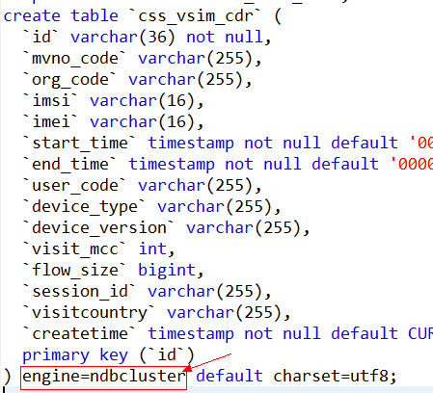

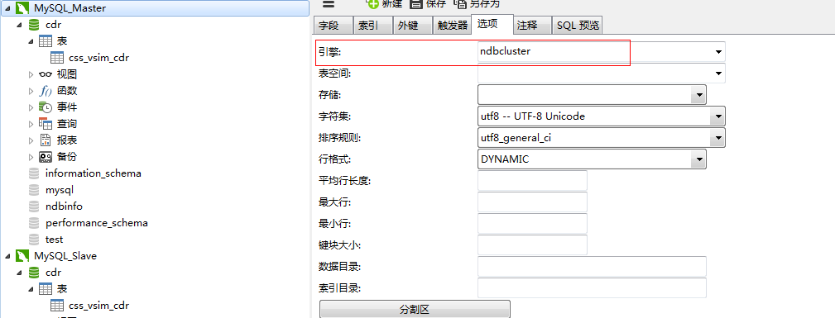

1. JDBC连接

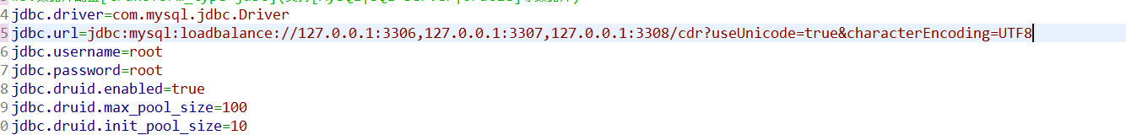

|  |
| --- |
| jdbc:mysql:loadbalance://127.0.0.1:3306,127.0.0.1:3307,127.0.0.1:3308/cdr?useUnicode=true&characterEncoding=UTF8 |

## MySQL主从搭建

1. **下载**

下载地址：<http://ftp.ntu.edu.tw/MySQL/Downloads/>

5.6.40版本：<http://ftp.ntu.edu.tw/MySQL/Downloads/MySQL-5.6/mysql-5.6.40-linux-glibc2.12-x86_64.tar.gz>

1. **解压**

**tar xvf mysql-5.6.40-linux-glibc2.12-x86_64.tar**

**mv mysql-5.6.40-linux-glibc2.12-x86_64 mysql**

1. **MySQL数据库配置（support-files/** **my-default.cnf）**

**basedir=/home/mysql**

**datadir=/home/mysql/data**

**port=3306**

**character-set-server=utf8**

**collation-server=utf8_general_ci**

**default-storage-engine=INNODB**

**max_connections=1000**

**skip-host-cache**

**skip-name-resolve**

**master库：**

**log-bin=mysql-bin**

**binlog_format=row**

**log-slave-updates=true**

**server_id=1**

**expire_logs_days=7**

**max_binlog_size=1G**

**slave库：**

**relay-log=relay-log-bin**

**relay-log-index=slave-relay-bin.index**

**server_id=2**

**max_relay_log_size=1G(默认0,根据max_binlog_size判断)**

**在线binlong设置**

**set global binlog_format=row**

**set global log-slave-updates=true(M-S/M-M中设置)**

**set global server_id=1**

**set session binlog_format=row**

**set session log-slave-updates=true(M-S/M-M中设置)**

**set session server_id=1**

**set global expire_logs_days=7**

**set global max_binlog_size=1073741824（100MB:** **104857600）**

1. **MySQL服务配置（support-files/** **mysql.server）**

**basedir=/home/mysql**

**datadir=/home/mysql/data**

1. **添加系统mysql组和mysql用户**

**groupadd mysql  
useradd -r -g mysql -s /bin/false mysql**

1. **进入安装目录且修改拥有者**

**chown -R mysql:mysql ./**

1. **安装**

**./scripts/mysql_install_db --user=mysql --basedir=/home/mysql --datadir=/home/mysql/data**



以上错误解决办法: yum install -y perl-Data-Dumper

1. **修改当前目录拥有者为root用户, data目录拥有者为mysql用户**

**chown -R root:root ./**

**chown -R mysql:mysql data**

1. **启动服务配置及授权**

**cp support-files/mysql.server /etc/init.d/mysql**

**chmod +x /etc/init.d/mysql**

1. **启动/停止服务**

**/etc/init.d/mysql start**

**/etc/init.d/mysql stop**

1. **SQL操作配置**

**master库：**

CREATE USER slave IDENTIFIED BY 'slave';

GRANT REPLICATION SLAVE, REPLICATION CLIENT ON *.* TO ' slave'@'%';

-- GRANT ALL PRIVILEGES ON *.* TO 'canal'@'%' ;

FLUSH PRIVILEGES;

**slave库：**

change master to master_host='192.168.1.11',master_user='slave',master_password='slave',master_log_file='mysql-bin.000001',master_log_pos=0;

1. **重启服务查看主从状态**

**master库：**

show master status;

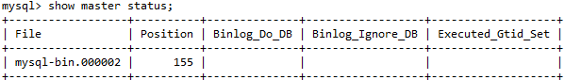

**slave库：**

stop slave;

SET GLOBAL SQL_SLAVE_SKIP_COUNTER=1;

Start slave;

show slave status;

检查Slave_IO_Running: Yes ,Slave_SQL_Running: Yes 即为成果，否则重复步骤11、12的slave操作

注：问题slave始终不成功可删除/usr/local/mysql/data/auto.cnf的uuid

## 数据库常见问题

1. **查杀进程**

my.ini配置innodb_thread_concurrency=10

数据库线程锁定解决办法(Navicate)

1. **查询线程(命令: show full processlist;)**

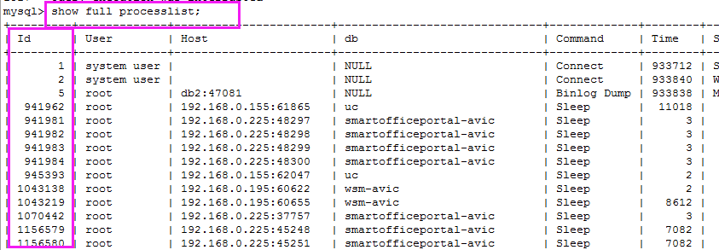

**B．杀进程(命令:kill *id*;)**

1. **解锁表**

**命令: unlock tables;**

1. **高性能配置**

**命令: set global innodb_flush_log_at_trx_commit=2;**

**set global sync_binlog=500;**

**my.cnf配置：**

**innodb_flush_log_at_trx_commit=2**

**sync_binlog=500**