文件名称：MySQL主从部署手册（Linux）

文件编号：

项目名称：调兵山项目

项目编号：

物料编码：

版 本 号：A

文件密级：秘密

文件状态：CFC

受控标识：受控

|  |  |
| --- | --- |
| 拟制/日期： | 2019年 月 日 |
| 审核： | 2019年 月 日 |
| 会签： |  |
|  |  |
| 批准： | 2019年 月 日 |

**文件发放范围：**

**修订页**

| 序号 | 版本号 | 修订内容简述 | 拟制/日期 | 审核 | 批准 |
| --- | --- | --- | --- | --- | --- |
|  | A | 创建 | 张毅 |  |  |
|  |  |  |  |  |  |
|  |  |  |  |  |  |
|  |  |  |  |  |  |
|  |  |  |  |  |  |
|  |  |  |  |  |  |
|  |  |  |  |  |  |
|  |  |  |  |  |  |
|  |  |  |  |  |  |
|  |  |  |  |  |  |
|  |  |  |  |  |  |
|  |  |  |  |  |  |
|  |  |  |  |  |  |
|  |  |  |  |  |  |
|  |  |  |  |  |  |
|  |  |  |  |  |  |
|  |  |  |  |  |  |
|  |  |  |  |  |  |
|  |  |  |  |  |  |
|  |  |  |  |  |  |
|  |  |  |  |  |  |
|  |  |  |  |  |  |
|  |  |  |  |  |  |
|  |  |  |  |  |  |
|  |  |  |  |  |  |

1. **下载**

下载地址：<https://dev.mysql.com/downloads/mysql/#downloads>

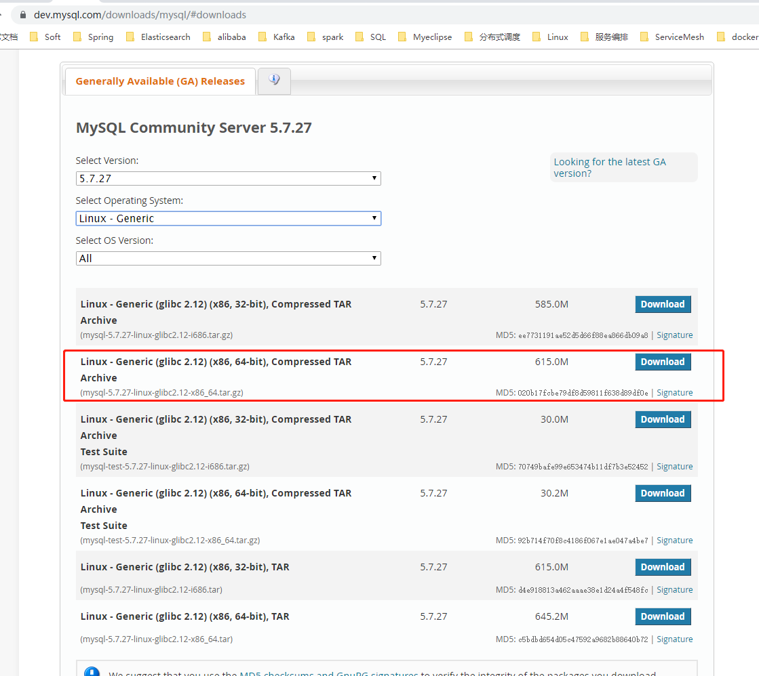

1. **解压**

**tar xvf mysql-5.7.27-linux-glibc2.12-x86_64.tar**

**mv mysql-5.7.27-linux-glibc2.12-x86_64 mysql**

1. **修改MySQL配置文件（**/etc/mysql/my.cnf**）**

**basedir=/opt/deploy/data/mysql**

**datadir=/opt/deploy/data/mysql/data**

**port=3306**

**character-set-server=utf8**

**collation-server=utf8_general_ci**

**default-storage-engine=INNODB**

**max_connections=1000**

**skip-host-cache**

**skip-name-resolve**

**master库：**

**log-bin=mysql-bin**

**binlog_format=row**

**log-slave-updates=true**

**server_id=1**

**expire_logs_days=3**

**max_binlog_size=100M**

**slave库：**

**relay-log=relay-log-bin**

**relay-log-index=slave-relay-bin.index**

**server_id=2**

**max_relay_log_size=100M (默认0,根据max_binlog_size判断)**

1. **修改MySQL服务配置（support-files/ mysql.server）**

**basedir=/opt/deploy/data/mysql**

**datadir=/opt/deploy/data/mysql/data**

1. **添加系统mysql组和mysql用户**

**groupadd mysql  
useradd -r -g mysql -s /bin/false mysql**

1. **进入安装目录且修改拥有者**

**chown -R mysql:mysql ./**

1. **安装**

**cd /opt/deploy/data/mysql**

./**bin/mysqld** [**--initialize**](https://dev.mysql.com/doc/refman/5.7/en/server-options.html#option_mysqld_initialize) **--initialize-insecure --explicit_defaults_for_timestamp=true --user=mysql  --basedir=/opt/deploy/data/mysql --datadir=/opt/deploy/data/mysql/data**

./**bin/mysqld_safe --user=mysql &**

1. **安装目录授权**

**chown -R root:root ./**

**chown -R mysql:mysql data**

1. **启动服务配置及授权**

**cp support-files/mysql.server /etc/init.d/mysql**

**chmod +x /etc/init.d/mysql**

1. **启动/停止服务**

**/etc/init.d/mysql start**

**/etc/init.d/mysql stop**

1. **MySQL用户root授权**

**Cd /opt/deploy/data/mysql/bin**

**./mysql –uroot –p**

INSERT INTO `mysql`.`user`(`Host`, `User`, `Select_priv`, `Insert_priv`, `Update_priv`, `Delete_priv`, `Create_priv`, `Drop_priv`, `Reload_priv`, `Shutdown_priv`, `Process_priv`, `File_priv`, `Grant_priv`, `References_priv`, `Index_priv`, `Alter_priv`, `Show_db_priv`, `Super_priv`, `Create_tmp_table_priv`, `Lock_tables_priv`, `Execute_priv`, `Repl_slave_priv`, `Repl_client_priv`, `Create_view_priv`, `Show_view_priv`, `Create_routine_priv`, `Alter_routine_priv`, `Create_user_priv`, `Event_priv`, `Trigger_priv`, `Create_tablespace_priv`, `ssl_type`, `ssl_cipher`, `x509_issuer`, `x509_subject`, `max_questions`, `max_updates`, `max_connections`, `max_user_connections`, `plugin`, `authentication_string`, `password_expired`, `password_last_changed`, `password_lifetime`, `account_locked`) VALUES ('%', 'root', 'Y', 'Y', 'Y', 'Y', 'Y', 'Y', 'Y', 'Y', 'Y', 'Y', 'Y', 'Y', 'Y', 'Y', 'Y', 'Y', 'Y', 'Y', 'Y', 'Y', 'Y', 'Y', 'Y', 'Y', 'Y', 'Y', 'Y', 'Y', 'Y', '', '', '', '', 0, 0, 0, 0, 'mysql_native_password', '*81F5E21E35407D884A6CD4A731AEBFB6AF209E1B', 'N', '2019-08-22 07:44:01', NULL, 'N');

**flush privileges;**

**exit;**

1. **辅助配置**

# *#加入环境变量，编辑 /etc/profile，这样可以在任何地方用mysql命令了*

***export PATH=$PATH:/usr/local/mysql//bin***

***source /etc/profile***

1. **SQL操作配置**

**master库：**

CREATE USER slave IDENTIFIED BY 'slave';

GRANT REPLICATION SLAVE, REPLICATION CLIENT ON *.* TO ' slave'@'%';

-- GRANT ALL PRIVILEGES ON *.* TO 'canal'@'%' ;

FLUSH PRIVILEGES;

**slave库：**

change master to master_host='192.168.1.11',master_user='slave',master_password='slave',master_log_file='mysql-bin.000001',master_log_pos=0;

1. **重启服务查看主从状态**

**master库：**

show master status;

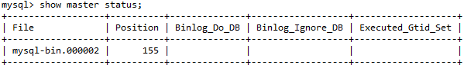

**slave库：**

stop slave;

SET GLOBAL SQL_SLAVE_SKIP_COUNTER=1;

Start slave;

show slave status;

检查Slave_IO_Running: Yes ,Slave_SQL_Running: Yes 即为成果，否则重复步骤11、12的slave操作

注：问题slave始终不成功可删除/opt/deploy/data/mysql/data/auto.cnf的uuid

1. **调优配置**

**innodb_flush_log_at_trx_commit=2**

**sync_binlog=500**

**event_scheduler=1**

**max_connections=1000**