**Prometheus+Grafana部署使用说明**

1. **部署场景**

Prometheus+Grafana以及Canal结合使用，从而达到Canal性能监控，以便掌握Canal对MySQL变化情况的性能掌握。

1. **Prometheus部署**
2. **下载**

<https://github.com/prometheus/prometheus/releases/download/v2.3.2/prometheus-2.3.2.linux-amd64.tar.gz>

1. **安装**

tar -zxvf prometheus-2.3.2.linux-amd64.tar.gz

1. **配置**

**1) 配置prometheus.yml**

|  |
| --- |
| - job_name: 'canal'  static_configs:  - targets: ['localhost:11112']  //端口配置即为canal.properties中的canal.metrics.pull.port |

**2)shell脚本(service.sh)**

|  |
| --- |
| #!/bin/bash  path="${BASH_SOURCE-$0}"  path="$(dirname "${path}")"  path="$(cd "${path}";pwd)"  base=${path}  base_path="$(cd "${base}";pwd)"  conf=${base_path}/prometheus.yml  log=${base_path}/logs/ prometheus.log  data=${base_path}/data/  adrress=0.0.0.0:9090  pid=` ps -ef| grep prometheus | grep –v grep|grep –v canal|awk ‘{print $2}’`  if [ ! -z "$pid" ] ; then  echo "---[`uname`]prometheus pid[$pid] is running ! "  kill $pid  fi  if [ ! -d ${base_path}/logs ] ; then  echo "---[`uname`]${base_path}/logs is not exist ! "  mkdir -p ${base_path}/logs  fi  if [ ! -d ${base_path}/data ] ; then  echo "---[`uname`]${base_path}/data is not exist ! "  mkdir -p ${base_path}/data  fi  if [ -f $log ] ; then  rm -rf ${base_path}/logs/*  fi  OPTS=" --config.file=$conf --web.listen-adress=$adress --storage.tsdb.path=$data --web.enable.lifecycle --web.enable.admin-api"  ./prometheus $OPTS 1>$log 2>&1 & |

1. **启动**

./service.sh

1. **Web访问**

<http://localhost:9090>

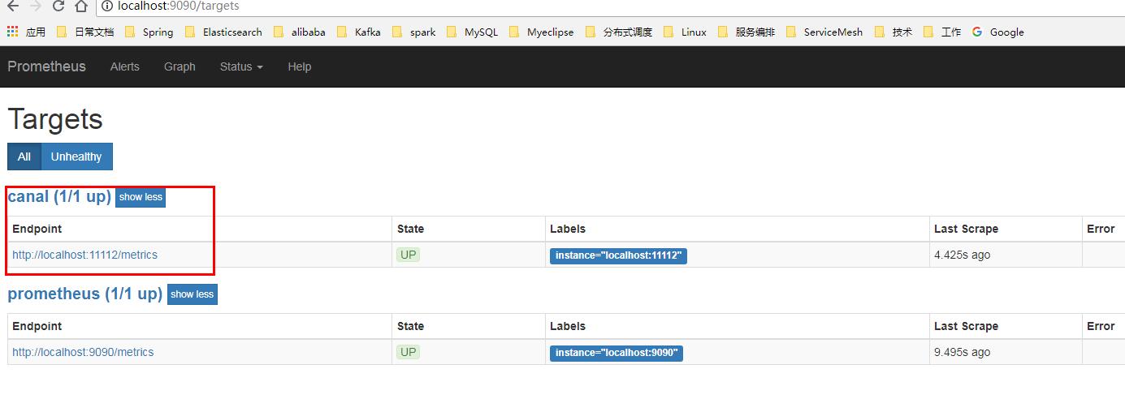

1. **Grafana部署**
2. **下载**

<https://s3-us-west-2.amazonaws.com/grafana-releases/release/grafana-5.2.2.linux-amd64.tar.gz>

1. **安装**

tar -zxvf grafana-5.2.2.linux-amd64.tar.gz

1. **配置**
2. **配置defaults.ini**

|  |
| --- |
| [paths]  data = /home/ grafana-5.2.2/data  logs = /home/ grafana-5.2.2/logs  plugins = /home/ grafana-5.2.2/plugins  provisioning = /home/ grafana-5.2.2/conf/provisioning  [server]  protocol = http  http_addr =127.0.0.1  http_port = 3000  domain = localhost  socket = /home/ grafana-5.2.2/tmp/grafana.sock |

1. **Shell脚本(service.sh)**

|  |
| --- |
| #!/bin/bash  path="${BASH_SOURCE-$0}"  path="$(dirname "${path}")"  path="$(cd "${path}";pwd)"  base=${path}/..  base_path="$(cd "${base}";pwd)"  conf=${base_path}/conf/defaults.ini  log=${base_path}/logs/server.log  pid=` ps -ef| grep grafana-server | grep –v grep|grep –v prometheus|awk ‘{print $2}’`  if [ ! -z "$pid" ] ; then  echo "---[`uname`]prometheus pid[$pid] is running ! "  kill $pid  fi  if [ ! -d ${base_path}/logs ] ; then  echo "---[`uname`]${base_path}/logs is not exist ! "  mkdir -p ${base_path}/logs  fi  if [ -f $log ] ; then  rm -rf ${base_path}/logs/*  fi  OPTS=" "  cd ${base_path}  ./bin/grafana-server start 1>$log 2>&1 & |

1. **启动**

./service.sh

1. **Web访问**

<http://localhost:3000>

用户名/密码：admin/admin

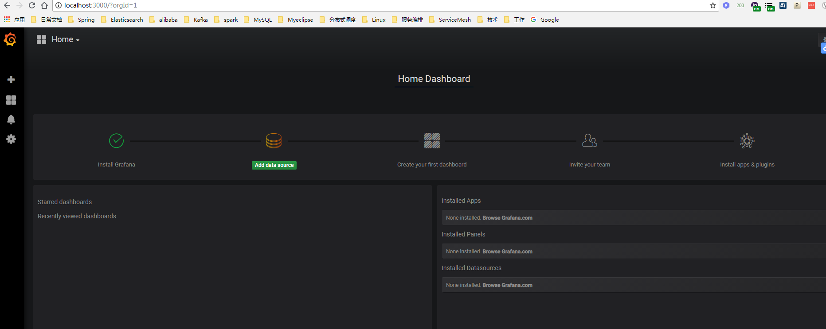

1. **Canal与Prometheus配置**
2. **Datasource配置（Prometheus）**

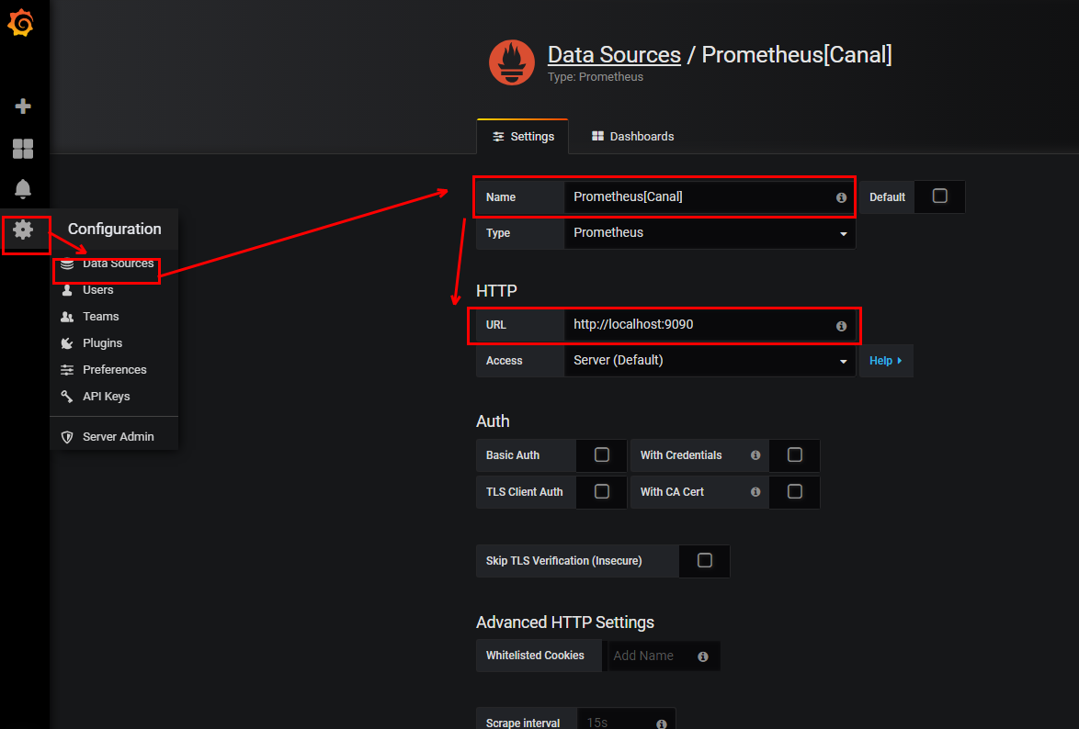

1. **DashBoard配置（Canal配置）**

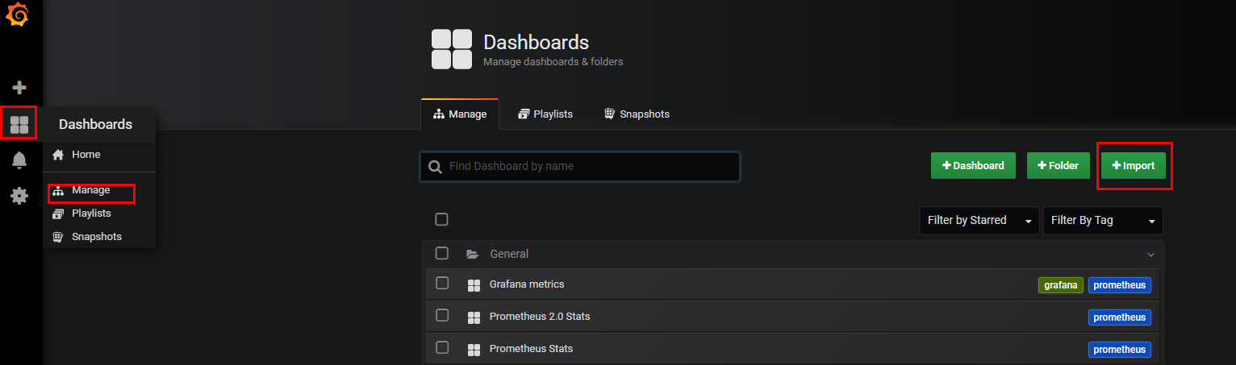

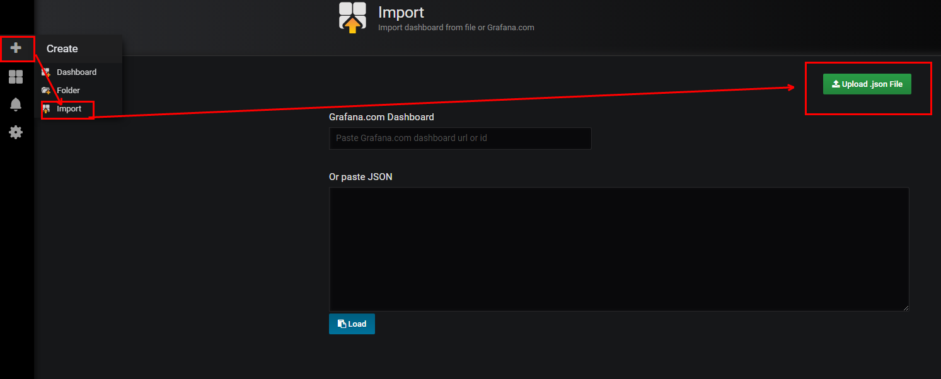

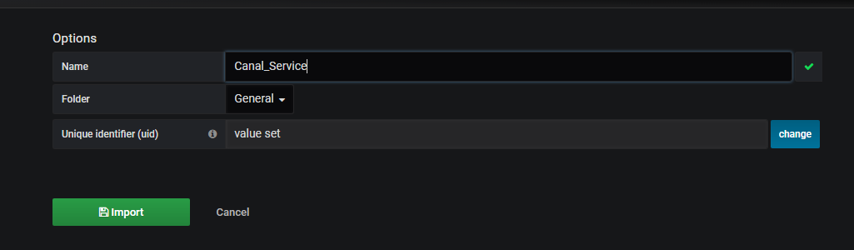

1. **Canal实例性能指标观察**

