Linux Process Manager
Project Name: Linux Process Manager
Document Type: Technical Design and Implementation Documentation
Prepared By: Anurag
Role: Intern
Organization: Accops Systems Pvt. Ltd.
Project Duration: 11 February – 6 April 2026
Platform: Ubuntu Linux Virtual Machine
Programming Language: C#
Framework: .NET 8 SDK
Kernel Feature Used : Linux Control Groups (Cgroups v2), eBPF, bpftrace, and X11 Clipboard Event Monitoring.
Testing Tool: stress-ng, clipnotify, xclip

Table of Contents
- Introduction
- Project Objectives
- System Requirements
- Development Environment Setup
- Installation of Required Packages
- Installation of .NET SDK
- Installation of Cgroup Tools
- Installation of stress-ng Tool
- Project Creation and Configuration
- Project Structure and File Description
- Application Architecture
- Command Execution Mechanism
- Suspend Process Implementation
- Resume Process Implementation
- CPU Restriction Implementation using Cgroups
- Memory Restriction Implementation using Cgroups
- Process Blocking Implementation
- User-Specific Process Blocking Implementation
- Process Monitoring and Restriction
- Exclude List Management (Process Protection Feature)
- Clipboard Monitoring and Hooking Implementation
- Testing and Demonstration Procedure
- Process Monitoring and Verification
- Error Handling and Exception Management
- Security Considerations
- Troubleshooting Guide
- Conclusion

1. Introduction
The Linux Process Manager (App.Net) is a console-based system administration application developed using C# and the .NET 8 framework. The application enables administrators to manage processes running on a Linux operating system by controlling their execution state and restricting their resource usage.
Modern operating systems allow multiple processes to run concurrently. Without proper control, some processes may consume excessive CPU or memory, which can negatively impact overall system performance.
This application solves this problem by allowing administrators to:
- Suspend processes without terminating them
- Resume suspended processes
- Restrict CPU usage of processes
- Restrict memory usage of processes
- Remove applied restrictions
The application interacts directly with the Linux kernel using system commands executed from C#. These commands use Linux Control Groups (cgroups), which is a kernel feature used to manage resource usage.

2. Project Objectives
The primary objectives of this project are:

2.1 Process Control
Provide the ability to suspend and resume processes dynamically without terminating them. This allows temporary control over process execution.

2.2 Resource Management
Allow administrators to restrict CPU and memory usage of specific processes using Linux kernel resource control mechanisms.

2.3 Kernel-Level Integration
Use Linux Control Groups (cgroups) to enforce restrictions at the kernel level, ensuring efficient and reliable resource management.

2.4 Administrative Interface
Provide a command-line interface (CLI) that allows administrators to manage processes interactively.

2.5 Demonstration of Linux Kernel Interaction
Demonstrate how a C# application can interact with Linux kernel features using system commands.

3. System Requirements

Hardware Requirements
The following hardware is required to run the application:
- Minimum 4 GB RAM
- Dual-core processor or higher
- Minimum 20 GB disk space

Software Requirements
The following software components are required:
- Ubuntu Linux 20.04 or later
- .NET SDK 8.0
- cgroup-tools package
- stress-ng tool

4. Development Environment Setup
The development and testing environment consists of Ubuntu Linux running inside a virtual machine.
- To verify the Ubuntu version, the following command is used:
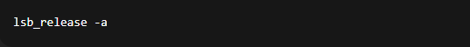

This command displays information about the Linux distribution.

- Updating system packages:
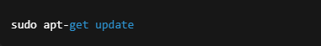

This command updates the package index and ensures the latest versions of packages are available.

5. Installation of Required Packages
To install required system packages, the following commands are used:
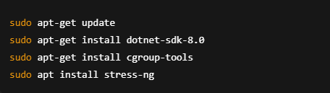
These packages provide:
- .NET runtime and SDK for C# development
- cgroup management tools
- stress testing utilities

6. Installation of .NET SDK
The .NET SDK is required to build and run the C# application.
- Installation command:
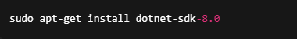

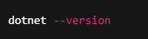
- Verification command:
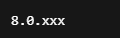
- Expected output:

This confirms that .NET SDK is successfully installed.

7. Installation of Cgroup Tools
Cgroup tools are required to create and manage control groups.
Installation command:
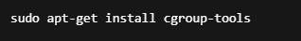
These tools provide commands such as:
- cgcreate
- cgset
- cgclassify
- cgdelete
These commands are used by the application to restrict CPU and memory usage.

8. Installation of stress-ng Tool
The stress-ng tool is used to simulate CPU and memory load for testing.
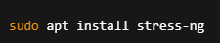
- Installation command:

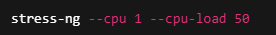
- Example CPU stress command:

- Example memory stress command:
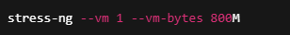

8. Installation for Process Blocking using eBPF
The process blocking functionality is implemented using eBPF (Extended Berkeley Packet Filter) and bpftrace, which allows the application to monitor process execution at the kernel level.
This feature enables blocking a process globally or for a specific user.

Required Packages:

The following packages must be installed:
• bpftrace
• python3 (for dummy_load.py demo)
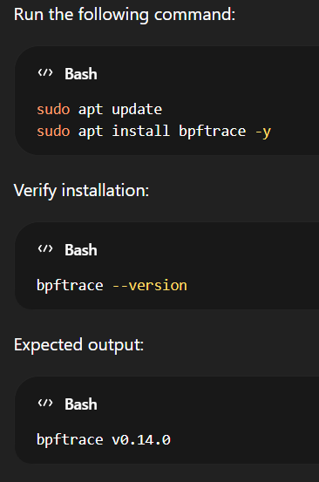
Install bpftrace:

9. Project Creation and Configuration
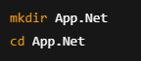
- Create project directory:

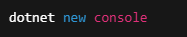
- Create new console application:

- Build the application:

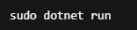
- Run the application:

This starts the Linux Process Manager CLI.

10. Project Structure and File Description
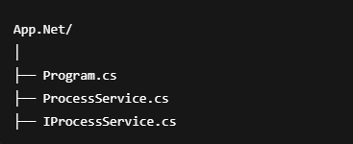
Project structure:

Program.cs
Handles user input and command routing.
ProcessService.cs
Contains implementation of process management logic.
IProcessService.cs
Defines interface methods for process management.

11. Application Architecture
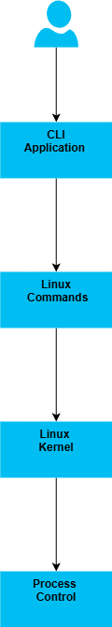
Architecture flow:

The application uses the ProcessStartInfo class to execute Linux commands.
These commands interact with the Linux kernel to control process execution.

12. Command Execution Mechanism
The application executes Linux commands using C#:
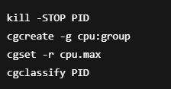

These commands interact directly with the kernel.

13. Suspend Process Implementation
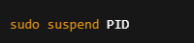
Suspend command:

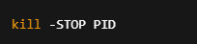
Internal command executed:

This sends SIGSTOP signal to the process.
The kernel stops process execution without terminating it.
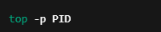
Verification:

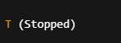
Process state becomes:

14. Resume Process Implementation
Resume command:
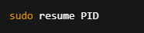
Internal command executed:
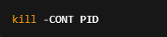
This resumes the suspended process.

15. CPU Restriction Implementation using Cgroups
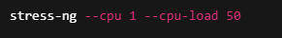
Start CPU stress:

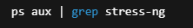
Find process ID:

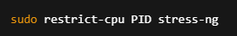
Apply CPU restriction:

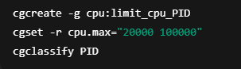
Internal commands executed:

This limits CPU usage to 20%

16. Memory Restriction Implementation using Cgroups
Start memory stress:
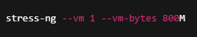
Apply restriction:
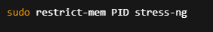
Internal commands executed:
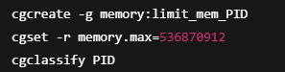
This limits memory usage to 512MB.

17.Process Blocking Implementation:
The Global Process Blocking feature prevents execution of a specific process for all users. This implementation uses eBPF and bpftrace to monitor process execution at the Linux kernel level and immediately terminate the process when detected.
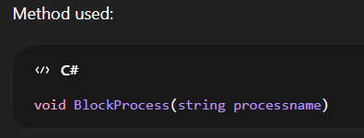

Used the “sudo block-process python3” :
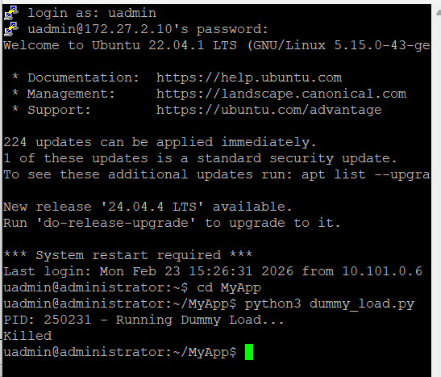
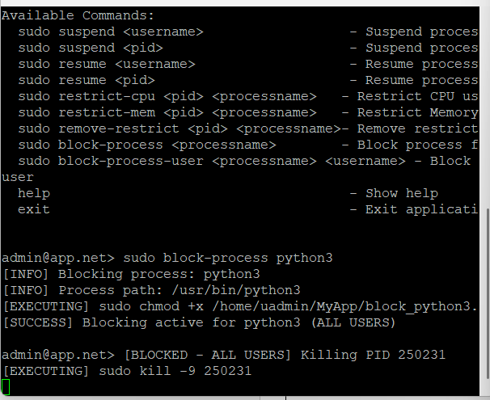

18. User-Specific Process Blocking Implementation
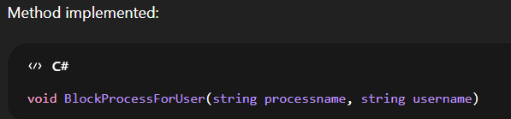
This feature blocks execution of a process for a specific user only. Other users are not affected.

Command executed:
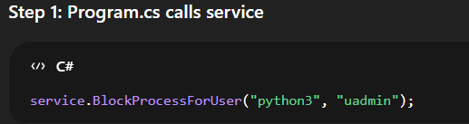

Create UID-specific script:

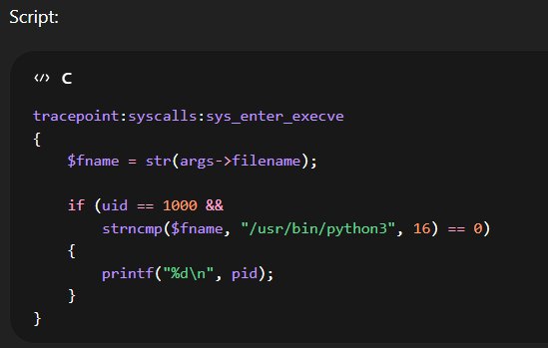

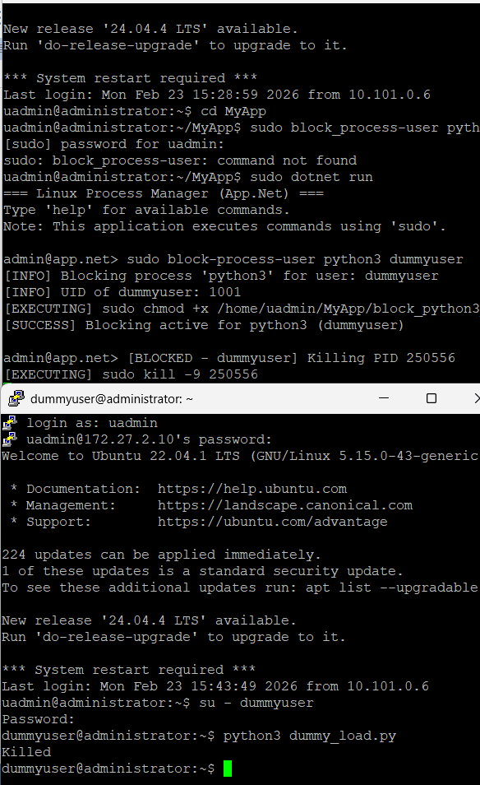

19. Process Monitoring and Restriction
The Linux Process Manager includes an automatic monitoring system that continuously observes system resource usage and applies restrictions when excessive CPU or memory consumption is detected.
This feature ensures that the system remains stable and prevents any single process from consuming excessive resources that could degrade overall performance.
The monitoring system runs in the background and performs the following operations:
• Monitors total CPU usage of the system
• Monitors total memory usage of the system
• Identifies processes consuming excessive resources
• Automatically applies CPU and memory restrictions using Linux Control Groups (cgroups)
This functionality is implemented in the SystemMonitorService class.

Monitoring Mechanism :
The monitoring system runs continuously in a background thread.
The following steps are performed repeatedly:
Step 1: Read system CPU usage
Command executed internally:

This calculates total CPU usage by subtracting idle CPU percentage from 100%.

Step 2: Read system memory usage
Command executed internally:
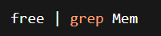
This retrieves total and used memory values.
Step 3: Calculate memory usage percentage
Memory Usage % = (Used Memory / Total Memory) × 100
Step 4: Compare with threshold values
Threshold values used:
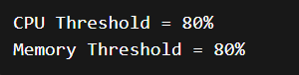
If CPU usage or memory usage exceeds these values, restriction is triggered.

Process Identification:
When threshold is exceeded, the system identifies high resource-consuming processes.
Internal command executed:

This command retrieves:
• Process ID (PID)
• Process Name
• CPU usage percentage
• Memory usage percentage
The system selects processes with:
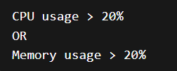

Automatic CPU Restriction:
When a process exceeds resource limits, CPU restriction is applied automatically.
Steps performed:
Step 1: Create cgroup directory

Step 2: Set CPU usage limit
This limits CPU usage to:
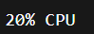
Step 3: Assign process to cgroup

Automatic Memory Restriction
Memory restriction is applied using cgroups.
Steps performed:
Step 1: Create cgroup directory
Step 2: Set memory limit
This limits memory usage to:
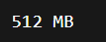
Step 3: Assign process to cgroup
Normal Condition:
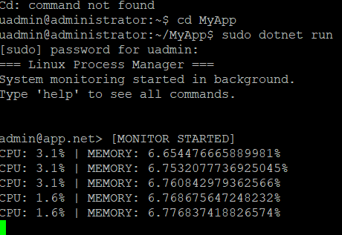

After Stress-ng:
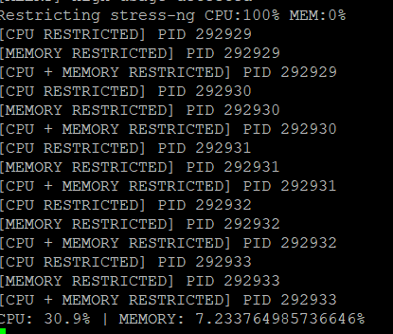

Verify:

20. Exclude List Management (Process Protection Feature)

Introduction
The Exclude List feature is implemented to prevent critical system processes and administrator-defined processes from being affected by process management operations such as:
- Suspend
- Resume
- CPU restriction
- Memory restriction
- Blocking
This ensures that essential system services are not accidentally interrupted, which could lead to system instability or crashes.

Types of Excluded Processes
The application maintains two types of excluded processes:

1. Default Excluded Processes (System Protected)
These are predefined critical system processes that cannot be removed.
Example:
- systemd
- bash
- sudo
- sshd
- init
- dotnet
- MyApp
These are stored internally in the application.

2. User-Defined Excluded Processes
Administrators can dynamically add or remove processes from the exclude list during runtime.
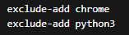

Working Mechanism:
Before performing any operation on a process, the system checks whether the process is part of the exclude list.

Validation Logic:

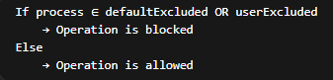

Implementation Details
The exclude list is implemented using two collections:
- defaultExcluded → fixed list (cannot be modified)
- userExcluded → dynamic list (modifiable at runtime)

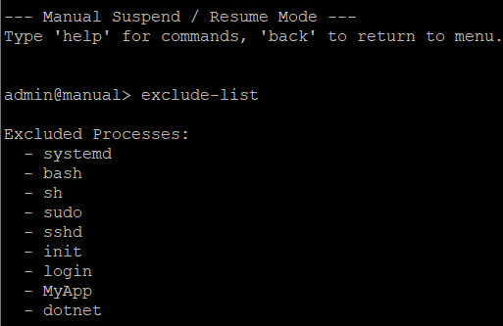

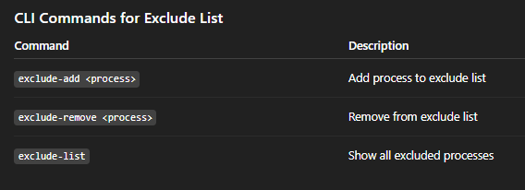

21. Clipboard Monitoring and Hooking Implementation

Introduction
The Linux Process Manager also includes a Clipboard Monitoring and Hooking feature that allows the system to observe clipboard activity in real time and modify clipboard content when required.
Clipboard operations are common in desktop environments where users frequently copy and paste information. In some cases, administrators may need to monitor clipboard usage or automatically modify specific content copied by users.
This feature enables the application to:
• Detect clipboard changes in real time
• Read the current clipboard content
• Replace specific text within the clipboard
• Update the clipboard with modified content
The implementation uses Linux clipboard utilities and event-driven monitoring mechanisms.

Clipboard Monitoring Mechanism:
The system monitors clipboard activity using the clipnotify utility.
The clipnotify tool listens for clipboard ownership changes using the X11 XFixes extension.
When a clipboard change occurs, the application is notified immediately.
This approach is event-driven, meaning the system reacts only when clipboard content changes, instead of continuously polling the clipboard.
Internal mechanism:
- The application launches the clipnotify process.
- The process blocks until clipboard ownership changes.
- When the user copies new content, clipnotify exits.
- The application reads the updated clipboard content.
- A C# event is triggered to notify the system.

Clipboard Hooking (Text Replacement):
The Clipboard Hook feature allows the system to automatically modify clipboard content.
When clipboard data is copied, the application performs the following steps:
Step 1: Detect clipboard change using clipnotify
Step 2: Retrieve clipboard content
Step 3: Check if the clipboard contains specific text
Step 4: Replace the text if a match is found
Step 5: Write the modified content back to the clipboard

Real-Time Clipboard Event Handling:
The system implements an event-driven model using C# events.
This event is triggered whenever the clipboard content changes.
The event provides the updated clipboard text as a parameter, allowing other components of the application to react to clipboard activity.
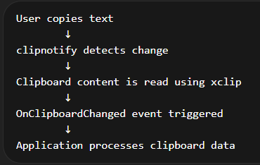

Demonstration:
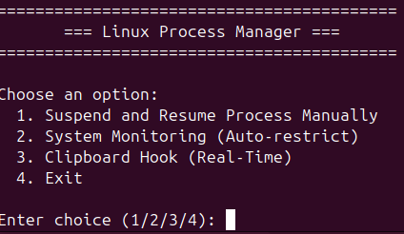

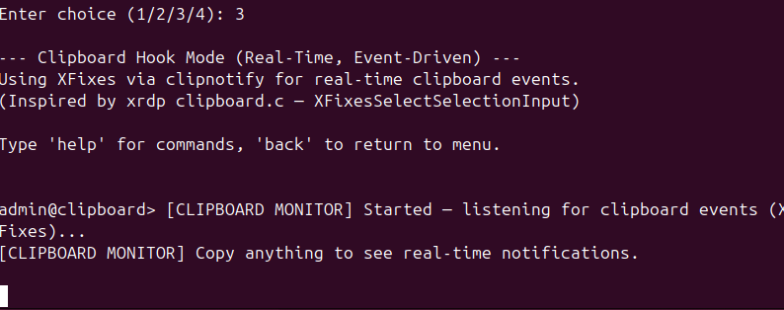

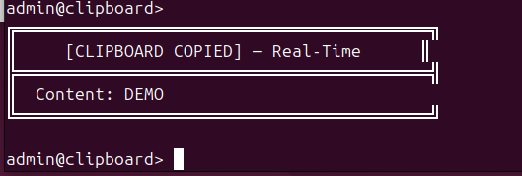

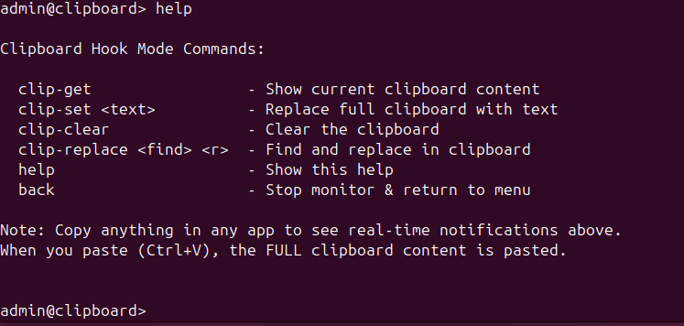

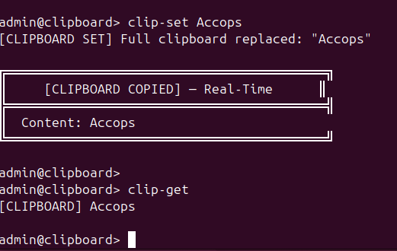

22. Testing and Demonstration Procedure
Test suspend:
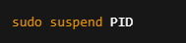
Test resume:
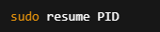
Test CPU restriction:
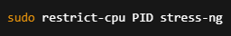
Test memory restriction:
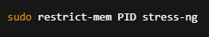
Process Blocking:
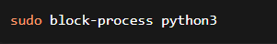
User-Specific Process Blocking:
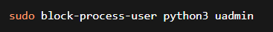

Process Monitoring and Restriction:

Workflow diagram (Monitoring):
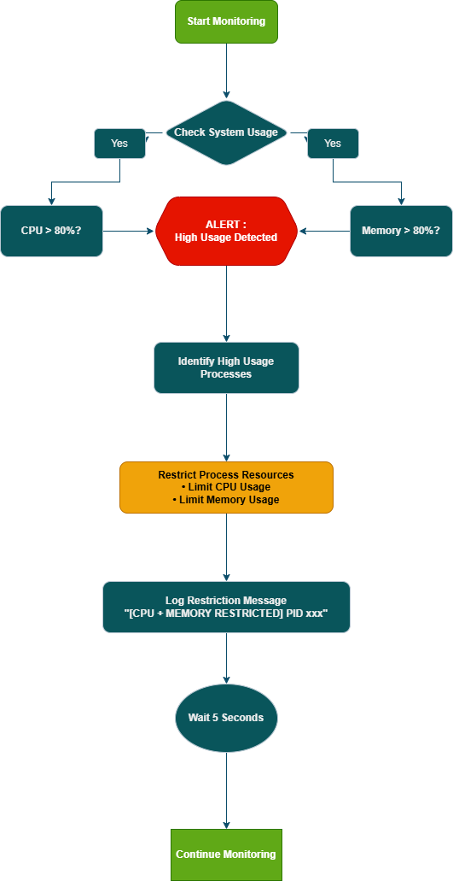

23. Process Monitoring and Verification
Commands used:
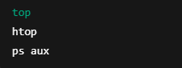
These commands show process state and resource usage.
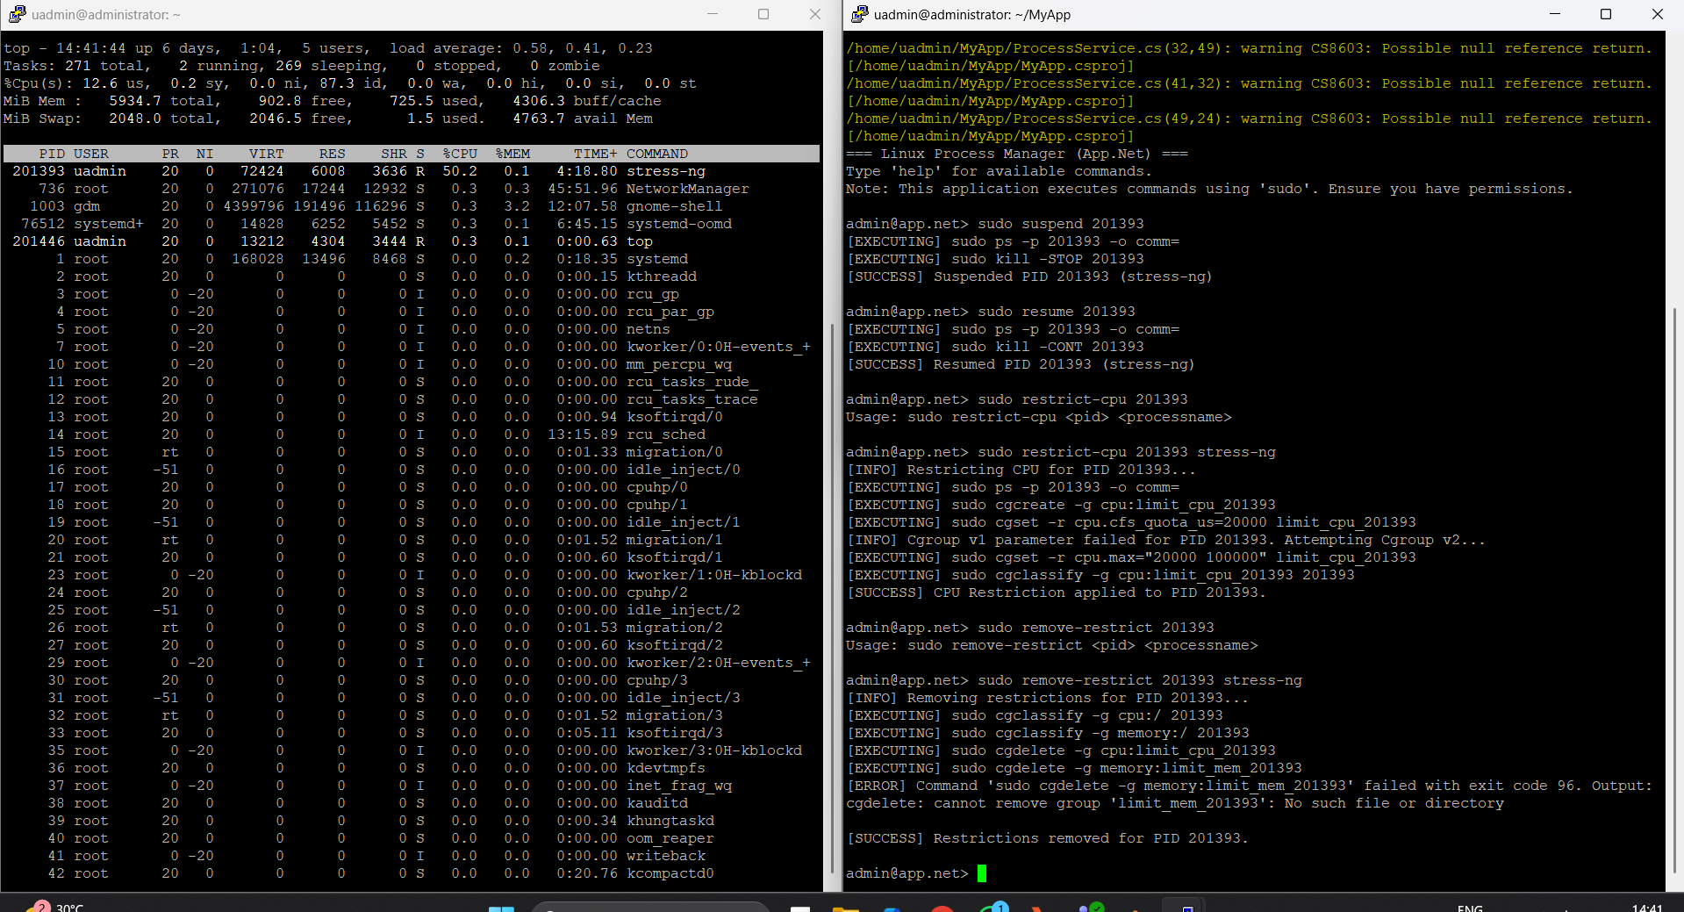

24. Error Handling and Exception Management
Handled errors include:
- Invalid PID
- Permission errors
- Command execution failure
Error messages are displayed to the user.

25. Security Considerations
Critical system processes are excluded:
- systemd
- bash
- sudo
- dotnet
This prevents system crash.

26. Troubleshooting Guide
Permission denied → Use sudo
PID not found → Use ps aux
cgroup error → Install cgroup-tools

27. Conclusion
The Linux Process Manager successfully implements process control, resource management, automatic system monitoring, and clipboard monitoring using C# and Linux kernel features. The application allows administrators to suspend and resume processes using Linux signals (SIGSTOP and SIGCONT), enabling safe control of process execution without terminating them.
The project demonstrates CPU and memory restriction using Linux Control Groups (cgroups), which enforce resource limits at the kernel level and help maintain system stability and performance. The application also includes automatic process monitoring, which continuously tracks system CPU and memory usage and automatically applies restrictions to high resource-consuming processes when predefined thresholds are exceeded.
In addition, the system implements global and user-specific process blocking using eBPF and bpftrace, providing enhanced security and administrative control. The integration of C# with Linux system commands using ProcessStartInfo enables effective interaction with kernel-level features.
A key feature of the system is the Exclude List functionality, which ensures that critical system processes and administrator-defined processes are protected from any management operations. Before executing actions such as suspend, resume, or resource restriction, the system verifies whether the process is part of the exclude list. If a process is found in this list, the operation is safely blocked and an event notification is generated. This mechanism prevents accidental interruption of essential system services, thereby enhancing system reliability and stability.
The project also demonstrates a real-time clipboard monitoring and hooking mechanism. The application monitors clipboard changes using the clipnotify utility and retrieves clipboard data using the xclip tool. When clipboard content changes, the system detects the event, reads the clipboard data, and can optionally modify the text before updating the clipboard. This event-driven clipboard monitoring system demonstrates interaction with the Linux graphical clipboard environment and provides the ability to dynamically analyze or modify copied text.
Overall, the project demonstrates the practical implementation of process management, automatic resource restriction, clipboard monitoring, protected execution through exclude lists, and kernel-level process control in a Linux environment using C# and .NET, ensuring efficient system performance, security, and robustness.

