**Online compliant registration and management system**

Name : vemula reddeppa

Email : [reddeppavemula7@gmail.com](mailto:reddeppavemula7@gmail.com)

Roll NO : 20HU1A0451

College Name : Chebrolu engineering college Phone number: 9676462696

**source code:**

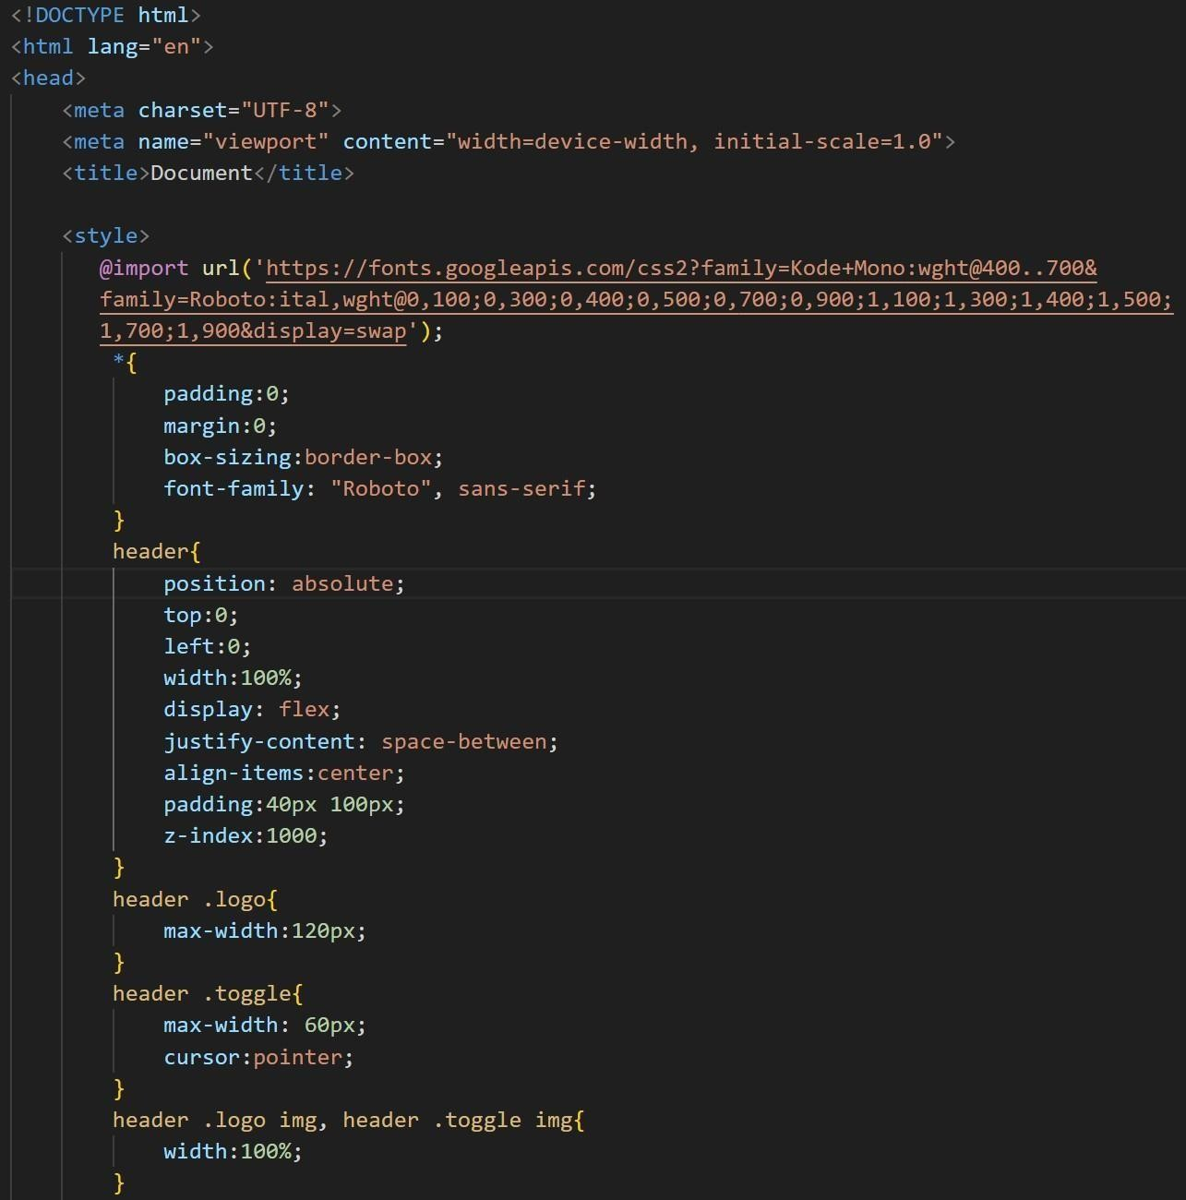

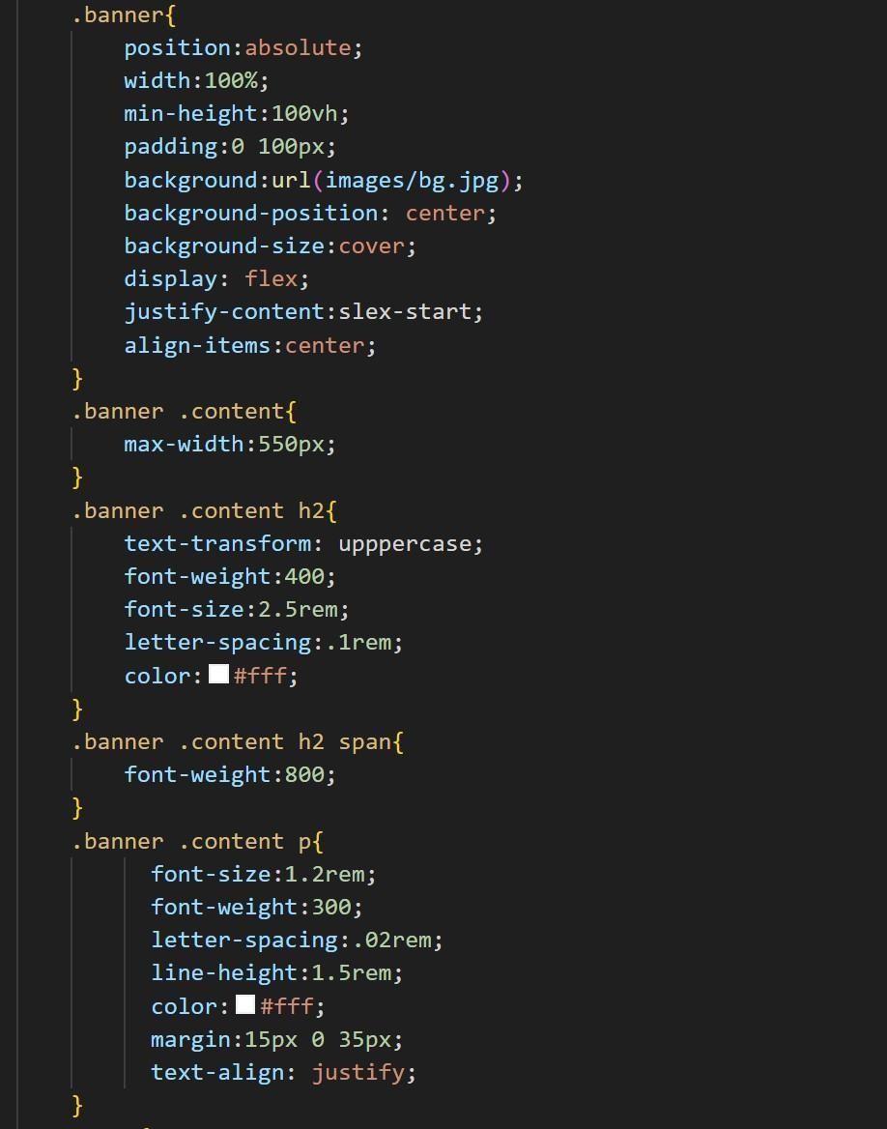

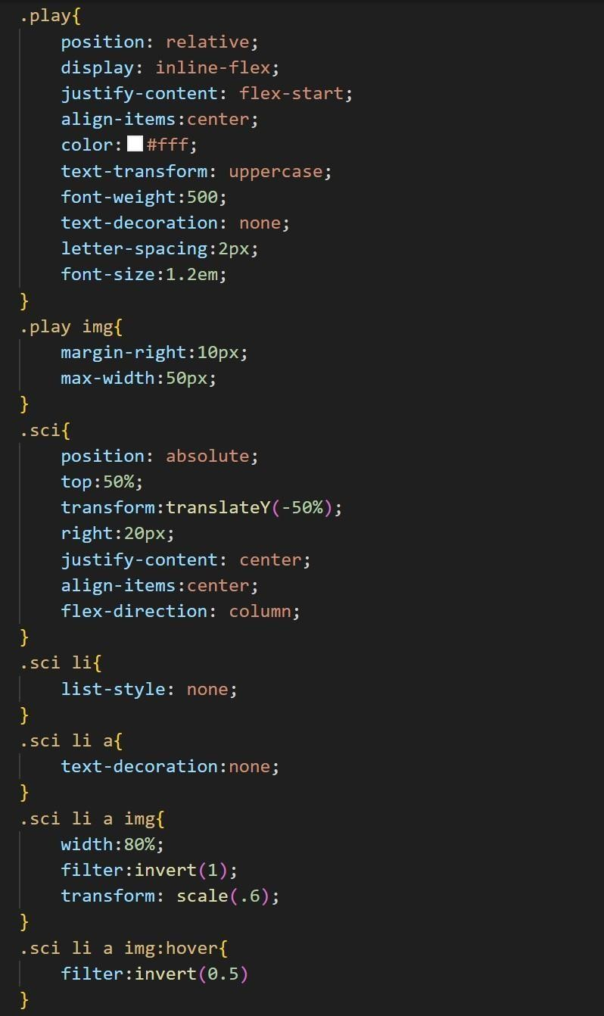

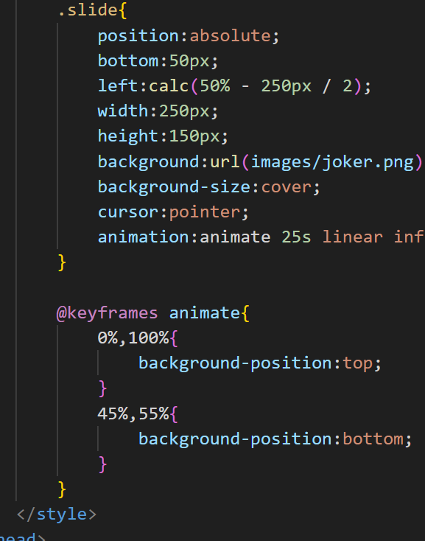

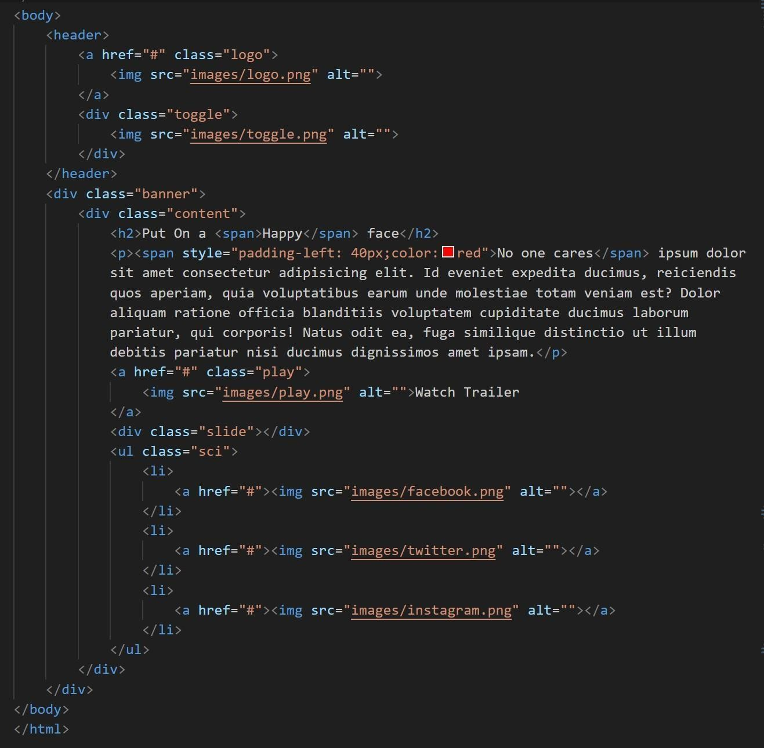

**flnal output :**



live demo : <https://4727yesuraju.github.io/static-webpage/> source code: <https://github.com/4727yesuraju/static-webpage>