React.js Component Creation

Name : vemula reddeppa

Email:reddeppavemula7@gmail.com

Phone no : 9676462696

Roll NO : 20HU1A0451

College Name : Chebrolu engineering college

**Source Code:**

**CARD COMPONENT:**

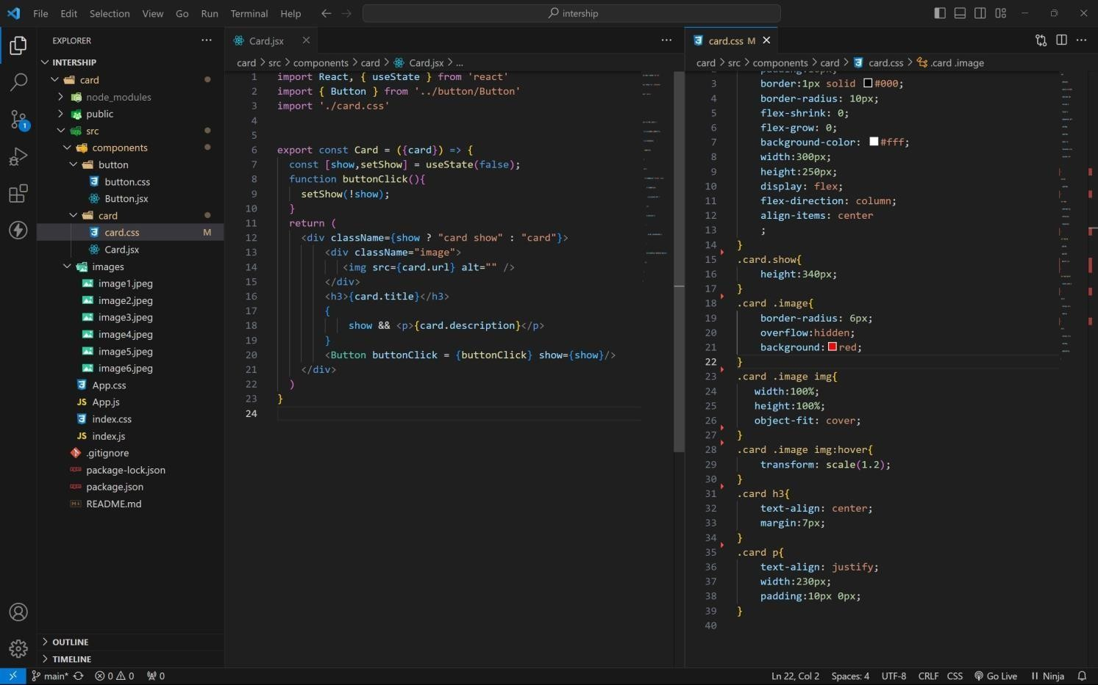

BUTTON COMPONENT:

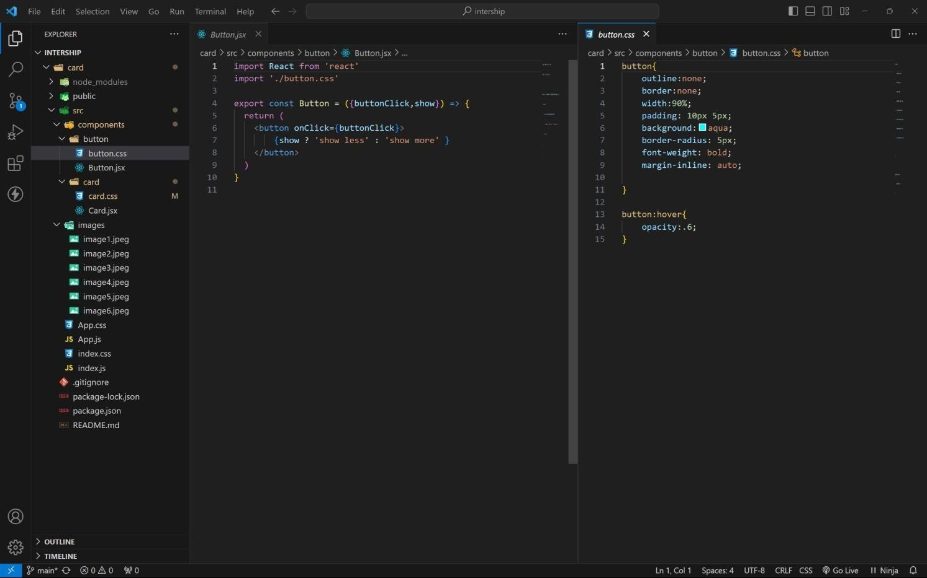

APP COMPONENT:

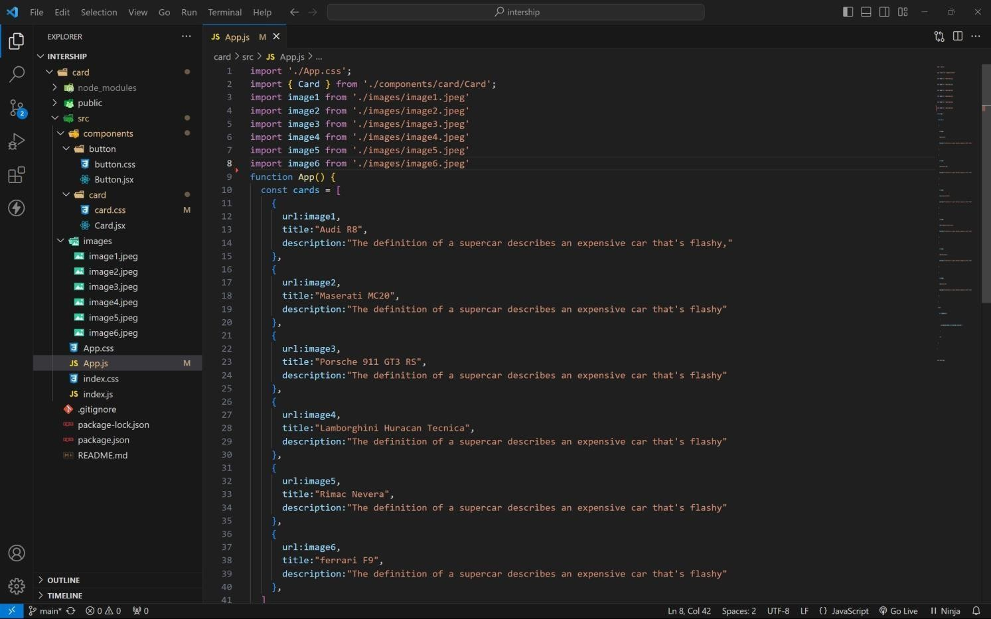

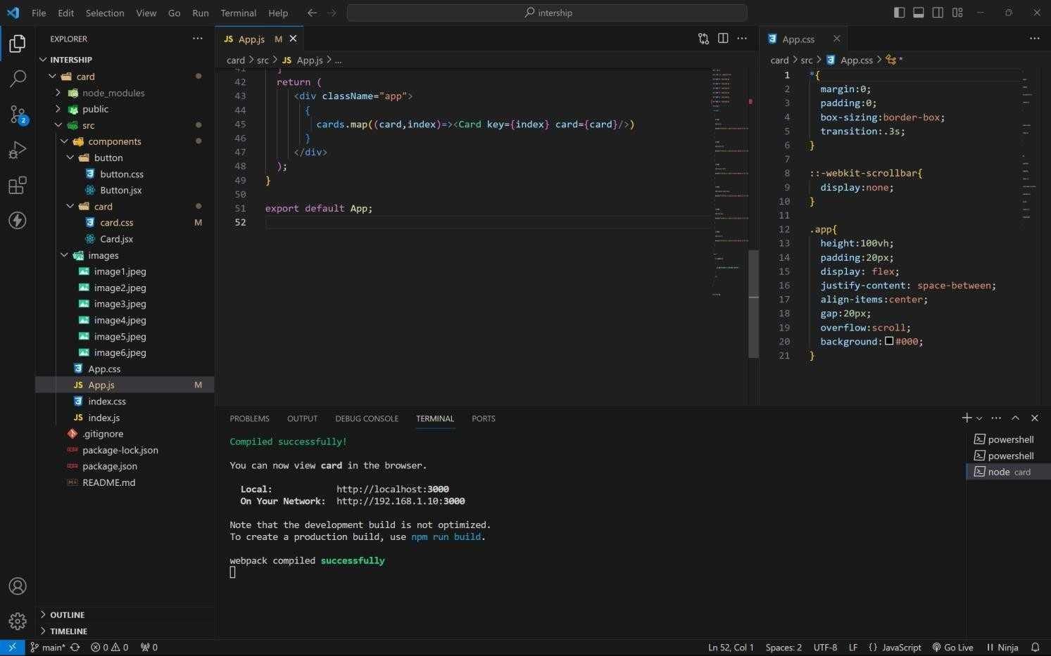

Approach:

1 . initially taking an array of objects like below

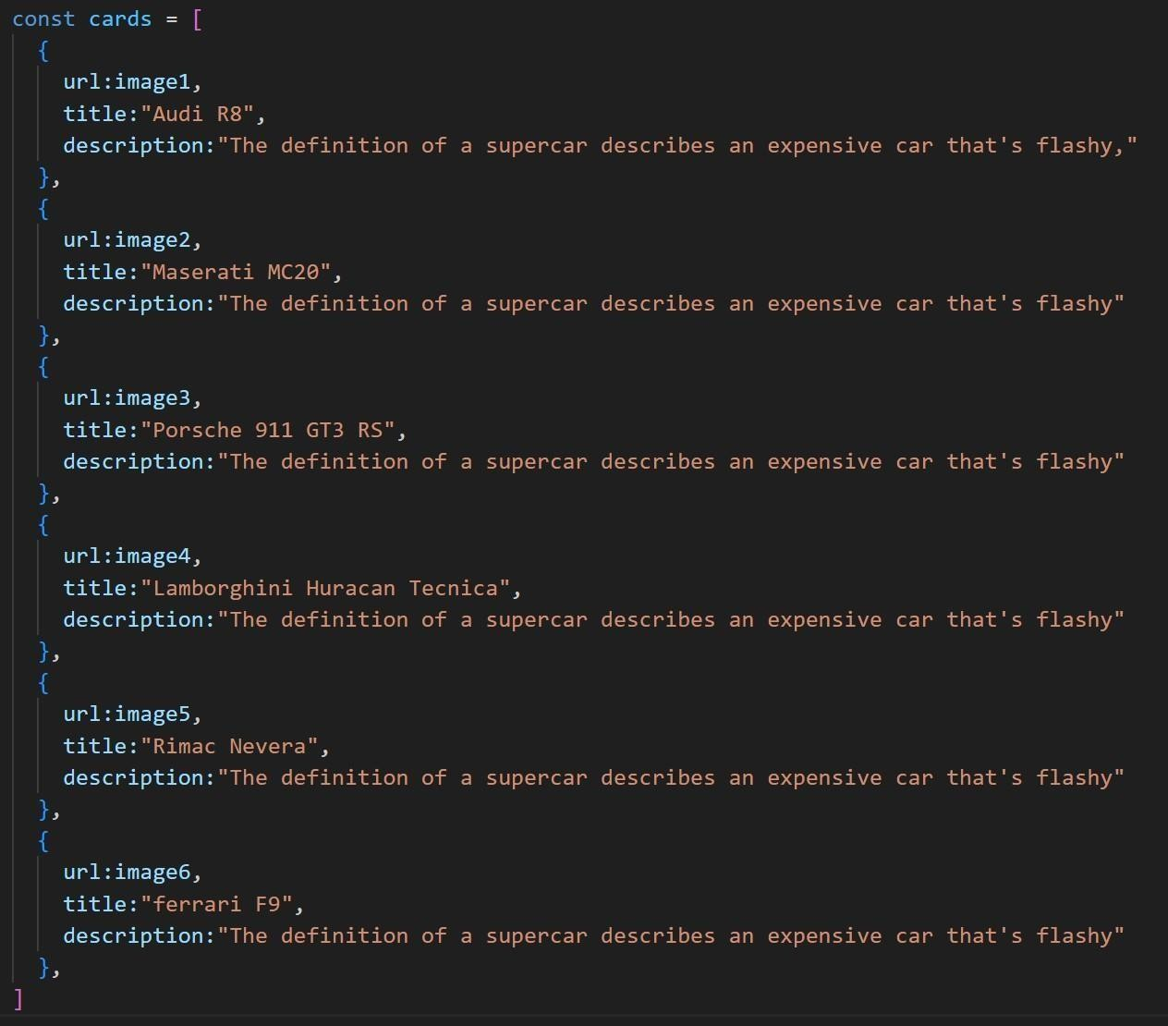

1. **. Passing this card array to child (card component) of App component by using props;**
2. **. getting data as argument like {card} in card component.**
3. **. in card component i use one state [show, set Show] to get extra info as description.**
4. **. When we click the button then show becomes true by assigning set Show (! show).**

OUTPUT:

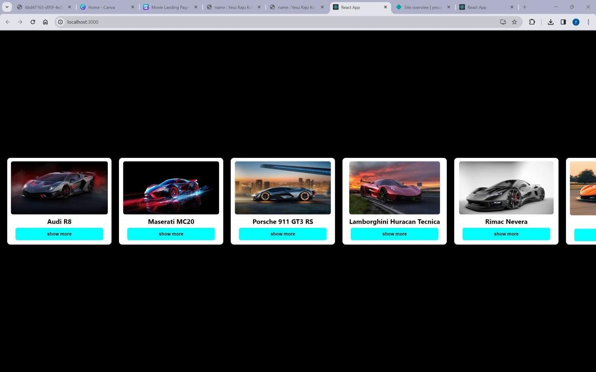

AFTER BUTTON CLICKS:

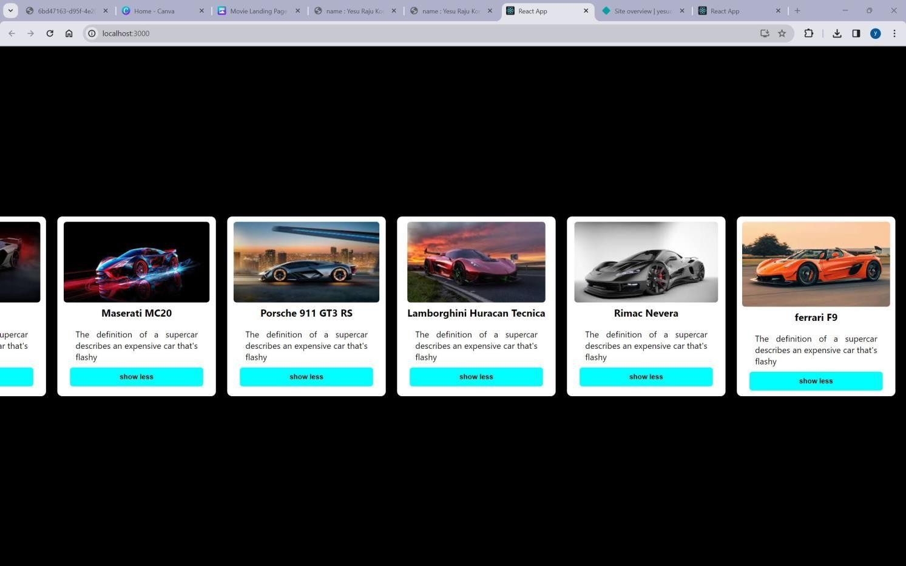

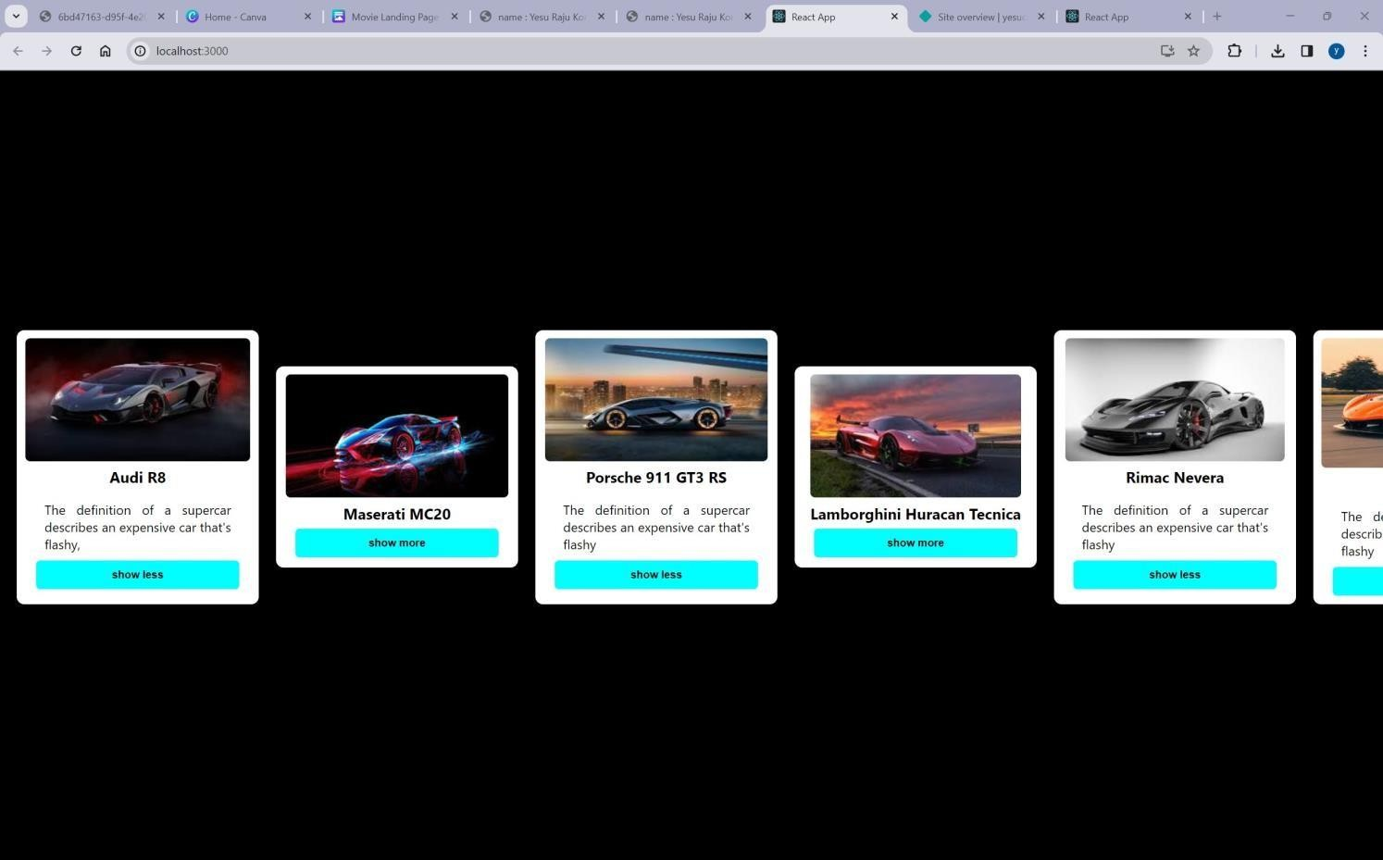

GitHub link: <https://github.com/4727yesuraju/card> live demo: [https://yesucard.netlify.app](https://yesucard.netlify.app/)