02 Arrays and Strings  
Test your Knowledge  
1. When to use String vs. StringBuilder in C# ?

Stringbuilder represents a mutable string of characters (can be changed) and strings are immutable so you cannot change them

2. What is the base class for all arrays in C#?

Array class

3. How do you sort an array in C#?

Array.sort() or CompareTo()

4. What property of an array object can be used to get the total number of elements in  
an array?

Array.GetLength(Int32)

5. Can you store multiple data types in System.Array?

No, only similar datatypes

6. What’s the difference between the System.Array.CopyTo() and System.Array.Clone()?

Clone() returns a new array containing all the elements in the original array. CopyTo() copies the elements into an existing array.

Practice Arrays  
1. Copying an Array  
Write code to create a copy of an array. First, start by creating an initial array. (You can use  
whatever type of data you want.) Let’s start with 10 items. Declare an array variable and  
assign it a new array with 10 items in it. Use the things we’ve discussed to put some values  
in the array.  
Now create a second array variable. Give it a new array with the same length as the first.  
Instead of using a number for this length, use the Lengthproperty to get the size of the  
original array.  
Use a loop to read values from the original array and place them in the new array. Also  
print out the contents of both arrays, to be sure everything copied correctly.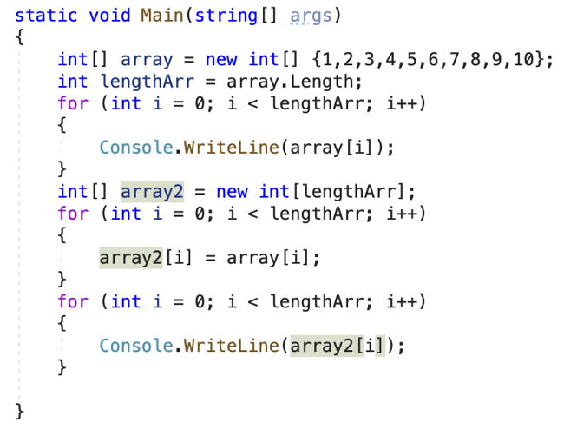  
2. Write a simple program that lets the user manage a list of elements. It can be a grocery list,  
"to do" list, etc. Refer to Looping Based on a Logical Expression if necessary to see how to  
implement an infinite loop. Each time through the loop, ask the user to perform an  
operation, and then show the current contents of their list. The operations available should  
be Add, Remove, and Clear. The syntax should be as follows:  
+ some item  
- some item  
--  
Your program should read in the user's input and determine if it begins with a “+” or “-“ or  
if it is simply “—“ . In the first two cases, your program should add or remove the string  
given ("some item" in the example). If the user enters just “—“ then the program should  
clear the current list. Your program can start each iteration through its loop with the  
following instruction:

3. Write a method that calculates all prime numbers in given range and returns them as array  
of integers  
static int[] FindPrimesInRange(startNum, endNum){}

4. Write a program to read an array of n integers (space separated on a single line) and an  
integer k, rotate the array right k times and sum the obtained arrays after each rotation as  
shown below.  
After r rotations the element at position I goes to position (I + r) % n.  
The sum[] array can be calculated by two nested loops: for r = 1 ... k; for I = 0 ... n-1.  
Input Output Comments  
3 2 4 -1 3 2 5 6 rotated1[] = -1 3 2 4  
2 rotated2[] = 4 -1 3 2  
sum[] = 3 2 5 6  
1 2 3 4 5 12 10 8 6 9 rotated1[] = 5 1 2 3 4  
3 rotated2[] = 4 5 1 2 3  
rotated3[] = 3 4 5 1 2  
sum[] = 12 10 8 6 9

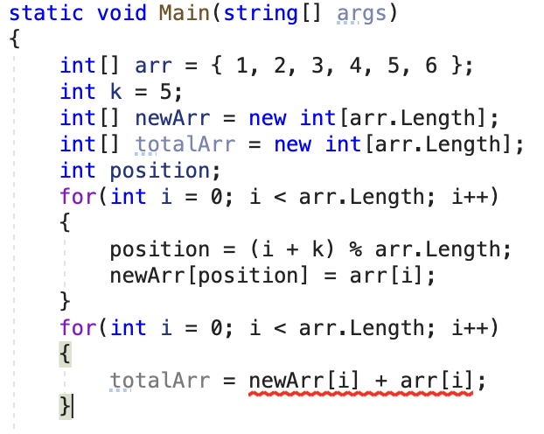  
5. Write a program that finds the longest sequence of equal elements in an array of integers.  
If several longest sequences exist, print the leftmost one.  
Input Output  
2 1 1 2 3 3 2 2 2 1 2 2 2  
1 1 1 2 3 1 3 3 1 1 1  
4 4 4 4 4 4 4 4  
0 1 1 5 2 2 6 3 3 1 1

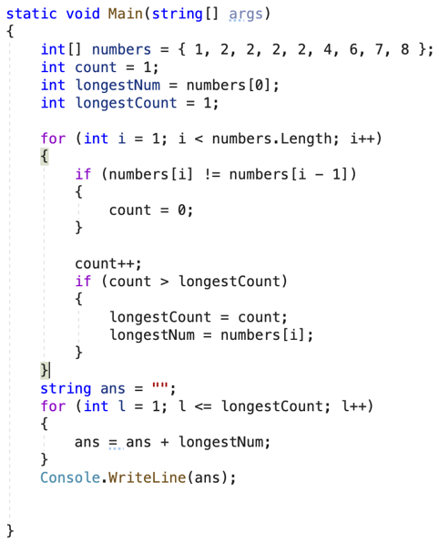  
7. Write a program that finds the most frequent number in a given sequence of numbers. In  
case of multiple numbers with the same maximal frequency, print the leftmost of them

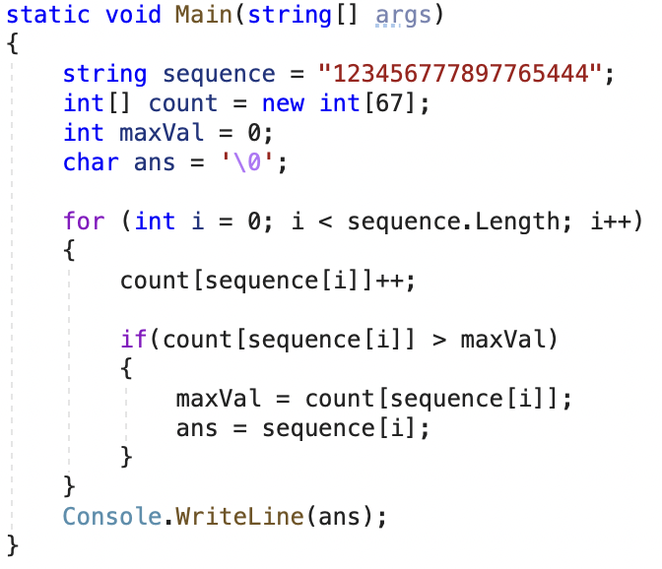

Practice Strings  
1. Write a program that reads a string from the console, reverses its letters and prints the  
result back at the console.  
Write in two ways  
Convert the string to char array, reverse it, then convert it to string again  
Print the letters of the string in back direction (from the last to the first) in a for-loop  
Input Output  
sample elpmas  
24tvcoi92 29iocvt42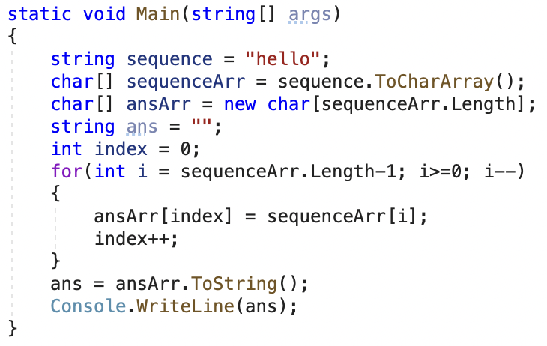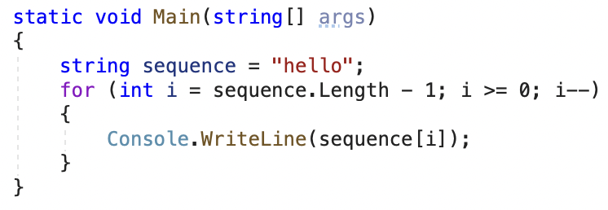  
2. Write a program that reverses the words in a given sentence without changing the  
punctuation and spaces  
Use the following separators between the words: . , : ; = ( ) & [ ] " ' \ / ! ? (space).  
All other characters are considered part of words, e.g. C++, a+b, and a77 are  
considered valid words.  
The sentences always start by word and end by separator.  
C# is not C++, and PHP is not Delphi!  
Delphi not is PHP, and C++ not is C#!  
The quick brown fox jumps over the lazy dog /Yes! Really!!!/.  
Really Yes dog lazy the over jumps fox brown /quick! The!!!/.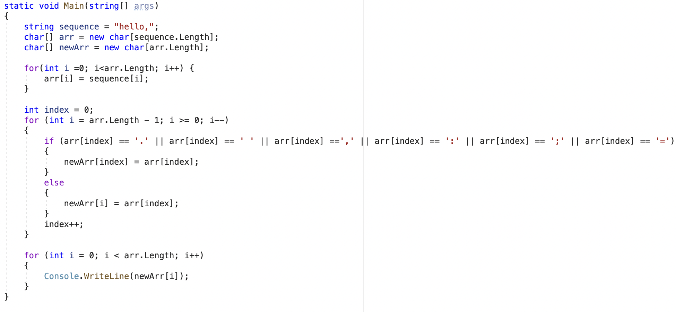  
3. Write a program that extracts from a given text all palindromes, e.g. “ABBA”, “lamal”, “exe”  
and prints them on the console on a single line, separated by comma and space.Print all  
unique palindromes (no duplicates), sorted  
Hi,exe? ABBA! Hog fully a string: ExE. Bob  
a, ABBA, exe, ExE

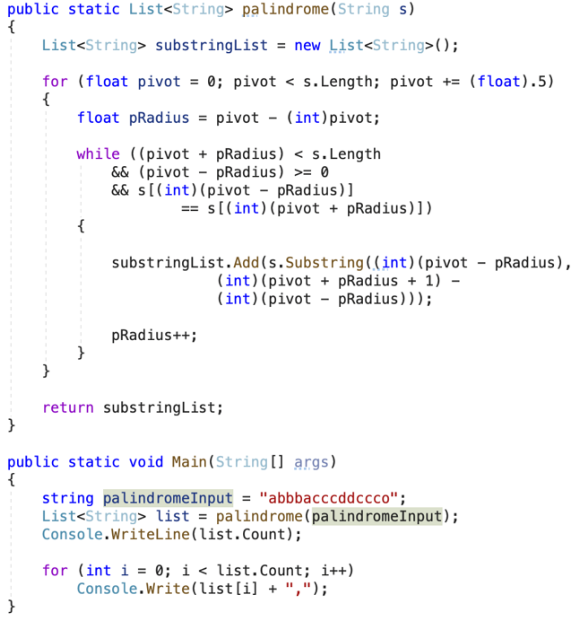

4. Write a program that parses an URL given in the following format:  
[protocol]://[server]/[resource]  
The parsing extracts its parts: protocol, server and resource.  
The [server] part is mandatory.  
The [protocol] and [resource] parts are optional.  
https://www.apple.com/iphone  
[protocol] = "https"  
[server] = "www.apple.com"  
[resource] = "iphone"  
ftp://www.example.com/employee  
[protocol] = "ftp"  
[server] = "www.example.com"  
[resource] = "employee"  
https://google.com  
[protocol] = "https"  
[server] = "google.com"  
[resource] = ""  
www.apple.com  
[protocol] = ""  
[server] = "www.apple.com"  
[resource] = ""

