**通过机器学习优化多因子选股模型**

**摘　要：**

机器学习算法可以很好地刻画变量之间的复杂关系，因而在描述股市的变化规律时可以捕捉到更加精细的市场信号，获得较为稳健的超额收益。本文主要研究用不同的机器学习算法学习选股策略，并在此基础上控制最大回撤率。

本文工作主要分为三部分。

针对

**关键词：**单变量线性回归 多元线性回归 随机森林回归 Adaboost回归 支持向量回归(SVR) LSTM 等权重线性模型 择时模型 风险控制

目录

1 问题重述 3

1.1 问题背景 3

1.2 要解决的问题 3

1.3 我们的工作 3

2 符号说明 4

3 问题分析 4

4 模型的建立与求解 4

4.1 数据采集 4

4.2 数据预处理 5

4.3 单因子测试与分析 5

4.3.1 单变量线性回归模型 5

4.3.2 单因子交易策略 6

4.3.3 单因子回测结果 6

4.4 多因子测试与分析 7

4.4.1 多因子选择 7

4.4.2 机器学习算法训练 8

4.4.3 多因子选股交易策略 8

4.4.4 多因子选股模型回测结果 9

4.5 风险控制 10

4.5.1 择时模型 10

4.5.2 交易策略 10

4.5.3 回测结果 10

5 模型的评价与推广 12

5.1 模型的优点 12

5.2 模型的局限性 12

5.3 未来改进 12

6 结论 12

参考文献 12

附录 13

单因子回测结果 13

# 问题重述

## 问题背景

优化收益和控制风险是投资永恒的主题。1992年，Fama通过分析美国市场多年的数据发现，美国股市绝大部分可以被市值、估值以及市场收益 3 个因子解释。Fama的工作开启了通过因子化分析股市获取超额收益的先河，此后学术界及业界不断地寻找其他能获取超额收益的因子及其组合和风险控制的方式。

在我国，基于财务因子及长周期的量价因子为主要因子的传统多因子模型在A股市场曾经获得过较为稳健的超额收益，但是由于 A 股市场存在明显的风格切换（比如 2017 年下半年从传统的小市值风格切换到只有极少数大市值股票上涨，而绝大部分股票下跌的风格），传统多因子模型的稳定性及有效性受到了较大的考验。

随着硬件的发展，各种机器学习算法的应用范围不断扩大，在很多问题上都展现了强大的求解能力，得到了很多有现实意义的成果（如人脸识别，自然语言处理，搜索引擎等等）。在量化交易的问题中，机器学习算法能够通过对因子的非线性表达，捕捉到更加精细的市场信号，获取较为稳健的超额收益。

## 要解决的问题

根据2016年1月1日至2018年9月30日我国A股市场的数据，筛选出各大类股票因子中较优的子因子。在此基础上，分析不同的机器学习算法对提升这些因子的等权重线性模型表现的优劣，并使用“Auto-Trader 策略研究回测引擎”进行策略回测（初始资金为 1000 万元整，手续费为双边千分之 3，每月月初调仓）。

要解决以下三个问题：

1. 利用 Auto-Trader 中各大类因子的日频数据，分别做单因子策略研究和绩效分析，挑选出使得年化夏普比率（Sharpe ratio）最优的各个大类的因子。
2. 基于机器学习算法对 (1) 中挑选的因子，进行增强，利用2016年1月1日至2018年9月30日的数据进行选股和回测，比较不同机器学习算法选股策略与等权重线性模型选股策略之间年化夏普比率的优劣。
3. 对选股策略进行风险控制，要求将最大回撤控制在10%以内，重新完成 (2)。

## 我们的工作

* 制定单因子选股策略并进行回测，得到单因子选股模型的年化夏普率。
* 将选出的单因子都放入多因子模型中，用不同的机器学习算法(包括Random Forest Regression、Adaboost Regression、Multivariate Linear Regression、Support Vector Regression (SVR)，LSTM)预测股票收益率。对比不同机器学习算法的回测结果发现**Random Forest Regression**的效果最好，累计收益为**61.08%**，年化收益为19.61%。而**等权重线性模型**的累计收益为**35.08%**，年化收益为**11.96%**。可以看到,随机森林回归选股模型的效果要远好于等权重线性模型。
* **Random Forest Regression加上择时模型控制风险**，可以将最大回撤率控制在**8.5%**，同时累计收益为**25.30%**,年化收益率为**8.84%**。而**等权重线性模型**加上择时模型控制风险,最大回撤率为**13.79%**,同时累计收益为**28.39%**,年化收益率为**9.84%**。可以看到,虽然随机森林回归模型在进行风险控制后累计收益略逊于等权重线性模型的结果,但是随机森林回归模型的最大回撤率比等权重线性模型的结果好很多。用随机森林回归模型加上择时模型可以更好地控制风险。

# 符号说明

|  |  |
| --- | --- |
| 符号 | 解释 |
| $$x_{i}, i=1,2…$$ | 极值处理前的原始因子序列。 |
|  | 经过极值处理后的因子序列。 |
|  | 原始因子序列的中位数。 |
|  | 因子序列的中位数。 |
|  | 每个月第 $j$ 天的收盘价。 |
|  | 月平均收益率。 |

# 问题分析

To Be Completed……

# 模型的建立与求解

## 数据采集

我们使用Auto-Trader软件获得股票的相关数据，具体设置如下。

**样本范围**：沪深300成分股，剔除停牌股票等不正常股票。

**样本期**：2016年1月1日至2018年9月30日，按日提取。

**测试因子的选择**：我们测试的因子包括了基础科目衍生类、质量类、收益风险类、情绪类、成长类、常用技术指标类、动量类、价值类、每股指标类、模式识别类、特色技术指标、行业与分析师类共十二大类因子。测试全部子因子需要大量时间，出于提高效率的考虑，我们测试了基础科目衍生类、质量类因子和价值类的所有子因子，以及其他大类因子的部分子因子(10个左右)。我们根据我们对因子的理解，尽量选择表达能力不同的因子。

## 数据预处理

在获得原始数据之后，我们需要对原始数据进行预处理，主要包括数据对齐、缺失值处理、中位数去极值和标准化等步骤，如图1所示。

* **数据对齐：**上市公司财报的报告期和报告发布日期之间有一定延迟，导致因子数据和股市K线数据的日期可能存在差异，比如某个日期可能有K线数据而无对应的因子数据。为了避免这种情况，需要对日期进行修正，使得股市数据和因子数据能相互对应。
* **缺失值处理：**提取样本期内的因子数据时，某些因子数据可能会缺失。为了避免缺失值对拟合的影响，我们选择移除因子出现缺失值的样本。
* **极端值处理：**某些因子数据会出现个别极端的值，这样的值对描述因子数据的变化规律没有帮助，会干扰模型对因子数据的模拟。为了避免这种情况，我们用“中位数去极值法”处理数据，将超过上下限的极端值用上下限替代。具体处理如下：

$${\tilde{x}}_{i}=\left\{\begin{aligned}x_{M}+5x_{MAD}, x_{i}>x_{M}+5x_{MAD} \\ x_{i},x_{M}-5x_{MAD}≤x_{i}≤x_{M}+5x_{MAD} \\ x_{M}-5x_{MAD}, x_{i}<x_{M}-5x_{MAD}\end{aligned}\right. ,$$

其中， $x_{M}$ 表示因子序列的中位数， $x_{MAD}$ 表示 $|x_{i}-x_{M}|$ 的中位数。

* **z-score标准化：**由于各个因子的单位和量纲不同，为了使得因子之间存在可比性，需要对其进行z-score标准化处理，即对序列中的每一个因子，减去因子序列的均值，然后除以因子序列的标准差，使得因子序列近似成为一个符合均值为0，标准差为1的正态分布序列。



图1：数据预处理流程图

## 单因子测试与分析

我们使用Auto-Trader软件获取特定单因子数据。初始资金设为1000万元，手续费设为双边千分之3，每月初进行调仓，用Auto-Trader策略研究回测引擎得到回测报告。

### 单变量线性回归模型

由于股票市场是一个不稳定的混沌系统，很难捕捉其短期的变化规律，因此我们用股票一个月的平均收益率作为因变量，以平均各种不稳定因素。对**某个特定的股票**，回归模型拟合模型（图2）概括如下：

1. 在月初第一天，获得前21天的股票K线数据（近似为上一个月的数据）。若某日没有数据，则跳过该交易日。计算上一个月内股票的平均收益率作为因变量，股票的平均收益率计算公式为

$$r_{avg}=\frac{c_{j}-c_{i}}{c_{i}},$$

其中， $c_{j}, c_{i}$ 表示分别每个月第 $j,i (j>i)$ 天的收盘价，一般来说 $j$ 和 $i$ 相差约21天。

1. 获得上个月月初（一般来说是每个月的第一个交易日）的因子数据，对因子数据进行预处理得到自变量。
2. 将股票对应的因子数据作为自变量 $X$，平均收益率作为因变量 $Y$。计算出**样本期**内每个月对应的 $X$ 和 $Y$，可以得到多组训练样本。用单变量线性回归模型拟合 $X$ 和 $Y$ 之间的关系，即用

$$\hat{Y}=aX+b$$

拟合 $X$ 和 $Y$ 之间的关系。

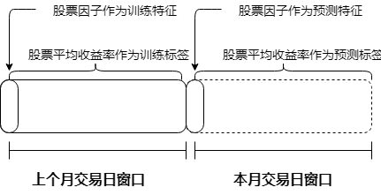

图2：单因子线性回归模型

将股票池中的每只股票执行以上过程，得到对应的线性回归模型。

### 单因子交易策略

在获得单变量回归模型之后，交易策略如下。

1. 对股票池中的**每只股票**，分别获取本月月初（一般为每个月的第一个交易日）的因子数据（已经预处理）作为待预测样本的特征，将其输入训练好的线性回归模型，得到股票在本月的预测平均收益率。
2. 将各只股票的平均收益率排序，排在前20%的股票视为强势股，排在后60%的股票视为弱势股。每次调仓时，若有弱势股则平仓；对无持仓的强势股，则以均等分配的可用资金进行开仓。

### 单因子回测结果

按照上述思路，我们对基础科目衍生类、质量类因子和价值类的所有子因子，以及其他大类因子的部分子因子进行测试。回测结果指标包括年化收益率、年化夏普率、最大回撤率和信息比率等。其中，年化夏普率的计算公式为

$$S_{A}=S_{m}\sqrt{N},$$

其中， $S_{m}$ 表示单位时间产品的夏普率， $N$ 表示不同周期的年化因子。我们的回测以月为单位，所以对应的 $N$ 为12。

在筛选因子时，主要考虑因素为年化夏普率，优先筛选每一类中年化夏普率最高的因子，当存在较多表现较优的因子时，综合各方面指标进行筛选。每个大类中年化夏普率排名靠前的子因子的测试结果如下表所示（**详细的测试结果可以参考附录-单因子测试结果**）。

|  |  |  |  |  |  |
| --- | --- | --- | --- | --- | --- |
| 测试因子 | 所属大类 | 年化收益率 | 年化夏普率 | 最大回撤率 | 信息比率 |
| AdminExpenseTTM | 基础科目衍生类 | 11.24% | 249.46% | 9.94% | 101.87% |
| NIAP | 基础科目衍生类 | 12.07% | 244.50% | 12.29% | 106.95% |
| FinanExpenseTTM | 基础科目衍生类 | 11.98% | 226.14% | 13.12% | 106.86% |
| NetIntExpense | 基础科目衍生类 | 10.95% | 195.80% | 15.56% | 96.33% |
| DebtEquityRatio | 质量类 | 2.10% | 212.91% | 16.91% | 36.36% |
| SuperQuickRatio | 质量类 | 9.83% | 195.88% | 20.08% | 80.67% |
| DDNCR | 收益风险类 | 3.81% | 40.59% | 22.74% | 48.49% |
| PVI | 情绪类 | 5.57% | 89.75% | 19.92% | 64.42% |
| TotalAssetGrowRate | 成长类 | 2.18% | 4.03% | 20.31% | 37.86% |
| MA120 | 常用技术指标类 | 6.54% | 103.88% | 20.86% | 68.30% |
| AD | 动量类 | 2.34% | 9.11% | 20.11% | 38.93% |
| PS | 价值类因子 | 6.27% | 107.76% | 12.39% | 70.83% |
| EnterpriseFCFPS | 每股指标类 | 10.00% | 182.89% | 16.92% | 91.71% |
| CDLCONCEALBABYSWALL | 模式识别类 | 1.54% | -10.53% | 23.23% | 34.98% |
| FY12P | 行业与分析师类 | 5.96% | 102.40% | 17.10% | 71.28% |
| STDDEV | 特色技术指标 | 3.51% | 35.60% | 15.77% | 46.89% |

表1：单因子回测结果

## 多因子测试与分析

我们主要测试了Random Forest Regression、Adaboost Regression、Multivariate Linear Regression、Support Vector Regression (SVR)，LSTM和等权重线性模型，共六个模型。

### 多因子选择

在第1问中，我们得出了每个大类因子的子因子年化夏普率。有些大类中年化夏普率较高的因子不止一个（如基础科目衍生类），我们将这些年化夏普率排名靠前的单因子都放入多因子模型中；而模式识别大类的因子年化夏普率都是负数，我们将这个大类的因子排除在多因子模型之外。

此外，注意到单因子年化夏普率的高低和策略有一定的关系，因子年化夏普率不能完全反映出因子变化对最终收益的影响。为了减少这种情况带来的影响，我们随机挑选几个年化夏普率排名不是很靠前的因子和排名靠前的因子一起放入多因子模型进行测试，选出回测效果较好的那一组。

最后，我们用于多因子模型的因子如下表所示。

|  |  |
| --- | --- |
| 大类因子 | 测试子因子 |
| 基础科目衍生类因子 | AdminExpenseTTM，FinanExpenseTTM，NetIntExpense，GrossProfit |
| 质量类因子 | ROIC，CashToCurrentLiability |
| 收益风险类因子 | DDNCR |
| 情绪类因子 | PVI |
| 成长类因子 | TotalAssetGrowRate |
| 常用技术指标类因子 | MA120 |
| 动量类因子 | AD |
| 价值类因子 | PS |
| 每股指标类 | EnterpriseFCFPS |
| 行业与分析师类 | FY12P |
| 特色技术指标 | STDDEV |

表2：用于多因子选股模型的因子

### 机器学习算法训练

我们对比了多种不同的机器学习算法，对**某个特定的股票**，这些算法训练过程可以概括如下。

1. 月初第一天，获得前21天的股票K线数据（近似为上一个月的数据）。若某日没有数据，则跳过该交易日。计算上一个月股票池中各股票的平均收益率作为因变量，**每个**股票的平均收益率计算公式为

$$r_{avg}=\frac{c_{j}-c_{i}}{c_{i}},$$

其中， $c_{j},c_{i}$ 表示分别每个月第 $j,i (j>i)$ 天的收盘价，一般来说j和i相差约21天。

1. 获得上个月月初（一般来说是每个月的第一个交易日）的多个因子的数据，对因子数据进行预处理得到自变量。
2. 将股票对应的因子数据作为自变量 $X$，平均收益率作为因变量 $Y$。这里的 $X$ 是一个多维向量， $Y$ 是一个标量。计算出样本期内每个月对应的 $X$ 和 $Y$，可以得到多组训练样本。用**不同的模型**（Random Forest Regression、Adaboost Regression、Multivariate Linear Regression、Support Vector Regression (SVR)，LSTM）拟合 $X$ 与 $Y$ 之间的关系，得到训练好的模型。

对股票池中的每只股票都执行以上过程，得到对应的模型。

### 多因子选股交易策略

我们选择的模型都是回归模型，将自变量输入模型之后，得到的输出是连续量。因此可以采取和单因子模型类似的策略。

1. 对股票池中的每只股票，获取其本月月初（一般为每个月的第一个交易日）的多因子数据（已经预处理）作为待预测的样本的特征，将其输入训练好的回归模型。回归模型的输出结果是一个连续值，代表股票在本月的预测收益率。
2. 将各只股票的平均收益率排序，排在前20%的股票视为强势股，排在后60%的股票视为弱势股。每次调仓时，若有弱势股则平仓；对无持仓的强势股，则以均等分配的可用资金进行开仓。

### 多因子选股模型回测结果

Random Forest Regression、Adaboost Regression、Multivariate Linear Regression、Support Vector Regression (SVR)，LSTM和等权重线性模型回测时间为2016-01-04~2018-09-28，回测结果大致情况如下（详细结果见**附件**），夏普率与年化夏普率的转换公式见4.3.3。

|  |  |  |  |  |  |  |  |
| --- | --- | --- | --- | --- | --- | --- | --- |
| 策略名称 | 年化收益率 | 阿尔法 | 贝塔 | 夏普比率 | 信息比率 | 最大回撤 | 换手率 |
| Random Forest Regression | 19.61% | 0.21 | 0.77 | 0.84 | 1.39 | 29.67% | 43.06% |
| Multivariate Linear Regression | 16.42% | 0.17 | 0.71 | 0.79 | 1.38 | 22.55% | 46.63% |
| 等权重线性模型 | 11.96% | 0.11 | 0.43 | 0.92 | 1.17 | 13.70% | 19.33% |
| LSTM | 11.07% | 0.1 | 0.32 | 0.85 | 0.93 | 11.86% | 89.83% |
| Adaboost Regression | 7.58% | 0.08 | 0.58 | 0.38 | 0.83 | 18.96% | 38.61% |
| Support Vector Regression (SVR) | 6.90% | 0.07 | 0.5 | 0.41 | 0.83 | 14.57% | 39.48% |

表3：机器学习算法和等权重线性模型回测结果

可以看到，Random Forest Regression（图3）有较好的效果，其年化收益率、阿尔法值和信息比率都是最高的，但是等权重线性模型（图4）的夏普率是最高的。在第3问中，我们将基于Random Forest Regression和等权重线性模型进一步讨论风险控制的问题。

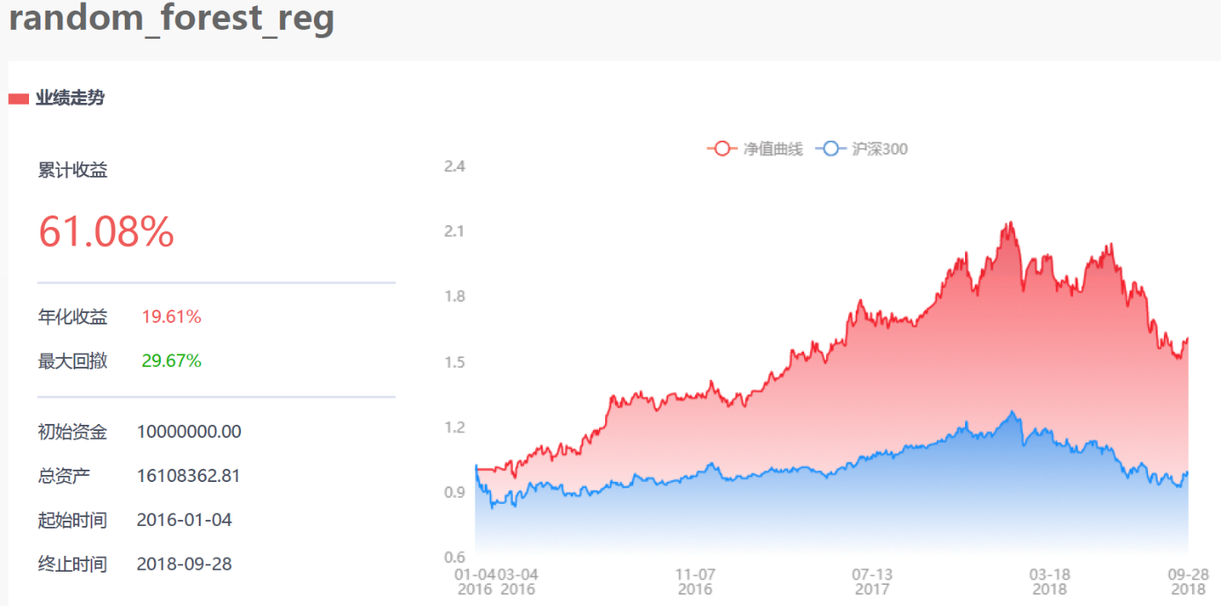

图3：随机森林回归模型回测结果

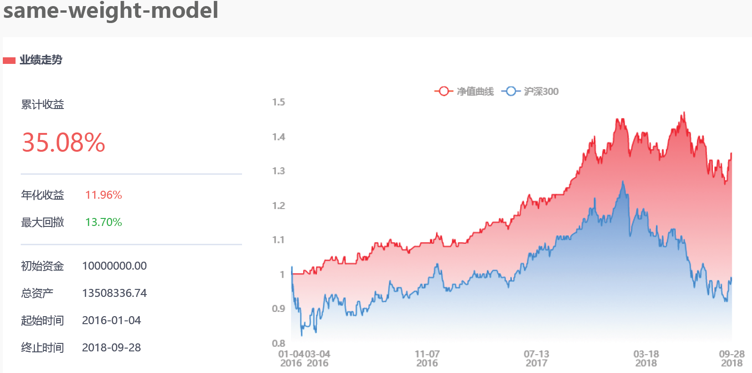

图4：等权重线性模型回测结果

## 风险控制

我们用择时模型对随机森林回归选股模型和等权重线性选股模型进行风险控制。

### 择时模型

### 交易策略

### 回测结果

我们测试了多组不同的参数，分别选出在随机森林选股模型和等权重线性模型上表现最好的那组，最后的结果概括如下**（详细内容见附件）**。

|  |  |  |  |  |  |  |  |
| --- | --- | --- | --- | --- | --- | --- | --- |
| 策略名称 | 年化收益率 | 阿尔法 | 贝塔 | 夏普比率 | 信息比率 | 最大回撤 | 换手率 |
| Random Forest Regression | 8.84% | 0.08 | 0.32 | 0.71 | 0.81 | 8.50% | 63.65% |
| 等权重线性模型 | 9.84% | 0.09 | 0.37 | 0.76 | 0.93 | 13.79% | 19.09% |

表4：择时模型风险控制结果

对比表3，可以看到，随机森林回归选股模型的最大回撤率有明显下降，并且年化收益率大幅度降低。而使用了择时模型控制风险的等权重线性模型的最大回撤率不降反增，我们分析认为这是因为择时模型……

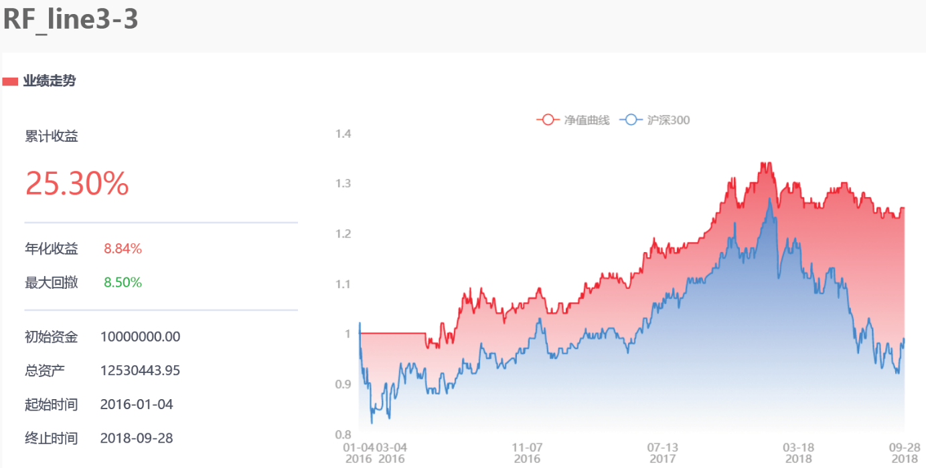

图5：择时模型+随机森林回归选股模型回测结果

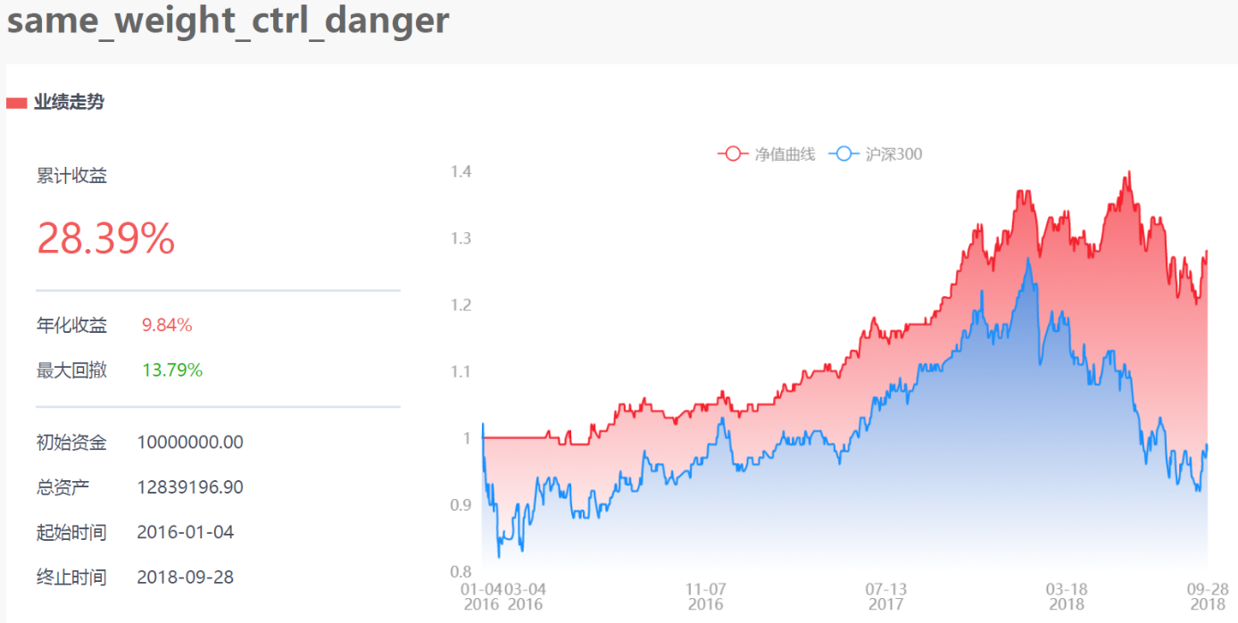

图6：择时模型+等权重线性选股模型回测结果

# 模型的评价与推广

## 模型的优点

本文的结论基于多种不同的机器学习算法，在测试多种不同

## 模型的局限性

## 未来改进

# 结论

我们首先

# 参考文献

1. 林晓明，陈烨，华泰多因子模型体系初探——华泰多因子系列之一，2016.9.21
2. 罗军，胡海涛，大浪淘金， Alpha因子何处寻，2011.8.15
3. 宋旸，李莘泰，多因子模型研究之一：单因子测试，2017.10.11
4. 宋旸，李莘泰，多因子模型研究之二：收益预测模型，2017.12.29
5. 宋旸，李莘泰，多因子模型研究之三：风险模型与组合优化，2018.04.16
6. 刘富兵，李辰，基于组合权重优化的风格中性多因子选股策略－－数量化专题之五十七，2015.04.26

# 附录

## 单因子回测结果

**回测结果按年化夏普率由高到低排序。**

基础科目衍生类因子测试结果：

|  |  |  |  |  |  |  |
| --- | --- | --- | --- | --- | --- | --- |
| 测试因子 | 年化收益率 | 年化夏普率 | 最大回撤率 | alpha | beta | 信息比率 |
| AdminExpenseTTM | 11.24% | 249.46% | 9.94% | 11.02% | 45.31% | 101.87% |
| NIAP | 12.07% | 244.50% | 12.29% | 12.14% | 50.84% | 106.95% |
| FinanExpenseTTM | 11.98% | 226.14% | 13.12% | 12.38% | 55.82% | 106.86% |
| NetIntExpense | 10.95% | 195.80% | 15.56% | 11.57% | 56.47% | 96.33% |
| IntFreeCL | 9.06% | 168.39% | 16.89% | 9.46% | 51.12% | 84.37% |
| FCFE | 8.21% | 146.25% | 13.15% | 8.64% | 49.39% | 75.39% |
| NetDebt | 8.04% | 146.21% | 13.10% | 8.40% | 48.43% | 75.15% |
| EBIAT | 6.95% | 131.85% | 15.50% | 7.28% | 50.48% | 77.02% |
| GrossProfit | 6.16% | 109.87% | 11.80% | 6.52% | 49.45% | 68.93% |
| TotalPaidinCapital | 6.17% | 108.33% | 16.45% | 6.49% | 47.30% | 65.44% |
| EBIT | 6.20% | 107.69% | 18.12% | 6.70% | 52.32% | 70.92% |
| IntFreeNCL | 6.11% | 96.48% | 13.89% | 6.77% | 51.58% | 63.06% |
| DA | 5.35% | 88.46% | 13.15% | 5.69% | 47.49% | 60.65% |
| COnonperAdelQpct | 5.88% | 87.33% | 17.27% | 6.53% | 48.08% | 56.07% |
| OperateProfitTTM | 5.62% | 83.56% | 22.35% | 6.60% | 59.33% | 66.99% |
| SalesExpenseTTM | 5.12% | 71.78% | 23.21% | 6.16% | 59.98% | 63.53% |
| WorkingCapital | 4.94% | 71.45% | 21.52% | 5.64% | 52.95% | 58.32% |
| TotalFixedAssets | 4.17% | 56.49% | 16.57% | 4.63% | 48.73% | 52.47% |
| GrossProfitTTM | 4.34% | 55.73% | 23.74% | 5.28% | 58.00% | 57.82% |
| TRevenueTTM | 3.84% | 41.22% | 18.21% | 5.09% | 62.53% | 54.19% |
| NetProfitTTM | 3.55% | 38.34% | 18.47% | 4.30% | 53.71% | 49.62% |
| OperateNetIncome | 3.44% | 36.33% | 17.82% | 4.16% | 53.84% | 49.96% |
| EBITDA | 3.38% | 35.64% | 18.80% | 3.88% | 48.76% | 46.36% |
| FCFF | 2.88% | 23.56% | 11.71% | 3.23% | 45.70% | 41.85% |
| NetTangibleAssets | 2.26% | 5.97% | 26.61% | 3.29% | 55.19% | 36.88% |
| SaleServiceRenderCashTTM | 2.20% | 5.22% | 16.06% | 2.70% | 48.01% | 37.44% |
| TProfitTTM | 2.14% | 3.52% | 24.12% | 3.08% | 57.40% | 41.30% |
| NIAPCut | 2.04% | 1.02% | 24.89% | 3.07% | 59.45% | 41.51% |
| NetInvestCFTTM | 1.82% | -4.40% | 15.75% | 2.84% | 59.66% | 40.59% |
| CostTTM | 1.79% | -5.08% | 18.30% | 2.76% | 57.45% | 37.87% |
| COperDpct | 1.37% | -16.21% | 17.61% | 1.96% | 49.51% | 31.87% |
| NetProfitAPTTM | 1.32% | -17.07% | 22.70% | 2.14% | 55.50% | 34.67% |
| NetOperateCFTTM | 1.13% | -21.74% | 25.39% | 2.03% | 57.49% | 34.24% |
| IntDebt | 1.10% | -24.04% | 17.86% | 1.51% | 46.33% | 29.40% |
| TEAP | 0.47% | -38.60% | 17.16% | 1.22% | 53.33% | 26.62% |
| NonOperatingNPTTM | 0.34% | -40.66% | 26.97% | 1.31% | 58.02% | 27.18% |
| COperDTTMpct | -0.52% | -54.52% | 20.54% | 0.81% | 60.28% | 17.74% |
| COperApct | -0.46% | -63.76% | 20.30% | 0.16% | 50.78% | 19.08% |
| RevenueTTM | -0.76% | -63.89% | 23.52% | 0.39% | 59.82% | 17.49% |
| RetainedEarnings | -0.80% | -68.20% | 25.48% | 0.09% | 55.35% | 16.68% |
| NetWorkingCapital | -1.02% | -68.81% | 18.64% | 0.10% | 57.92% | 14.49% |
| COnonperDpct | -1.69% | -74.27% | 26.12% | -0.09% | 63.02% | 8.73% |
| COperDdelQpct | -1.37% | -75.82% | 24.65% | -0.33% | 55.07% | 11.23% |
| COperDdelpct | -1.67% | -86.78% | 21.37% | -0.83% | 52.41% | 9.17% |
| TCostTTM | -1.60% | -97.90% | 18.79% | -1.08% | 50.65% | 10.86% |
| COperAdelQpct | -2.30% | -102.29% | 28.18% | -1.55% | 50.75% | 4.59% |
| ASSI | -2.38% | -105.02% | 21.32% | -1.48% | 55.33% | 4.46% |
| IntCL | -2.47% | -110.87% | 19.95% | -1.91% | 47.51% | 3.40% |
| AssetImpairLossTTM | -2.60% | -114.69% | 21.79% | -1.94% | 50.91% | 2.67% |
| COperATTMpct | -3.27% | -117.64% | 31.06% | -2.05% | 60.95% | -2.36% |
| NetFinanceCFTTM | -3.32% | -124.07% | 26.28% | -2.26% | 59.27% | -2.82% |
| COnonperDTTMpct | -3.85% | -126.06% | 26.72% | -2.84% | 52.97% | -5.75% |
| COnonperDdelpct | -4.21% | -140.00% | 23.18% | -3.28% | 53.71% | -8.54% |
| COnonperATTMpct | -4.42% | -141.76% | 26.85% | -3.37% | 56.34% | -10.14% |
| TotalAssets | -4.34% | -149.49% | 23.58% | -3.46% | 55.73% | -10.29% |
| COnonperDdelQpct | -3.28% | -159.06% | 20.61% | -3.62% | 31.11% | -1.98% |
| NRProfitLoss | -5.43% | -172.52% | 30.53% | -4.44% | 59.67% | -19.48% |
| COnonperAdelpct | -5.89% | -182.87% | 27.30% | -5.05% | 56.04% | -21.58% |
| ValueChgProfit | -10.78% | -229.02% | 37.30% | -9.71% | 53.96% | -41.92% |
| COperAdelpct | -9.10% | -234.11% | 32.50% | -8.00% | 64.34% | -46.14% |
| COnonperApct | -8.48% | -243.57% | 30.95% | -7.87% | 55.10% | -40.12% |

质量类因子测试结果：

|  |  |  |  |  |  |  |
| --- | --- | --- | --- | --- | --- | --- |
| 测试因子 | 年化收益率 | 年化夏普率 | 最大回撤率 | alpha | beta | 信息比率 |
| DebtEquityRatio | 2.10% | 212.91% | 16.91% | 2.88% | 52.01% | 36.36% |
| SuperQuickRatio | 9.83% | 195.88% | 20.08% | 10.86% | 57.95% | 80.67% |
| NonCurrentAssetsRatio | -6.66% | 192.10% | 25.21% | -6.21% | 51.31% | -27.56% |
| EquityToAsset | -4.19% | 155.69% | 25.77% | -3.57% | 49.16% | -8.42% |
| EquityFixedAssetRatio | -7.57% | 148.22% | 38.10% | -6.45% | 48.24% | -23.94% |
| FixAssetRatio | -8.77% | 146.91% | 31.68% | -8.04% | 57.55% | -42.67% |
| CurrentRatio | -0.55% | 123.69% | 14.45% | 0.08% | 49.66% | 17.51% |
| CurrentAssetsRatio | 11.58% | 106.47% | 19.06% | 12.72% | 66.89% | 105.79% |
| QuickRatio | -0.30% | 91.97% | 20.49% | 0.78% | 52.92% | 17.38% |
| IntangibleAssetRatio | -5.39% | 89.26% | 21.77% | -5.31% | 42.25% | -16.79% |
| BondsPayableToAsset | -8.83% | 85.69% | 31.64% | -8.74% | 47.62% | -42.24% |
| DebtsAssetRatio | -4.19% | 78.11% | 25.77% | -3.57% | 49.16% | -8.42% |
| LongDebtToWorkingCapital | -2.94% | 60.85% | 21.71% | -2.43% | 49.53% | 0.18% |
| LongTermDebtToAsset | 2.72% | 51.31% | 14.18% | 3.17% | 46.50% | 39.78% |
| LongDebtToAsset | -4.01% | 51.02% | 20.96% | -3.45% | 50.12% | -7.64% |
| BLEV | -1.65% | 42.64% | 23.80% | -1.18% | 46.62% | 9.27% |
| DebtTangibleEquityRatio | 0.15% | 39.75% | 17.66% | 0.81% | 49.14% | 21.88% |
| CashToCurrentLiability | 6.97% | 37.93% | 16.99% | 8.04% | 58.55% | 69.24% |
| OperCashInToCurrentLiability | 7.85% | 24.29% | 14.15% | 9.06% | 63.55% | 80.42% |
| CurrentAssetsTRate | 4.24% | 18.44% | 9.86% | 4.45% | 43.73% | 50.62% |
| AccountsPayablesTRate | -2.77% | 2.38% | 16.98% | -2.53% | 45.07% | 1.43% |
| ROA | 4.27% | -4.16% | 18.66% | 5.35% | 59.15% | 54.73% |
| NOCFToTLiability | -1.60% | -5.41% | 22.18% | -0.61% | 57.95% | 11.05% |
| OperCashInToAsset | 1.76% | -5.97% | 18.40% | 2.81% | 56.27% | 34.35% |
| MLEV | -1.75% | -17.45% | 31.15% | -0.49% | 58.59% | 8.61% |
| TSEPToTotalCapital | -0.51% | -19.41% | 17.84% | 0.14% | 47.29% | 16.37% |
| TotalAssetsTRate | -6.27% | -24.55% | 26.65% | -5.69% | 53.27% | -25.08% |
| EquityTRate | -4.36% | -24.55% | 26.86% | -3.67% | 54.46% | -11.04% |
| FinancialExpenseRate | 11.28% | -25.45% | 16.03% | 12.10% | 60.91% | 101.10% |
| TotalProfitCostRatio | 3.61% | -25.95% | 15.57% | 4.48% | 54.51% | 48.18% |
| AdminiExpenseRate | 0.47% | -42.58% | 20.27% | 0.73% | 43.70% | 24.52% |
| NPToTOR | -6.20% | -45.45% | 25.11% | -5.60% | 52.78% | -23.92% |
| SalesCostRatio | 0.89% | -46.53% | 15.94% | 2.03% | 56.39% | 26.97% |
| NetProfitRatio | -3.10% | -48.18% | 21.65% | -1.98% | 59.39% | -1.03% |
| GrossIncomeRatio | 0.89% | -49.77% | 15.94% | 2.03% | 56.39% | 26.97% |
| TaxRatio | -9.59% | -51.36% | 36.10% | -8.75% | 62.82% | -52.89% |
| OperatingExpenseRate | 1.12% | -54.74% | 18.05% | 2.26% | 55.92% | 28.13% |
| OperatingProfitRatio | -10.17% | -56.16% | 31.80% | -10.28% | 46.85% | -52.21% |
| OperatingProfitToTOR | -10.52% | -59.26% | 32.90% | -10.25% | 53.94% | -56.50% |
| EBITToTOR | 5.47% | -60.17% | 15.44% | 6.50% | 58.58% | 62.76% |
| NetNonOIToTP | -3.09% | -64.17% | 27.72% | -1.62% | 63.98% | -0.96% |
| ROE | -0.33% | -74.25% | 25.11% | 0.65% | 57.41% | 20.85% |
| InventoryTRate | 6.49% | -81.02% | 28.40% | 7.65% | 56.85% | 60.83% |
| FixedAssetsTRate | -9.50% | -81.77% | 35.77% | -8.82% | 45.36% | -34.62% |
| NOCFToOperatingNI | 1.31% | -83.86% | 13.88% | 1.96% | 50.87% | 31.95% |
| CashRateOfSales | -3.25% | -86.84% | 24.50% | -2.27% | 55.36% | -2.01% |
| SaleServiceCashToOR | 6.06% | -88.30% | 18.85% | 7.40% | 64.18% | 67.81% |
| SalesServiceCashToORLatest | -2.38% | -94.05% | 20.00% | -1.65% | 53.38% | 4.55% |
| CashRateOfSalesLatest | -3.25% | -94.95% | 24.50% | -2.27% | 55.36% | -2.01% |
| NetNonOIToTPLatest | 8.71% | -98.64% | 23.13% | 9.65% | 60.55% | 86.62% |
| PeriodCostsRate | 0.77% | -104.02% | 21.62% | 2.16% | 60.07% | 26.03% |
| InvestRAssociatesToTP | 0.91% | -104.37% | 18.46% | 1.87% | 54.90% | 28.26% |
| InvestRAssociatesToTPLatest | -8.71% | -105.76% | 33.66% | -8.20% | 54.26% | -42.27% |
| DividendCover | -5.00% | -107.27% | 22.47% | -3.92% | 58.89% | -14.98% |
| OperatingNIToTPLatest | 1.75% | -110.59% | 24.07% | 2.66% | 55.46% | 35.91% |
| NPCutToNP | -1.11% | -116.88% | 18.07% | -0.13% | 56.77% | 14.38% |
| OperatingNIToTP | -2.03% | -119.64% | 25.77% | -1.03% | 57.18% | 7.16% |
| DividendPaidRatio | -6.01% | -119.74% | 38.26% | -4.05% | 56.91% | -15.21% |
| RetainedEarningRatio | -6.01% | -119.74% | 38.26% | -4.05% | 56.91% | -15.21% |
| DEGM | -2.23% | -123.78% | 24.90% | -1.37% | 55.93% | 5.79% |
| ACCA | -1.71% | -129.27% | 30.39% | -0.55% | 57.03% | 8.87% |
| CFO2EV | 0.14% | -131.29% | 14.48% | 0.81% | 52.50% | 24.48% |
| NOCFToOperatingNILatest | -6.56% | -131.29% | 25.77% | -5.55% | 61.35% | -28.68% |
| NOCFToNetDebt | -2.07% | -134.61% | 19.67% | -1.60% | 46.43% | 6.24% |
| NetProfitCashCover | -5.81% | -147.27% | 25.57% | -4.93% | 57.54% | -21.78% |
| InventoryTDays | 0.17% | -149.45% | 22.45% | 0.83% | 50.94% | 23.46% |
| OperatingCycle | -3.02% | -149.45% | 23.68% | -2.23% | 52.29% | -0.36% |
| AccountsPayablesTDays | -0.12% | -151.73% | 15.61% | 0.54% | 48.23% | 19.33% |
| ARTRate | -4.74% | -155.98% | 20.76% | -4.11% | 53.05% | -13.61% |
| ARTDays | -2.12% | -160.60% | 16.21% | -1.73% | 44.21% | 5.73% |
| CashConversionCycle | 2.96% | -169.25% | 15.17% | 3.55% | 49.80% | 43.07% |
| InteBearDebtToTotalCapital | -2.88% | -174.95% | 18.01% | -2.43% | 45.92% | 0.62% |
| TangibleAToInteBearDebt | -7.18% | -182.46% | 26.46% | -6.47% | 51.27% | -27.33% |
| TangibleAToNetDebt | -4.08% | -195.16% | 21.51% | -3.39% | 51.53% | -8.01% |
| TSEPToInterestBearDebt | -0.47% | -200.36% | 14.64% | 0.23% | 48.89% | 17.02% |
| NOCFToInterestBearDebt | -1.79% | -202.62% | 17.89% | -0.58% | 59.01% | 8.62% |
| InterestCover | 3.64% | -202.90% | 14.89% | 4.30% | 50.04% | 46.25% |
| ROIC | 12.90% | -205.14% | 22.45% | 13.78% | 61.10% | 101.87% |
| ROEDiluted | -0.28% | -218.29% | 21.15% | 0.77% | 59.12% | 22.03% |
| ROEAvg | -1.60% | -220.37% | 21.79% | -0.65% | 58.14% | 11.22% |
| ROECut | 4.03% | -243.81% | 18.71% | 4.83% | 56.55% | 57.53% |
| ROECutWeighted | -2.19% | -254.40% | 22.28% | -1.20% | 57.03% | 5.90% |
| ROEWeighted | 1.83% | -259.13% | 22.82% | 2.67% | 55.05% | 37.42% |
| ROAEBIT | 3.99% | -281.19% | 18.67% | 5.21% | 58.92% | 48.79% |
| ROE5 | 5.71% | -303.16% | 13.80% | 6.49% | 56.10% | 67.08% |
| ROA5 | 8.84% | -322.73% | 18.24% | 9.65% | 55.68% | 79.84% |

收益风险类因子测试结果：

|  |  |  |  |  |  |  |
| --- | --- | --- | --- | --- | --- | --- |
| 测试因子 | 年化收益率 | 年化夏普率 | 最大回撤率 | alpha | beta | 信息比率 |
| DDNCR | 3.81% | 40.59% | 22.74% | 4.87% | 56.77% | 48.49% |
| BackwardADJ | 1.70% | -8.53% | 11.95% | 1.88% | 42.50% | 33.05% |
| Kurtosis120 | 0.59% | -28.48% | 21.16% | 2.18% | 62.65% | 24.46% |
| Sharperatio60 | 0.06% | -40.17% | 31.29% | 1.36% | 56.29% | 19.59% |
| InformationRatio60 | -1.28% | -74.40% | 27.69% | -0.20% | 56.89% | 12.23% |
| InformationRatio20 | -1.86% | -86.51% | 19.20% | -0.80% | 55.71% | 7.76% |
| DDNSR | -4.30% | -144.26% | 32.83% | -3.47% | 52.49% | -9.13% |
| DDNBT | -3.80% | -146.16% | 21.56% | -3.14% | 52.62% | -6.38% |
| DASTD | -4.30% | -164.33% | 22.76% | -3.83% | 49.57% | -10.00% |
| Sharperatio20 | -5.52% | -172.30% | 21.19% | -4.65% | 55.64% | -18.45% |
| Variance60 | -5.10% | -175.26% | 28.50% | -4.52% | 50.88% | -15.45% |
| HSIGMA | -6.59% | -197.85% | 28.85% | -5.99% | 49.91% | -24.08% |
| Skewness20 | -7.20% | -227.02% | 27.52% | -6.61% | 55.16% | -33.13% |
| Kurtosis20 | -7.76% | -231.18% | 30.89% | -7.18% | 53.57% | -34.74% |

情绪类因子测试结果：

|  |  |  |  |  |  |  |
| --- | --- | --- | --- | --- | --- | --- |
| 测试因子 | 年化收益率 | 年化夏普率 | 最大回撤率 | alpha | beta | 信息比率 |
| PVI | 5.57% | 89.75% | 19.92% | 6.13% | 52.11% | 64.42% |
| JDQS20 | 6.00% | 79.07% | 18.92% | 7.43% | 60.84% | 58.21% |
| MONEYFLOW20 | 4.39% | 57.86% | 21.49% | 5.21% | 55.35% | 56.35% |
| TVMA20 | 3.11% | 24.91% | 22.02% | 4.26% | 59.39% | 45.83% |
| OBV20 | 2.90% | 22.20% | 14.06% | 3.42% | 45.87% | 39.11% |
| VOL20 | 2.65% | 15.55% | 14.97% | 3.42% | 51.86% | 40.04% |
| CGO_10 | -1.91% | -91.19% | 24.36% | -0.90% | 56.61% | 7.90% |
| VR | -2.38% | -106.77% | 19.89% | -1.50% | 56.05% | 4.61% |
| VSTD20 | -2.36% | -111.81% | 15.80% | -1.81% | 49.10% | 4.44% |
| ST_20 | -3.61% | -141.18% | 23.99% | -2.84% | 55.62% | -5.21% |
| FR_pure | -5.99% | -194.78% | 26.92% | -5.31% | 54.73% | -23.14% |
| TK_20 | -6.50% | -198.57% | 27.75% | -5.82% | 53.08% | -25.02% |
| AR | -9.51% | -239.41% | 35.13% | -8.72% | 55.80% | -42.30% |
| ACD20 | -8.93% | -262.59% | 31.72% | -8.45% | 54.71% | -44.81% |

成长类因子测试结果：

|  |  |  |  |  |  |  |
| --- | --- | --- | --- | --- | --- | --- |
| 测试因子 | 年化收益率 | 年化夏普率 | 最大回撤率 | alpha | beta | 信息比率 |
| TotalAssetGrowRate | 2.18% | 4.03% | 20.31% | 3.35% | 58.54% | 37.86% |
| NPParentCompanyGrowRate | 2.18% | 4.00% | 17.47% | 3.36% | 59.23% | 38.42% |
| NetProfitGrowRate | 0.66% | -30.11% | 15.59% | 1.89% | 60.47% | 27.99% |
| SGRO | -1.93% | -98.11% | 18.22% | -1.24% | 51.38% | 7.67% |
| EGRO | -3.03% | -121.67% | 23.76% | -2.10% | 57.34% | -0.55% |
| TotalProfitGrowRate | -4.20% | -147.97% | 23.98% | -3.32% | 56.49% | -9.50% |
| FinancingCashGrowRate | -7.60% | -235.01% | 28.98% | -7.09% | 53.61% | -34.90% |
| OperatingRevenueGrowRate | -9.36% | -253.99% | 33.06% | -8.67% | 57.50% | -46.25% |

常用技术指标因子测试结果：

|  |  |  |  |  |  |  |
| --- | --- | --- | --- | --- | --- | --- |
| 测试因子 | 年化收益率 | 年化夏普率 | 最大回撤率 | alpha | beta | 信息比率 |
| MA120 | 6.54% | 103.88% | 20.86% | 7.36% | 55.41% | 68.30% |
| MA10 | 4.78% | 67.56% | 17.97% | 5.47% | 52.55% | 56.75% |
| EMA12 | 3.03% | 23.62% | 23.21% | 4.04% | 56.69% | 44.31% |
| UOS | -2.12% | -85.47% | 22.85% | -0.92% | 53.80% | 5.33% |
| DBCD | -4.09% | -144.39% | 18.39% | -3.24% | 54.80% | -8.31% |
| CR20 | -8.74% | -221.99% | 32.62% | -7.67% | 60.62% | -39.66% |
| CHAIKINVOLATILITY | -11.87% | -350.98% | 36.53% | -11.93% | 51.74% | -67.17% |

动量类因子测试结果：

|  |  |  |  |  |  |  |
| --- | --- | --- | --- | --- | --- | --- |
| 测试因子 | 年化收益率 | 年化夏普率 | 最大回撤率 | alpha | beta | 信息比率 |
| AD | 2.34% | 9.11% | 20.11% | 2.78% | 47.45% | 38.93% |
| CCI5 | -0.06% | -50.89% | 15.85% | 0.76% | 54.06% | 22.36% |
| CMOSD | -0.72% | -66.42% | 25.31% | 0.05% | 52.19% | 16.38% |
| PVT | -1.65% | -92.77% | 17.59% | -0.89% | 54.29% | 10.47% |
| CMO | -4.42% | -156.71% | 22.46% | -3.60% | 56.27% | -11.47% |
| BEARPOWER | -6.98% | -187.48% | 30.14% | -5.70% | 63.60% | -29.35% |
| SRMI | -6.27% | -199.02% | 24.47% | -5.64% | 53.03% | -24.16% |
| BIAS20 | -9.71% | -284.97% | 31.02% | -9.53% | 49.13% | -46.78% |

价值类因子测试结果：

|  |  |  |  |  |  |  |
| --- | --- | --- | --- | --- | --- | --- |
| 测试因子 | 年化收益率 | 年化夏普率 | 最大回撤率 | alpha | beta | 信息比率 |
| PS | 6.27% | 107.76% | 12.39% | 6.82% | 52.78% | 70.83% |
| TA2EV | 6.46% | 97.50% | 22.46% | 7.41% | 55.57% | 64.29% |
| PEG5Y | 4.89% | 66.87% | 17.41% | 5.68% | 52.43% | 54.43% |
| LFLO | 4.28% | 52.02% | 24.27% | 5.42% | 61.43% | 58.01% |
| ETOP | 3.01% | 24.20% | 17.84% | 3.94% | 56.79% | 46.60% |
| LCAP | 2.98% | 22.78% | 23.78% | 4.17% | 62.53% | 49.93% |
| PB | 2.50% | 10.78% | 29.60% | 3.63% | 55.59% | 36.90% |
| NLSIZE | 2.19% | 4.34% | 25.18% | 3.42% | 62.83% | 43.18% |
| CTOP | 1.91% | -2.29% | 22.10% | 2.44% | 50.11% | 37.78% |
| CETOP | 1.64% | -9.14% | 19.05% | 2.29% | 51.26% | 34.86% |
| PE | 1.11% | -17.12% | 27.26% | 2.79% | 60.91% | 25.55% |
| MktValue | 1.22% | -18.48% | 26.41% | 2.35% | 60.94% | 34.74% |
| NegMktValue | 0.19% | -41.80% | 26.81% | 1.43% | 62.37% | 26.22% |
| CTP5 | -0.20% | -45.14% | 20.17% | 1.22% | 58.66% | 18.27% |
| StaticPE | -2.25% | -96.67% | 28.15% | -1.16% | 57.74% | 5.28% |
| PEG3Y | -3.86% | -138.59% | 21.41% | -2.96% | 55.98% | -6.77% |
| ForwardPE | -4.14% | -148.67% | 29.98% | -3.28% | 56.81% | -9.27% |
| ETP5 | -5.40% | -180.68% | 24.55% | -4.77% | 51.86% | -17.70% |
| PCF | -11.10% | -311.34% | 36.11% | -10.90% | 53.06% | -58.68% |

每股指标类因子测试结果：

|  |  |  |  |  |  |  |
| --- | --- | --- | --- | --- | --- | --- |
| 测试因子 | 年化收益率 | 年化夏普率 | 最大回撤率 | alpha | beta | 信息比率 |
| EnterpriseFCFPS | 10.00% | 182.89% | 16.92% | 10.52% | 54.52% | 91.71% |
| EPS | 4.02% | 47.98% | 20.05% | 4.96% | 57.81% | 54.91% |
| BasicEPS | 2.12% | 2.75% | 25.36% | 3.19% | 58.50% | 39.35% |
| OperatingProfitPS | -0.27% | -54.63% | 26.54% | 0.68% | 56.53% | 21.03% |
| TORPS | -0.68% | -66.80% | 25.20% | 0.12% | 54.23% | 17.70% |
| CashFlowPS | -1.06% | -74.52% | 19.14% | -0.19% | 55.00% | 14.56% |
| NetAssetPS | -1.61% | -78.96% | 26.20% | -0.18% | 64.47% | 10.77% |

模式识别类因子测试结果：

|  |  |  |  |  |  |  |
| --- | --- | --- | --- | --- | --- | --- |
| 测试因子 | 年化收益率 | 年化夏普率 | 最大回撤率 | alpha | beta | 信息比率 |
| CDLCONCEALBABYSWALL | 1.54% | -10.53% | 23.23% | 2.68% | 59.36% | 34.98% |
| CDLSHOOTINGSTAR | 1.54% | -10.53% | 23.23% | 2.68% | 59.36% | 34.98% |
| CDLEVENINGDOJISTAR | 1.54% | -10.53% | 23.23% | 2.68% | 59.36% | 34.98% |
| CDLENGULFING | 1.54% | -10.53% | 23.23% | 2.68% | 59.36% | 34.98% |
| CDLPIERCING | 1.54% | -10.53% | 23.23% | 2.68% | 59.36% | 34.98% |
| CDLINVERTEDHAMMER | 1.54% | -10.53% | 23.23% | 2.68% | 59.36% | 34.98% |

行业与分析师类因子测试结果：

|  |  |  |  |  |  |  |
| --- | --- | --- | --- | --- | --- | --- |
| 测试因子 | 年化收益率 | 年化夏普率 | 最大回撤率 | alpha | beta | 信息比率 |
| FY12P | 5.96% | 102.40% | 17.10% | 6.49% | 53.42% | 71.28% |
| EPIBS | 5.96% | 102.40% | 17.10% | 6.49% | 53.42% | 71.28% |
| PEIndu | 3.84% | 44.30% | 22.20% | 4.65% | 54.52% | 51.11% |
| RSTR24 | 2.64% | 13.04% | 25.17% | 4.34% | 67.46% | 42.25% |
| SFY12P | 2.38% | 9.42% | 20.84% | 3.23% | 55.23% | 41.63% |
| PSIndu | 1.91% | -1.98% | 19.50% | 2.83% | 53.63% | 34.72% |
| PBIndu | -0.69% | -61.03% | 26.56% | 0.47% | 58.70% | 17.17% |
| EgibsLong | -1.13% | -71.92% | 28.19% | -0.07% | 56.77% | 13.58% |
| FEARNG | -2.77% | -115.70% | 22.74% | -1.88% | 56.38% | 1.50% |
| FSALESG | -3.20% | -125.03% | 21.29% | -2.55% | 48.75% | -1.57% |
| PCFIndu | -5.90% | -181.05% | 32.61% | -5.00% | 56.89% | -21.66% |
| RSTR12 | -13.04% | -316.76% | 36.83% | -12.51% | 61.95% | -72.52% |

特色技术指标测试结果：

|  |  |  |  |  |  |  |
| --- | --- | --- | --- | --- | --- | --- |
| 测试因子 | 年化收益率 | 年化夏普率 | 最大回撤率 | alpha | beta | 信息比率 |
| STDDEV | 3.51% | 35.60% | 15.77% | 4.37% | 53.99% | 46.89% |
| BOP | 3.10% | 26.28% | 12.30% | 4.00% | 55.58% | 45.89% |
| LINEARREG | 3.05% | 24.01% | 29.23% | 4.02% | 55.31% | 43.24% |
| AVGPRICE | 3.02% | 23.61% | 26.11% | 3.95% | 54.50% | 42.91% |
| KAMA | 2.20% | 4.83% | 21.48% | 3.09% | 55.19% | 39.09% |
| TSF | 1.59% | -9.97% | 29.67% | 2.33% | 51.32% | 32.64% |
| APO | -4.32% | -148.43% | 20.59% | -3.47% | 54.62% | -9.91% |