**Real-time object detection and post change detection using unmanned aerial vehicles**

Abstract-Object detection is detection and classification of objects in images. In aerial scenarios we want to detect objects on the ground and the objects are almost near to being two-dimensional. The background of the objects is also complex. This poses as a challenge for detection and classification of objects. There are numerous applications of unmanned aerial vehicles (UAV). There are often mismatches in the detected objects. Objection detection can be achieved in real-time using already existing algorithms. Change detection is difficult to be achieved in real-time along with object detection.

Introduction

Object detection in aerial images deals with detection of objects that we are interested in that are present on the ground. In recent times more and more aerial data is available and the applications are numerous. However, there are many challenges on working with aerial images. The images are taken in a bird’s eye view and objects have complex background with the objects having variant appearances. These factors increase the difficulty of detecting objects in aerial images. YOLO deep learning algorithm can be used to achieve real-time object detection.

The images obtained from the UAV are used to detect previously detected objects. The detected objects are stored along with a distance measure for comparing the region of interests, to detect changes.

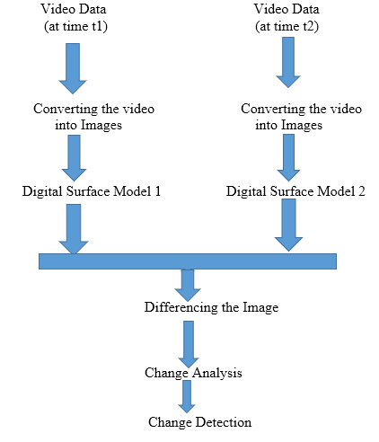

Fig 1:proposed model for change detection