# This is a test

>>> import matplotlib.pyplot as plt  
>>> import numpy as np  
>>> from IPython.display import Image,HTML,YouTubeVideo,SVG

>>> x = np.linspace(-5,5,100)

>>> y = np.sin(2*x)*np.cos(20*x)

>>> plt.plot(x,y)  
>>> plt.savefig('fig1.png',dpi=300)

$$E=mc^{2}$$

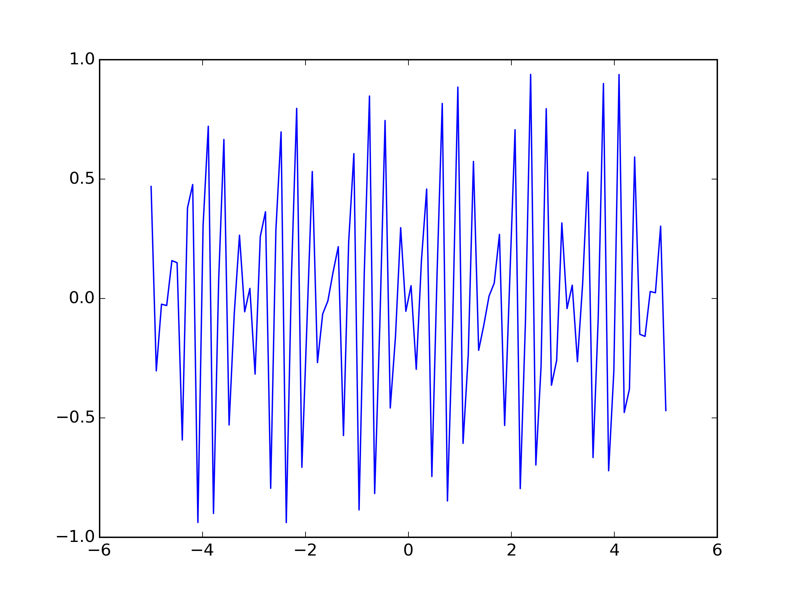

Ma figure: This is a nice figure