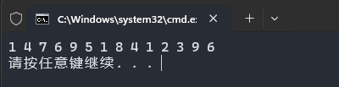

#include <iostream>

**using** **namespace** std;

int main() {

int a[5][5] = {{1, 0, 0, 0, 0}, {4, 7, 0, 0, 0}, {6, 9, 5, 0, 0}, {1, 8, 4, 1, 0}, {2, 3, 0, 9, 6}};

int b[16], index = 0;

**for** (int i = 0; i < 5; i++)

**for** (int j = 0; j <= i; j++)

**if** (a[i][j])

b[index++] = a[i][j];

**for** (int i = 0; i < index; i++)

cout << b[i] << ' ';

cout << endl;

**return** 0;

}