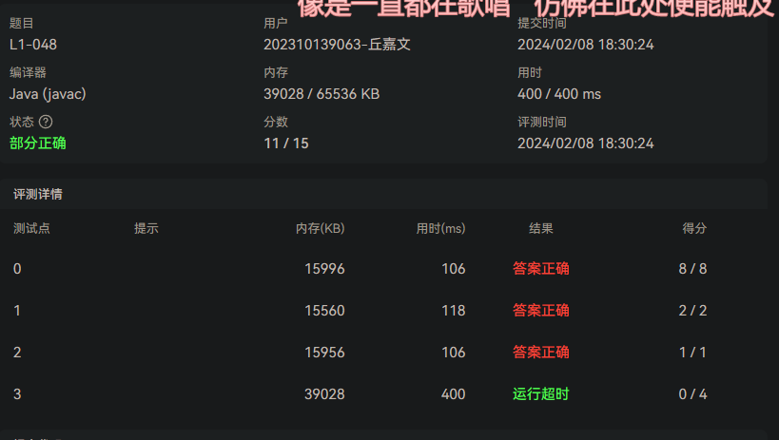

import java.util.Scanner;

public class Main {

public static void main(String[] args) {

Scanner sc = new Scanner(System.in);

int r1 = 0, r2 = 0, c1 = 0, c2 = 0;

r1 = sc.nextInt();

c1 = sc.nextInt();

int[][] m1 = new int[r1][c1];

for(int i = 0; i < r1; i++) {

for(int j = 0; j < c1; j++) {

m1[i][j] = sc.nextInt();

}

}

r2 = sc.nextInt();

c2 = sc.nextInt();

int[][] m2 = new int[r2][c2];

for(int i = 0; i < r2; i++) {

for(int j = 0; j < c2; j++) {

m2[i][j] = sc.nextInt();

}

}

if (c1 != r2) {

System.out.printf("Error: %d != %d", c1, r2);

} else {

int[][] m3 = new int[r1][c2];

for (int i = 0; i < r1; i++) {

for (int j = 0; j < c2; j++) {

int sum = 0;

for (int k = 0; k < c1; k++) {

sum += m1[i][k] \* m2[k][j];

}

m3[i][j] += sum;

}

}

System.out.printf("%d %d\n", r1, c2);

for (int i = 0; i < r1; i++) {

for (int j = 0; j < c2; j++) {

System.out.printf("%d",m3[i][j]);

if (j != c2 - 1)

System.out.printf(" ");

}

System.out.print("\n");

}

}

}

}