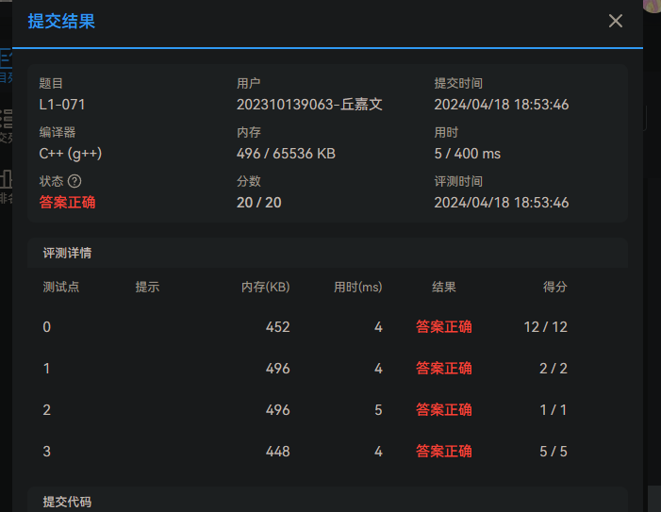

*setleaf*写错了，其实不需要构建一棵树，因为满二叉树的叶子节点是有规律可循的

#include <bits/stdc++.h>

**using** **namespace** std;

#define ll long long

map<ll, ll> tree;

ll tree_size;

ll cnt = 1;

*/\**

*void setleaf(ll index) {*

*if (index >= tree_size)*

*return;*

*if (index * 2 >= tree_size && index * 2 + 1 >= tree_size) {*

*cout << "index " << index << " cnt = " << cnt << endl;*

*tree[index] = cnt++;*

*} else {*

*setleaf(index * 2);*

*setleaf(index * 2 + 1);*

*}*

*}*/*

int main() {

ios_base::sync_with_stdio(false);

cin.tie(NULL);

ll n, m;

cin >> n >> m;

tree_size = pow((ll)2, (ll)(n+1));

*//cout << "tree_size = " << tree_size << endl;*

*//setleaf(1);*

vector<ll> ans(m);

char c;

ll ptr = 1;

**for** (int i = 0; i < m; i++) {

ptr = 1;

**for** (int j = 0; j < n; j++) {

cin >> c;

ptr = ptr * 2;

**if** (c == 'n')

ptr++;

}

ans[i] = ptr - tree_size / 2 + 1;

}

**for** (int i = 0; i < m; i++) {

cout << ans[i];

**if** (i != m -1)

cout << endl;

}

**return** 0;

}