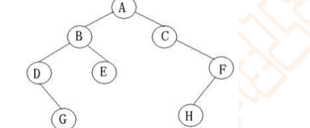

前：ABDGECFH

中：DGBEACFH

后：GDEBHFCA