**1.创建Maven 项目：**

添加jar包

|  |
| --- |
| <dependency>  <groupId>javax.servlet</groupId>  <artifactId>javax.servlet-api</artifactId>  <version>3.0.1</version>  <scope>provided</scope>  </dependency>  <dependency>  <groupId>mysql</groupId>  <artifactId>mysql-connector-java</artifactId>  <version>5.1.18</version>  </dependency> |

1. 创建包分类：

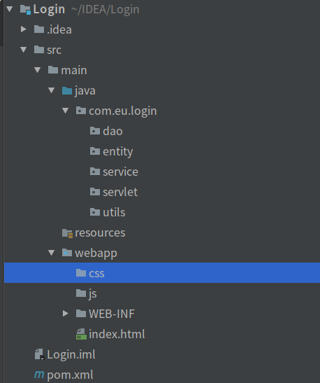

1. 引入css和js 文件

|  |
| --- |
| <script src="js/jquery.min.js"></script>  <link href="css/bootstrap.min.css" rel="stylesheet">  <script src="js/bootstrap.min.js"></script> |

1. 写登录页面：

|  |
| --- |
| <div class="container" style="background-color: white; margin-top: 200px;width: 500px;">  <div class="text-center" style="margin: 50px;">  <h1 class="h1">登录界面</h1>  <form action="/login" method="post">  <div class="form-group input-group">  <label class="input-group-addon" for="username">用户名</label>  <input type="text" class="form-control" id="username" name="username" placeholder="请输入用户名">  </div>  <div class="form-group input-group">  <label class="input-group-addon" for="password">密码</label>  <input type="password" class="form-control" id="password" name="password" placeholder="请输入密码">  </div>  <button type="submit" class="btn btn-success btn-group-sm">登录</button>  </form>  </div>  </div> |
|  |
|  |

1. 创建数据表

|  |
| --- |
| create database login default character set utf8; |