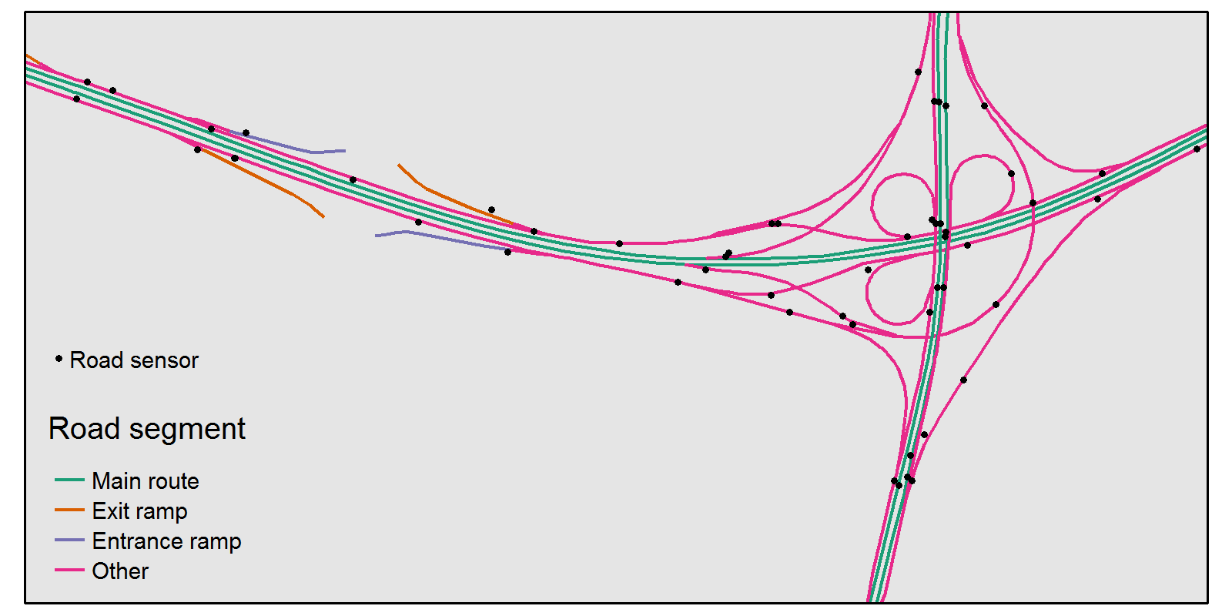

*Figure X. Road sensors on the interchange between the A12 (horizontal) and the A27 (vertical)*

# Road lengths

Road lengths are needed to be calculated traffic intensities and densities. A detailed ESRI shape file of the Dutch highways is used for this purpose. The amount of detail is illustrated in Figure X, where an interchange is illustrated. The metadata of this shape file include the traffic direction and type of road segment which is depicted by color in Figure X. On the left-hand side of this figure there are connection roads (exit and entrance ramps) to the Utrecht city. For each highway, the main route is defined as the route that goes from the one end to the other end point. In Figure X, the main route is colored green. For the traffic intensities, we are primarily interested in the main routes, since intensities on interchanging routes are mixtures of these.

The road lengths are determined as follows. First of all, since the shape file is projected in rijksdriehoekstelselcoördinaten, a Cartesian coordinate system optimized for the Netherlands, the difference between any two points in this coordinate system corresponds approximately to the real distance in meters. Counting the lengths of all main route road segments is not yet sufficient, since there may exist overlapping road segments due to different highway lanes or road works. Therefore, per highway and per direction, all main route road segments are combined to form one continuous polyline. This is done by constructing a graph of all endpoints, where a linked is formed between two endpoints if they are closer than 250 meters. The main route polyline is defined as the shortest path in this graph between the endpoints of the highway. If a highway consist of several disjoint parts, a polyline is generated per part.

The polylines are split by NUTS3 regions, which are illustrated in Figure Y.

# D:\tijn\rdevel\geo\test\NDW_example\plots\highways.png

*Figure Y. Highways per NUTS3 region*

# Projection of road sensors to main roads

Per highway, all road sensors are collected that are closer than 25 meters to that highway. These road sensors are projected on the highway polyline at the shortest distance. Also the distance of each road sensor to the starting point of the highway along the highway is determined. By these distances, the order of road sensors can be easily determined. Furthermore, it is possible the calculate the density of road sensor on specific parts of the highway.