Uselog update

1. related software
userlog modbus_client modbustcp_client modbus_tcp_server station_mc http_weichen

2. database
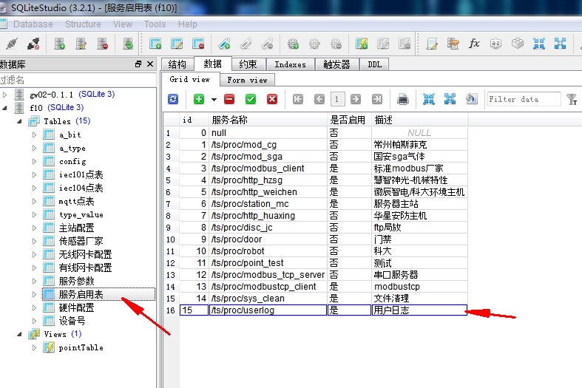
3. reboot result/ts/log/modbus/*.log /ts/log/station/*.log /ts/log/weichen/*.log

