

SIMATS ENGINEERING

Saveetha Institute of Medical and Technical Sciences Chennai- 602105

Student Name: B ABHISHEK Reg. No.:192472049
Course Code: CSA0621 Slot: D
Course Name: Design and Analysis of Algorithms
Course Faculty: Dr .G. Nagarajan

Project Title: Optimized Medical Resource Allocation During Disasters Using Greedy and Priority Scheduling Algorithms
Module Photographs: (2 photographs –Module Photo and presentation image)
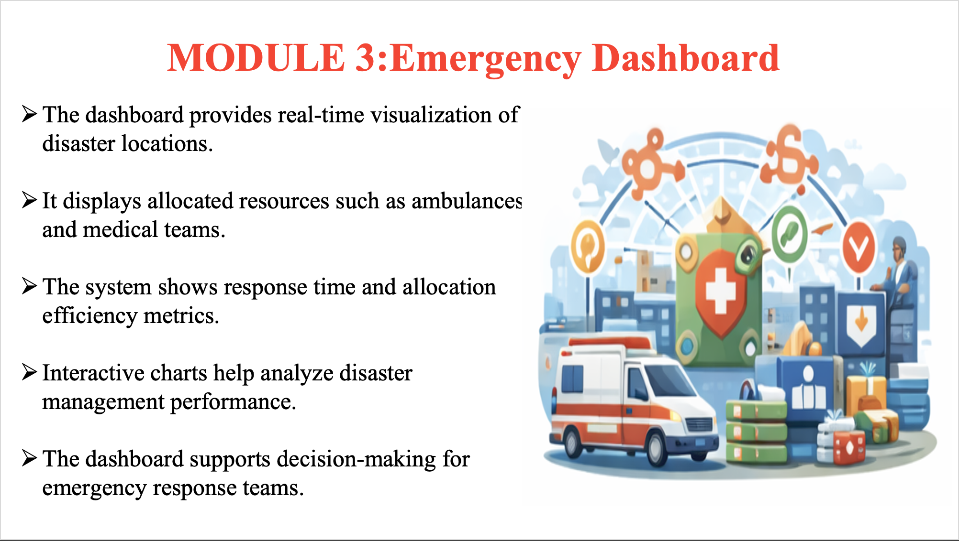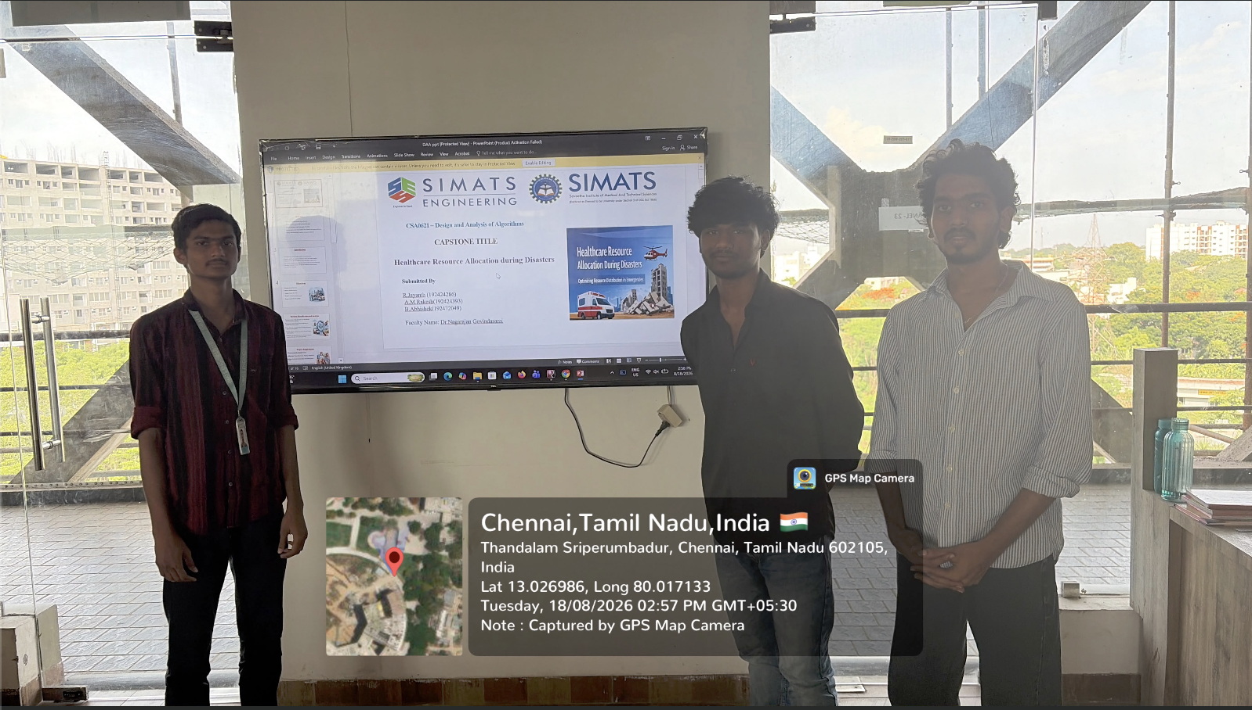
Project Description: MODULE 3: Emergency Dashboard
The Emergency Dashboard provides a centralized view of disaster situations and medical resources. It displays the locations of different disaster areas and the number of affected people. The dashboard shows the availability of ambulances, medical staff, medicines, and other essential supplies. It helps identify the priority level of each emergency situation. The resources are allocated using Greedy and Priority Scheduling Algorithms. The dashboard displays which resources are assigned to each disaster location. It also shows response time and resource utilization. The information can be updated whenever resource availability changes. This helps emergency teams monitor situations effectively. It supports quick decision-making during critical situations. Overall, the dashboard improves the efficiency of medical resource allocation during disasters.

Student Signature Guide Signature

