10. Implement binary tree creation and traversal (preorder, inorder, postorder).
#include <stdio.h>
#include <stdlib.h>

// Structure for tree node
struct Node
{
int data;
struct Node *left;
struct Node *right;
};

// Create new node
struct Node* createNode(int value)
{
struct Node *newNode;

newNode = (struct Node*)malloc(sizeof(struct Node));

newNode->data = value;
newNode->left = NULL;
newNode->right = NULL;

return newNode;
}

// Preorder Traversal
void preorder(struct Node *root)
{
if(root != NULL)
{
printf("%d ", root->data);
preorder(root->left);
preorder(root->right);
}
}

// Inorder Traversal
void inorder(struct Node *root)
{
if(root != NULL)
{
inorder(root->left);
printf("%d ", root->data);
inorder(root->right);
}
}

// Postorder Traversal
void postorder(struct Node *root)
{
if(root != NULL)
{
postorder(root->left);
postorder(root->right);
printf("%d ", root->data);
}
}

int main()
{
// Creating Binary Tree
struct Node *root = createNode(1);

root->left = createNode(2);
root->right = createNode(3);

root->left->left = createNode(4);
root->left->right = createNode(5);

// Traversals
printf("Preorder Traversal:\n");
preorder(root);

printf("\n\nInorder Traversal:\n");
inorder(root);

printf("\n\nPostorder Traversal:\n");
postorder(root);

return 0;
}

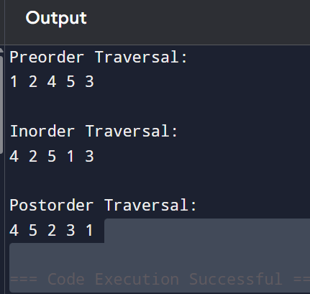
11. Represent a graph using adjacency matrix and adjacency list.

using adjacency matrix
#include <stdio.h>

#define MAX 10

int main()
{
int graph[MAX][MAX];
int vertices, edges;
int i, j, src, dest;

printf("Enter number of vertices: ");
scanf("%d", &vertices);

// Initialize matrix with 0
for(i = 0; i < vertices; i++)
{
for(j = 0; j < vertices; j++)
{
graph[i][j] = 0;
}
}

printf("Enter number of edges: ");
scanf("%d", &edges);

// Input edges
for(i = 0; i < edges; i++)
{
printf("Enter edge (source destination): ");
scanf("%d %d", &src, &dest);

graph[src][dest] = 1;
graph[dest][src] = 1; // Undirected graph
}

// Display adjacency matrix
printf("\nAdjacency Matrix:\n");

for(i = 0; i < vertices; i++)
{
for(j = 0; j < vertices; j++)
{
printf("%d ", graph[i][j]);
}

printf("\n");
}

return 0;
}
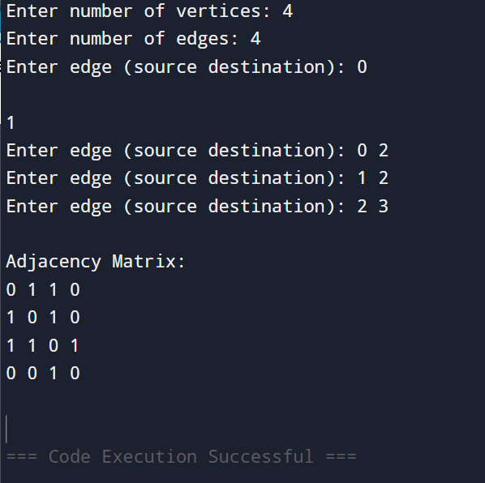
#include <stdio.h>
#include <stdlib.h>

#define MAX 10

// Node structure
struct Node
{
int vertex;
struct Node *next;
};

struct Node *adjList[MAX];

// Create new node
struct Node* createNode(int v)
{
struct Node *newNode;

newNode = (struct Node*)malloc(sizeof(struct Node));

newNode->vertex = v;
newNode->next = NULL;

return newNode;
}

// Add edge
void addEdge(int src, int dest)
{
struct Node *newNode;

// Add edge src -> dest
newNode = createNode(dest);
newNode->next = adjList[src];
adjList[src] = newNode;

// Add edge dest -> src (Undirected graph)
newNode = createNode(src);
newNode->next = adjList[dest];
adjList[dest] = newNode;
}

// Display adjacency list
void display(int vertices)
{
int i;
struct Node *temp;

printf("\nAdjacency List:\n");

for(i = 0; i < vertices; i++)
{
printf("%d -> ", i);

temp = adjList[i];

while(temp != NULL)
{
printf("%d -> ", temp->vertex);
temp = temp->next;
}

printf("NULL\n");
}
}

int main()
{
int vertices, edges;
int i, src, dest;

printf("Enter number of vertices: ");
scanf("%d", &vertices);

// Initialize adjacency list
for(i = 0; i < vertices; i++)
{
adjList[i] = NULL;
}

printf("Enter number of edges: ");
scanf("%d", &edges);

// Input edges
for(i = 0; i < edges; i++)
{
printf("Enter edge (source destination): ");
scanf("%d %d", &src, &dest);

addEdge(src, dest);
}

display(vertices);

return 0;
}

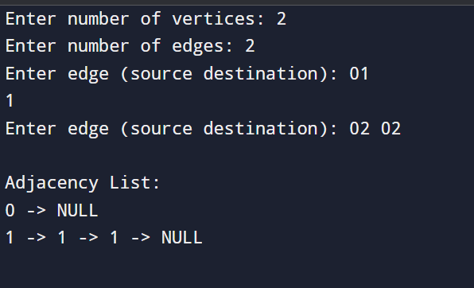
12. Implement graph traversal: BFS and DFS.

#include <stdio.h>

#define MAX 10

int graph[MAX][MAX];
int visited[MAX];
int queue[MAX];
int front = -1, rear = -1;
int vertices;

// Queue operations for BFS
void enqueue(int value)
{
queue[++rear] = value;
}

int dequeue()
{
return queue[++front];
}

// BFS Traversal
void BFS(int start)
{
int i;

printf("BFS Traversal: ");

visited[start] = 1;
enqueue(start);

while(front != rear)
{
int node = dequeue();

printf("%d ", node);

for(i = 0; i < vertices; i++)
{
if(graph[node][i] == 1 && visited[i] == 0)
{
visited[i] = 1;
enqueue(i);
}
}
}
}

// DFS Traversal
void DFS(int start)
{
int i;

printf("%d ", start);

visited[start] = 1;

for(i = 0; i < vertices; i++)
{
if(graph[start][i] == 1 && visited[i] == 0)
{
DFS(i);
}
}
}

int main()
{
int edges;
int i, src, dest;
int start;

printf("Enter number of vertices: ");
scanf("%d", &vertices);

// Initialize graph
for(i = 0; i < vertices; i++)
{
visited[i] = 0;

for(int j = 0; j < vertices; j++)
{
graph[i][j] = 0;
}
}

printf("Enter number of edges: ");
scanf("%d", &edges);

// Input edges
for(i = 0; i < edges; i++)
{
printf("Enter edge (source destination): ");
scanf("%d %d", &src, &dest);

graph[src][dest] = 1;
graph[dest][src] = 1; // Undirected graph
}

printf("Enter starting vertex: ");
scanf("%d", &start);

// BFS
BFS(start);

// Reset visited array for DFS
for(i = 0; i < vertices; i++)
{
visited[i] = 0;
}

printf("\nDFS Traversal: ");

// DFS
DFS(start);

return 0;
}

