GIT Branching Assignment 2 172506

Objective: Commit HTML, CSS & JavaScript assignments into GIT.

SECTION-1 (HTML assignments) - Steps to follow:

1. First take a backup of your assignments & projects. This is required because due to incorrect GIT operation you may lose your files. 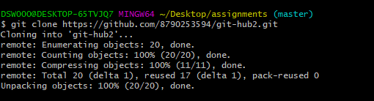
2. Create an empty directory ‘Assignments’ & cd to ‘Assignments’. 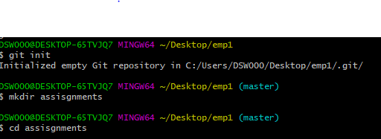
3. Create a file README.txt inside ‘Assignments’ & write few lines about the contents of ‘Assignments’ folder. 
4. Commit README.txt file. Now create a new branch ‘html-assignments’. 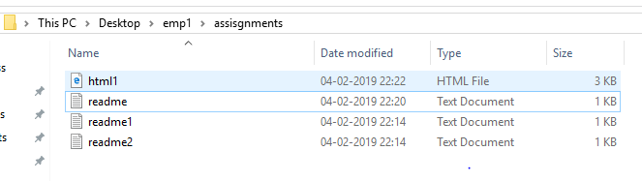C:\Users\DSW000\Desktop\git assignment 2(3).PNG
5. Switch to ‘html-assignments’ branch. 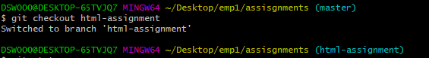
6. Copy all HTML assignments inside ‘Assignments’ folder. 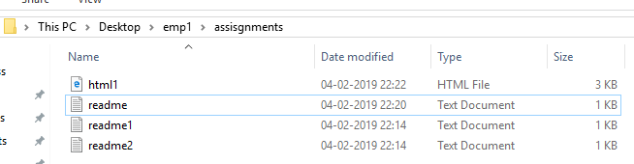
7. Commit HTML assignments into ‘html-assignments’ branch. 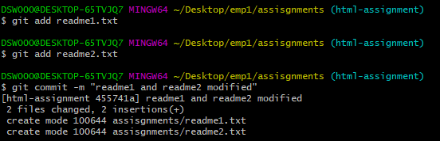
8. Make minor changes into few files belonging to ‘html-assignments’ branch. 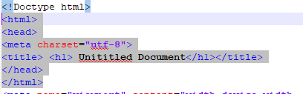
9. Commit those changed files. 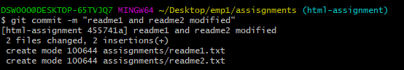
10. Switch to master branch. 
11. Make minor changes into README.txt file & commit those changes into master. 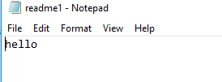
12. Again switch to ‘html-assignments’ branch. 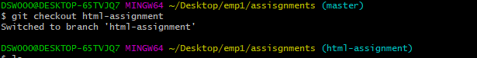
13. Make minor changes into few files belonging to ‘html-assignments’ branch. 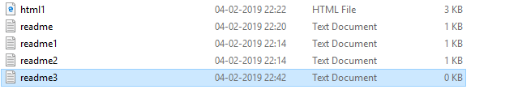
14. Commit those changes. 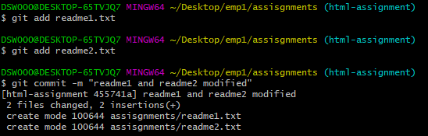
15. Switch to master. 
16. Merge ‘html-assignments’ branch into master. Confirm all html assignments are shown in master. 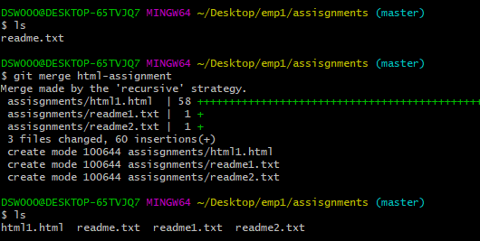
17. Finally delete the ‘html-assignments’ branch. 

SECTION-2 - (CSS assignments) Steps to follow:

1. Create a new branch ‘css-assignments’. 
2. Switch to ‘css-assignments’ branch. 
3. Copy all CSS assignments inside ‘Assignments’ folder. 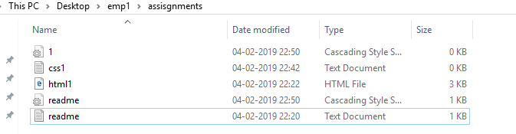
4. Commit CSS assignments into ‘css-assignments’ branch. 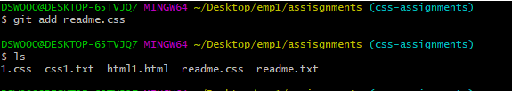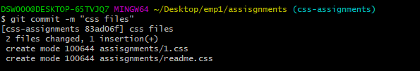
5. Make minor changes into README.txt file on line 1 belonging to ‘css-assignments’ branch. 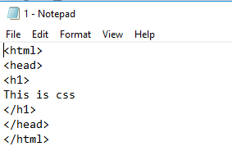
6. Commit those changed files. 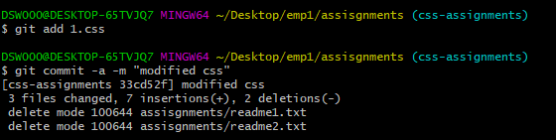
7. Switch to master branch. 
8. Make minor changes into README.txt file on line 3 & commit those changes into master. 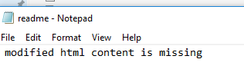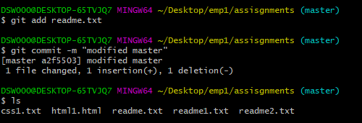
9. Again switch to ‘css-assignments’ branch. 
10. Make minor changes into few files belonging to ‘css-assignments’ branch. 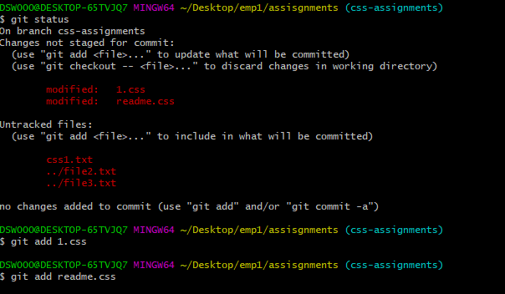
11. Commit those changes. 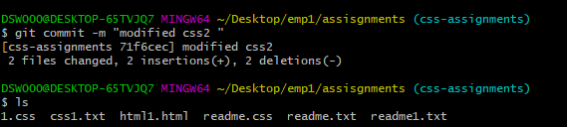
12. Switch to master. 
13. Merge ‘css-assignments’ branch into master. Confirm all css assignments are shown in master. 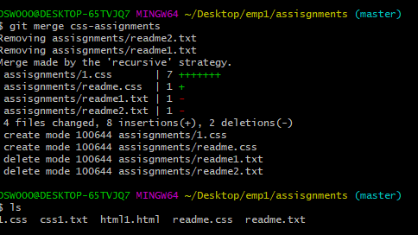
14. Finally delete the ‘css-assignments’ branch. 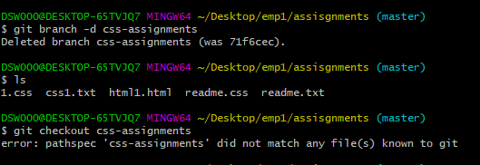

SECTION-3 - (JavaScript assignments) Steps to follow:

1. Create a new branch ‘js-assignments’. 
2. Switch to ‘js-assignments’ branch. 
3. Copy all JavaScript assignments inside ‘Assignments’ folder. 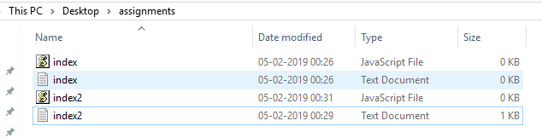
4. Commit JavaScript assignments into ‘js-assignments’ branch. 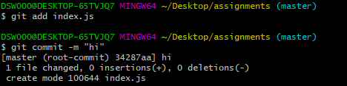
5. Make minor changes into README.txt file on line 1 belonging to ‘js-assignments’ branch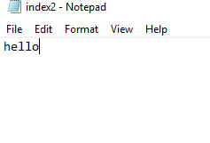.
6. Commit those changed files. 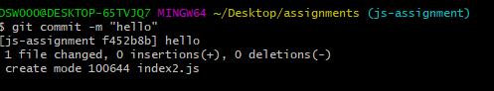
7. Switch to master branch. 
8. Make minor changes into README.txt file on line 1 & commit those changes into master. 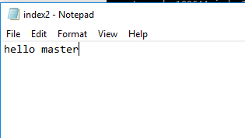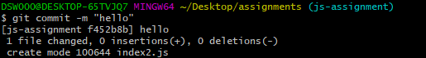
9. Again switch to ‘js-assignments’ branch. 
10. Make minor changes into few files belonging to ‘js-assignments’ branch. 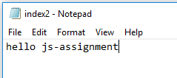
11. Commit those changes. 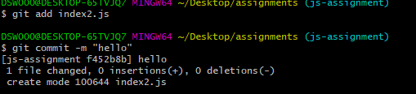
12. Switch to master. 
13. Merge ‘js-assignments’ branch into master. Confirm all JavaScript assignments are shown in master. 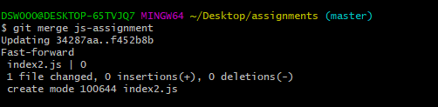
14. Finally delete the ‘js-assignments’ branch. 