**部署以太网**

telnet（非ssh）登录：Admin@huawei

先删除默认的Celluar路由

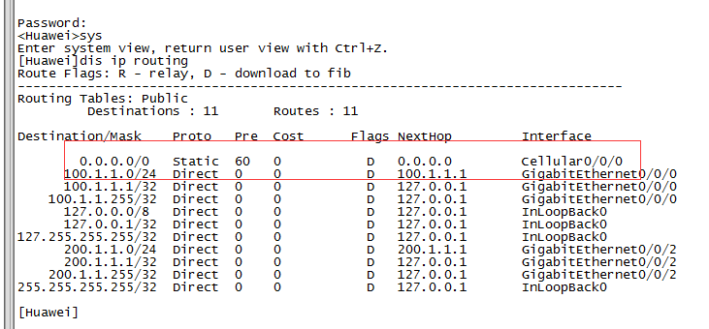

undo ip route-static 0.0.0.0 0.0.0.0 Cellular0/0/0

**进入网口EG1，开启dhcp，设置NAT**

interface g 0/0/1

ip address dhcp-alloc

nat outbound 3000

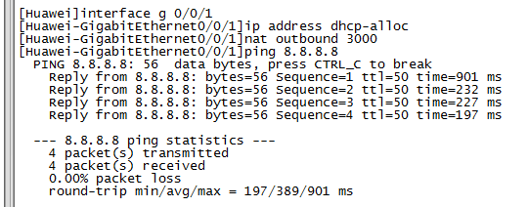

**登录虚机，检查网络**

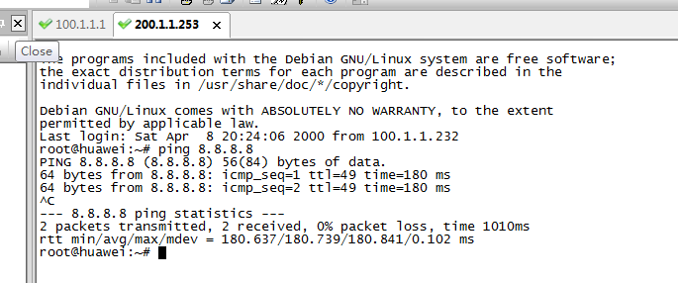

**恢复部署4G LTE网络**

重启设备（只要不执行save命令，重启都会恢复之前的配置）或添加默认路由即可

ip route-static 0.0.0.0 0.0.0.0 Cellular0/0/0

**准备编译环境**

|  |
| --- |
| sudo apt-get update  sudo apt-get install -y \  apt-transport-https \  ca-certificates \  curl \  software-properties-common  curl -fsSL https://download.daocloud.io/docker/linux/ubuntu/gpg | sudo apt-key add -  sudo add-apt-repository \  "deb [arch=$(dpkg --print-architecture)] https://download.daocloud.io/docker/linux/ubuntu \  $(lsb_release -cs) \  stable"  sudo apt-get update  sudo apt-get install -y -q docker-ce=17.03.1*  sudo service docker start  sudo service docker status |

加速器：curl -sSL https://get.daocloud.io/daotools/set_mirror.sh | sh -s http://025c6c16.m.daocloud.io

sudo docker pull 1587/osc-builder

sudo docker run -v /mnt/hgfs/share_VM:/data -v /dev:/dev -v /lib/modules/:/lib/modules -v /run:/run --add-host='osc:127.0.0.1' --privileged -i --rm -t 1587/osc-builder /bin/bash

解压到编译主机~/data目录下，在docker编译容器中执行./make即可