|  |
| --- |
| **A**  **PROJECT REPORT ON** |
|  |
|  |
| REFURBEDWHEELS.COM  (Buying and selling Preowned cars) |
|  |
|  |
| SUBMITTED IN  PARTIAL FULFILLMENT OF  **DIPLOMA IN ADVANCED COMPUTING (PG-DAC)** |
|  |
|  |
|  |
|  |
|  |
|  |
|  |
| **BY**  **Abhishek Gulab Chavan**  **Amit Ashok Shinde**  **Sahil Yashwant Chaudhari**  **Sanket Suresh Salokhe** |
|  |
|  |
| **UNDER THE GUIDENCE OF**  **Vrushabh Kumtale Sir** |
|  |
|  |
|  |
| **AT**  **SUNBEAM INSTITUTE OF INFORMATION TECHNOLOGY,**  **Karad** |

|  |  |
| --- | --- |
|  | |
| **SUNBEAM INSTITUTE OF INFORMATION TECHNOLOGY,**  **Karad** | |
|  | |
|  | |
|  | |
|  | |
| **CERTIFICATE** | |
|  | |
| This is to certify that the project | |
|  | |
| REFURBEDWHEELS.COM  (Buying and selling Preowned cars) | |
|  | |
| Has been submitted by | |
|  | |
| **Abhishek Gulab Chavan**  **Amit Ashok Shinde**  **Sahil Yashwant Chaudhari**  **Sanket Suresh Salokhe** | |
|  | |
|  | |
| In partial fulfillment of the requirement for the Course of **PG Diploma in Advanced Computing (PG-DAC March 2024)** as prescribed by The **CDAC** ACTS, PUNE. | |
|  | |
|  | |
| Place: Karad | Date: 14-AUG-2024 |
|  | |
|  | |
| Vrushabh Kumtale Sir | Pratik Ninganur Sir |
| **Project Guide** | **Course Coordinator** |

**ACKNOWLEDGEMENT**

A project usually falls short of its expectation unless aided and guided by the right persons at the right time. We avail this opportunity to express our deep sense of gratitude towards **Mr. Prashant Lad (Center Coordinator, SIIT, Karad)** and **Mr. Pratik Ninganur (Course Coordinator, SIIT, Karad).**

We are deeply indebted and grateful to them for their guidance, encouragement and deep concern for our project. Without their critical evaluation and suggestions at every stage of the project, this project could never have reached its present form.

Last but not the least we thank the entire faculty and the staff members of Sunbeam Institute of Information Technology, Karad for their support.

Sahil Yashwant Chaudhari

**DAC March 24 Batch,**

**SIIT Karad**

**INDEX**

|  |  |  |
| --- | --- | --- |
|  | **INTRODUCTION** | 1 |
|  | 1.1 Introduction | 1 |
|  | 1.2 Scope | 1 |
|  | **REQUIREMENTS** | 2 |
|  | 2.1 Functional Requirements | 3 |
|  | 2.1.1 Registration | 3 |
|  | 2.1.2 Login | 3 |
|  | 2.1.3 Buy Vehicle | 3 |
|  | 2.1.4 Sell Vehicle | 3 |
|  | 2.1.5 See Blogs | 3 |
|  | 2.1.6 Raise Concerns | 3 |
|  | 2.1.7 Sort Vehicles | 3 |
|  | 2.1 Functional Requirements of Admin | 4 |
|  | 2.2.1 Blogs | 4 |
|  | 2.2.2 Manage Users | 5 |
|  | 2.2.3 See Concerns | 5 |
|  | **DESIGN** | 6 |
|  | 3.1 Database Design | 6 |
|  | 3.1.1 User Table | 6 |
|  | 3.1.2 Concern Table | 6 |
|  | 3.1.3 Blogs Table | 6 |
|  | 3.1.4 Vehicle Information table | 7 |
|  | 3.1.5 Car Image Table | 7 |
|  | 3.2 Actual Flow of Application/Platform | 7 |
|  | **CODING STANDARDS IMPLEMENTED** | 8 |
|  | **TEST REPORT** | 9 |
|  | **E-R DIAGRAM** | 10 |
|  | **CONCLUSION** | 20 |
|  | **REFERENCES** | 21 |

**LIST OF TABLES**

|  |  |  |
| --- | --- | --- |
| **Section** | **Table Title** | **Page** |
| DESIGN | User Table | 6 |
| DESIGN | Concern Table | 6 |
| DESIGN | Blogs Table | 6 |
| DESIGN | Vehicle Info. Table | 7 |
| DESIGN | Car Image Table | 7 |
| CODING STANDARDS | Naming and Capitalization | 8 |
| TESTING REPORT | General Testing | 9 |

**LIST OF FIGURES**

|  |  |  |
| --- | --- | --- |
| **Section** | **Figure Title** | **Page** |
| **E-R DIAGRAM** | E-R Diagram | 10 |
| **APPENDIX A** | Login Page | 11 |
|  | Register Page | 12 |
|  | Add Car Page | 13 |
|  | View Cars | 14 |
|  | Car Details | 15 |
|  | Car Details with Seller Contact | 16 |
|  | Listed Cars | 17 |
|  | (Admin Side) Concerns raised by Users | 17 |
|  | Manage User | 18 |
|  | All Blogs Delete and Edit | 18 |
|  | Add New Blog | 19 |

1. INTRODUCTION

1.1 INTRODUCTION

The web based “**Car buy and Sell**” project is an platform to make user a web based service where in one can sell and buy pre-owned cars.

This project is a dynamic web-based application designed to simplify the buying and selling of used and pre-owned vehicles. The platform offers a user-friendly interface where sellers can easily list their vehicles, and buyers can browse through a wide range of options with detailed information, images, and pricing. Advanced search features ensure that users can quickly find the vehicles that meet their needs.

Beyond its core marketplace functionality, the application includes a blog section where users can stay updated on the latest automotive news and trends.

The blog is regularly updated by the admin, providing valuable insights, tips, and industry updates. This combination of a robust marketplace and informative content makes the application a comprehensive hub for all things related to pre-owned vehicles.

1.2 SCOPE

* **Security Features**: Implement strong password policies, encryption for sensitive data, and multi-factor authentication
* **Email Verification**: Send an email with a verification link to confirm the user's email address during sign-up
* **Password Reset**: Allow users to request a password reset, sending a secure link to their email to create a new password.

2. REQUIREMENTS

**2.1 FUNCTIONAL REQUIREMENTS OF USER**

2.1.1 REGISTRATION

Here one who want use this platform must be registered user/customer. Where in we are taking basic information like Name, Email, Password, Mobile Number.

2.1.2 LOGIN

An user who is successfully registered on website can use this functionality. After user Logged in successfully he will be authorized to access some features on this platform.

2.1.3 BUY VEHICLE

Here using this feature one can see the details of the vehicle of his interest also he can get details of the owner of vehicle along with the asking price.

2.1.4 SELL VEHICLE

The user which logged in successfully can sell the vehicle where he has to add the details of vehicle like make, model, year of purchase etc.

2.1.5 SEE BLOGS

The user can get information regarding recent trends in market which will be on form of blogs.

2.1.6 RAISE CONCENRS

The user can raise concerns if he has any basically this feature is like feedback of platform.

2.1.7 SORT VEHICLES

Afte the logging in the user will be able go through the list of cars available for sales and can sort vehicle based on year of make.

**2.2 FUNCTIONAL REQUIREMENTS OF ADMIN**

2.2.1 BLOGS

This feature of admin side- The blog is regularly updated by the admin, providing valuable insights, tips, and industry updates. This combination of a robust marketplace and informative content makes the application a comprehensive hub for all things related to pre-owned vehicles.

2.2.2 MANAGE USERS

Here admin can manage user where he has authority to delete user from the platform. After deleting the user along with user his vehicle and their images will be deleted.

2.2.3 SEE CONCERNS

This functionality is like combination of concerns and feedback to the platform which will help to enhance the performance of platform for future operations.

3. DESIGN

**3.1 DATABASE DESIGN**

3.1.1 User Table

|  |  |  |  |  |
| --- | --- | --- | --- | --- |
| FIELD | DATA TYPE | NULL (constraint) | KEY | EXTRA INFO |
| UserID | bigint | NO | PRIMARY | Auto_increment |
| Email | Varchar(25) | NO | UNIQUE |  |
| First_name | Varchar(25) | YES |  |  |
| Last_name | Varchar(25) | YES |  |  |
| Mobilenumber | Varchar(25) | YES |  |  |
| Password | Varchar(25) | NO |  |  |
| Role | Varchar(25) | YES |  |  |
| Created_at | dateTime(6) | YES |  |  |
| Updated_at | dateTime(6) | YES |  |  |

3.1.2 Concern Table

|  |  |  |  |  |
| --- | --- | --- | --- | --- |
| FIELD | DATA TYPE | NULL (constraint) | KEY | EXTRA INFO |
| id | bigint | NO | PRIMARY | Auto_increment |
| Concerns | Varchar(1000) | YES |  |  |
| Email | Varchar(100) | NO |  |  |
| Name | Varchar(100) | NO |  |  |
| Subject | Varchar(255) | YES |  |  |

3.1.3 Blogs Table

|  |  |  |  |  |
| --- | --- | --- | --- | --- |
| FIELD | DATA TYPE | NULL (constraint) | KEY | EXTRA INFO |
| id | bigint | NO | PRIMARY | Auto_increment |
| DateOfUploading | Datetime(6) | YES |  |  |
| Heading | Varchar(100) | YES |  |  |

|  |  |  |  |  |
| --- | --- | --- | --- | --- |
| Information | Varchar(1000) | YES |  |  |

3.1.4 Vehicle Information Table

|  |  |  |  |  |
| --- | --- | --- | --- | --- |
| FIELD | DATA TYPE | NULL (constraint) | KEY | EXTRA INFO |
| id | Bigint | NO | PRIMARY | Auto_increment |
| AskingPrice | Float | YES |  |  |
| KmDriven | Float | YES |  |  |
| Location | Varchar(25) | YES |  |  |
| Make | Varchar(25) | YES |  |  |
| Mileage | Float | YES |  |  |
| Model | Varchar(25) | YES |  |  |
| Ownership | Int | YES |  |  |
| Varient | Varchar(25) | YES |  |  |
| VehicleNumber | Varchar(10) | YES | UNIQUE |  |
| YearOfPurchase | Date | YES |  |  |
| User_userId | bigint | YES | MUL |  |

3.1.5 Car Image Table

|  |  |  |  |  |
| --- | --- | --- | --- | --- |
| FIELD | DATA TYPE | NULL (constraint) | KEY | EXTRA INFO |
| id | Bigint | NO | PRIMARY | Auto_increment |
| image | Varchar(255) | YES |  |  |
| Vehicle_id | bigint | NO | MUL |  |

**3.2 Actual Flow of Application/Platform**

Go to appendix A

4. CODING STANDARDS IMPLEMENTED

**Naming and Capitalization**

Below summarizes the naming recommendations for identifiers in Pascal casing is used mainly (i.e. capitalize first letter of each word) with camel casing (capitalize each word except for the first one) being used in certain circumstances.

|  |  |  |  |
| --- | --- | --- | --- |
| **Identifier** | **Case** | **Examples** | **Additional Notes** |
| Class | Pascal | Person, BankVault, SMSMessage, Dept | Class names should be based on "objects" or "real things" and should generally be **nouns**. No ‘_’ signs allowed. Do not use type prefixes like ‘C’ for class. |
| Method | Camel | getDetails, updateStore | Methods should use **verbs** or verb phrases. |
| Parameter | Camel | personName, bankCode | Use descriptive parameter names. Parameter names should be descriptive enough that the name of the parameter and its type can be used to determine its meaning in most scenarios. |
| Interface | Pascal with "I" prefix | Disposable | Do not use the ‘_’ sign |
| Property | Pascal | ForeColor, BackColor | Use a noun or noun phrase to name properties. |
| Associated private member variable | _camelCase | _foreColor, _backColor | Use underscore camel casing for the private member variables |
| Exception Class | Pascal with "Exception" suffix | WebException, |  |

5. TEST REPORT

**General Testing**

|  |  |  |  |  |
| --- | --- | --- | --- | --- |
| SR.NO | TEST CASE | EXPECTED RESULT | ACTUAL RESULT | ERROR  (if any) |
| 1 | REGISTER | Register Successfully and redirect to login page | OK | NO |
| 2 | LOGIN | After Logging in Successfully redirect to Home Page | OK | In case of invalid email or password it will show message regarding that |
| 3 | SEE List of vehicle | At home page user must be able to see list of cars available | OK | NO |
| 4 | Get Vehicle Details(BUY NOW) | Show details of that particular vehicle | OK | NO |
| 5 | Show Contact Details | Get details of owner of vehicle | OK | NO |
| 6 | Sort by Model | Get vehicles purchased under that make period | OK | NO |
| 7 | Send Message | Raised concerns must be sent to admin | OK | NO |
| 8 | Listed Car for Sale | Particular user who logged in must see his listed vehicle for sale | OK | NO |
| 9 | Add New Blog | Blog is added by admin | OK | NO |
| 10 | All Blogs(edit and delete) | Deleted and Edited Blogs | OK | NO |
| 11 | Manage Users | Delete particular user selected by admin | OK | NO |
| 12 | View Concerns | Get list of concerns | OK | NO |

6. E-R DIAGRAM

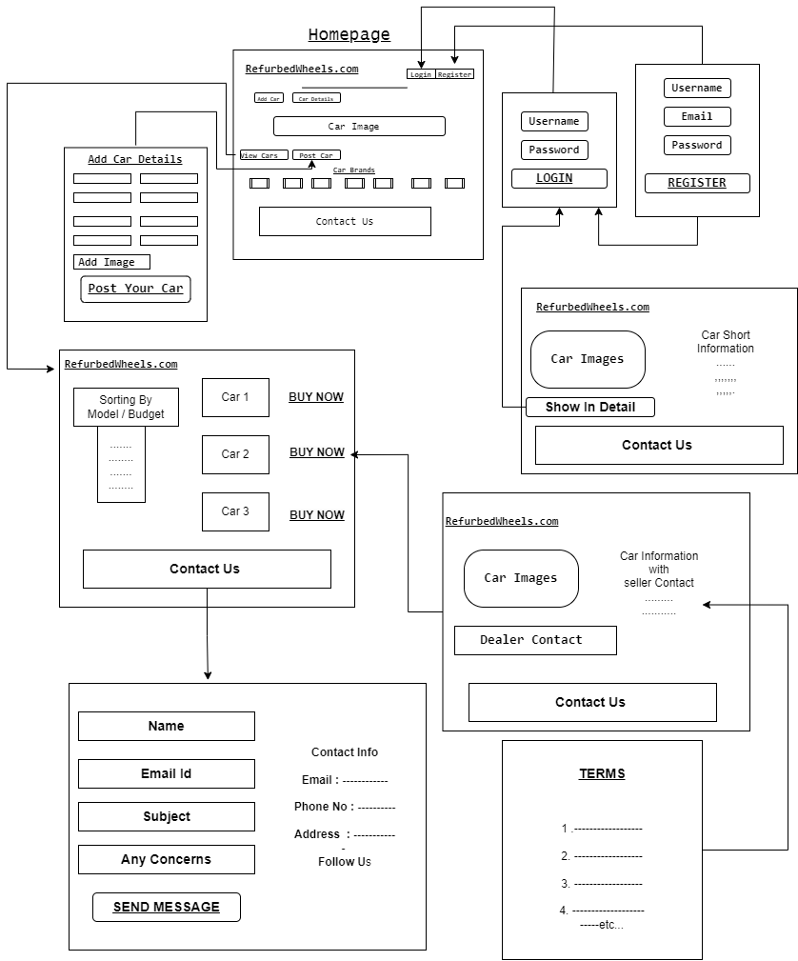

Appendix A

**Login Page**

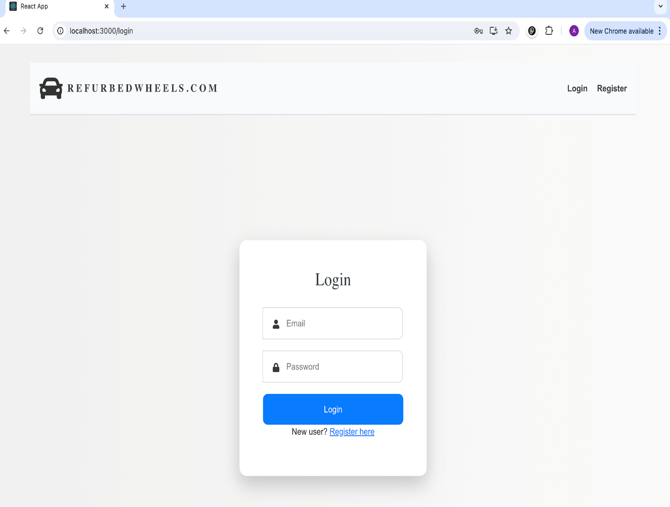

**Register Page**

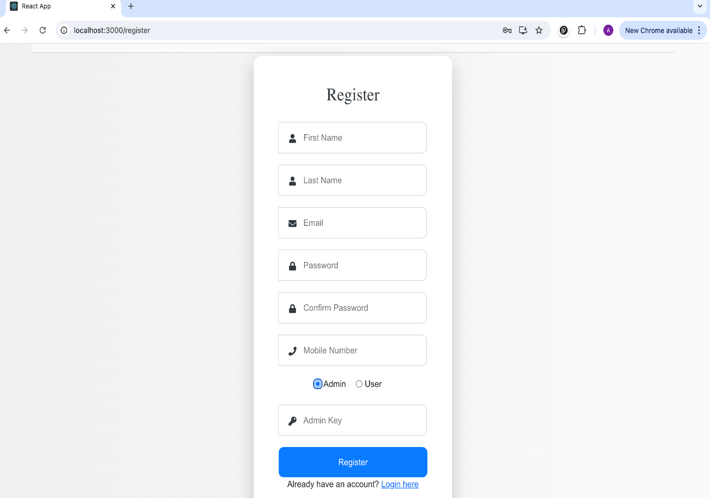

**Add Car Page**

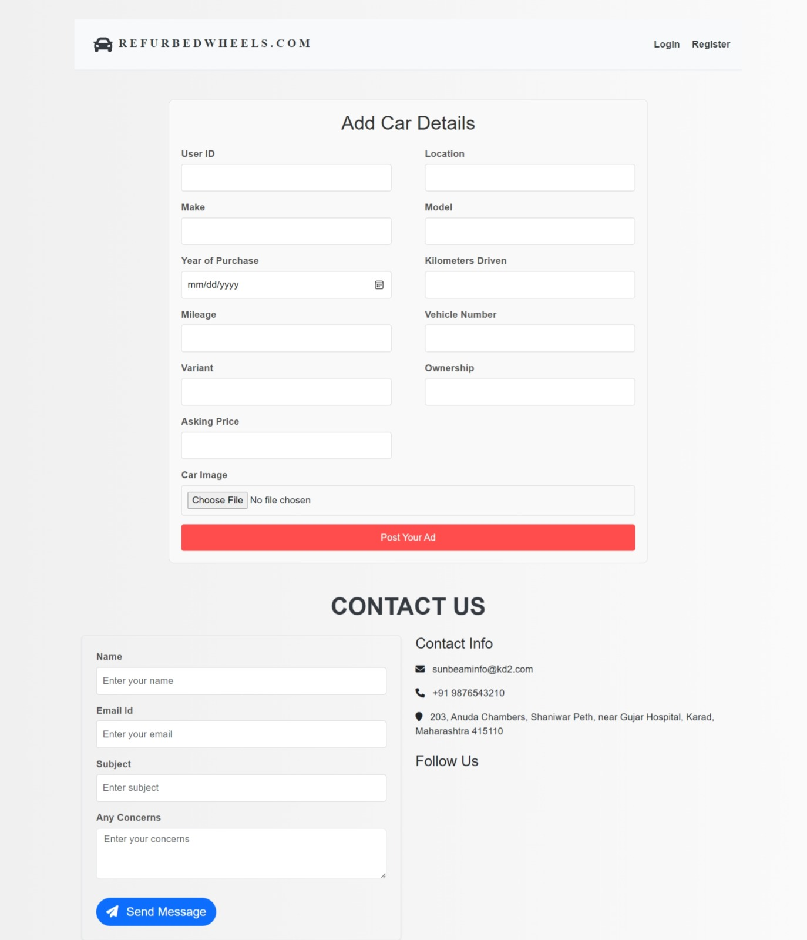

**View Cars**

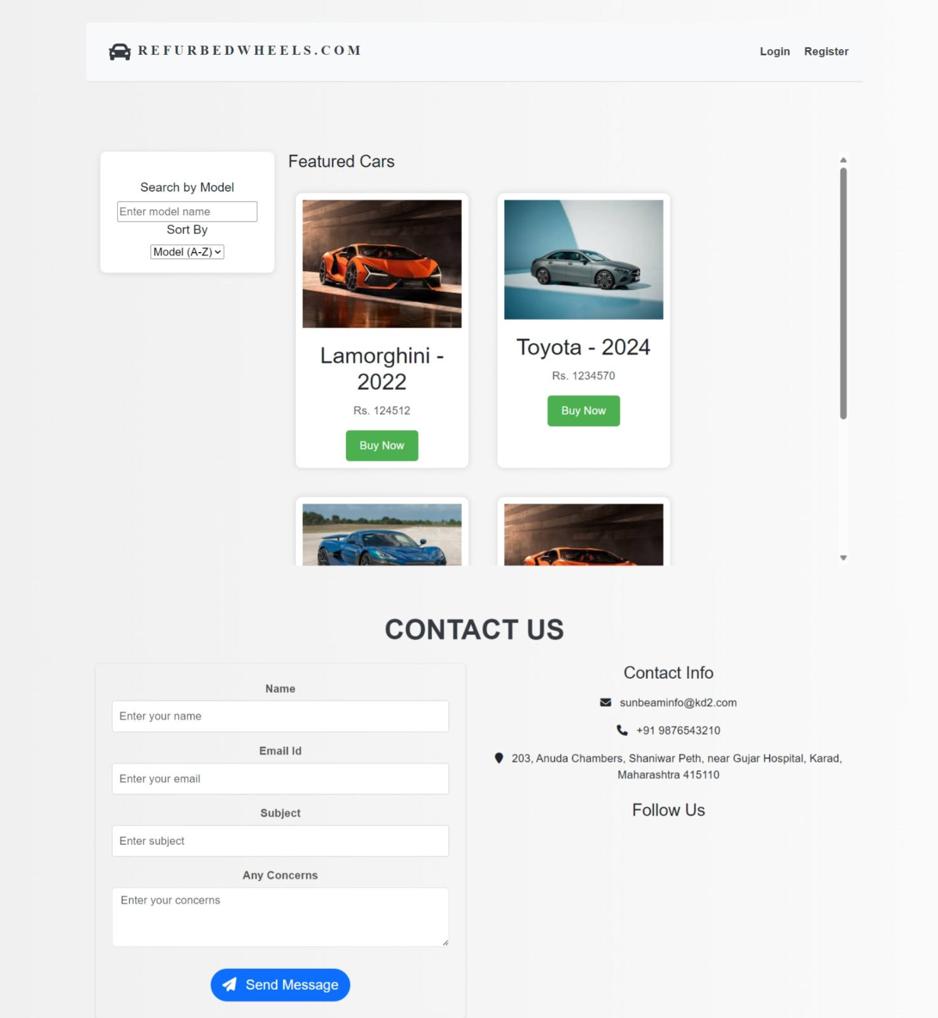

**Car Details**

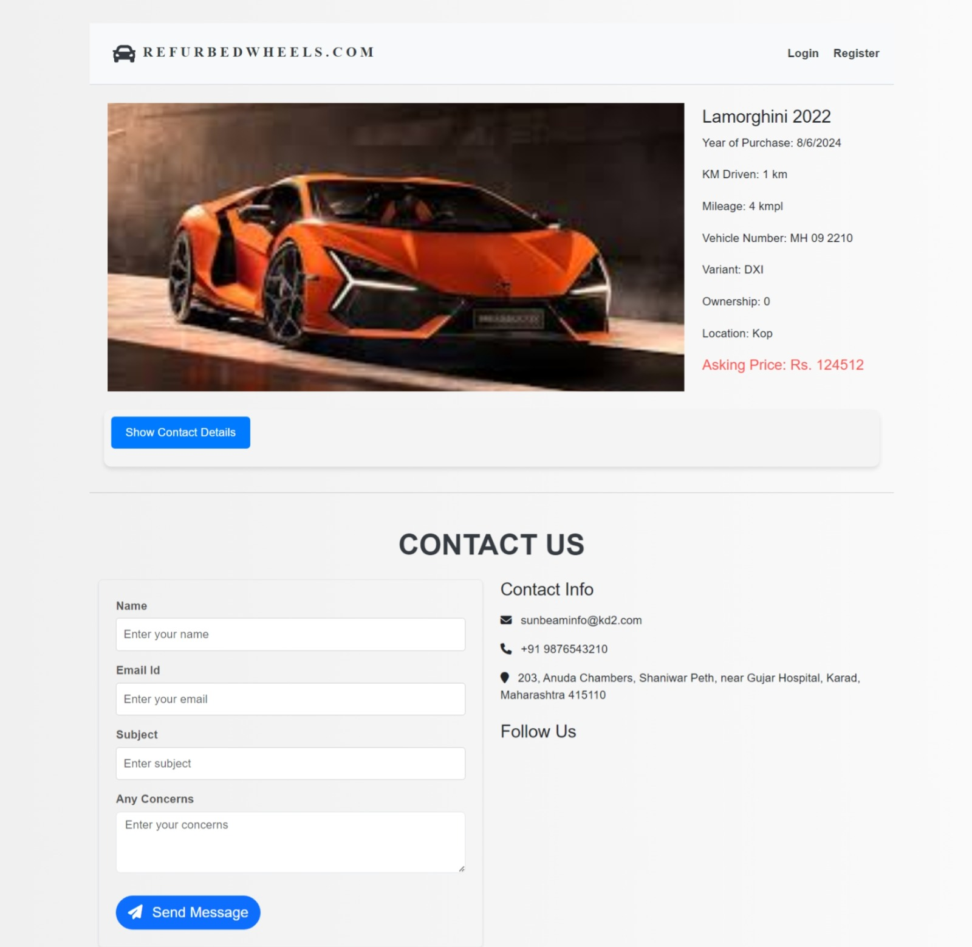

**Car details with Seller Contact**

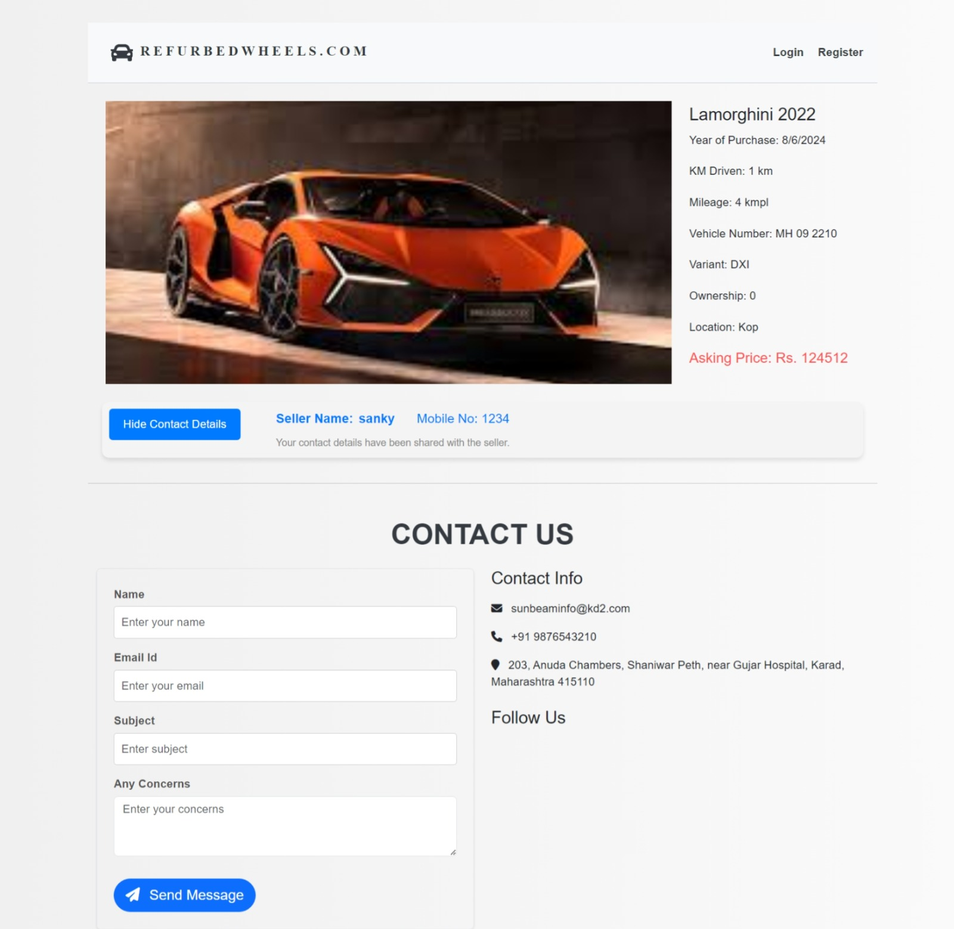

**Listed Cars of User with Delete car functionality**

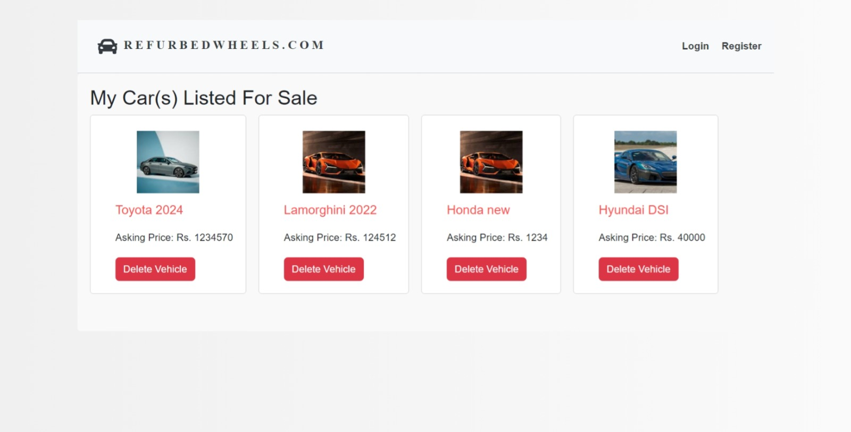

**(Admin side) Concerns raised by Users**

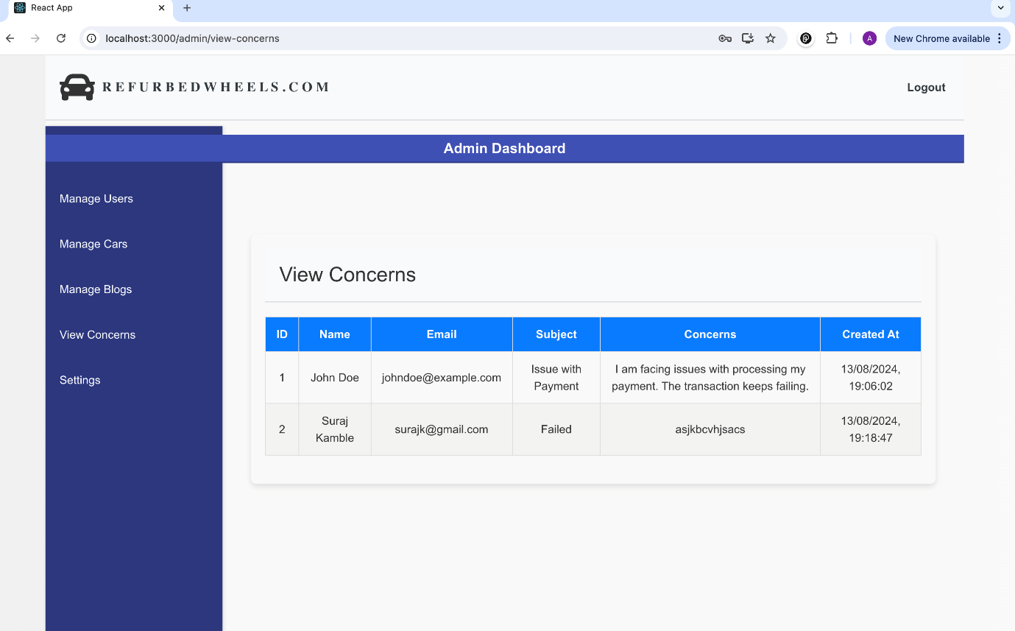

**Manage User**

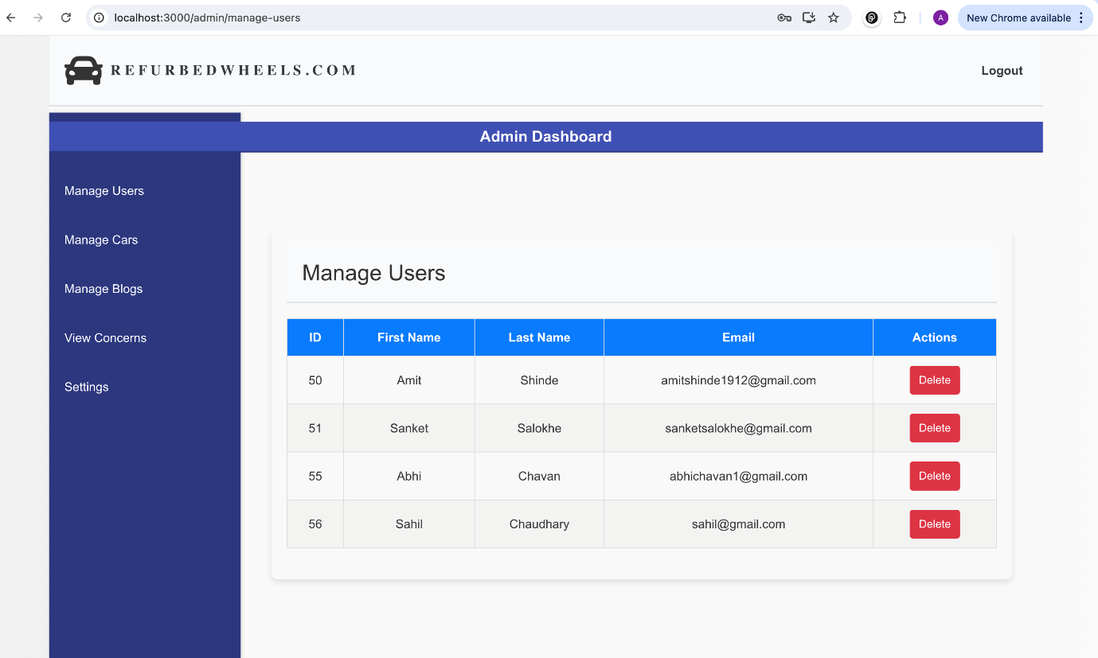

**All Blogs Delete and Edit**

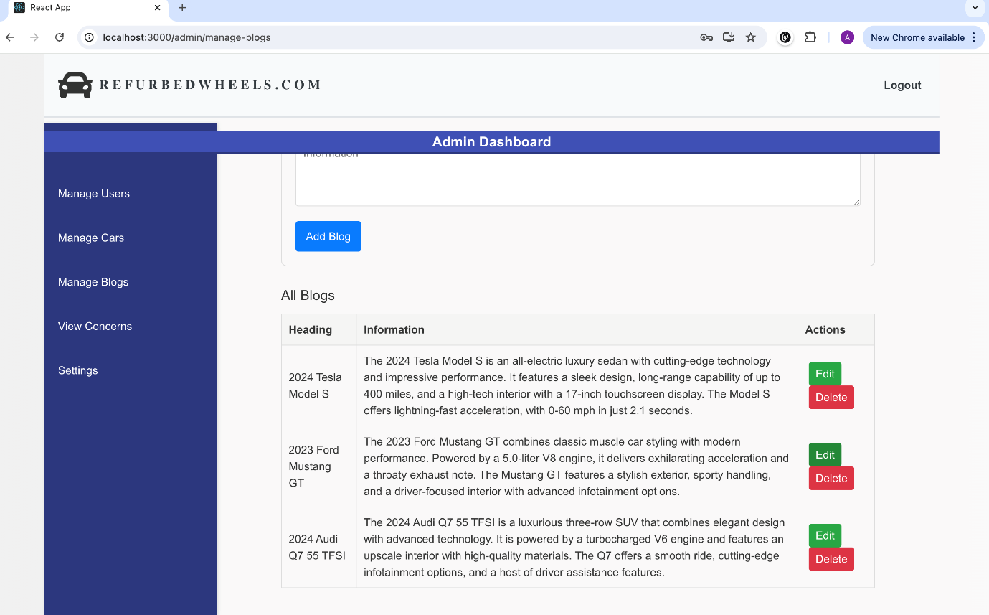

**Add New Blog**

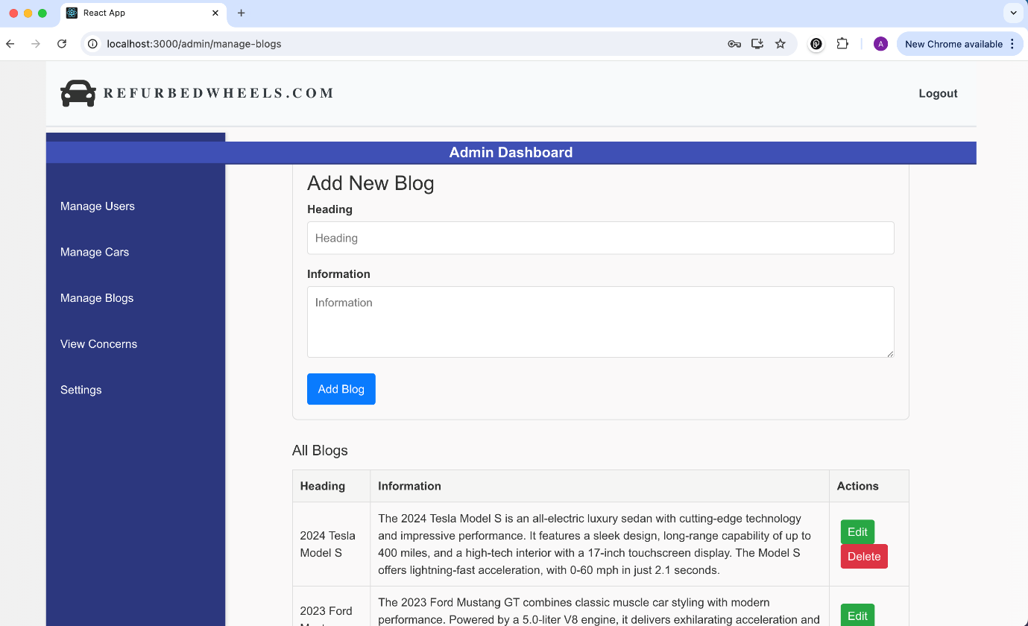

7. CONCLUSION

The "Car Buy and Sell" web-based platform makes it easier to buy and sell used cars by offering a simple and user-friendly interface. The platform includes key features like sorting vehicles, handling user concerns, and providing an updated blog with the latest car news. The backend is well-structured with a solid database, ensuring everything runs smoothly. The testing process showed that the application works as expected, proving its reliability and readiness for use. Overall, this project offers a complete solution for anyone interested in the used car market.

References :

1. *W3Schools* - A comprehensive guide for learning web development technologies including HTML, CSS, and JavaScript (https://www.w3schools.com/).

2. *MDN Web Docs* - An essential resource for web developers, offering documentation on web technologies like HTML, CSS, and JavaScript (https://developer.mozilla.org/en-US/).

3. *Java Docs* - Official documentation for Java, providing detailed information on Java classes, methods, and packages (https://docs.oracle.com/javase/8/docs/api/).

4. *Stack Overflow* - A platform for developers to find solutions to coding problems and share knowledge (https://stackoverflow.com/).

5. *Car Dekho* - An online marketplace for buying and selling new and used cars, with detailed reviews and pricing information (https://www.cardekho.com).

6. *Car Wale* - A car marketplace providing car listings, comparisons, reviews, and buying guides (https://www.carwale.com).