Project Title : RefurbedWheels.com (Buying and selling refurbished cars)

Description :
We are developing a fullstack web application using Java Spring Boot and React to create an online marketplace for buying and selling refurbished cars. This user friendly platform simplifies the process of finding and listing preowned vehicles, empowering both buyers and sellers with a transparent and great experience.

Admin Requirement :
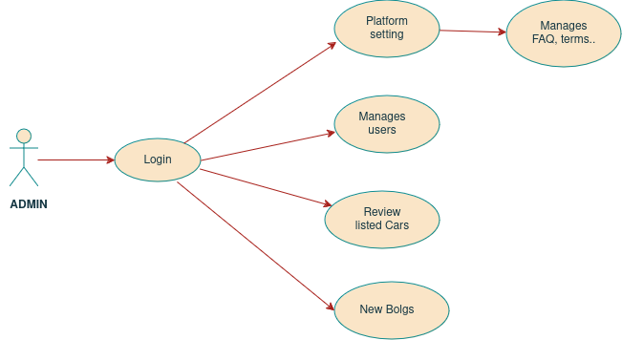

Buyer requirement :

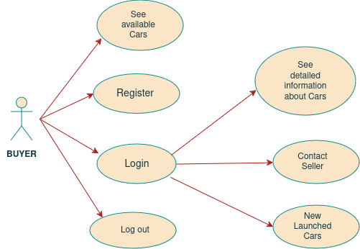

Seller requirements :

