Linux Assignment - 01

1. List the directory contents date wise sorted.

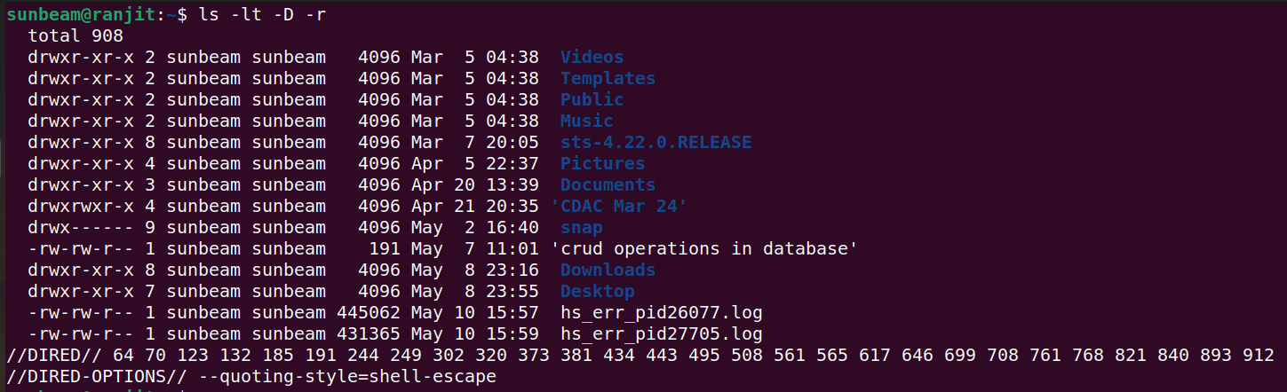

2. List the directory contents size wise sorted.

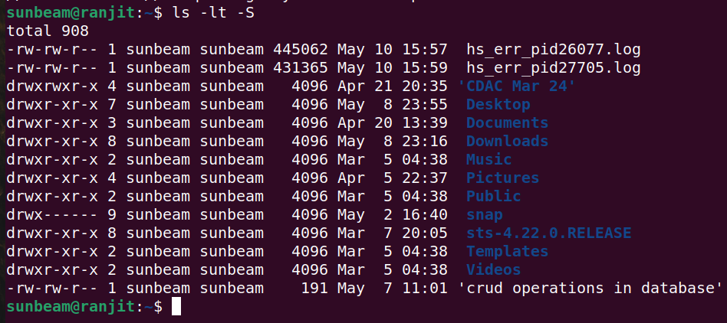

3. List directory contents along with their inode no.

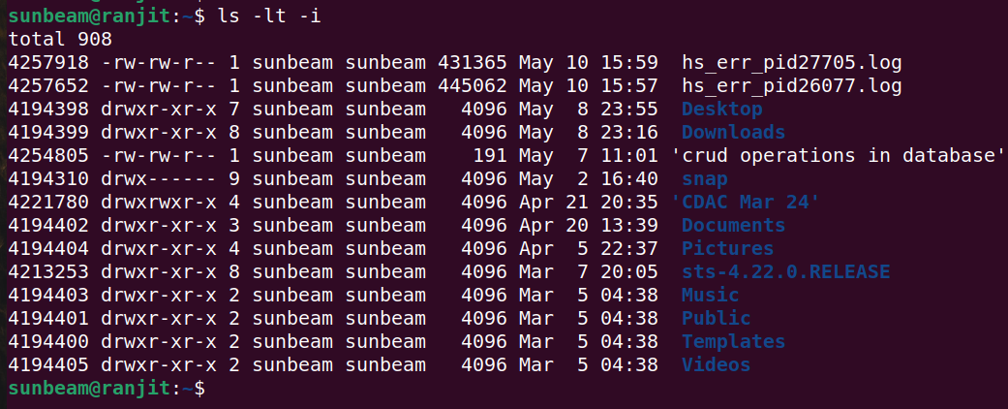

4. List the contents of the subdirectory.
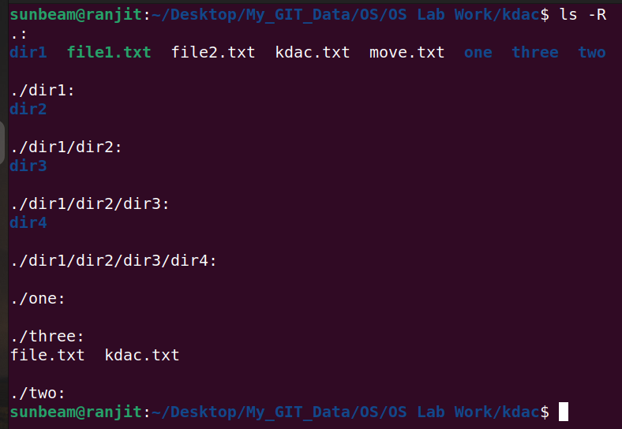

5. Create a file, write your surname and name in it and save.
i. now open the same file and add your address in it and
save.
ii. reopen the same file and check your name and address in
it.

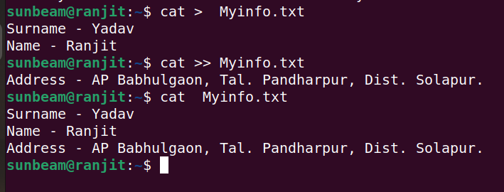

6. how to change the time stamp of file.

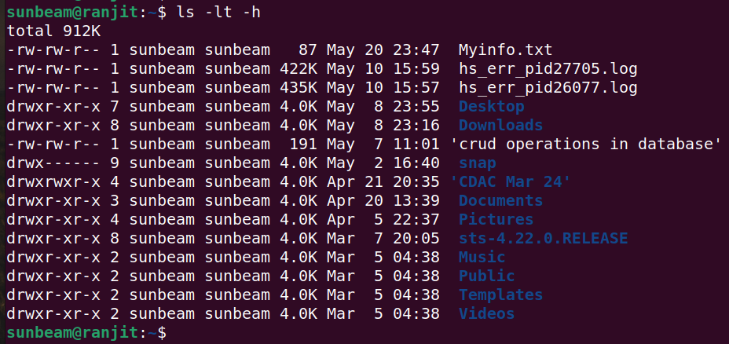
7. Create directory structure : Give following commands

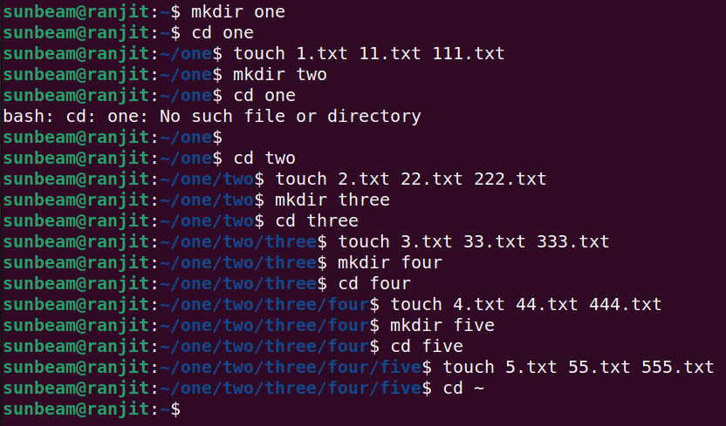
8. Considering above directory structure , Do following
operations :
1)
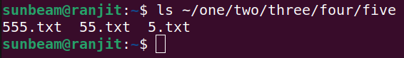
2)

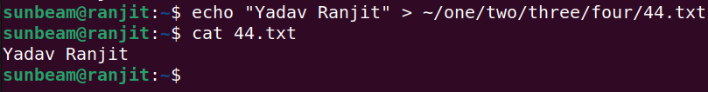
3)
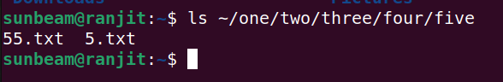
4), 5)

6)

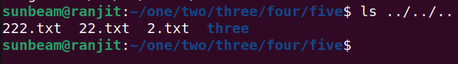
7)

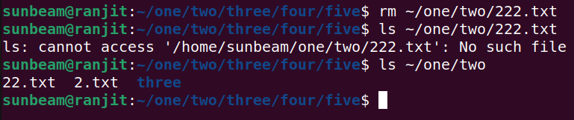
8), 9)

10)

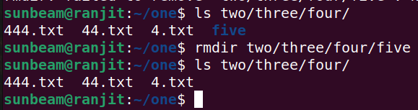
11)
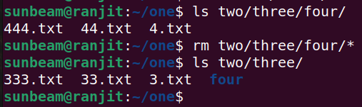
12)
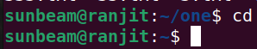

9. change the time stamp of file named "3.txt" which resides
in directory named "three".

