Assignment No – 4

Create a file named "data.txt" and write the following lines in it(write as it is).
Linux is open source.
In Linux everything is file
files have permissions.
files have inode no.
files have size.
there are several types of files

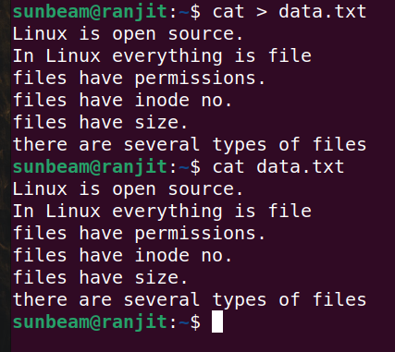

compose the commands fulfilled following requirement
i. count the no. of words ,characters and lines from above 2 file.

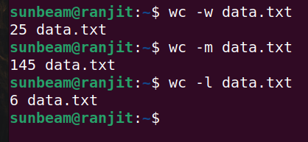

ii. list the lines having word "files"

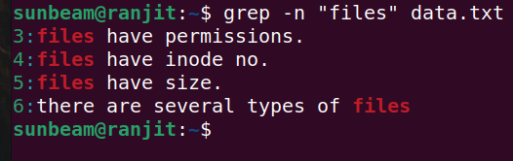
iii. list the lines having word "file"

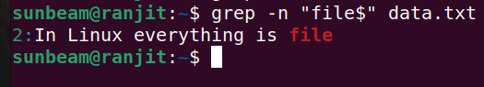
iv. list the lines which don't have word "files".

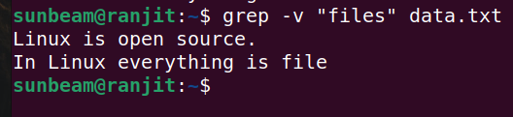
v. list the lines having word "have".

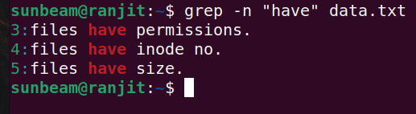

vi. list the lines starts with letter "f"
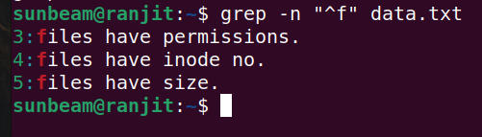

vii. list the lines ends with "."

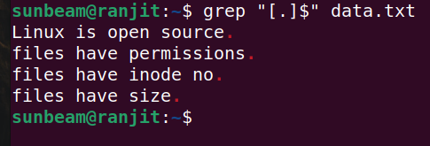

viii. list only first two lines.

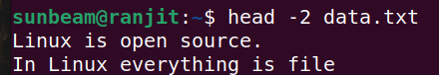

ix. list only last three lines

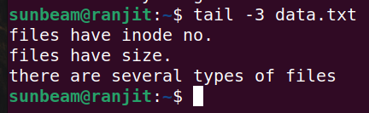

x. list line no.3,4 and 5 .

