A
PROJECT REPORT ON
E-MED
Appointment Booking System
SUBMITTED IN
PARTIAL FULFILLMENT OF

DIPLOMA IN ADVANCED COMPUTING (PG-DAC)

BY

Ganesh Shitole
Yogeeta Bobade
Parimal Kautkar
UNDER THE GUIDENCE OF

Rushabh Sir
AT

SUNBEAM INSTITUTE OF INFORMATION TECHNOLOGY,
Karad

SUNBEAM INSTITUTE OF INFORMATION TECHNOLOGY,
Karad
CERTIFICATE
This is to certify that the project
E-MED
Appointment Booking System
Has been submitted by
Parimal Kautkar
In partial fulfillment of the requirement for the Course of PG Diploma in Advanced Computing (PG-DAC March 2024) as prescribed by The CDAC ACTS, PUNE.
Place: Karad | Date: 14-AUG-2024
Rushabh Sir | Pratik Nignagur
Project Guide | Course Coordinator

ACKNOWLEDGEMENT

A project usually falls short of its expectation unless aided and guided by the right persons at the right time. We avail this opportunity to express our deep sense of gratitude towards Mr. Prashant Lad (Center Coordinator, SIIT, Karad) and Mr. Pratik Ninganur (Course Coordinator, SIIT, Karad).
We are deeply indebted and grateful to them for their guidance, encouragement and deep concern for our project. Without their critical evaluation and suggestions at every stage of the project, this project could never have reached its present form.
Last but not the least we thank the entire faculty and the staff members of Sunbeam Institute of Information Technology, Karad for their support.

Parimal kautkat
DAC March 24 Batch,
SIIT Karad

INDEX
- INTRODUCTION
  - 1.1 Introduction
  - 1.2 Product Overview and Summary
    - 1.2.1 Purpose
    - 1.2.2 Scope
    - 1.2.3 User Classes and Characteristics
    - 1.2.4 Design and Implementation Constraints
- REQUIREMENTS
  - 2.1 Functional Requirements
    - 2.1.1 Use Case for User
    - 2.1.2 Use Case for Administrator

- PROJECT DESIGN
  - 3.1 Data Model
    - 3.1.1 Database Design
  - 3.2 Process Model
    - 3.2.1 Functional Decomposition Diagram
    - 3.2.2 Data Flow Diagram (DFD)
- TEST REPORT
  - 4.1 General Testing
    - 4.1.1 Test Cases and Results
  - 4.2 Static Testing
    - 4.2.1 Deviations and Comments
- PROJECT RELATED STATISTICS
  - 5.1 Work Performed and Milestones
    - 5.1.1 Timeline of Project Activities
- CONCLUSION
The E-MED Appointment Booking System significantly improves the efficiency of managing healthcare appointments. It provides a seamless experience for users, supports effective communication, and ensures secure handling of sensitive information. The project's successful completion highlights its potential to positively impact the healthcare industry by enhancing the overall patient and provider experience.
- REFERENCE
  - 7.1 Books
  - 7.2 Online Resources

1. INTRODUCTION TO PROJECT

E-MED: Online Healthcare Appointment Booking Application
E-MED is a user-friendly online platform designed to streamline the process of accessing healthcare services. It connects patients with the right healthcare professionals, ensuring they receive the care they need with ease. The platform offers several key features:
E-MED supports three primary user roles—patients, doctors, and administrators—each with specific functionalities, ensuring a smooth and efficient healthcare experience for all users.
Key Features and Functionalities:
1. Search for Doctors:
•Specialization-Based Search: Users can search for doctors based on their area of
specialization (e.g., cardiologists, dermatologists, pediatricians).
•Location-Based Search: Users can find doctors in their nearby area by entering their
location details.
•Detailed Profiles: Each doctor’s profile includes their background information, field
of specialization, clinic details (location, timings, consultation fees), and contact
numbers.
2. Appointment Booking:
•Scheduling and Availability: Patients can view the doctors’ available time slots and
book appointments accordingly.
•Real-Time Booking: The system provides real-time updates on doctor availability,
ensuring that patients can book appointments conveniently without any conflicts.
3. User Accounts and Profiles:
•Patient Profiles: Users must create an account to book appointments. Once
registered, they can maintain their profiles, which include personal information and
past appointment records.
•Secure Login: The application ensures secure access to patient and doctor profiles
through a robust authentication mechanism.
4. Communication:
•Contact Information: Patients can directly contact doctors using the provided
contact numbers for any inquiries or follow-ups.
•Notification System: The application can send reminders and notifications to
patients regarding their upcoming appointments, reducing the chances of missed
appointments.

2. REQUIREMENTS

2.1 FUNCTIONAL REQUIREMENTS

Patient Functionalities
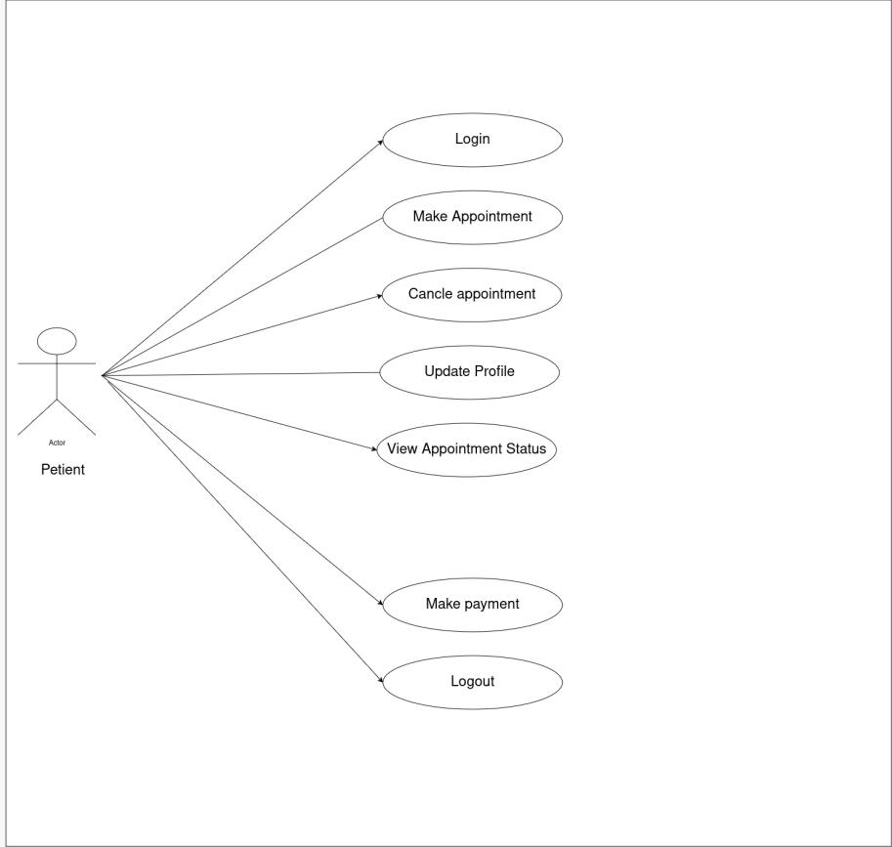

1. Account Management:
  - Login: Patients can securely log into the platform using their credentials. The login process ensures that their personal information and appointment history are protected.
  - Update Profile: Patients can update their personal details, including contact information, address, and medical history. Keeping their profiles up-to-date is crucial for accurate communication with healthcare providers.
  - Logout: Patients can securely log out of their accounts to ensure their information remains protected when not in use.
- Doctor Search and Appointment Booking:
  - Search for Doctors: Patients can search for doctors based on specific criteria:
    - Specialization-Based Search: Patients can find doctors based on their area of specialization, such as cardiology, dermatology, pediatrics, etc. This helps them connect with the right specialist for their health concerns.
    - Location-Based Search: Patients can search for doctors in their nearby area by entering their location details. This ensures that they can find healthcare providers that are conveniently located.
  - Book Appointment: After finding the right doctor, patients can view available time slots and book appointments directly through the platform. This feature provides real-time availability, ensuring that patients can select a suitable time without scheduling conflicts.
  - View Appointment Status: Patients can check the status of their appointments, whether it’s confirmed, pending, or canceled. This helps them stay informed about their upcoming consultations.
- Appointment Management:
  - Cancel Appointment: Patients can cancel their appointments if needed. This function is particularly useful in case of changes in their schedule or if they need to reschedule for a different time.
  - Make Payment: Patients can securely pay for their appointments through the platform. This ensures that all transactions are handled efficiently, with the payment details saved for future reference if needed.
- Communication and Support:
  - Contact Information: Patients can access the contact details of doctors directly through their profiles. This allows them to reach out for inquiries, follow-ups, or any pre-appointment clarifications.
  - Receive Notifications: The platform sends reminders and notifications regarding upcoming appointments. This helps reduce the chances of missed appointments and ensures that patients are well-prepared.

The Patient role in the E-MED platform is designed to provide a user-friendly and efficient experience, ensuring that users can easily access the healthcare services they need. By managing their appointments, profiles, and payments, patients can navigate their healthcare journey with confidence and ease.

Doctor Functionalities

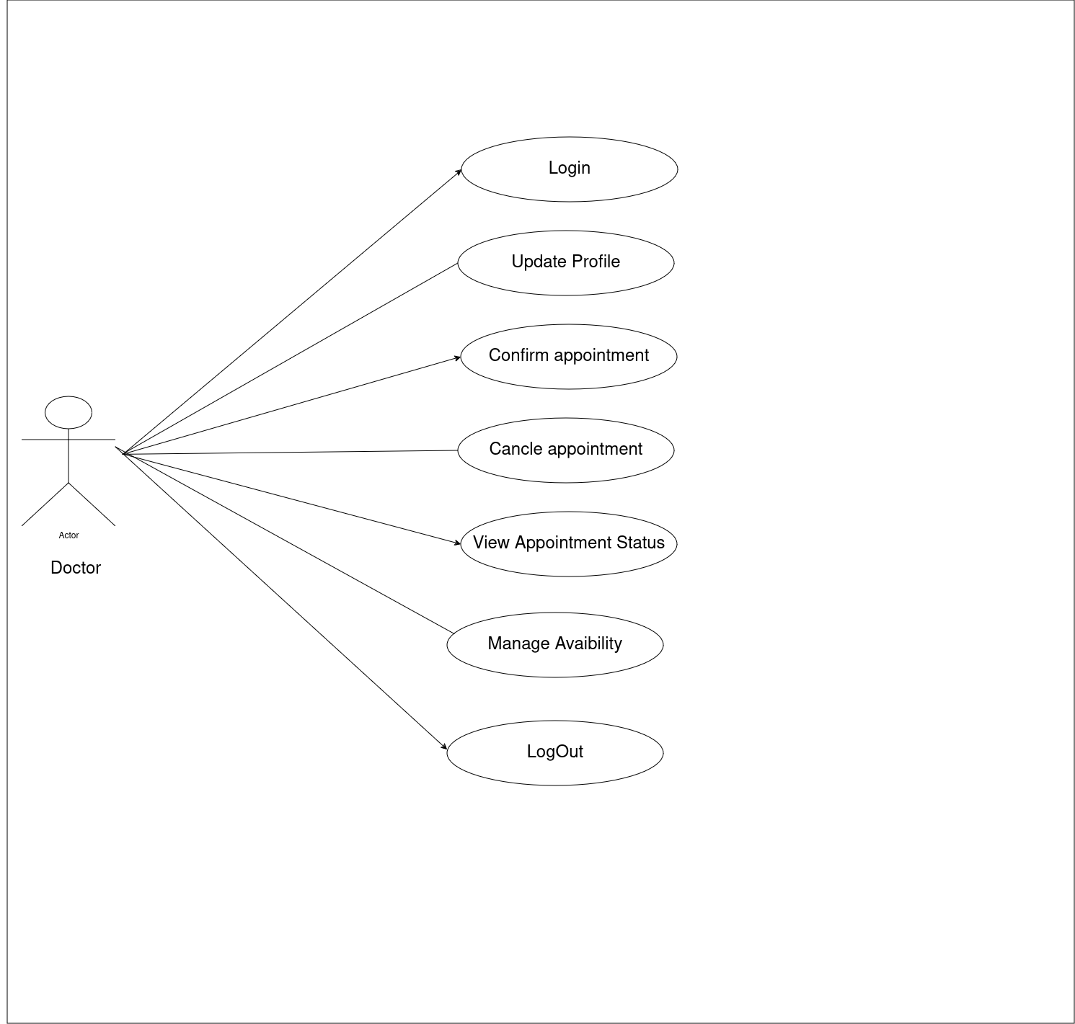

- User Authentication:
  - Login: Doctors can securely log into the application using their credentials. The platform employs robust authentication methods to ensure the security of sensitive information.
  - Logout: After managing their activities, doctors can securely log out of the application.
- Profile Management:
  - Create and Update Profile: Doctors can create and maintain their professional profiles, which include details such as their specialization, qualifications, clinic locations, consultation timings, and fees. Keeping this information up-to-date ensures that patients receive accurate details when searching for healthcare providers.
  - Manage Availability: Doctors can manage their availability by updating their working hours and appointment slots. This allows patients to book appointments during the times when the doctor is available.
- Appointment Management:
  - View Appointments: Doctors can view all scheduled appointments in a detailed manner, including the patient’s name, appointment time, and the reason for the visit. This helps them prepare in advance for their consultations.
  - Manage Appointments: Doctors have the ability to confirm, reschedule, or cancel appointments as necessary. This functionality allows doctors to manage their schedule efficiently and accommodate any changes due to unforeseen circumstances.
  - View Patient History: Before consultations, doctors can review the patient's appointment history and any notes from previous visits. This aids in providing more informed and personalized care to the patient.
- Communication with Patients:
  - Direct Contact: Doctors can access patient contact information for any necessary follow-ups or pre-appointment inquiries. This direct line of communication helps in building a strong doctor-patient relationship.
  - Send Notifications: Doctors can send notifications or reminders to patients regarding their appointments, such as confirmation, rescheduling, or follow-up reminders.

- Access to Analytics and Reports:
  - Appointment Analytics: Doctors can access reports that provide insights into their appointment statistics, such as the number of appointments per week or month, cancellations, and patient demographics. This information can help doctors manage their practice more effectively.
  - Patient Feedback: Doctors can review feedback provided by patients after consultations. This feedback is crucial for continuous improvement and maintaining high-quality care standards.
The Doctor role in the E-MED platform is tailored to ensure that healthcare professionals can manage their practice with ease and efficiency. By providing tools for profile management, appointment scheduling, and patient communication, the platform supports doctors in delivering high-quality care and maintaining a well-organized practice.

Admin Functionalities
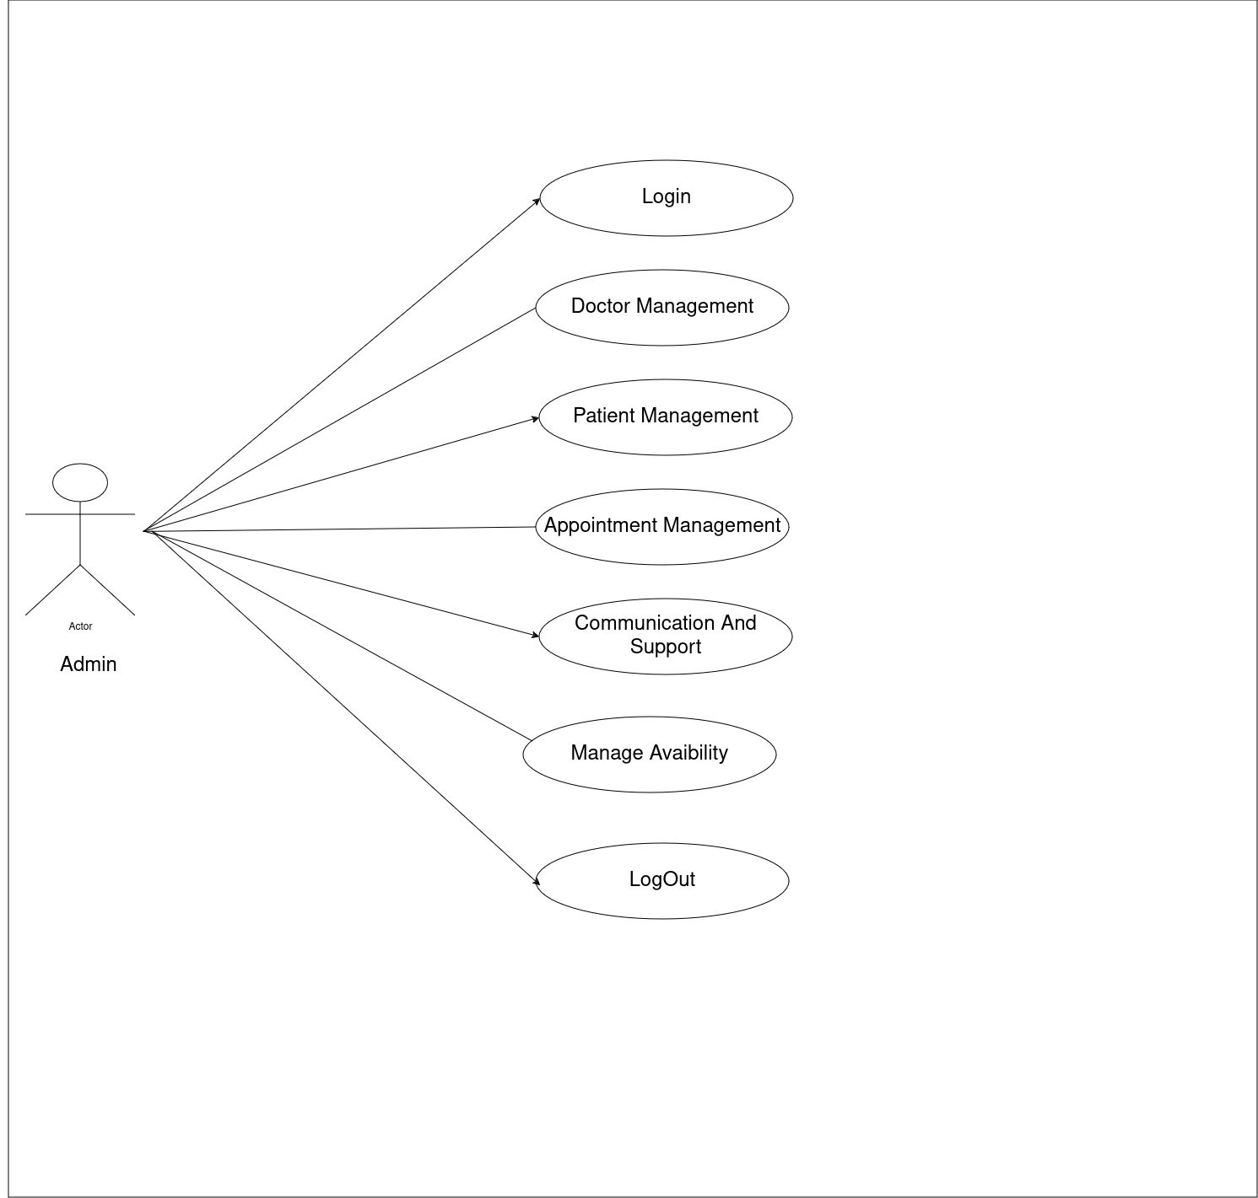

- Doctor Management:
  - Add Doctor: Admins can add new doctors to the platform by creating their profiles. This includes entering details such as the doctor's name, specialization, clinic address, consultation fees, and available time slots. Accurate doctor profiles are essential for patient searches and bookings.
  - Edit Doctor: Admins can update existing doctor profiles to reflect changes in specialization, contact details, clinic hours, or consultation fees. This ensures that the information presented to patients is always current.
  - Delete Doctor: Admins have the ability to remove a doctor's profile from the platform. This function is useful when a doctor retires, moves to a different location, or no longer practices on the platform. Deleting a doctor ensures that patients do not attempt to book appointments with unavailable professionals.
- Patient Management:
  - Add Patient: Admins can create new patient profiles on the platform, which includes entering their personal information, contact details, and any relevant medical history. This is particularly useful for onboarding new patients who may need assistance in setting up their profiles.
  - Update Details: Admins can update patient profiles, including changes to contact information, address, or other personal details. Keeping patient profiles accurate is essential for communication and billing purposes.
  - Delete Patient: Admins can remove a patient’s profile from the platform. This might be necessary in cases where a patient no longer uses the platform, requests account deletion, or if there are any issues that require their account to be deactivated.
- Appointment Management:
  - Confirm Appointment: Admins can confirm appointments scheduled by patients. This function ensures that the booking is valid and that the doctor is informed of the upcoming consultation.
  - Cancel Appointment: Admins can cancel appointments if necessary. This might be due to doctor unavailability, patient requests, or scheduling conflicts. Canceling appointments in a timely manner helps avoid confusion and maintains the platform’s reliability.
  - Make Appointment: In addition to overseeing appointments, Admins can also directly schedule appointments on behalf of patients or doctors. This is particularly useful in cases where users face technical difficulties or need assistance.

- System-Wide Operations:
  - Oversee Appointments: Admins have a comprehensive view of all appointments on the platform. They monitor bookings, cancellations, and confirmations to ensure that the system runs smoothly without any conflicts.
  - Update System Details: Admins can update various system details, such as consultation fees, availability of doctors, and patient contact information. This function is critical for maintaining accurate and up-to-date information across the platform.
- Communication and Support:
  - Handle Inquiries: Admins act as the primary contact for resolving any issues related to doctor availability, appointment scheduling, billing, or account management. They ensure that both patients and doctors receive prompt and effective support.

3. DESIGN

Entity Relationship Diagram
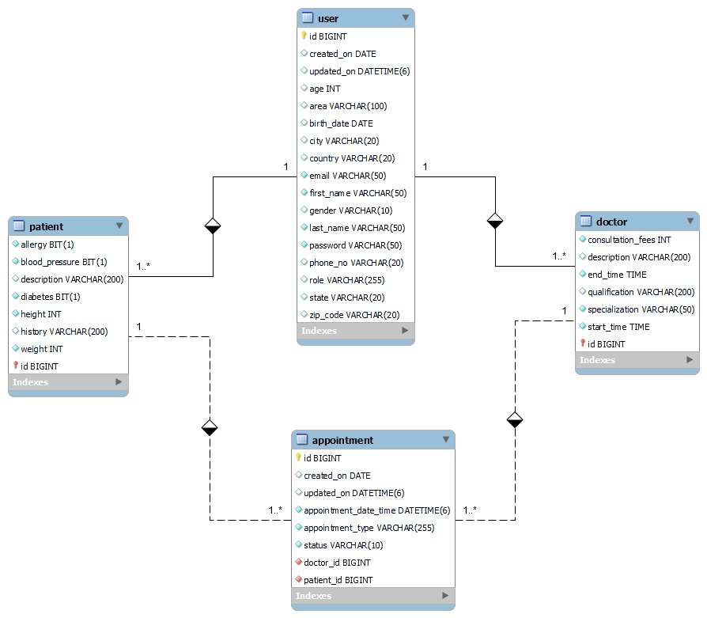

3.1 Database Design

The following table structures depict the database design.

1) User Table
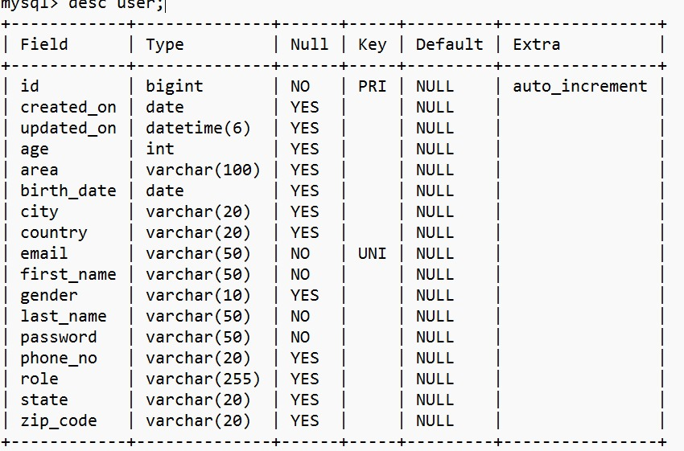

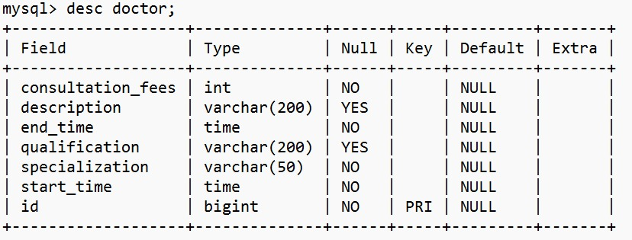
2) Doctor Table

3) Patient Table
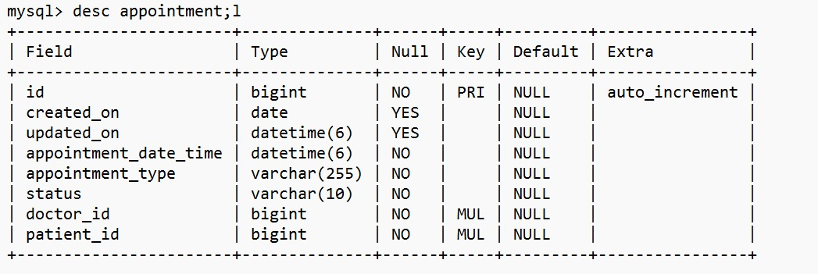
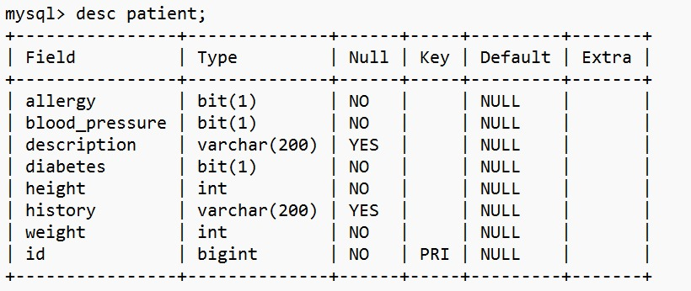

4) Appointment Table

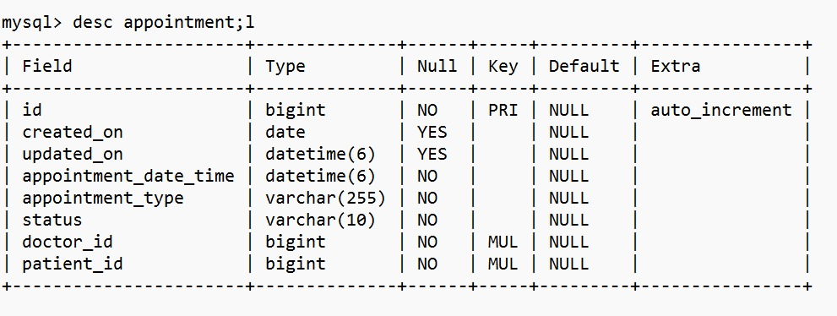

4. CODING STANDARDS IMPLEMENTED

Naming and Capitalization
Below summarizes the naming recommendations for identifiers in Pascal casing is used mainly (i.e. capitalize first letter of each word) with camel casing (capitalize each word except for the first one) being used in certain circumstances.
Identifier | Case | Examples | Additional Notes
Class | Pascal | Person, BankVault, SMSMessage, Dept | Class names should be based on "objects" or "real things" and should generally be nouns. No ‘_’ signs allowed. Do not use type prefixes like ‘C’ for class.
Method | Camel | getDetails, updateStore | Methods should use verbs or verb phrases.
Parameter | Camel | firstName, bankCode | Use descriptive parameter names. Parameter names should be descriptive enough that the name of the parameter and its type can be used to determine its meaning in most scenarios.
Interface | Pascal with "I" prefix | Disposable | Do not use the ‘_’ sign
Property | Pascal | ForeColor, BackColor | Use a noun or noun phrase to name properties.
Associated private member variable | _camelCase | _foreColor, _backColor | Use underscore camel casing for the private member variables
Exception Class | Pascal with "Exception" suffix | WebException,

Comments
- Comment each type, each non-public type member, and each region declaration.
- Use end-line comments only on variable declaration lines. End-line comments are comments that follow code on a single line.
- Separate comments from comment delimiters (apostrophe) or // with one space.
- Begin the comment text with an uppercase letter.
- End the comment with a period.
- Explain the code; do not repeat it

5. TEST REPORT

Another group called Linux did the testing and the report of the testing is given hereunder.
GENERAL TESTING:
SR-NO | TEST CASE | EXPECTED RESULT | ACTUAL RESULT | ERROR MESSAGE
1 | Register Page | Redirected to Next page | OK | Nothing
2 | Login Page | Pop-up will come | Ok | Please enter username and password again .
3 | Reset login | Only users password will be reseted | Ok | Nothing
4 | Quick Search for Doctors | Provides all doctor details based on the search criteria | Ok | Nothing
5 | Booking appointment | All the fields should be filled for submission | Ok | Nothing
6 | Checking login or not | Verify if the user is logged in or not | Ok | Nothing
7 | Add Patient Details for Appointment | Add patient information according to the appointment details | Ok | Nothing
8 | Go to Appointment Details Page | Displays the added patient and appointment information | Ok | Nothing
9 | Save Appointment Details | Saves all appointment data into the booking table | Ok | Nothing
10 | Transaction | On back it should be reverted to previous page | Ok | Nothing
11 | View transaction done | It shows you all transactions done previously | Ok | Nothing
12 | Logout | It will logout from user profile. | Ok | Nothing
 | STATIC TESTING
SR-NO | Deviation | Program
1 | Commenting not followed | All Web Application

6. PROJECT MANAGEMENT RELATED STATISTICS

DATE | WORK PERFORMED | SLC Phase | Additional Notes
May 12,2024 | Project Allotment and User Requirements Gathering | Feasibility Study | Met with the client to understand the requirements for the doctor-patient booking system.
Jun 17,2024 | Initial SRS Document Validation  And Team Structure Decided | Requirement Analysis  (Elicitation) | Presented the initial SRS to the client to refine and confirm the requirements
JUN 18,2024 | Designing the use-cases, Class Diagram, Collaboration Diagram, E-R Diagram and User Interfaces | Requirement Analysis &  Design Phase | Completed the database design and key structural components.
JUN 20,2024 | Business Logic Component design Started | Design Phase | Started designing the core business logic for appointment scheduling and user management.
July 27, 2024 | Coding Phase Started | Coding Phase | Implemented 70% of the class library, including core functions like user authentication and profile management.
Aug 1,2024 | Implementation of Web Application and Window Application Started | Coding Phase | Continued development of the class library and initiated the front-end development.
Aug 2,2024 | Off | Off | Off
Aug 3, 2024 | Implementation of Web Application and Window Application Continued | Coding Phase and Unit Testing | Modified the class library as per the evolving project needs and continued implementation.
Aug 4, 2024 | Implementation of Web Application and Window Application Continued | Coding Phase and Unit Testing | Continued implementation and initial testing of the core functionalities.
Aug 5, 2024 | After Ensuring Proper Functioning the Required Validations were Implemented | Coding Phase and Unit Testing | Added necessary validations and performed module integration.
Aug 6, 2024 | The Project was Tested by the respective Team Leaders and the Project Manager | Testing Phase (Module Testing) | Conducted comprehensive module testing to ensure functionality.
Aug 7, 2024 | The Project was Submitted to Other Project Leader of Other Project Group For Testing | Testing Phase (Acceptance Testing) | Submitted the project to another team for acceptance testing, and vice versa.
Aug 8 2024 | The Errors Found were Removed | Debugging | Resolved all identified errors and prepared the project for final submission.
Aug 14, 2024 | Final Submission of Project | Final Submission | Successfully completed and submitted the E-MED application.

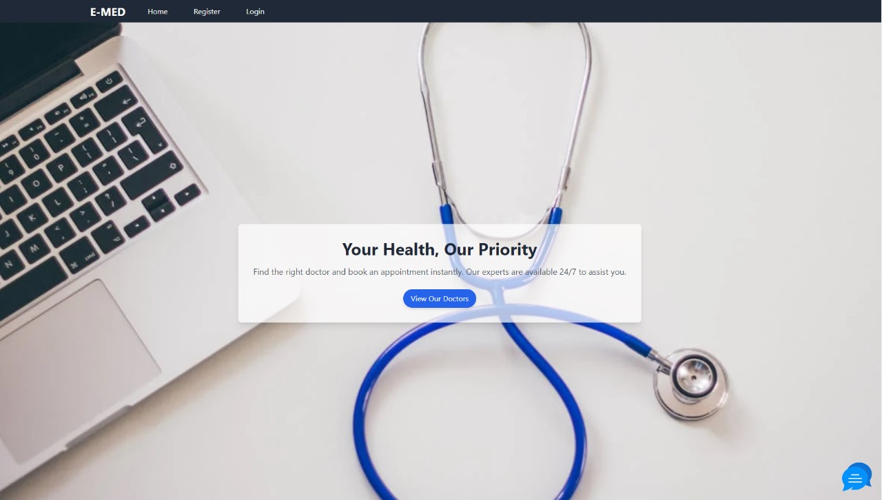
Home
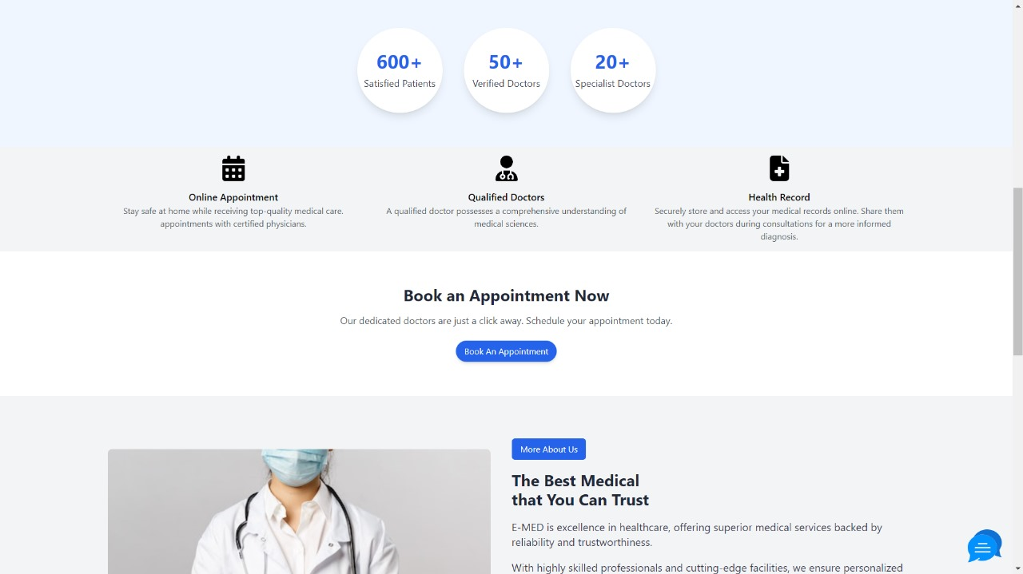


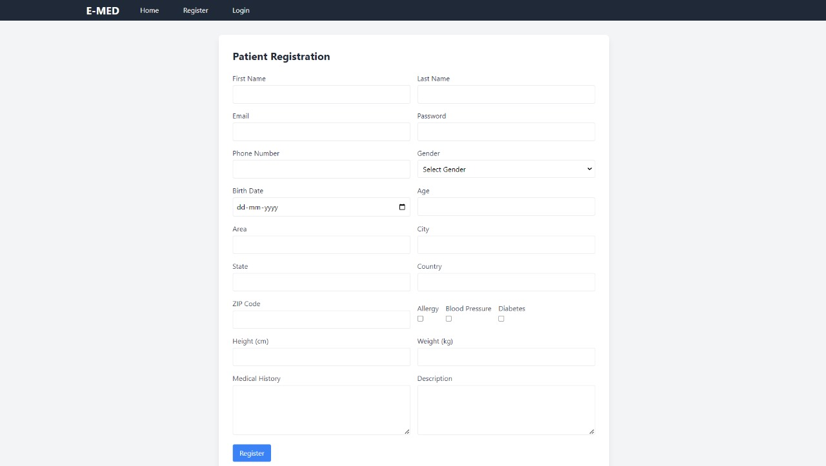
Patient Registration

Doctor Registration
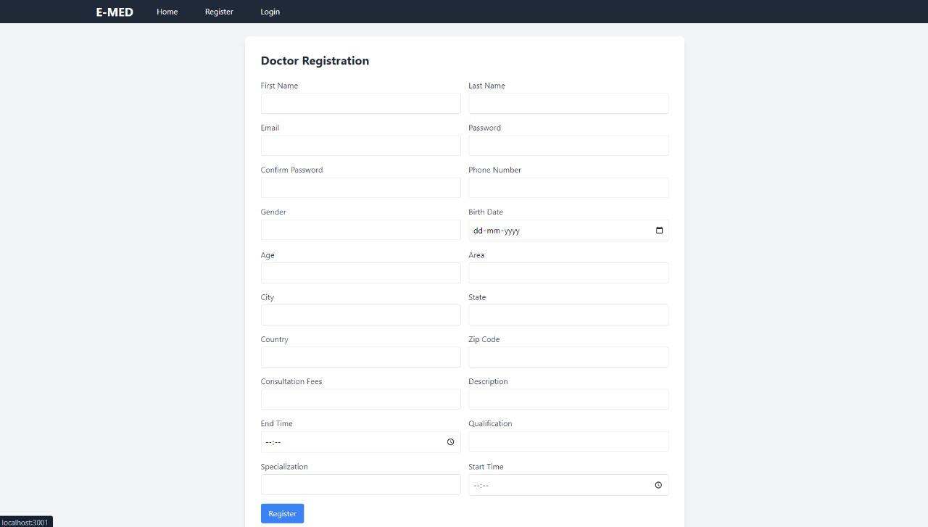

Login :
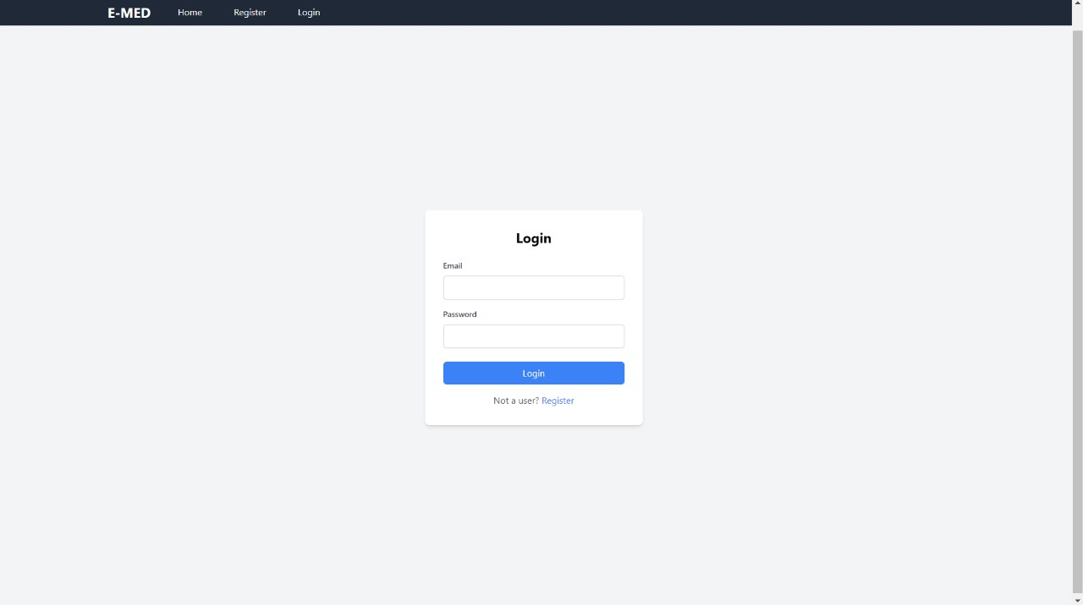

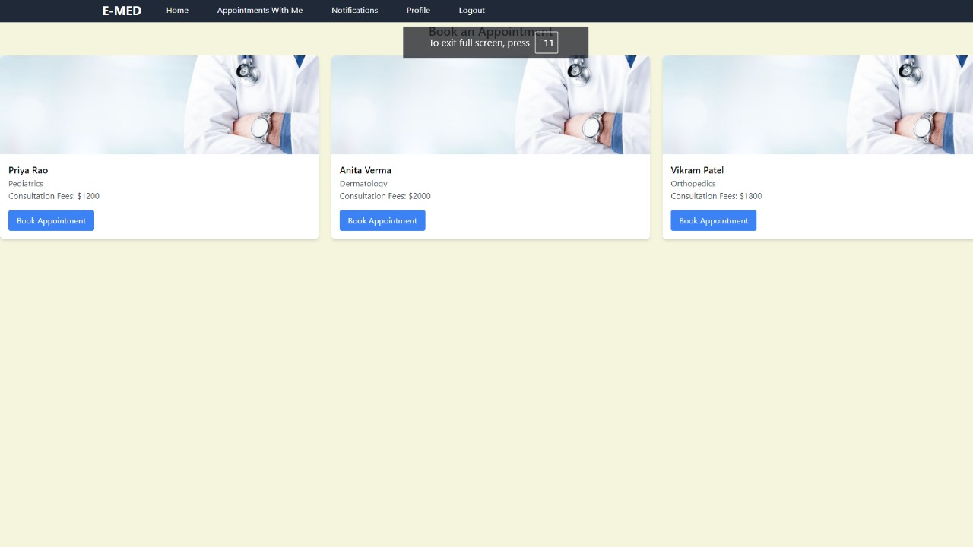
View Doctor List :

Slot Booking :
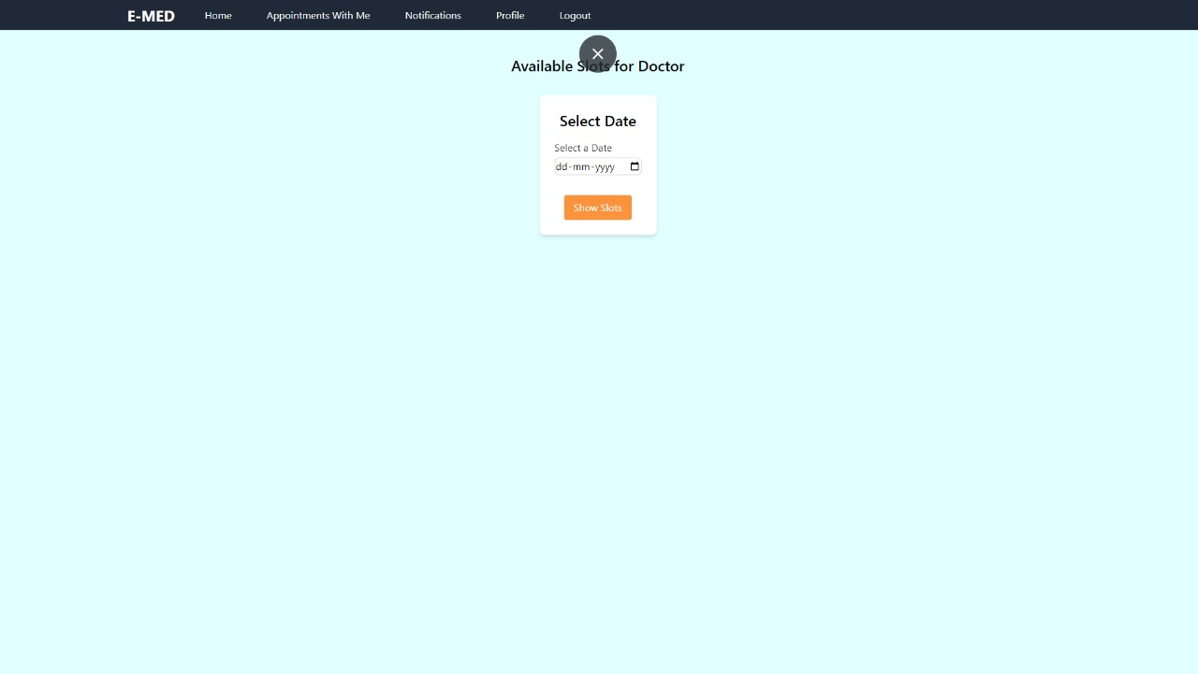

Select Available Slot For Booking :
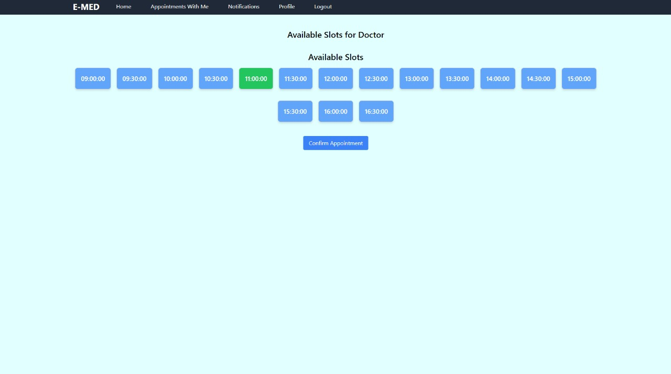

Appointment Booked Popup :

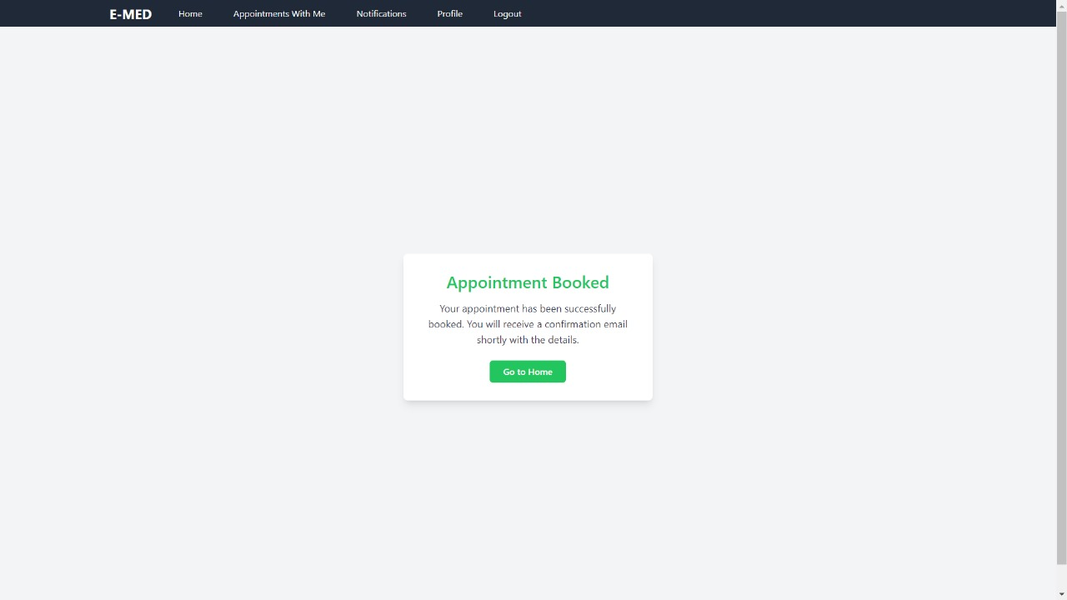

Contact Us :
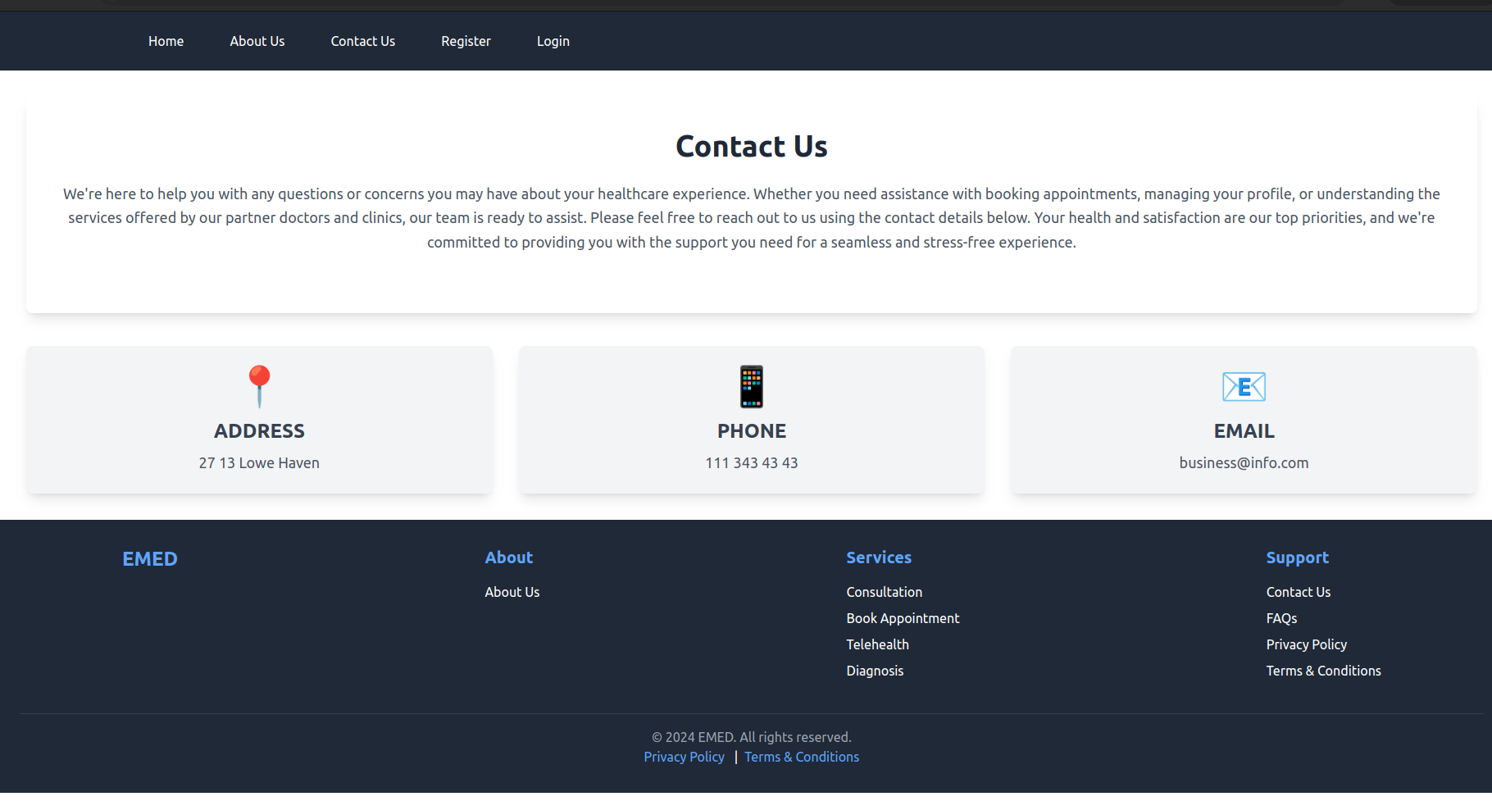
About Us :
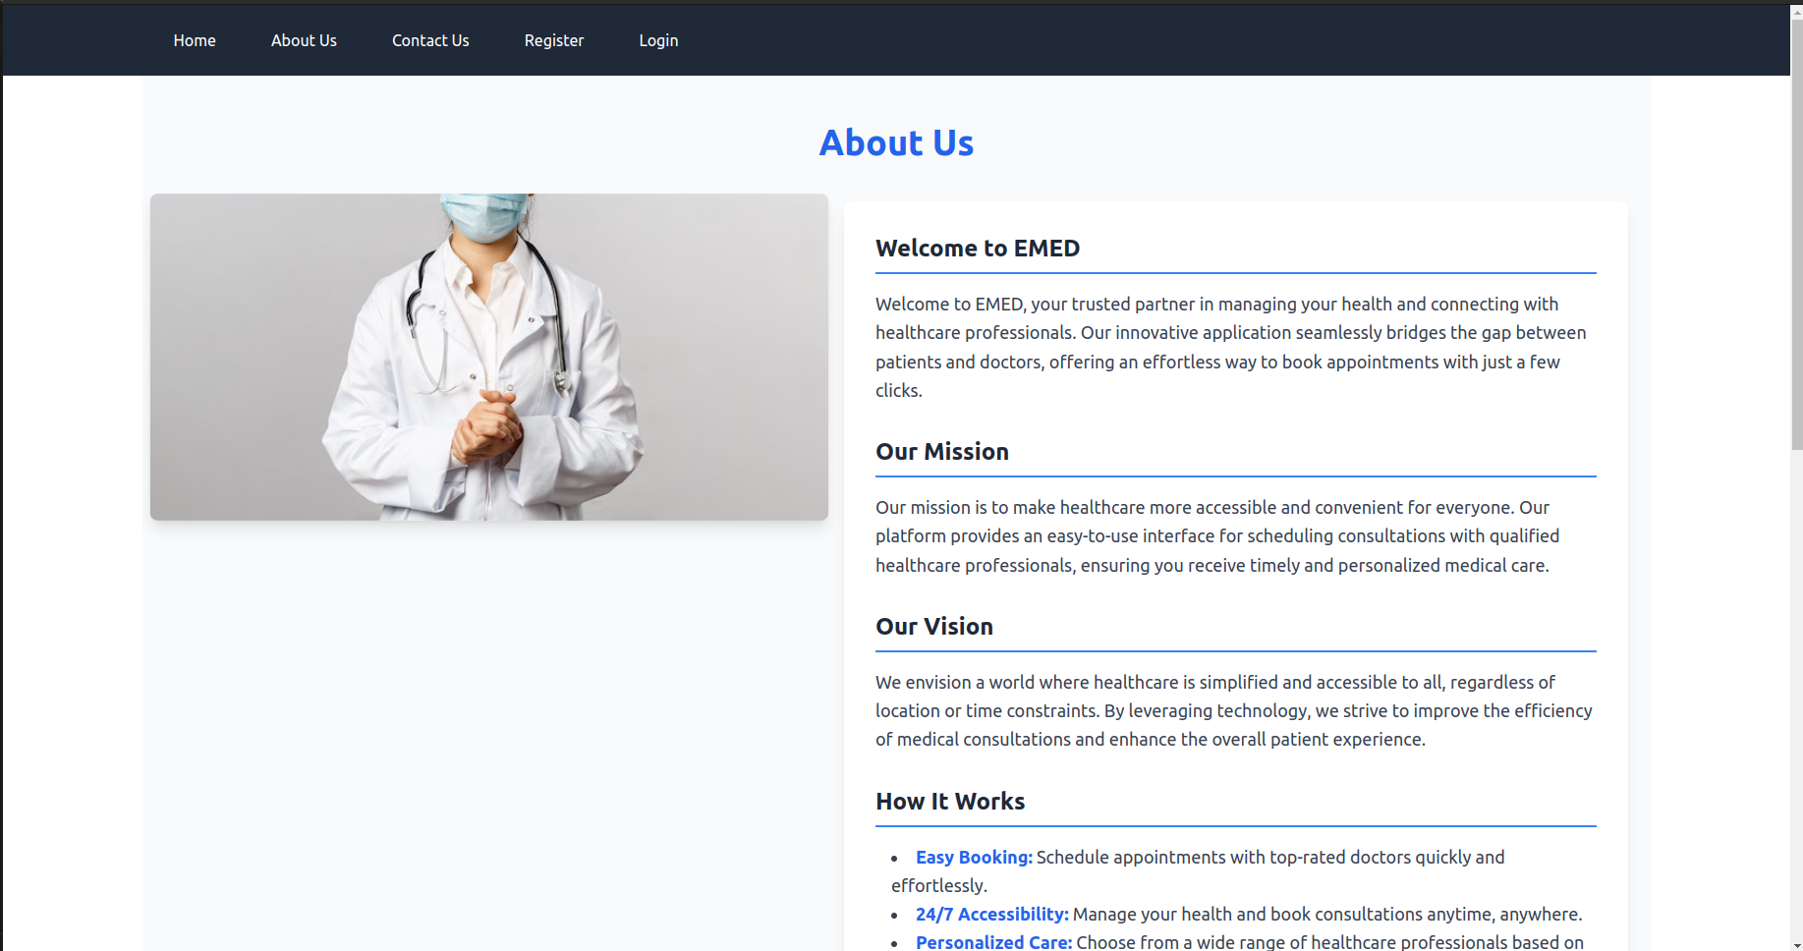
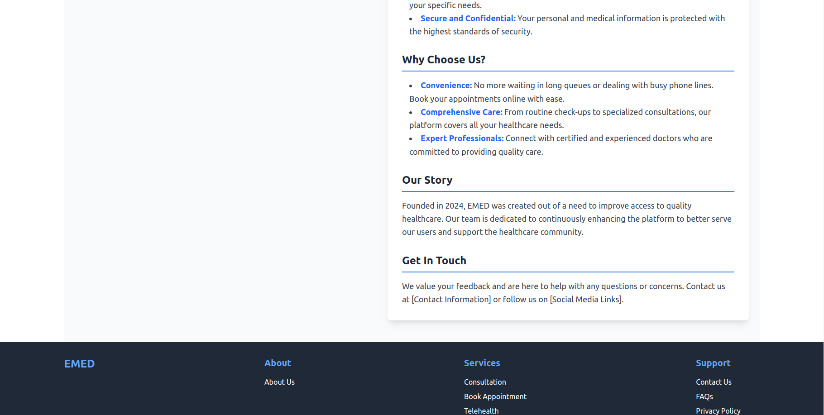

Refference :

Books:
- "Healthcare Information Management Systems: Cases, Strategies, and Solutions"
  - Author(s): Charlotte A. Weaver, Marion J. Ball
  - Description: This book covers various healthcare information management systems, including patient appointment scheduling and management.

Online Resources:
- IEEE Xplore Digital Library
  - Description: Provides access to research papers and articles on the latest advancements in healthcare IT systems, including appointment booking systems.
  - Link: IEEE Xplore

- HealthIT.gov
  - Description: Official site for resources on health IT, including best practices for implementing systems like appointment booking.
  - Link: HealthIT.gov

