Requirements

Project Title : Online Digital Wallet System

Description : Main objective of our project is to create a web application of digital Wallet System for transacting digital currency. The project objective was to facilitate online transactions across through internet through a customer customer to web platform.

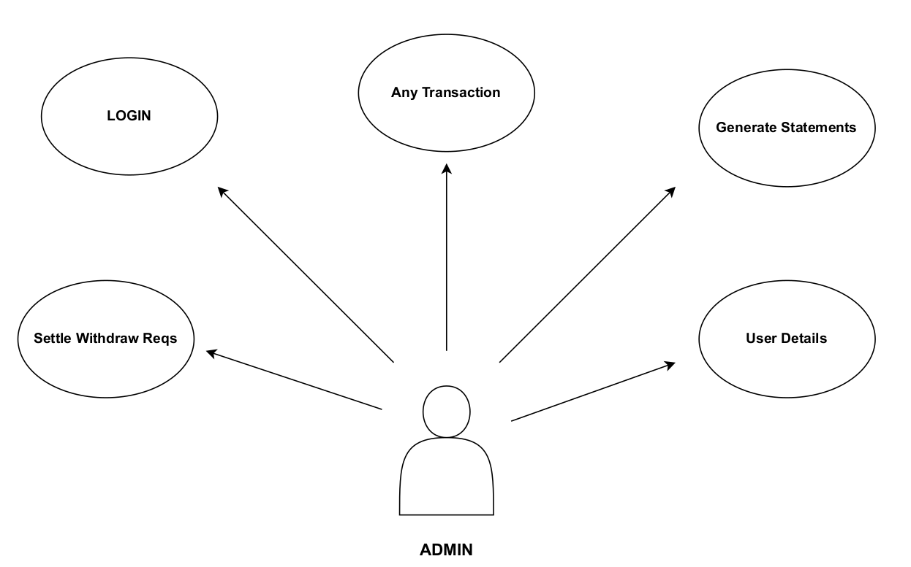

Fig 1: Admin

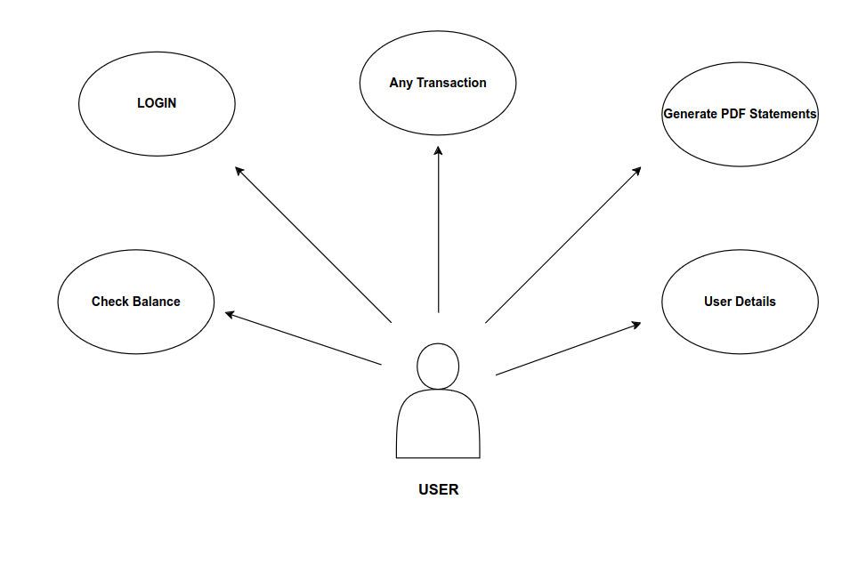
Fig 2: User

