SQL Assignment – 5

Q1. Write a query that will give you all orders for more than Rs. 1000.

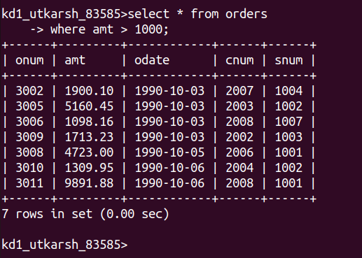

Q2. Write a Query that will give the names and cities of all salespeople in London with a commision above .10.

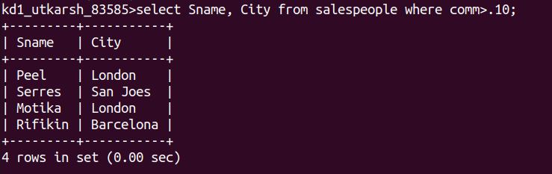

Q3. Write a Query on the Customers table whose output will exclude all customers with rating <=100, unless they are located in Rome.

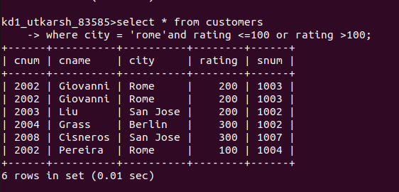

Q4. What will be the output from the following query ?

select * from orders
where (amt < 100 OR
NOT (odate = ‘1990-10-03’
and cnum > 2003) );

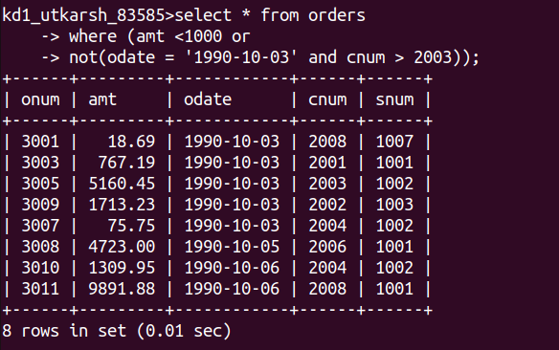

Q5. What will be the output of the following query ?

select * from orders
where NOT ((odate = ‘1990-10-03’ OR snum
> 1006) AND amt >= 1500);

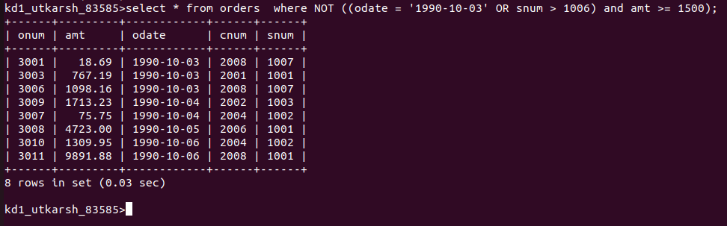

Q6. What is the simpler way to write this query ?
Select snum,sname,city,comm from salespeople
where (comm > .12 OR comm <.14);

