SQL_ASSIGNMENT 13

1) Question

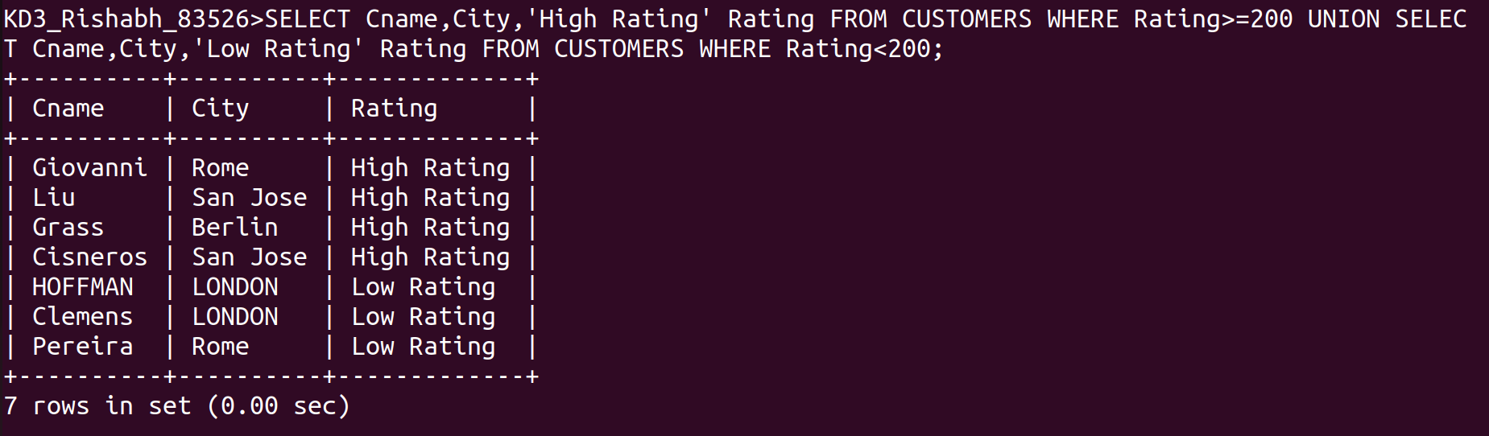
2) Question

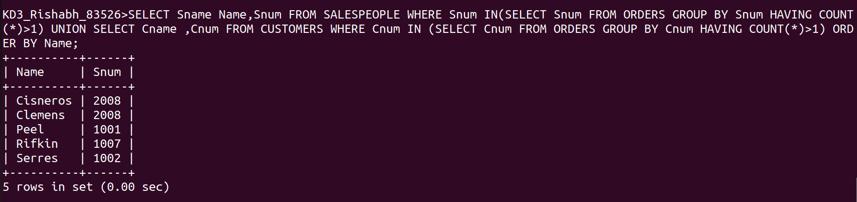
3) Question

