**Child Adoption System**

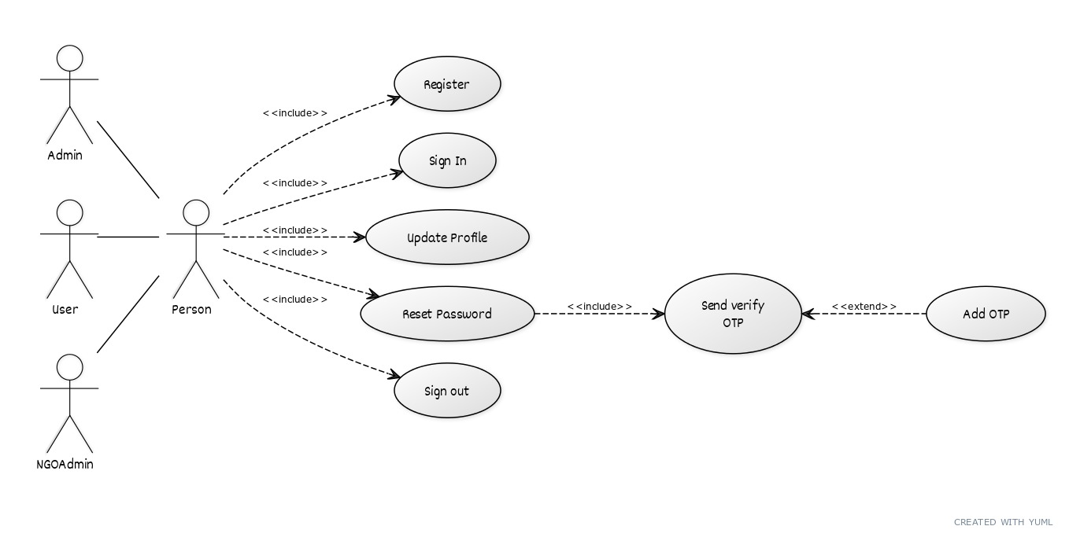The aim of our project is to provide online help to orphanages so that they can help the orphan children and people who want to adopt children. In our project, we have given details of children in the orphanage. People who want to adopt any child can register online and employees will confirm the time of visit to the orphanage house to see the child.

Fig: Common functionalities for all.

.

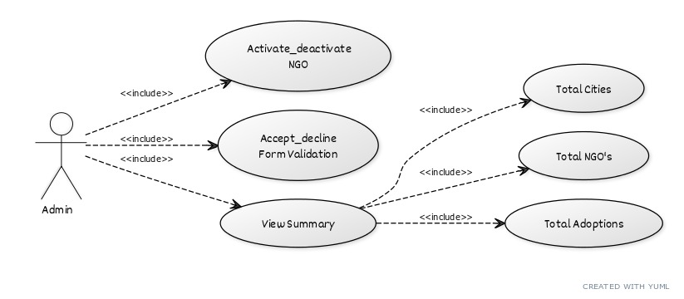Fig: Admin Functionalities

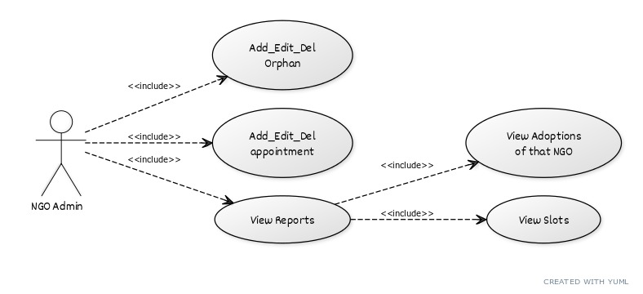Fig: NGO Admin functionalities

Fig: User functionalities

