ASSIGNMENT 4

1. count the no. of words ,characters and lines from above 2 file.(man wc)
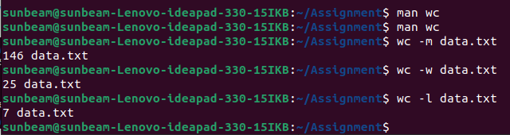
2.list the lines having word "files" (man grep)
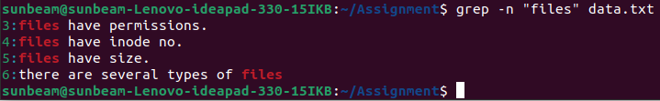
3.list the lines having word "file" (man grep)
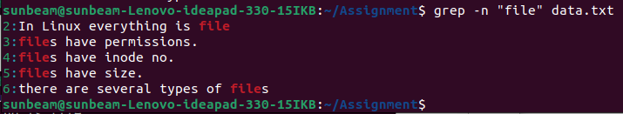
4.list the lines which don't have word "files" (man grep)
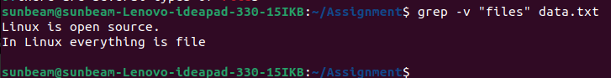
5.list the lines having word "have" . (man grep)
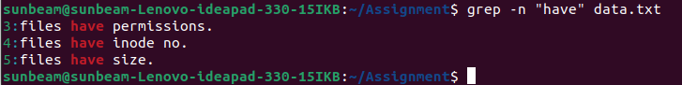

6.list the lines starts with letter "f" (man grep)

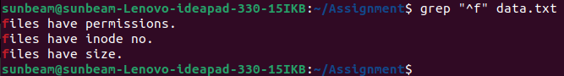
7.list the lines ends with "." (man grep)

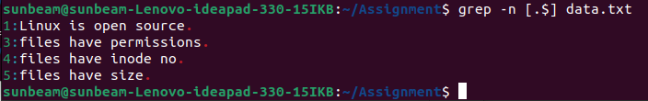
8.list only first two lines.(man head)

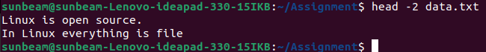
9.list only last three lines.(man tail)
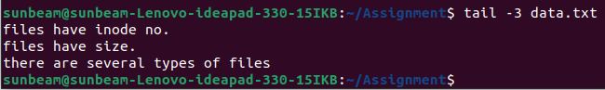
10.list line no.3,4 and 5 . (man head and tail)
