**Bus Ticket Booking System**

**Project Description:**

The objective of this project is to create online Bus ticket Booking system where a traveller can request all bus information as per their journey requirements. They can get information about bus schedules, fare etc. Bus Ticket booking system is to provide an option to customers to book the tickets and to check the confirmation. So this system maintains a centralized repository of all related information.

**Scope:**

The Bus Ticket Booking System will allow users to search for available bus routes, book tickets, manage bookings, and make payments through an online platform.

**Functional Requirements**

**User Management**

1. **User Registration**: Users should be able to register by providing necessary details such as username, email, password, and contact information.
2. **User Login**: Registered users should be able to log in securely to access the system.
3. **User Profile Management**: Users should be able to update their profile information and change passwords.

**Bus Management**

1. **View Available Buses**: Users should be able to view available buses based on origin, destination, and journey date.
2. **Bus Details**: Users should be able to view details of each bus including name, type, total seats, available seats, etc.

**Route Management**

1. **Search Routes**: Users should be able to search for available routes based on origin and destination.
2. **Route Details**: Users should be able to view details of each route including distance, duration, fare, etc.

**Booking Management**

1. **Book Tickets**: Users should be able to select a bus and route, choose the number of seats, and book tickets for a specific journey date.
2. **View Booking History**: Users should be able to view their booking history including past and upcoming trips.
3. **Cancel Bookings**: Users should be able to cancel booked tickets within a specified time frame.

**Payment Management**

1. **Payment Gateway Integration**: Provide secure payment options for users to make online payments for booked tickets.
2. **Payment Confirmation**: Users should receive confirmation of successful payment and booking.

**UML Diagrams:**

Figure.1 Membership module

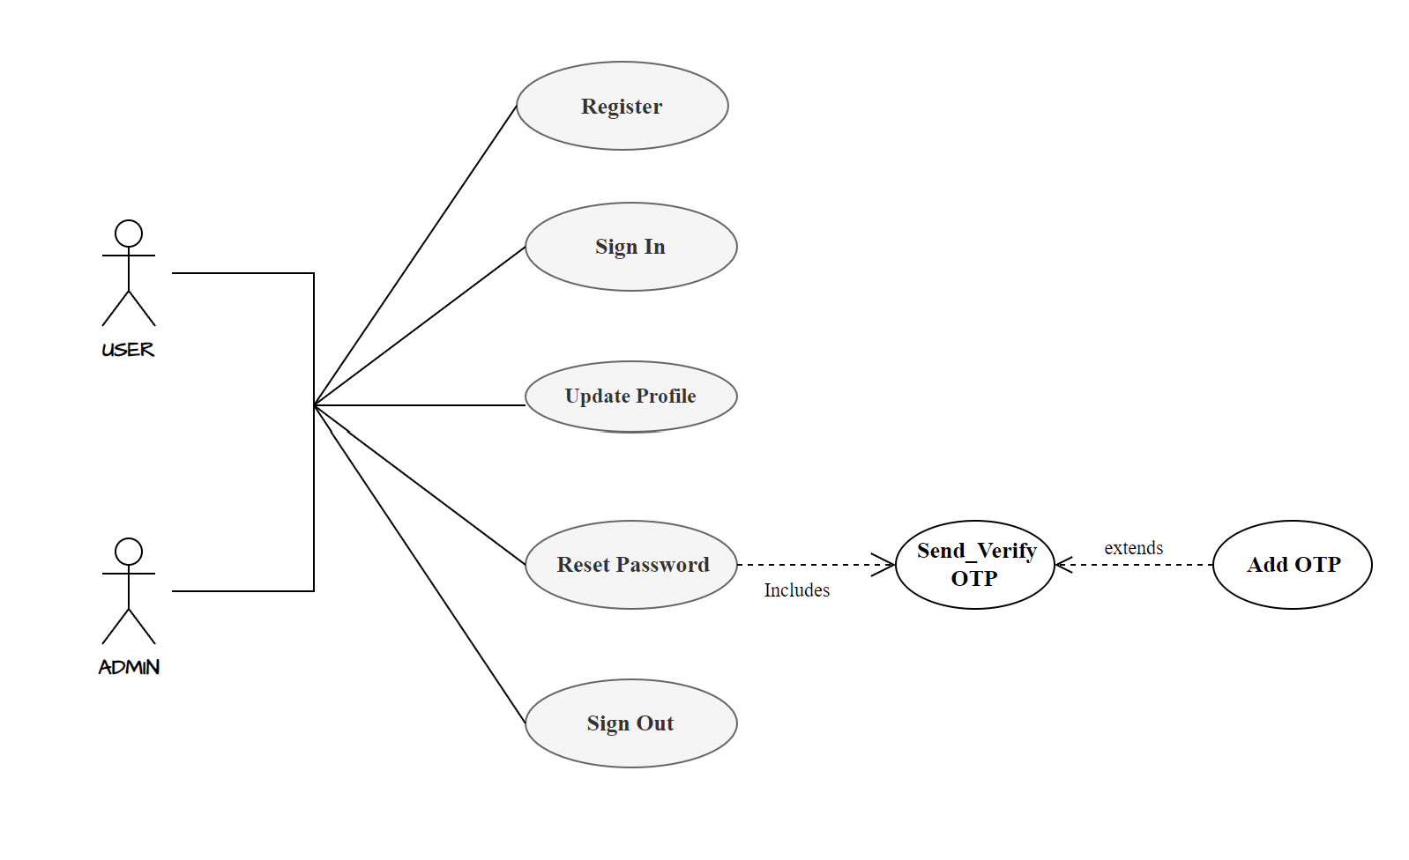

Figure.2 Admin Functionalities

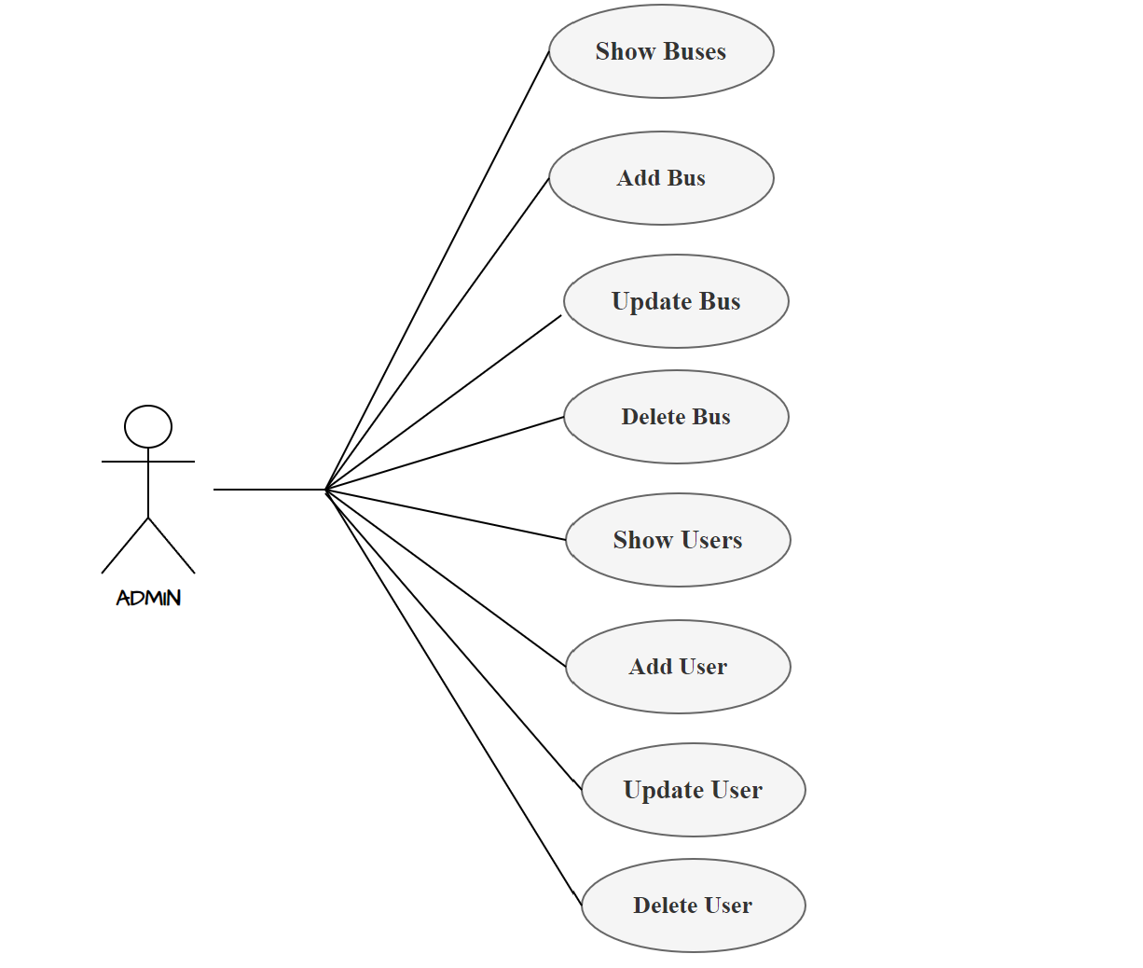

Figure. 3 User Functionality

