**Online Bus Booking System**

**Objective:**

The objective of this project is to create online Bus ticket Booking system where a traveller can request all bus information as per their journey requirements. They can get information about bus schedules, fare etc. Bus Ticket booking system is to provide an option to customers to book the tickets and to check the confirmation. So this system maintains a centralized repository of all related information.

**UI Pages:**

1. User Side

     - Homepage/Search page

     - Bus listing page

     - Seat selection page

     - Passenger details page

     - Payment page

     - Confirmation page

- Update Password

- Reset Password

2. Admin Side

  - Admin Login screen

  - Admin Dashboard

  -Admin to Add Bus

  -Admin to Update Bus

  -Admin to Show Bus

  -Admin to Delete Bus

  -Admin to Add User

  -Admin to Update User

  -Admin to Show User

  -Admin to Delete User

3.Registration Page

-User Registration

-Bus Registration

**UI Pages:**

1. User Side

     - Homepage /Search page

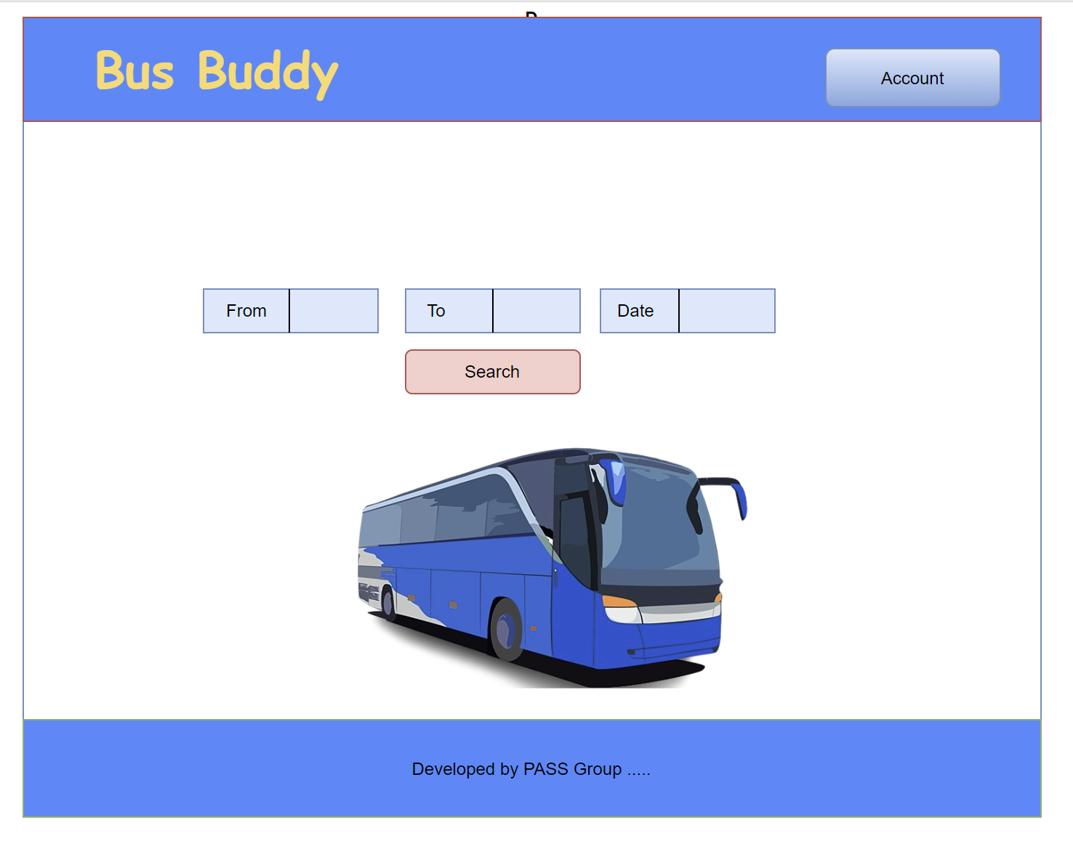

 - Bus listing page

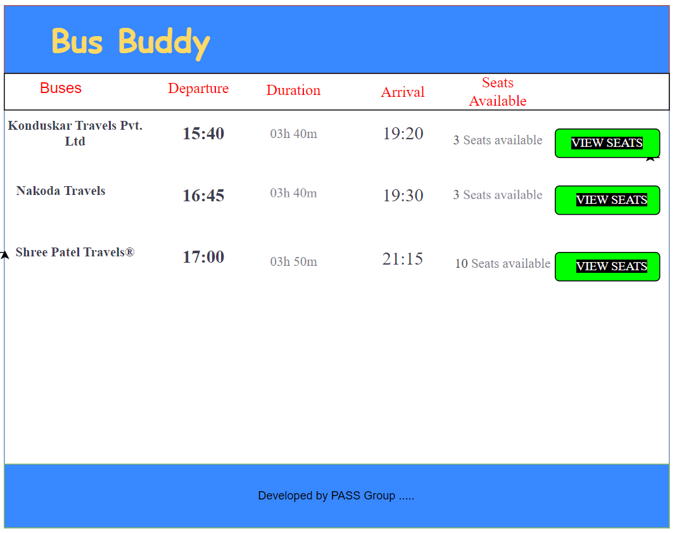

- Seat selection page

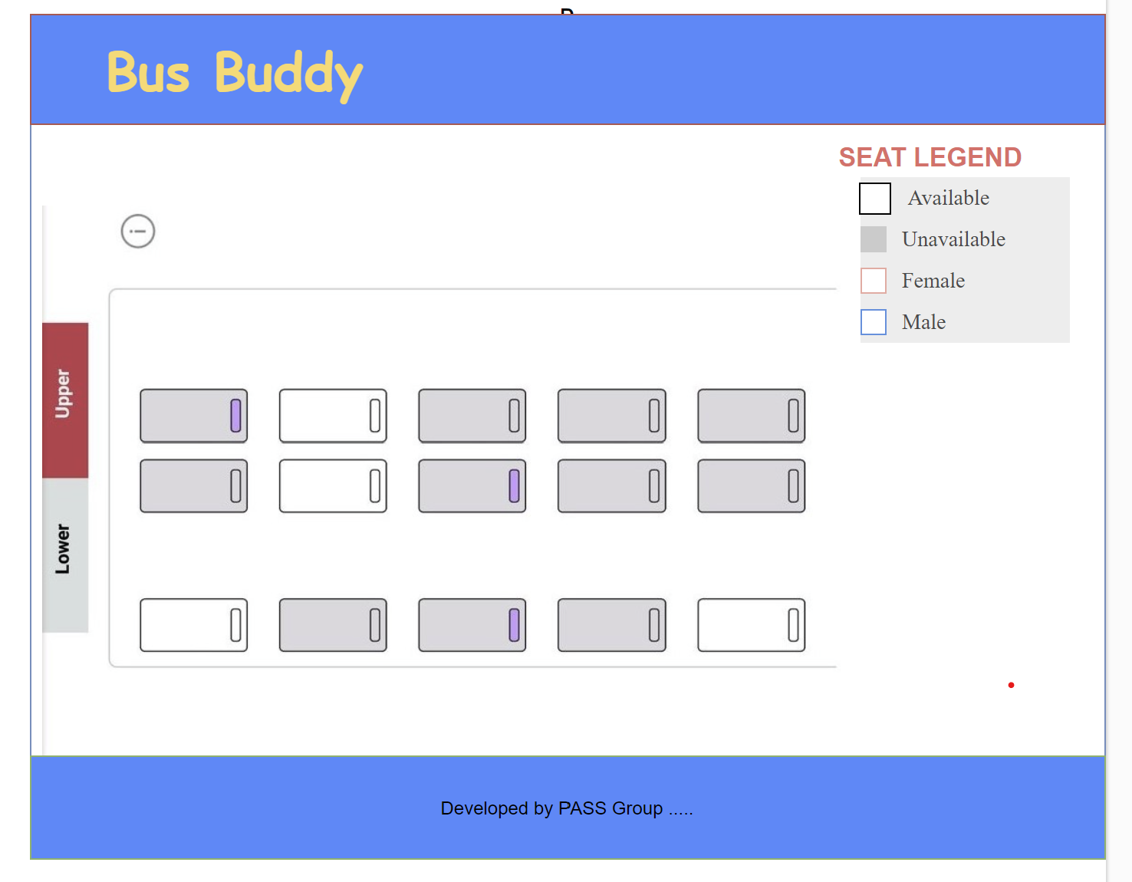

 - Passenger details page

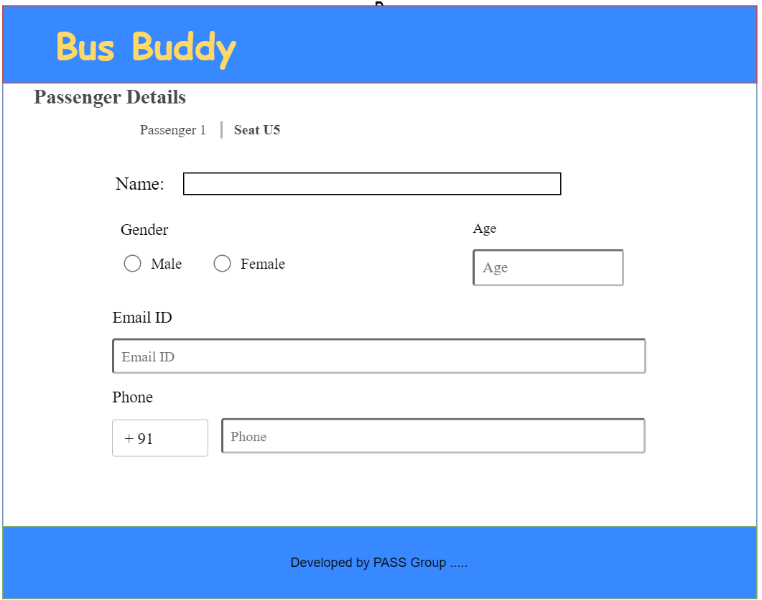

- Payment page

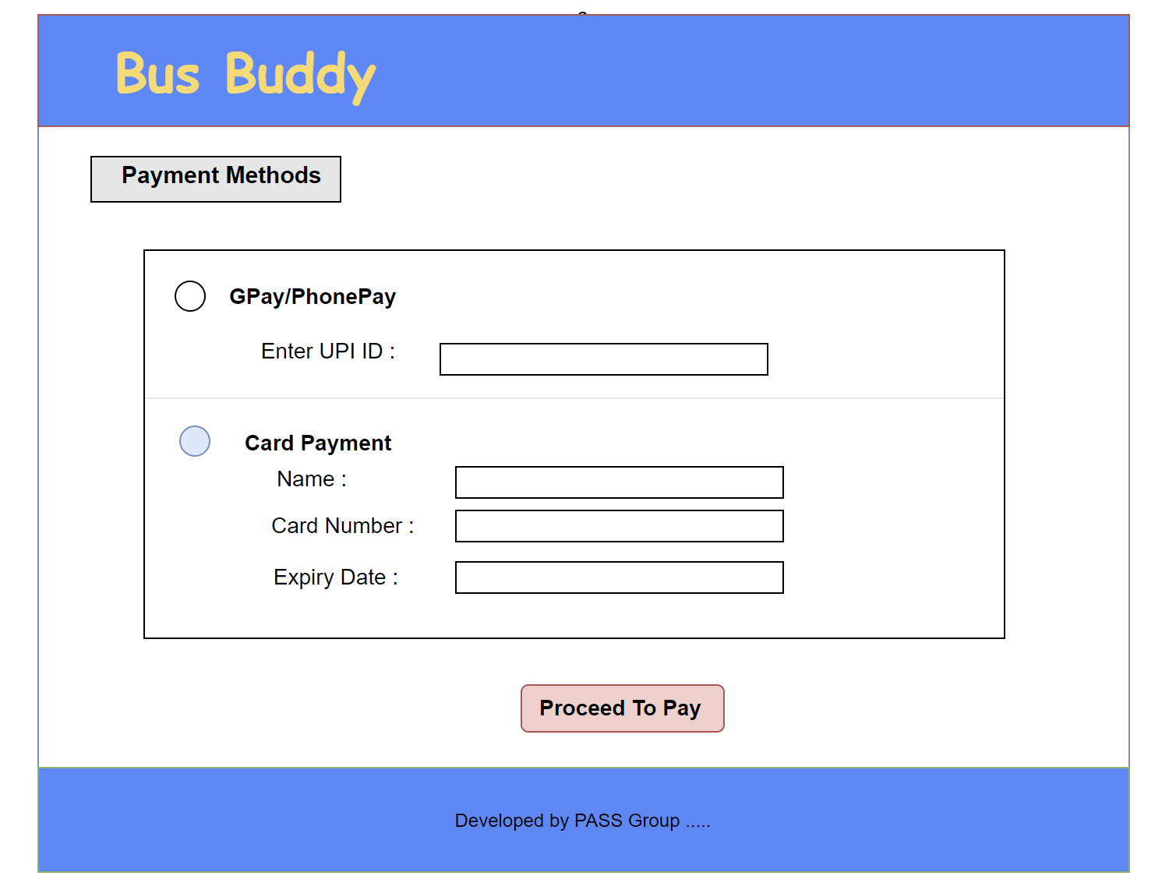

 - Confirmation page

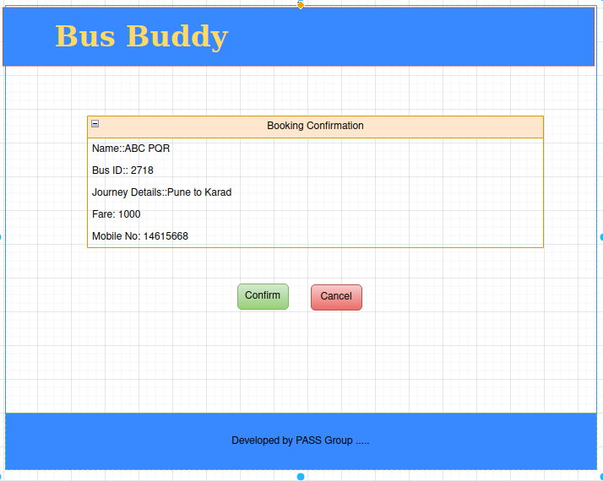

    - Update Profile

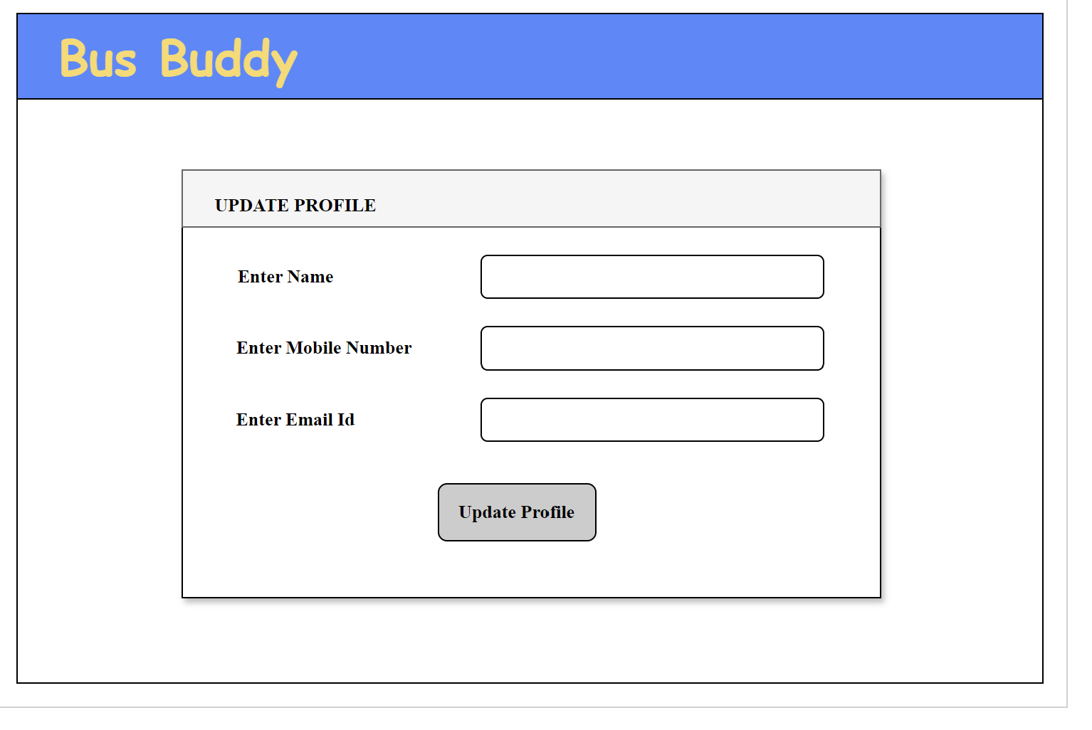     - - Reset Password

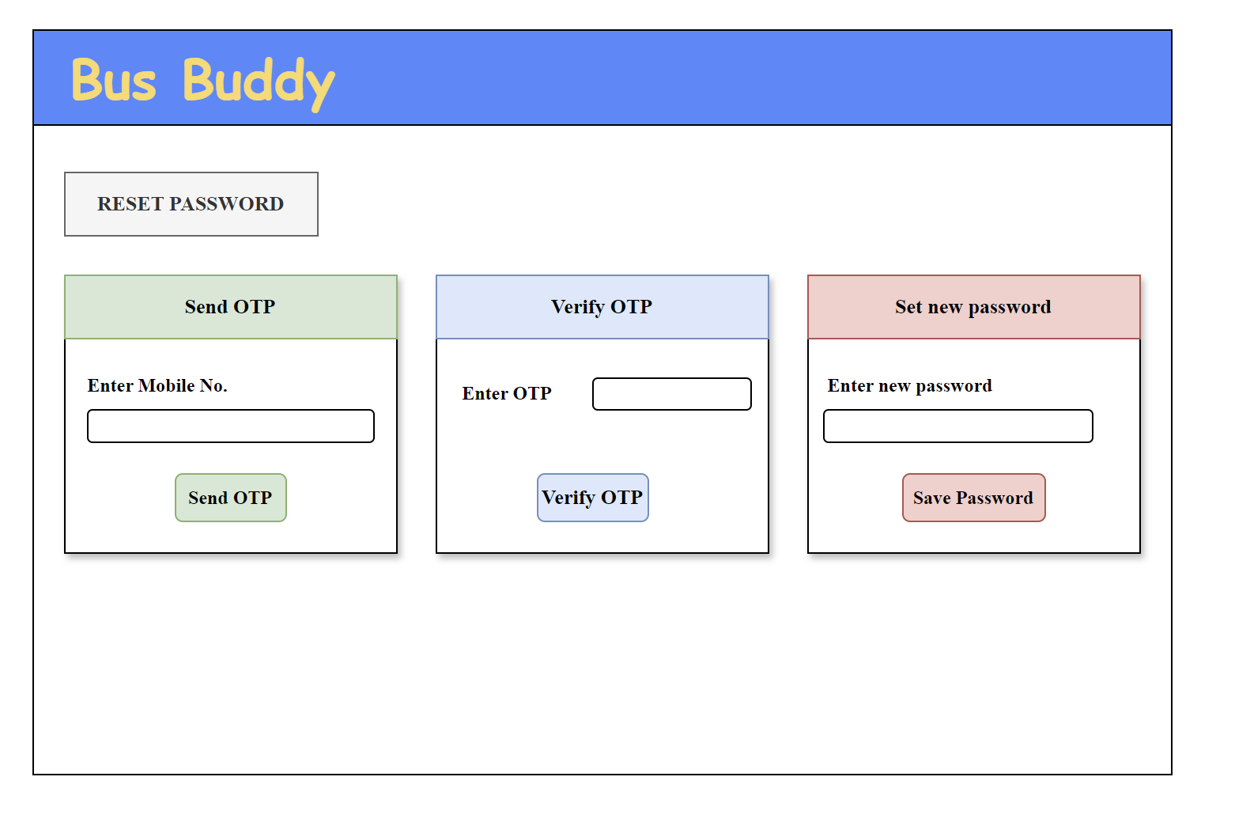

2. Admin Side

  - Admin Login screen

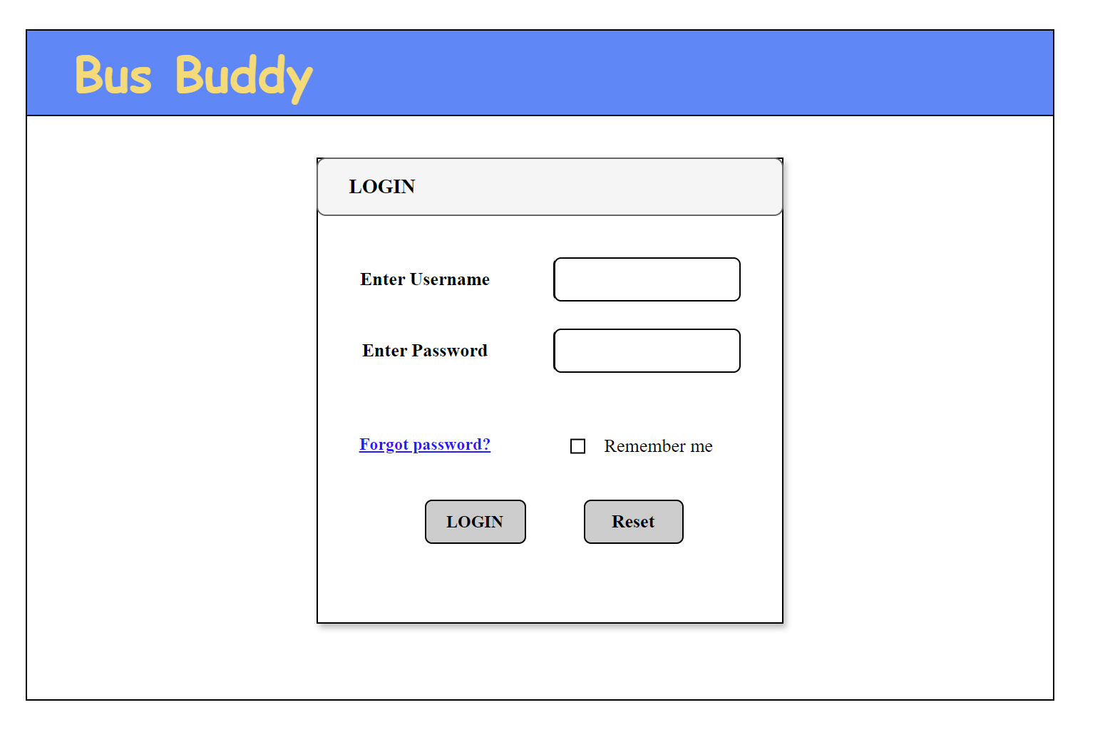

  - Admin Dashboard

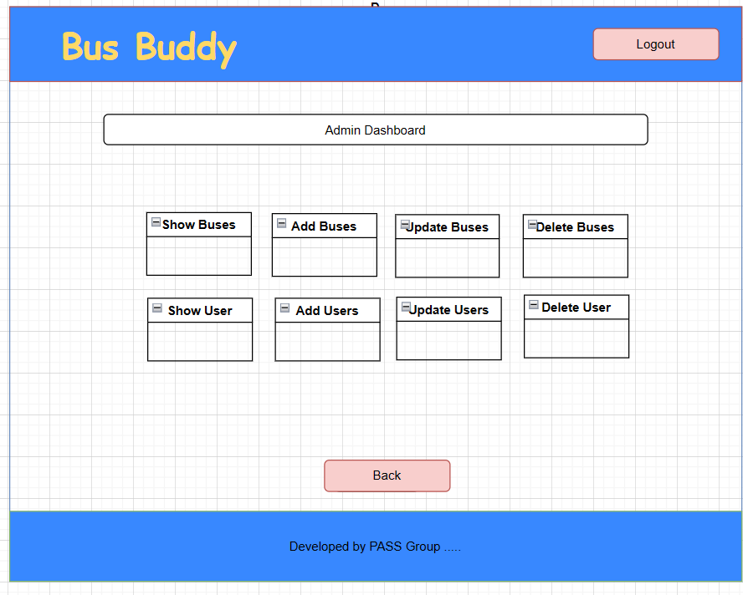

  -Admin to Add Bus

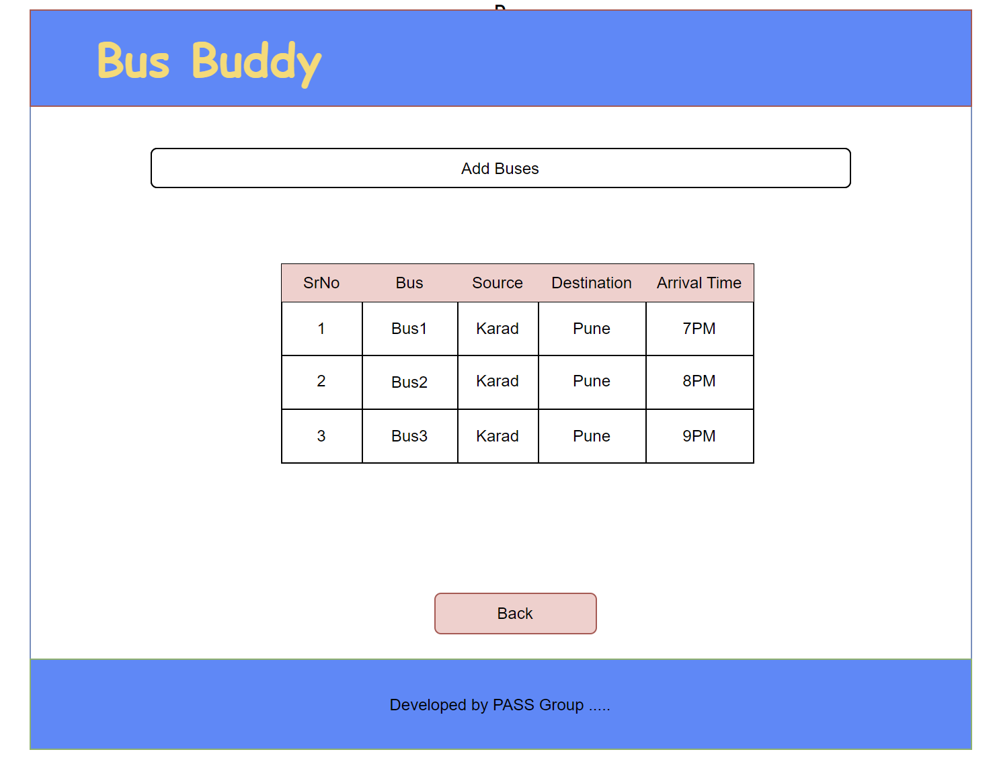

  -Admin to Update Bus

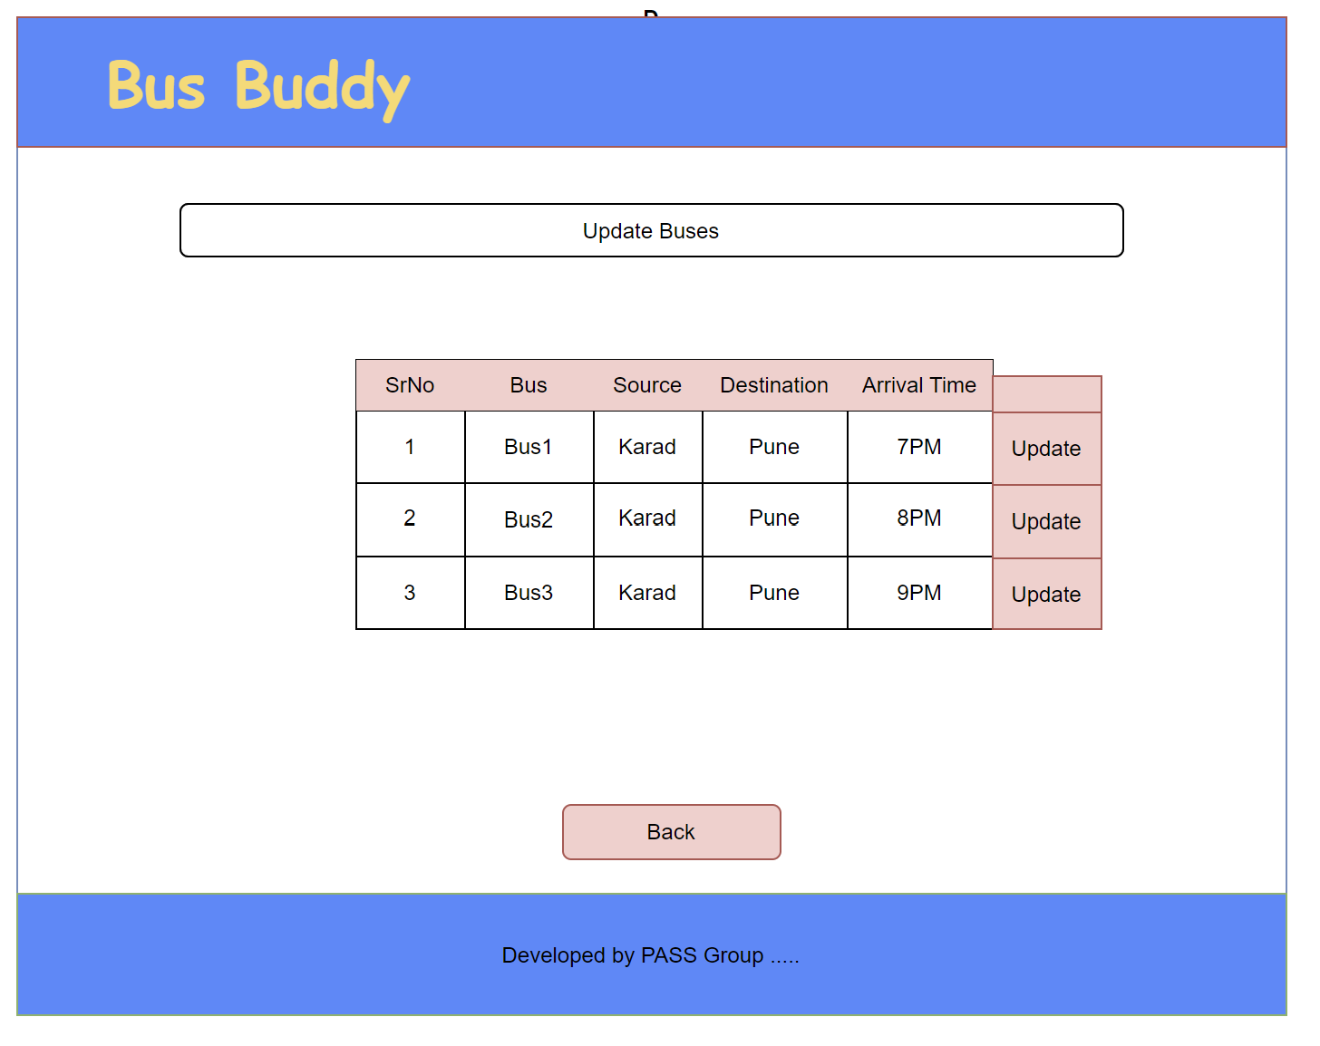

  -Admin to Show Bus

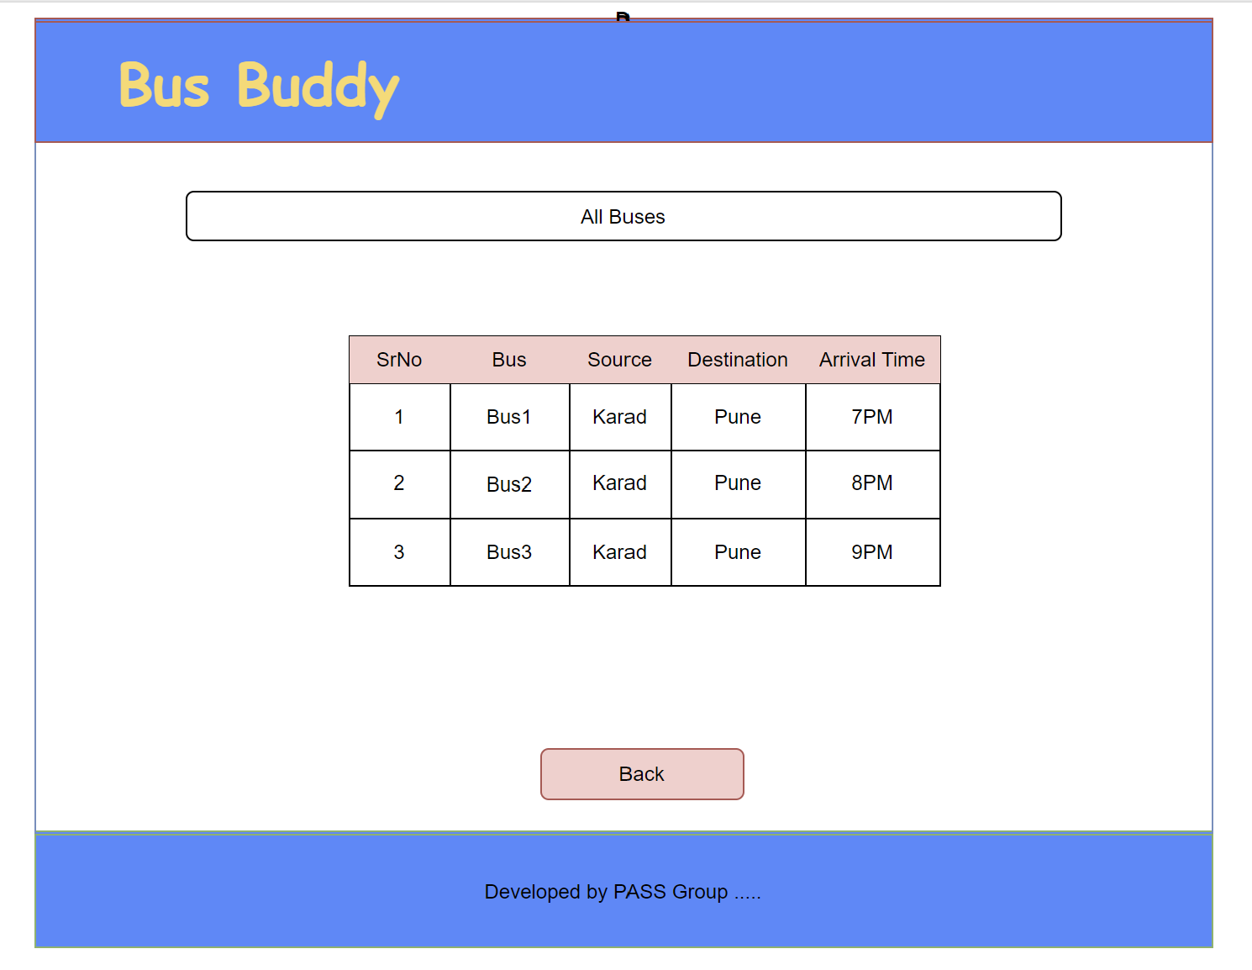

  -Admin to delete Bus

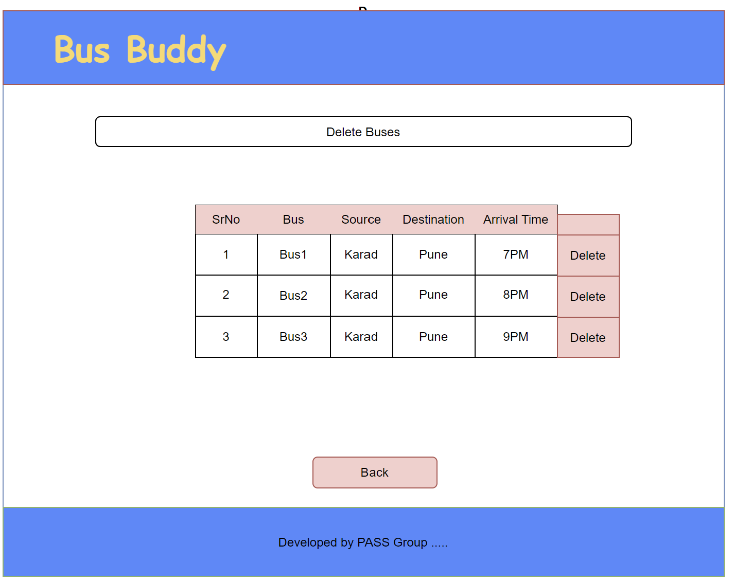

  -Admin to Add User

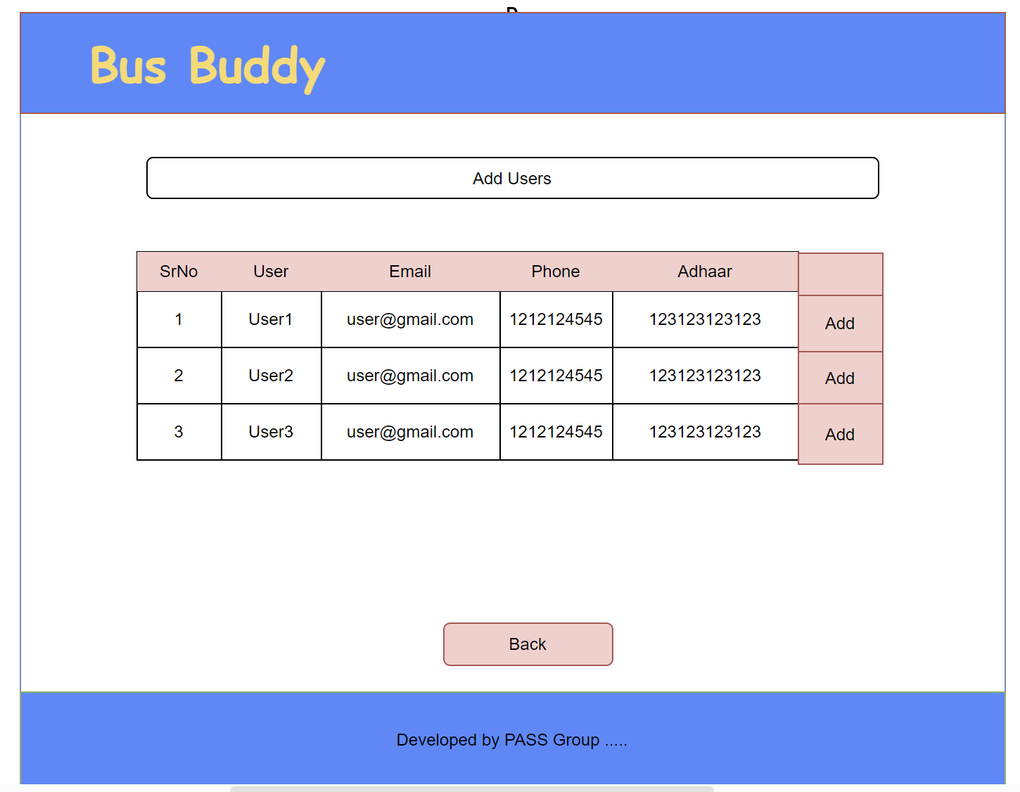

  -Admin to Update User

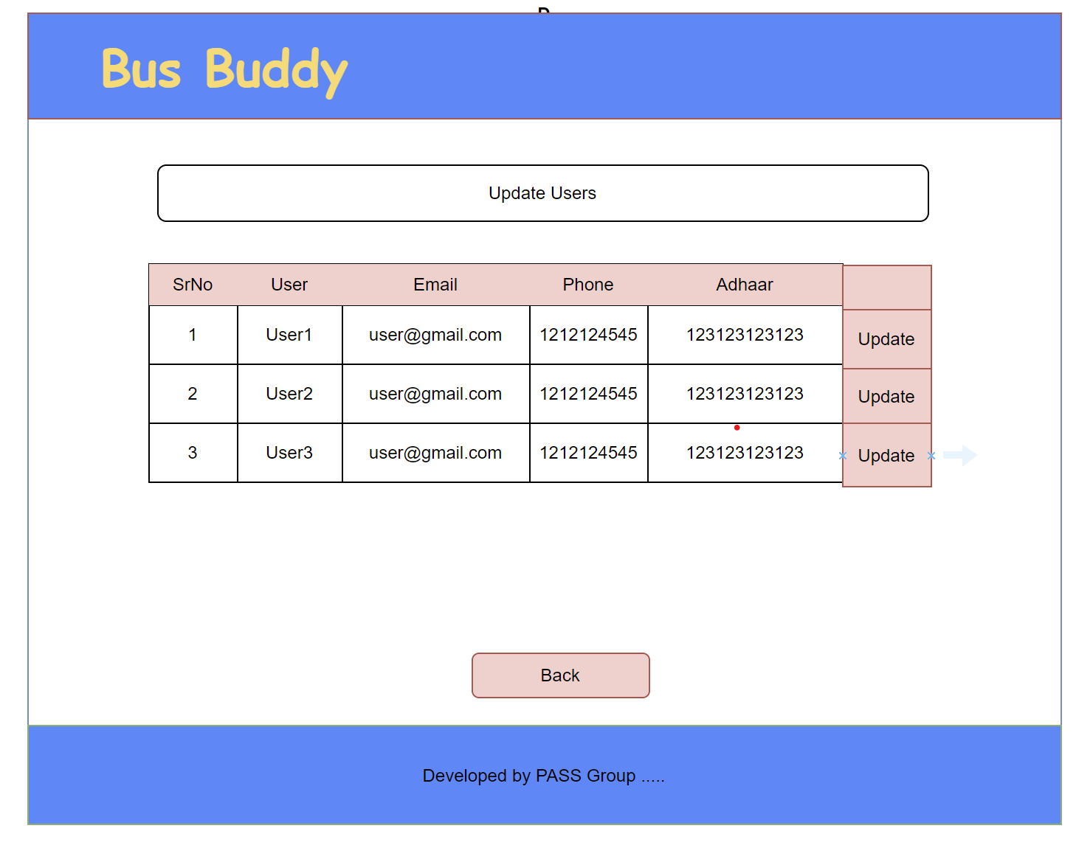

  -Admin to Show User

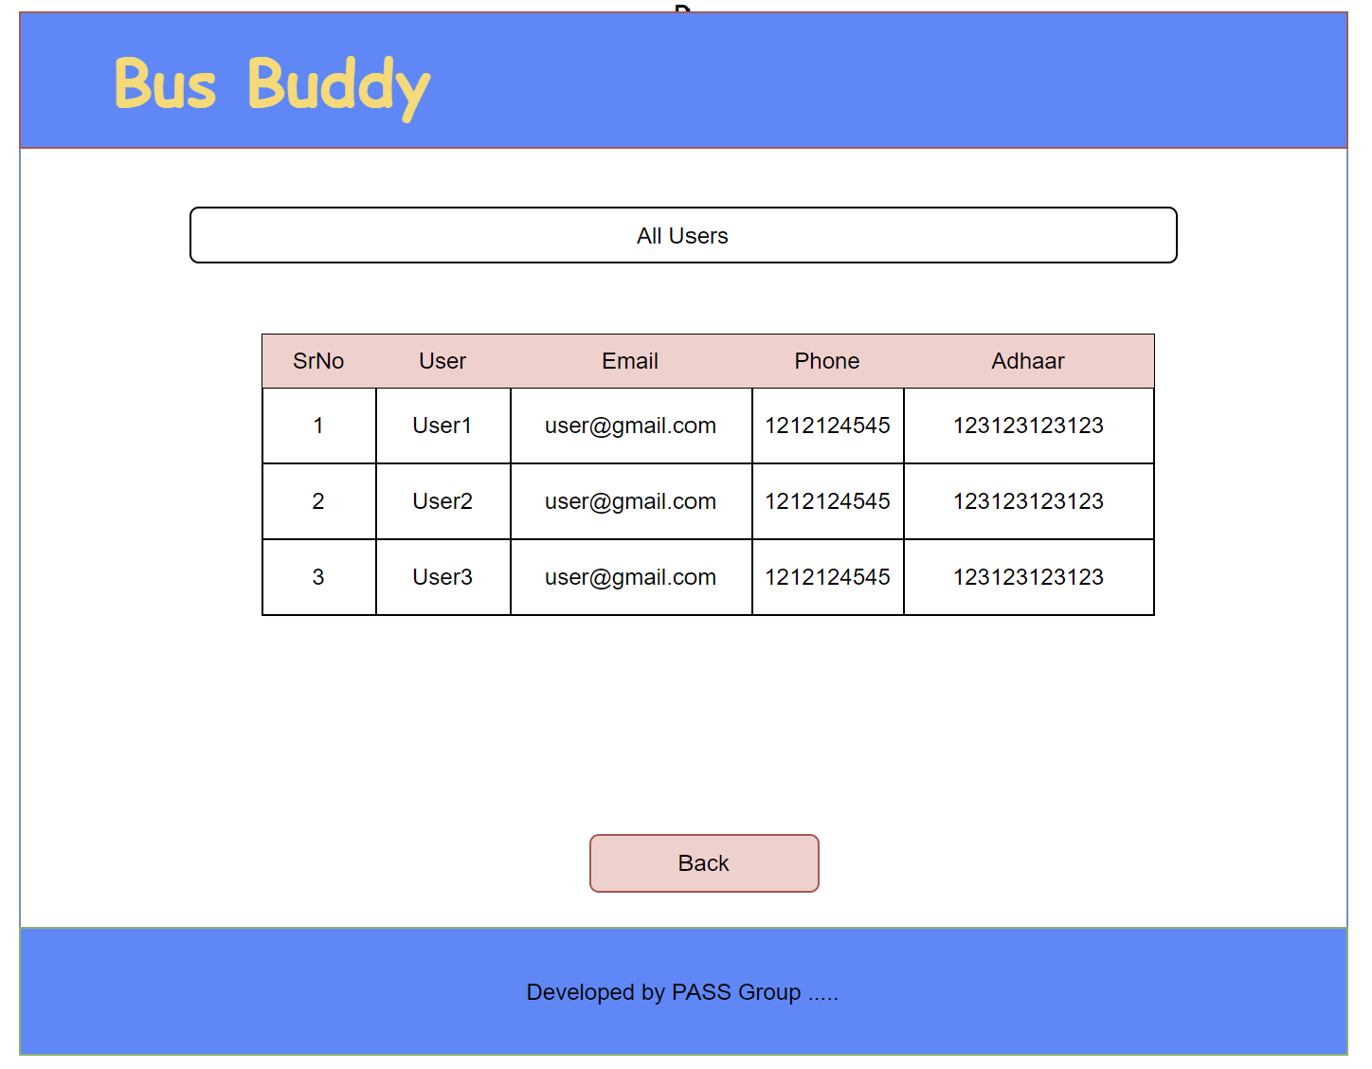

  -Admin to delete User

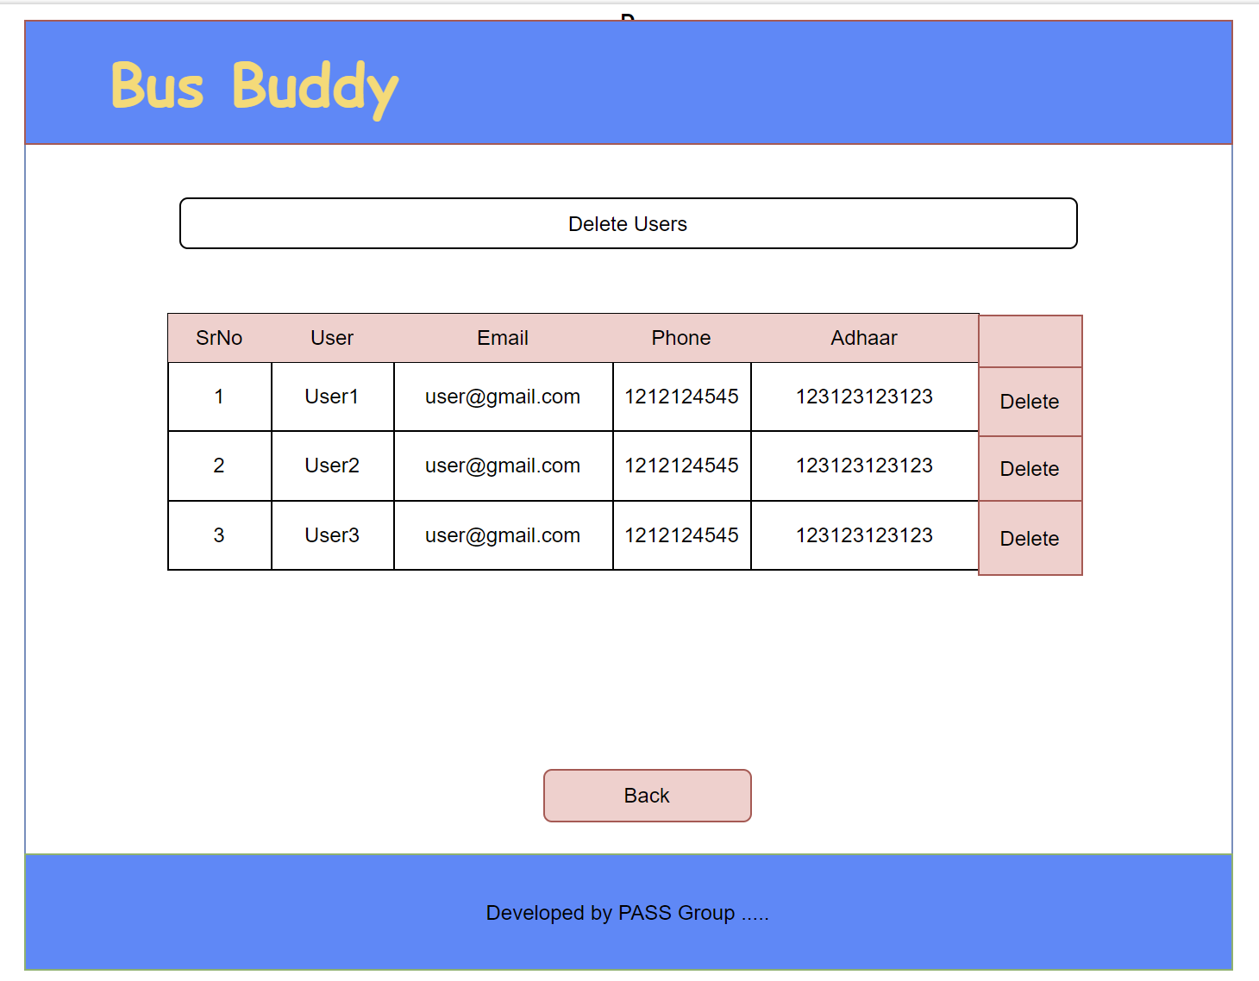

3.Registration Page

Registration Form for Bus

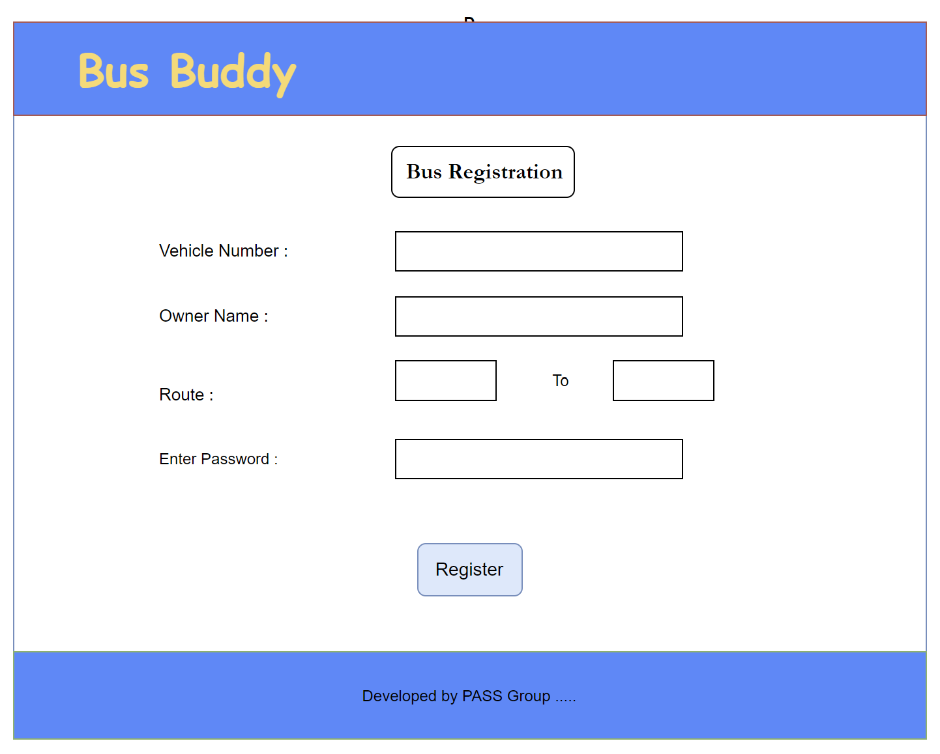

Registration form for user

